Estimating Personal Values in Text

General Methods
Across three pilot studies and four waves of our main study, we gathered data to estimate how people perceived the values present in two forms of text: song lyrics and political speeches. We conducted pilot studies with the primary aim of estimating the number of observations for each piece of text, per text type (lyrics vs. speeches). We conducted our main study to gather perceptions of values in text more broadly, one for lyric and one for speech excerpts. We stratified our participant samples by self-reported ethnicity for both lyrics and speeches (Asian, African American / Black, `Latino/Histpanic, White), and for speeches we further stratify participants by self-reported political leaning (Conservative, Moderate, Liberal). We used an existing sample of lyrics roughly stratified across four strata (year of release, genre, popularity, and lyrical topic). We sampled political speeches of U.S. presidents, stratified by president and by speech. As studies generally shared the same overall procedure to recruit participants and gather observations, we herein describe the stimuli, survey design, and participant recruitment procedure.
Our procedures were reviewed, determined to have minimal risk to participants, and thus approved by the Human Research Ethics Committee at Delft University of Technology. The study plans and analysis were preregistered on the Open Science Framework (https://osf.io/fhq75).
All analyses were conducted in R (R Core Team, 2025) within the RStudio integrated development environment (RStudio Team, 2025), along with the here (Müller, 2020) helper functions for managing file paths. Data wrangling and statistical analysis relied on the tidyverse suite (Wickham et al., 2019), helper functions from rlang (Henry & Wickham, 2024) and ggplot2 for visualization (Wickham, 2016). Reliability analyses were conducted with the psych package (Revelle, 2023), mixed-effects models were estimated with lme4 (Bates et al., 2015), and p values from statistical tests were estimated with lmerTest (Kuznetsova et al., 2017). Additional APA formatting and reporting used gt (Iannone et al., 2023) and papaja (Aust & Barth, 2022).

Stimuli
We aimed to gather two sets of stimuli, one each representing diverse lyrics, and political speeches. Both sets were developed using stratified sampling approaches. See Appendix A: Stimuli for further details regarding stimuli data and sampling procedures.

Song Lyrics
We used the same initial pool of song lyric excerpts as Demetriou et al. (2024), who obtained lyrics with permission via the API of Musixmatch. Musixmatch crowdsources lyrics by hosting a platform where users add, correct, sync, and translate the lyrics to songs. Musixmath further engages in quality assurance which includes spam detection, formatting, checking spelling and translation, and manual verification, via their employee editors and a community of curators that function similarly to moderators on forums like Reddit.
Demetriou et al. (2024) aimed at gathering a diverse sample of songs using a procedure they called “fuzzy stratified sampling”. An ideal scenario would have been to gather a representative sample of lyrics, with a pre-determined target number of songs, randomly sampled from within clearly defined strata (Groves et al., 2009). However, Demetriou et al. (2024) note that the population of songs is enormous, with many streaming services reporting over 100 million songs in their catalogues, and that no work to their (or our) knowledge has been conducted to determine a complete list of strata, or an appropriate target number of songs on which to gather perceptions of values. Further, while some strata that may relate to language use in song lyrics are conceptually clear, such as the year of release which may indicate time-appropriate slang or current events, other strata are far less clear: e.g. (1) the year of release is a conceptually clear stratum compared to (2) popularity for which no single ideal method for its estimation exists despite a plurality of approaches, which in turn is more clear than (3) genre for which there may be some overlap in human labels, but no universally agreed upon musicological taxonomy (Liem et al., 2012), which in turn is practically more clear than (4) the topic of the lyrics, for which topic estimation is likely to be imprecise. Demetriou et al. (2024) thus aim for a diverse rather than a fully representative sample, by taking a stratified sampling approach while acknowledging that the strata are “fuzzy”, and some important strata may be missing.
Briefly, Demetriou et al. (2024) uniformally randomly sampled an initial pool of 60,000 artists in the Spotify Million Playlist Dataset (MPD) (Chen et al., 2018). The MPD contains the metadata of approximately 2 million individual tracks from approximately 300,000 artists, as they were arranged in playlists by users. Demetriou et al. (2024) then drew the metadata of every song from the entire discography of those 60,000 artists from the Spotify API and checked the availability of those songs in the Musixmatch database, resulting in large pool of approximately 510,000 songs from approximately 15,400 artists. Musixmatch provided the first 30% of the lyrics of each of the 510,000 songs via their API.
From the pool of available 510,000 songs, Demetriou et al. (2024) then drew a sample of 2,200 song lyrics, the number of which was determined by their budgetary limitations. Songs were sampled within four “fuzzy” music strata: (1) year, the release date according to Musixmatch meta-data, which might contain some errors; (2) popularity, operationalized as the frequency that an artist appeared on a playlist in the MPD (Chen et al., 2018); (3) genre, estimated from topic modeling user-generated tags of artists in the MPD (Schindler et al., 2012), which were drawn from Last.fm and merged into the MPD; and (4) lyric topic, via topic modelling on a bag-of-words representation of the lyrics data. They observed a skew such that more recent and popular artists and songs appeared substantially more on playlists, and were far more likely to be sampled. Popularity had an especially severe skew. To increase sample diversity, popularity was divided into 7 ordinal bins which were approximately equal in terms of the number of songs in each bin. Year of release was divided into equally spaced ordinal bins with year being divided into decades (60s, 70s, 80s etc.), and genre and lyric topics were treated as non-ordinal categorical bins.
Demetriou et al. (2024) then manually screened songs for inclusion in the study. Screening primarily confirmed that the song metadata matched the song title and artist name if searched on the internet, and that the lyrics in the sample matched the lyrics of the song when listening to a streamed version. Screening secondarily removed songs that were (1) were more than approximately 20% non-English words or characters; (2) completely onomatopoetic or nonsense; (3) comprised of repeated single words or single phrases; or (4) consisted of too few words. Demetriou et al. (2024) selected a total of 380 songs. We (authors of present work) further screened songs using the same requirements until a total of 1,200 songs were considered usable. The first 800 excerpts were used in the main study, and the next 14 were used for the lyrics pilot study. As some songs lyrics contained non-lyric words, indicating e.g. section (i.e. verse or chorus), artist, or time stamp, included songs were manually corrected to only contain the song lyrics. Songs most frequently removed were completely non-English or contained a large number of non-English words, e.g. reggae songs written in Jamaican Patois or k-pop / j-pop which contained words in English as well as Korean or Japanese, followed by songs that had very few or single repeated words such as dance and electronic music.

Political Speeches
We chose the U.S. State of the Union addresses as the overall corpus, as the addresses are a long-running, formally recorded corpus of public speech, that has regularly been delivered to congress each year, by presidents of both parties of a two-party system. Speeches were sampled from the UVA Miller center repository, which maintains an archive of presidential communications, including presidential speech recordings and transcripts. Presidents generally gave a single State of the Union address each year of their presidency. Our samples were therefore stratified within (1) president, and (2) speech. We excluded all speeches before 1900 so as to sample language that is approximately current, and the single speech by Zachary Taylor so as not to oversample a single speech. Speeches were grouped by president. Within each president, every speech was divided into a proportional number of chunks, with presidents who gave fewer speeches contributing more chunks per speech and those with many speeches contributing fewer: e.g. 7 per speech from 2 term presidents, and 14 per speech from single term presidents. Each president contributed roughly the same number of chunks (M_{chunks} = 55.3). From each chunk, we then sampled from the 200th word to the end of the sentence it was in. 328 excerpts were then randomly selected, 44.8% of which were from Democratic presidents (M_{excerpts} = 16) vs. 55.2% Republican presidents (M_{excerpts} = 15). The first 300 were used in the main study, and 14 each were used in two pilot studies.

Participants
We aimed to gather responses that approximate the average perspective of a target population, and possibly sub-groups of that population, of the values present in text. We chose the United States as the target population, given that lyrics are in almost all the most popular songs in the US, and that the US presidents are likely familiar to US residents, as are the language and topics discussed. Across all studies, participants were recruited using online survey participant recruitment platform Prolific, to draw a sample that was stratified based on information participant self-reported demographics at registration, according to categories determined by Prolific. We exclusively drew participants who reported residing in the United States, and that were fluent in English. To see if perspectives between sub-groups of the population varied, our sample of respondents was stratified by the 2024 US Census most common ethnicities: (Asian, African American / Black, `Latino/Histpanic, White). The options Prolific provided for specific ethnicity that were closest to the ethnicities listed in the US Censues were: White, Black/African American, Hispanic/Latino, and three Asian sub-categories, East Asian, South Asian, South East Asian, which we combined into a single ‘Asian’ category. We then aimed to recruit approximately equal numbers in each category. For perspectives on speech excerpts, we additionally stratified our samples by political leaning: (Conservative, Moderate, Liberal).

Procedure
The procedure, essentially a set of survey components, in order, is shown in Figure 1. In order to ensure that participants understood the task, the survey (1) asked participants to complete a questionnaire about themselves, (2) gave a 3-item comprehension quiz that gave feedback on the correctness of the response after each item, (3) repeated the instructions multiple times, and (4) contained an attention check to filter out low effort responses. For complete survey materials, see see Appendix B: Survey.
Figure 1
Survey components
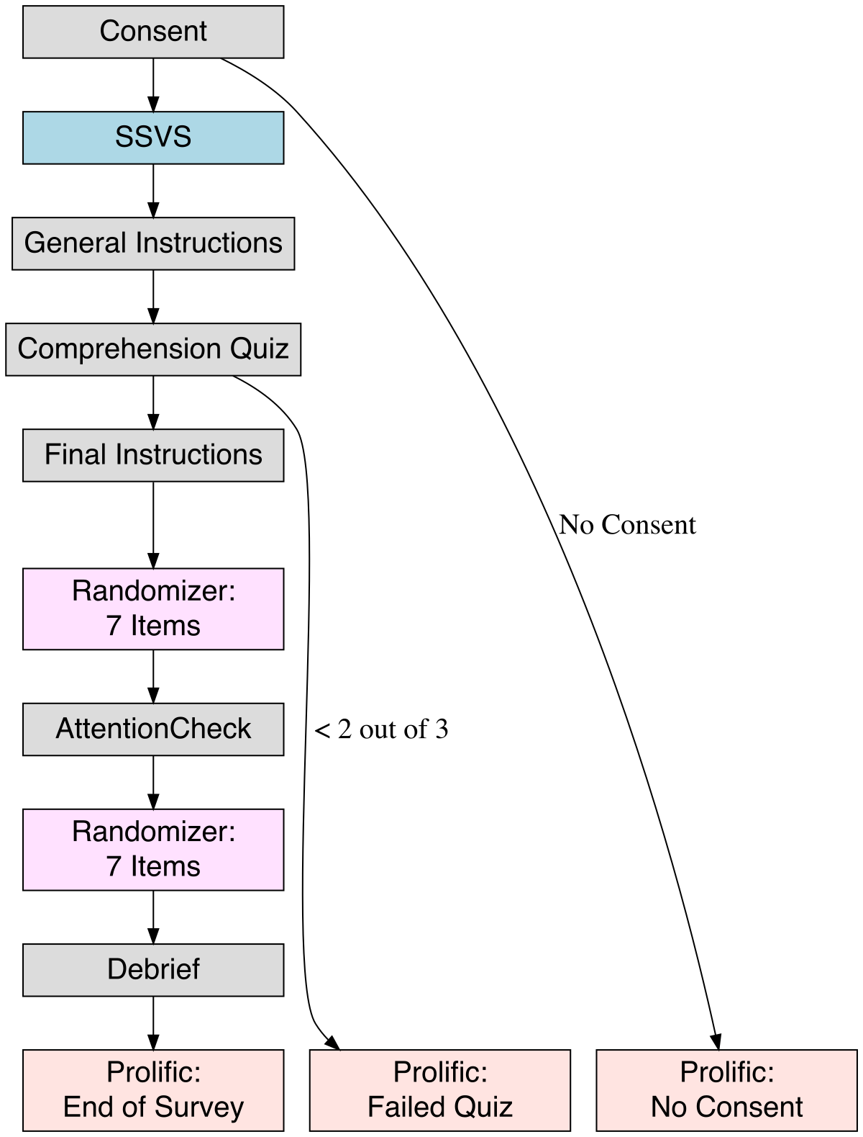
Note. Participants that failed the attention check were removed after having completed the entire survey.

Adapted Short Schwartz Value Survey
The primary measurement instrument in all surveys is the 10-item Short Schwartz Value Survey (SSVS) questionnaire developed by (Lindeman & Verkasalo, 2005), which participants completed on the Qualtrics survey platform. Each of the 10 questionnaire items in the SSVS is the name of a specific value in the Schwartz value inventory, along with a few descriptive words e.g. “POWER (social power, authority, wealth, influence on people and events)”.
Participants first completed the questionnaire about themselves to familiarize themselves with the task and with the Schwartz taxonomy of values. We asked participants to read the instructions from the Schwartz Value Survey in order to introduce the concept of personal values, and to instruct them on how to complete the questionnaire (Schwartz, 2005). The instructions explain that participants are to rate the following values as their importance as “a guiding principle in my life” using the given response format. The original, unbalanced likert scale in the Schwartz Value Survey (Schwartz, 2005) is also used in the Short Schwartz Value Survey (Lindeman & Verkasalo, 2005): a 9-point Likert scale which ranges from -1 (Opposed to their values) and 0 (Not at all Important), to 6 (Very Important) and 7 (Of Supreme Importance). Values are “ordered by relative importance”, essentially as a list of values ranked by priority Schwartz (1992). The SVS instructions therefore ask participants to first indicate the values that are at the very top i.e. 7 (Of Supreme Importance) or the very bottom -1 (Opposed to their values) of their personal value list using the extreme points of the likert scale. The instructions also explain that there normally are only one or two of these extreme values. Participants are then instructed to fill in the likert scales for the remaining values.

General Instructions
After completing the SSVS about themselves, participants then completed an adapted version of the SSVS for each of the lyric or speech excerpts they rated, thus producing annotations representing their perception of the values expressed by the text. Participants were shown a set of instructions for their primary task, the rating of values for each text excerpt. We used an SSVS version similar to (Demetriou et al., 2024), in which the instructions are slightly adapted. Firstly, for lyrics we asked participants to respond to the questions while considering the Speaker i.e. the person or thing whose perspective the lyrics reflect, which we distinguish from the Author of the text i.e. the person or people responsible for selection of words and their structure. In the case of speeches, we defined Speaker as the president delivering the speech, as opposed to the Author who may be the president, but may also be a team of speech writers and/or other staff, or other individuals who occasionally appear in the speech transcript. Secondly, we present participants with a ‘Not Applicable’ response option, as we expect that excerpts of text give an incomplete picture of the values of the Speaker. Thus, we give participants the option to indicate NA to indicate “Not Applicable” if they felt no information on the value is present in the text. We thus gather 10 likert-scale responses per item (lyric / speech excerpt) being rated, one for each of the 10 Schwartz values, within a range of -1 to 7, and with possible NAs, which comprise the annotations from each participant.

Comprehension Quiz
The comprehension quiz asked three questions shown in random order, each of which comprised of a brief scenario: (1) “If you feel a SPEAKER seeks POWER above all else as a life-guiding principle, how would you respond?”, to which the correct response was at the high end of the scale (i.e. 5, 6, or 7), (2) “If you feel a SPEAKER doesn’t give any indication of how important POWER is to them in the lyrics, how would you respond?” to which a correct response was “NA”, and (3) “If you feel a SPEAKER avoids POWER more than anything else, or sees it as completely unimportant to them, how would you respond?” to which a correct response was on the lower end of the scale (i.e. -1, 0, or 1). Questions were accompanied by the single item, POWER. After participants responded to each question, the survey displayed the correct response, along with a brief explanation e.g. “If you feel a SPEAKER seeks POWER above all else as a life-guiding principle, respond with a ‘7’, indicating it is of Supreme Importance to them”.

Attention Check
Our survey checked if participants were paying attention. As per Prolific guidelines, we include an attention check at the halfway point of the annotation component of the survey. The check appeared to be another song lyric, with the lyrics being instructions to participants to indicate “7” for the value of Stimulation, “0” for all other values. Participants who responded with “-1” or “NA” instead were also considered passing if they were consistent in the ratings of all values other than Stimulation. Participants who failed the attention check were returned to Prolific, and automatically replaced.

Exploratory Measures
We collected a number of exploratory measures which we felt might affect participant ratings, but for which we had no specific prediction. For lyrics we asked participants “Do you think the SPEAKER and the AUTHOR are the same person?”, and “Do you recognize the song that the lyrics come from?”, and for speeches we asked participants “Do you recognize the president that delivered the speech?”, and “Which party do you think the president belongs to?”.
Following the SSVS for each lyric or speech excerpt, we also assessed participant confidence in their ratings by asking “How confident are you in your ratings of these lyrics? / this speech?”, to which participants could respond on a scale from 1 (Completely Confident) to 5 (Completely Unconfident). [citation about Confidence]
For participants completing the survey for Lyrics texts, we also asked a series of descriptive questions regarding the importance of lyrics in their music preferences. [cite Appendix with exploratory analyses]

Pilot Methods

Ratings per stimulus
The primary aim of our pilot studies was to estimate the number of ratings needed per stimulus, to estimate an average perception of a given value in a given text. We made a determination using boostrapped estimates of inter-rater reliability for a range of incremental subsample sizes, as well as correlations between overall sample means and incremental subsample means. To do so, we followed a procedure similar to DeBruine & Jones (2018). This process essentially involves gathering data comprised of a) a relatively large number of ratings (e.g. ratings from 100 raters), on b) a relatively small sub-sample of the items to be rated (e.g. 15). Inter-rater reliability is repeatedly estimated on a range of different possible numbers of ratings. Doing so shows a sampling distribution of inter-rater reliability estimates for e.g. 5 vs. 10 vs. 15 etc. ratings per stimulus. This essentially allows for an estimate of a target number of ratings, in order to achieve a target inter-rater reliability, on average. We estimated the target number of ratings separately per text type (lyrics / speeches) as we expected that each form of text could vary in terms of degree of ambiguity, and separately per value, as we expected that this degree of ambiguity may vary by value and by text.
As we aim to represent the mean of a population of raters, we estimate inter-rater reliability as ‘general consensus’ (as opposed to ‘absolute agreement’) via intraclass correlation coefficient ICC(2,k)(Koo & Li, 2016). The ‘2’ indicates two-way random effects, in that both the targets of the ratings and the raters are treated as random samples from a larger population, and the ‘k’ indicates the reliabiliity of the average of k raters. In essence, ICC(2,k) estimates how consistently a group mean rating of k raters reflects the “true” score of each item, i.e. inter-rater agreement. We estimate the inter-rater agreement separately for each value (i.e. power, achievement etc.), for the overall sample of ratings, and for each of the subsample increments (i.e. 5, 10, or 15 ratings) during bootstrapping. We used a value of 0.75 as a threshold to indicate sufficent, or “good”, agreement (Koo & Li, 2016). To examine the general stability of mean ratings of a given value in a given text (value / item), we first estimate a canonical mean per value / item, and then estimate the correlation between the canonical mean, and the subsample mean per value / item. Although we did not see a recommended threshold for pearson correlations in (DeBruine & Jones, 2018), we set a threshold of 0.9 to indicate sufficient, or “high” correlation between sub-sample and overall sample means.
We thus aimed to bootstrap estimates of inter-rater reliability by incrementally sub-sampling numbers of raters, 50 times per increment, and then estimating a) inter-rater reliability in the form of consensus by estimating ICC(2,k), and b) the Pearson correlation between the sub-sample increment mean and the overall sample mean (DeBruine & Jones, 2018). We set the sub-sample increments to 5, ranging from 5 to 50, with replacement, 50 times for each increment: i.e. we sampled 5 raters 50 times, 10 raters 50 times, 15 raters 50 times etc. up to 50 raters 50 times, all with replacement. We then aim to determine a target number of ratings based on the distributions of ICC(2,k) and pearson’s r, relative to the thresholds we set. A secondary aim was to pilot our quiz, and to observe which question(s) participants found to be the most challenging.

Participants
We recruited a total of 300 participants: 100 each stratified by ethnicity completed the lyrics and the first speeches pilot, and 100 participants stratified by political orientation completed the second speeches pilot. Data were removed for 1 participant each in the pilot study using lyrics and the first pilot study using speeches as they erroneously completed the survey twice. 2 participants chose to withdraw their data prior to the time this manuscript was written in the second pilot using speeches (see Table 1).
# demographics table
pilot_demog_tbl <- imap_dfr(
pilot_2_demog_dfs,
~ summarize_demographics(.x, pilot_labels[[.y]] %||% .y))
pilot_demog_tbl %>%
gt() %>%
cols_align(align = "left", columns = c(Study)) %>%
cols_align(align = "center", columns = c(N, `% Female`, `Age range`, `Age M (SD)`)) %>%
fmt_number(columns = `% Female`, decimals = 1) %>%
format_apa_table(md("**Table 1**"), md("*Participant demographics — Pilot studies*"))
Table 1: Table 1
Participant demographics — Pilot studies
Study | N | Age M (SD) | Age range | % Female
Pilot 1 (Lyrics) | 99 | 36.1 (12.4) | 18–82 | 48.5
Pilot 2 (Speeches: Ethnicity) | 99 | 35.2 (11.2) | 18–64 | 48.5
Pilot 3 (Speeches: Political) | 98 | 36.8 (11.9) | 21–74 | 49.0
The pilot study using lyrics and the first using speeches were stratified by Ethnicity (see Table 2). The second pilot using speeches was stratified by Political Spectrum. This resulted in a sample of mostly ‘Black’ and ‘White’ identifying participants, although the default Ethnicity settings on Prolific do not include ‘Hispanic/Latino’ (see Tables 3a and Table 3b).
pilot_ethnicity_tbl <- imap_dfr(
pilot_2_demog_dfs[1:2],
~ summarize_ethnicity(.x, pilot_labels[[.y]] %||% .y))
pilot_ethnicity_tbl |>
gt() %>%
cols_label(
`Black/African American` = html("Black/<br>African American"),
`Latino/Hispanic` = html("Latino/<br>Hispanic"),
Asian = "Asian",
White = "White") |>
fmt_number(columns = -Study, decimals = 1) %>%
cols_align(align = "center",
columns = c(Asian, `Black/African American`,
`Latino/Hispanic`, White)) %>%
format_apa_table(md("**Table 2**"), md("*Participant ethnicity — Pilot studies*"))
Table 1: Table 2
Participant ethnicity — Pilot studies
Study | Asian | Black/<br>African American | Latino/<br>Hispanic | White
Pilot 1 (Lyrics) | 23 (23.2%) | 26 (26.3%) | 25 (25.3%) | 25 (25.3%)
Pilot 2 (Speeches: Ethnicity) | 24 (24.2%) | 25 (25.3%) | 25 (25.3%) | 25 (25.3%)
pilot_2_demog_dfs[[3]] |>
count(Ethnicity) %>%
mutate(
pct = 100 * n / sum(n),
value = paste0(n, " (", round(pct, 1), "%)")) |>
select(Ethnicity, value) |>
gt() |>
cols_label(Ethnicity = "Ethnicity (Simplified)", value = "N (%)") |>
cols_align(align = "center", columns = c(Ethnicity, value)) %>%
format_apa_table(md("**Table 3a**"), md("*Participant ethnicity, Pilot 3 Speeches: Political Spectrum*"))
Table 1: Table 3a
Participant ethnicity, Pilot 3 Speeches: Political Spectrum
Ethnicity (Simplified) | N (%)
Asian | 5 (5.1%)
Black | 35 (35.7%)
Mixed | 11 (11.2%)
Other | 3 (3.1%)
White | 42 (42.9%)
NA | 2 (2%)
pilot_spectrum_tbl <- imap_dfr(
pilot_2_demog_dfs["speeches2"],
~ summarize_spectrum(.x, pilot_labels[[.y]] %||% .y))
pilot_spectrum_tbl |>
gt() %>%
fmt_number(
columns = -Study,
decimals = 1
) %>%
cols_align(align = "center", columns = c(Conservative, Liberal, Moderate)) %>%
format_apa_table(md("**Table 3b**"), md("*Participants by political leaning — Main studies*"))
Table 1: Table 3b
Participants by political leaning — Main studies
Study | Conservative | Liberal | Moderate
Pilot 3 (Speeches: Political) | 33 (33.7%) | 32 (32.7%) | 33 (33.7%)

Pilot Results

Estimating the number of raters
p1 <- plot_raters(
pilot_2_lyrics_by_row_dfs[[1]] %>% filter(n <= 25),
metric = r, "Pearson's r", option = "plasma") +
geom_vline(xintercept = 0.9, color = "red", size = .4, linetype = "dashed")
p2 <- plot_raters(
pilot_2_lyrics_by_row_dfs[[1]] %>% filter(n <= 25),
metric = ICC2k, "ICC(2,k)", option = "plasma") +
geom_vline(xintercept = 0.75, color = "red", size = .4, linetype = "dashed")
(p1 /p2) +
plot_annotation(
title = "**Figure 2**",
subtitle = "*Reliability by Rater n: Lyrics Pilot*",
caption = "*Note.* Probability Density for Pearson's r and ICC(2,k).",
tag_levels = 'A') +
plot_layout(guides = "collect") &
theme(legend.position = "right",
plot.title = element_markdown(hjust = 0),
plot.subtitle = element_markdown(hjust = 0),
plot.caption = element_markdown(hjust = 0))
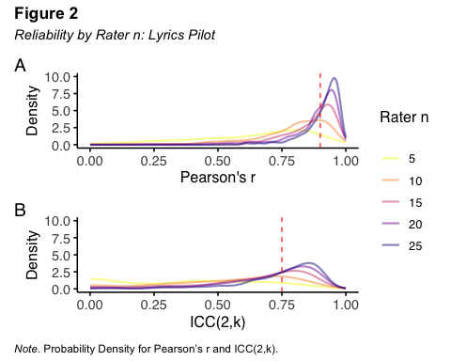
The results from our bootstrapping procedure for our lyrics pilot are shown in Figure 2. Results generally exceed our thresholds on average for both correlations between subsample means and the overall mean, as well as ICC(2,k), at 15 raters.
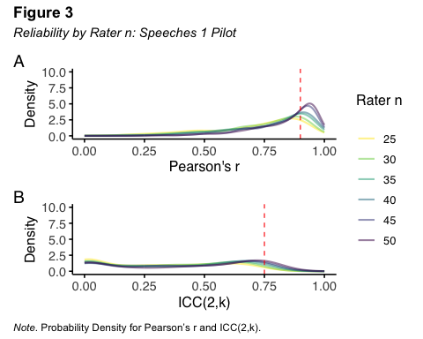
Our sample of annotators in our first speeches pilot were stratified by Ethncitiy. Our bootstrapping analysis shows sufficiently high correlations between subsample means and the overall mean at around 40 ratings on average, however, ICC2k scores do not reach sufficiently high ICC2k scores even with 50 ratings (see Figure 3).
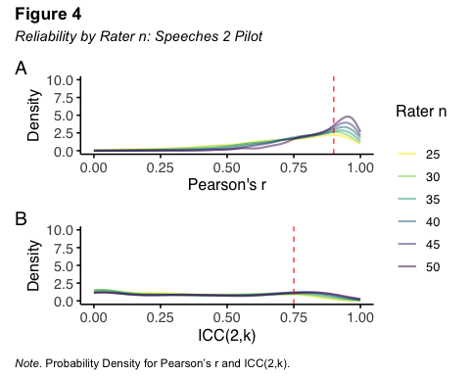
Our sample of annotators in our second speeches pilot were stratified by political affiliation. We observe a similar pattern, where the correlations between subsample means and the overall mean reach our threshold 35 ratings, but ICC2k scores are not sufficiently high even with 50 ratings (see Figure 4).

Exploring annotator sample strata
To probe a potential reason for the low ICC(2,k) values in our speeches samples, we examine overall ICC(2,k) scores, and for ethnicity and political leaning subgroups separately. For our lyrics pilot, we observe overall ‘good’ ICC(2,k) estimates, with the exception of SELF-DIRECTION, which shows a large confidence interval that exceeds our threshold (see Figure 5). These ICC(2,k) scores overall do not appear to improve when we estimate them separately for each Ethnicity (see Figure 6).
p1_1 <- pilot_2_lyrics_agreement_plots[[2]]
p1_2 <- pilot_2_lyrics_agreement_plots[[3]]
p1_3 <- pilot_2_lyrics_agreement_plots[[4]]
p1_4 <- pilot_2_lyrics_agreement_plots[[5]]
(p1_1 | p1_2) / (p1_3 | p1_4) +
plot_annotation(
title = "**Figure 6**",
subtitle = "*ICC(2,k) by Schwartz value, by Ethnicity: Lyrics Pilot*",
caption =
"*Note.* Error bars are 95% confidence intervals.
'Self' indicates reliability for the value 'self direction'.") &
theme(plot.title = element_markdown(hjust = 0),
plot.subtitle = element_markdown(hjust = 0),
plot.caption = element_markdown(hjust = 0))
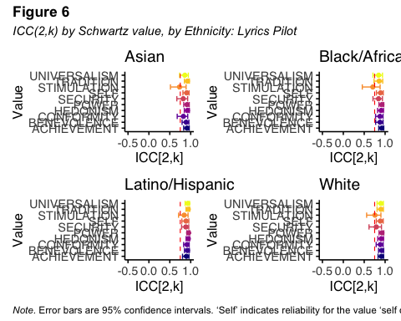
Overall, agreement on our two pilots which used political speech data was poor (see Figure 7).
p2 <- pilot_2_speeches1_agreement_plots[[1]]+ggtitle("")
p3 <- pilot_2_speeches2_agreement_plots[[1]]+ggtitle("")
(p2/p3) +
plot_annotation(
title = "**Figure 7**",
subtitle = "*ICC(2,k) by Schwartz value, by Ethnicity: Speeches Pilots 1 and 2*",
caption =
"*Note.* Error bars are 95% confidence intervals.
'Self' indicates reliability for the value 'self direction'.",
tag_levels = '1') &
theme(plot.title = element_markdown(hjust = 0),
plot.subtitle = element_markdown(hjust = 0),
plot.caption = element_markdown(hjust = 0))
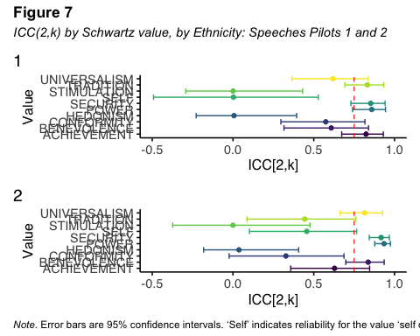
However ICC(2,k) appeared to improve when estimated separately for each ethnicity, with most values showing ICC(2,k) scores over the threshold. Note that estimation for HEDONISM is generally poor in subsamples, and that STIMULATION is poor in some subsamples (see Figure 8).
p1_1 <- pilot_2_speeches1_agreement_plots[[2]]
p1_2 <- pilot_2_speeches1_agreement_plots[[3]]
p1_3 <- pilot_2_speeches1_agreement_plots[[4]]
p1_4 <- pilot_2_speeches1_agreement_plots[[5]]
(p1_1 | p1_2) / (p1_3 | p1_4) +
plot_annotation(
title = "**Figure 8**",
subtitle = "*ICC(2,k) by Schwartz value, by Ethnicity: Speeches 1 Pilot*",
caption =
"*Note.* Error bars are 95% confidence intervals.
'Self' indicates reliability for the value 'self direction'.") &
theme(plot.title = element_markdown(hjust = 0),
plot.subtitle = element_markdown(hjust = 0),
plot.caption = element_markdown(hjust = 0))
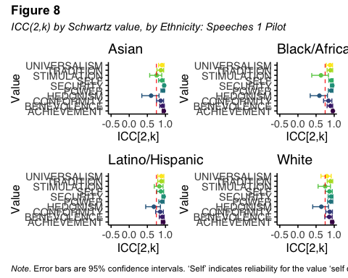
However ICC(2,k) also appeared to improve when estimated separately for each political leaning (see Figure 9). We note that HEDONISM shows poor agreement in both speeches pilots.
p1_1 <- pilot_2_speeches2_agreement_plots[[2]]
p1_2 <- pilot_2_speeches2_agreement_plots[[3]]
p1_3 <- pilot_2_speeches2_agreement_plots[[4]]
p1_4 <- patchwork::plot_spacer()
((p1_1 / p1_2) | (p1_3 / p1_4)) +
plot_annotation(
title = "**Figure 9**",
subtitle = "*ICC(2,k) by Schwartz value, by Political Leaning: Speeches 2 Pilot*",
caption =
"*Note.* Error bars are 95% confidence intervals.
'Self' indicates reliability for the value 'self direction'.") &
theme(plot.title = element_markdown(hjust = 0),
plot.subtitle = element_markdown(hjust = 0),
plot.caption = element_markdown(hjust = 0))
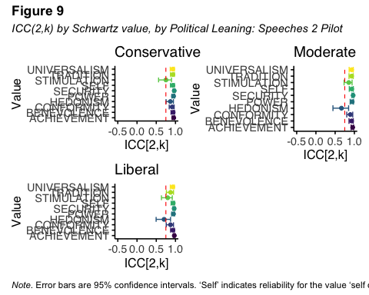

Exploring Quiz Results
summarize_study <- function(df) {
df %>%
summarise(
Q1 = sprintf("%d (%.1f%%)", sum(Quiz1, na.rm = TRUE),
mean(Quiz1, na.rm = TRUE) * 100),
Q2 = sprintf("%d (%.1f%%)", sum(Quiz2, na.rm = TRUE),
mean(Quiz2, na.rm = TRUE) * 100),
Q3 = sprintf("%d (%.1f%%)", sum(Quiz3, na.rm = TRUE),
mean(Quiz3, na.rm = TRUE) * 100)
) %>%
pivot_longer(everything(), names_to = "Question", values_to = "N_percent")
}
lapply(quiz_dfs, summarize_study) %>%
bind_rows(.id = "Study") %>%
pivot_wider(names_from = Study, values_from = N_percent) %>%
gt() %>%
tab_header(
title = md("**Table 4**"),
subtitle = md("*Pilot Studies: Quiz Item Correctness*")
) %>%
cols_label(
Question = "Item",
lyrics = "Pilot: Lyrics",
speeches1 = "Pilot: Speeches 1",
speeches2 = "Pilot: Speeches 2"
) %>%
cols_align(
align = "center",
columns = everything()
) %>%
cols_width(everything() ~ px(100)) |>
tab_options(
table.font.size = 12,
heading.align = "left",
table.border.top.width = px(0), # remove top rule
table.border.bottom.width = px(0), # remove bottom rule
table_body.hlines.width = px(0), # removes horizontal lines inside body
table_body.vlines.width = px(0) # removes vertical lines
) %>%
tab_source_note(
md("*Note.* Entries are number and percentage of participants who answered correctly. Quiz responses were not used to exclude participants in pilot studies."))
Table 1: Table 4
Pilot Studies: Quiz Item Correctness
Item | Pilot: Lyrics | Pilot: Speeches 1 | Pilot: Speeches 2
Q1 | 77 (77.8%) | 81 (81.8%) | 78 (79.6%)
Q2 | 48 (48.5%) | 43 (43.4%) | 42 (42.9%)
Q3 | 69 (69.7%) | 65 (65.7%) | 69 (70.4%)
Note. Entries are number and percentage of participants who answered correctly. Quiz responses were not used to exclude participants in pilot studies.
We observed that participants most often answered Question 2 incorrectly. The item explains that the SPEAKER gives no indication of how important the value is to them. Of those that responded incorrectly, the most common incorrect response was on the low end of the scale (-1 or 0). Thus, for Quiz 2 where the correct response was “NA”, 13% of participants indicated “0” and “9”% indicated “-1”, where 56% correctly indicated “NA”. Similarly in Quiz 3, 13% of participants incorrectly indicated “NA” where 50% and 20% of participants correctly indicated “-1”’ and “0” respectively. Thus, in the minds of some annotators, “NA” and the lower-end of the scale bear similar meaning.
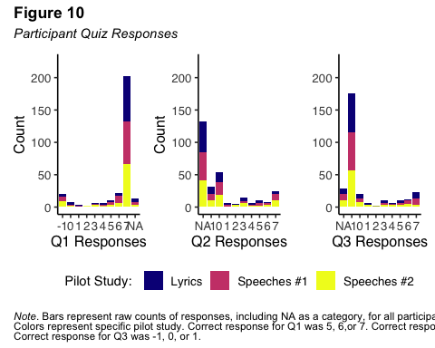

Conclusion
We tentatively conclude that Ethnicity will have a substantially smaller effect on ratings of song lyrics than either Ethnicity or Political Spectrum will have on ratings of speeches. Thus, the sample for our main study data collection will be stratified by Ethnicity, and for political speeches, it will also be stratified by political affiliation. We thus proceed with a target median 15 ratings per song lyric excerpt. Based on bootstrapped correlations between subsamples and the overall sample, as well as budgetary constraints, we aim for median 40 ratings per political speech excerpt. We also observe that some percentage of participants appear to confuse NA with the low end of the unbalanced likert scale (-1 or 0).

References
Aust, F., & Barth, M. (2022). Papaja: Create APA manuscripts with r markdown. https://github.com/crsh/papaja
Bassett, R., & Deride, J. (2019). Maximum a posteriori estimators as a limit of bayes estimators. Mathematical Programming, 174(1), 129–144.
Bates, D., Mächler, M., Bolker, B., & Walker, S. (2015). Fitting linear mixed-effects models using lme4. Journal of Statistical Software, 67(1), 1–48. https://doi.org/10.18637/jss.v067.i01
Chen, C.-W., Lamere, P., Schedl, M., & Zamani, H. (2018). Recsys challenge 2018: Automatic music playlist continuation. Proceedings of the 12th ACM Conference on Recommender Systems, 527–528.
DeBruine, L. M., & Jones, B. C. (2018). Determining the number of raters for reliable mean ratings. OSF. https://doi.org/10.17605/OSF.IO/X7FUS
Demetriou, A. M., Kim, J., Manolios, S., & Liem, C. (2024). Towards estimating personal values in song lyrics. ISMIR, 137–145.
Groves, R., Fowler, F., Couper, M., Lepkowski, J., Singer, E., & Tourangeau, R. (2009). Survey design. Hoboken: Wiley.
Henry, L., & Wickham, H. (2024). Rlang: Functions for base types and core r and ’tidyverse’ features. https://CRAN.R-project.org/package=rlang
Iannone, R., Cheng, J., & Schloerke, B. (2023). Gt: Easily create presentation-ready display tables. https://CRAN.R-project.org/package=gt
Koo, T. K., & Li, M. Y. (2016). A guideline of selecting and reporting intraclass correlation coefficients for reliability research. Journal of Chiropractic Medicine, 15(2), 155–163.
Kuznetsova, A., Brockhoff, P. B., & Christensen, R. H. B. (2017). lmerTest package: Tests in linear mixed effects models. Journal of Statistical Software, 82(13), 1–26. https://doi.org/10.18637/jss.v082.i13
Liem, C. C. S., Rauber, A., Lidy, T., Lewis, R., Raphael, C., Reiss, J. D., Crawford, T., & Hanjalic, A. (2012). Music Information Technology and Professional Stakeholder Audiences: Mind the Adoption Gap. In Dagstuhl follow-ups (Vol. 3). Schloss Dagstuhl - Leibniz-Zentrum fuer Informatik. https://doi.org/10.4230/DFU.VOL3.11041.227
Lindeman, M., & Verkasalo, M. (2005). Measuring values with the short schwartz’s value survey. Journal of Personality Assessment, 85(2), 170–178.
Müller, K. (2020). Here: A simpler way to find your files. https://CRAN.R-project.org/package=here
R Core Team. (2025). R: A language and environment for statistical computing. R Foundation for Statistical Computing. https://www.R-project.org/
Revelle, W. (2023). Psych: Procedures for psychological, psychometric, and personality research. https://CRAN.R-project.org/package=psych
RStudio Team. (2025). RStudio: Integrated development environment for r. Posit Software, PBC. http://www.rstudio.com/
Schindler, A., Mayer, R., & Rauber, A. (2012). Facilitating comprehensive benchmarking experiments on the million song dataset. ISMIR, 469–474.
Schwartz, S. H. (1992). Universals in the content and structure of values: Theoretical advances and empirical tests in 20 countries. In Advances in experimental social psychology (Vol. 25, pp. 1–65). Elsevier.
Schwartz, S. H. (2005). Schwartz value survey. Journal of Cross-Cultural Psychology.
Wickham, H. (2016). ggplot2: Elegant graphics for data analysis. Springer. https://ggplot2.tidyverse.org/
Wickham, H., Averick, M., Bryan, J., Chang, W., McGowan, L. D., François, R., Grolemund, G., Hayes, A., Henry, L., Hester, J., Kuhn, M., Pedersen, T. L., Miller, E., Bache, S. M., Müller, K., Ooms, J., Robinson, D., Seidel, D. P., Spinu, V., … Yutani, H. (2019). Welcome to the tidyverse. Journal of Open Source Software, 4(43), 1686. https://doi.org/10.21105/joss.01686

Appendix A: Stimuli

Lyrics Stimuli
Songs were sampled across four “fuzzy” strata: (1) Year of release, based on Musixmatch metadata; (2) Popularity, defined as the frequency with which an artist appeared on playlists in the Million Playlist Dataset (MPD); (3) Genre, estimated by topic modeling user-generated artist tags, which were originally drawn from Last.fm and merged into the MPD; and (4) Lyric topic, derived from topic modeling a bag-of-words representation of the lyrics. After selecting the final sample of 2,200 songs, Musixmatch provided the first 30% of the lyrics for each track via their API.
The code Demetriou et al. (2024) used to sample lyrics can be found here: https://anonymous.4open.science/r/lyrics-value-estimators-CE33/1_stimulus_sampling/stratified_sampling.py.
Note: neither the raw lyric data nor the unanonymized repository can be made available due to limitations in licensing.

Release Date
Release date was determined via Musixmatch metadata, some of which may contain errors. Metadata included a wide range of release years, beginning in 1890 (which appeared to include traditional songs e.g. Little Drummer Boy). There were a total of 14 bins in 10 equally spaced year intervals (1890, 1900) ~ (2020, 2030). Number and percentage of songs that were kept after the manual screening procedure, by the meta-data year range per year bin are shown in Figure 1 and Table 1.
Figure s-1
Manual screening outcome by year bin range
make_removed_counts(lyrics_df, year_bin_range)
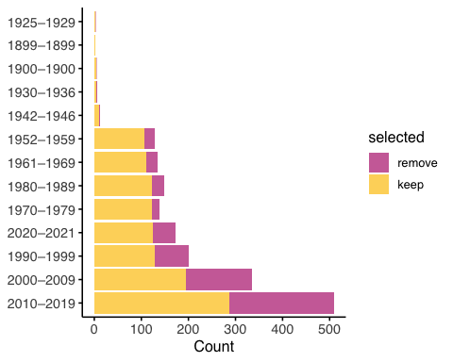
Note. “remove” indicates songs excluded due to manual screening criteria. Bins presented in reverse order of number of songs labelled “keep”. Each row indicates a decade-range year bin, with x axis labels showing the observed metadata range per year bin.
make_apa_freq_table(
lyrics_df|>rename(`Year Range`= year_bin_range),
`Year Range`,
title = md("**Table s-1**"),
subtitle = md("*Frequencies by release year bin*")
)
Table 1: Table s-1
Frequencies by release year bin
Year Range | Removed | Kept | Total n
2010–2019 | 222 (43.6%) | 287 (56.4%) | 509
2000–2009 | 142 (42.3%) | 194 (57.7%) | 336
1990–1999 | 71 (35.5%) | 129 (64.5%) | 200
2020–2021 | 47 (27.3%) | 125 (72.7%) | 172
1980–1989 | 27 (18.1%) | 122 (81.9%) | 149
1961–1969 | 24 (17.8%) | 111 (82.2%) | 135
1952–1959 | 23 (17.8%) | 106 (82.2%) | 129
1970–1979 | 17 (12.2%) | 122 (87.8%) | 139
1942–1946 | 3 (23.1%) | 10 (76.9%) | 13
1900–1900 | 1 (20.0%) | 4 (80.0%) | 5
1925–1929 | 1 (33.3%) | 2 (66.7%) | 3
1930–1936 | 1 (16.7%) | 5 (83.3%) | 6
1899–1899 | 0 (0.0%) | 3 (100.0%) | 3
Note. “Removed” indicates songs excluded due to manual screening criteria. Bins presented in reverse order of number of songs removed. Each row indicates a decade-range year bin, with column Year Range showing the observed metadata range per year bin.

Popularity
Popularity was extremely exponentially distributed, with an extreme left skew. We manually binned to make the quantiles per each of the 7 bins as similar as possible. Thus, the first bin contained the lowest 40% of the population in terms of popularity, while the 7th bin contained the highest 9%:
- Bin 0: 1–2 playlist appearances (≤ 40%)
- Bin 2: 2–3 appearances (41–53%)
- Bin 3: 3–4 appearances (54–60%)
- Bin 4: 4–6 appearances (61–70%)
- Bin 5: 7–14 appearances (71–80%)
- Bin 6: 15–60 appearances (81–91%)
- Bin 7: 61–203,345 appearances (top 9% of artists; 91–100%)
Figure s-2
Manual screening outcome by popularity bin percentile range
make_removed_counts(lyrics_df, artist_playlist_frequency_bin_label)
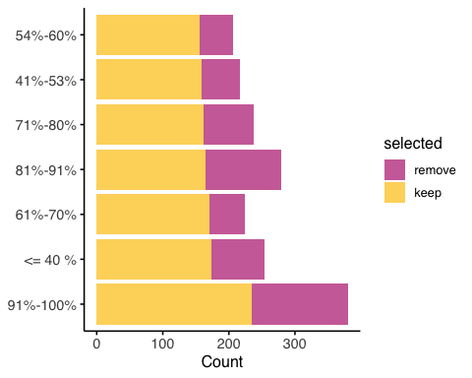
Note. “remove” indicates songs excluded due to manual screening criteria. Bins presented in reverse order of number of songs labelled “keep”.
make_apa_freq_table(
lyrics_df|>rename(`Artist Popularity`=artist_playlist_frequency_bin_label),
`Artist Popularity`,
title = md("**Table s-2**"),
subtitle = md("*Frequencies by artist playlist frequency*")
)
Table 1: Table s-2
Frequencies by artist playlist frequency
Artist Popularity | Removed | Kept | Total n
91%-100% | 145 (38.2%) | 235 (61.8%) | 380
81%-91% | 115 (41.2%) | 164 (58.8%) | 279
<= 40 % | 80 (31.5%) | 174 (68.5%) | 254
71%-80% | 76 (31.9%) | 162 (68.1%) | 238
41%-53% | 58 (26.7%) | 159 (73.3%) | 217
61%-70% | 53 (23.7%) | 171 (76.3%) | 224
54%-60% | 52 (25.1%) | 155 (74.9%) | 207
Note. “Removed” indicates songs excluded due to manual screening criteria. Bins presented in reverse order of number of songs removed. Each row indicates a popularity percentile range bin, with column Artist Popularity showing the observed percentile range per popularity bin.

Genre
Demetriou et al. (2024) used topic modelling applied to a bag-of-words representation of artist-tag data to estimate one of $25$ estimated genres for each included artist, which were then applied to songs. To get the initial pool, Demetriou et al. (2024) first uniformly sampled 60k artists from the Spotify Million Playlist Dataset (MPD)(Chen et al., 2018), which contains metadata on ~2 million tracks by ~300k artists. They then retrieved the full discographies of these artists via the Spotify API and cross-checked availability in Musixmatch, yielding a pool of ~510k songs from ~15.4k’ artists. We used Latent Dirichlet allocation to create a topic model of the artist tags in order to derive estimated genres, shown in the “Top LDA terms of initial pool” column of Table 3a.
From this pool, 2,200 songs were selected, and manually screened. As there is no definitive label for each estimated genre, we derived a second set of labels aimed at describing the 1,425 artists in the sample pool, as opposed to the initial 15.4k artist pool. Specifically, we gathered each unique artist in the 2,200 song sample, and drew the genre label tags for those artists from using the Spotify and Last.fm APIs. We then pooled all the artist genre tags for each artist, and estimated the tf-idf for each tag per genre bin. The top tf-idf terms are shown in the “Top tf-df terms of sample” column of table 3a.
make_genre_comparison_table(lyrics_df,
title = md("**Table s-4**"),
subtitle = md("*Comparison of terms of topic tags of initial pool of 15.4k artists, to secondary pool of 2200 songs*")
) %>%
cols_width(lda_genre_terms ~ px(350), artist_topic_bin_labels ~ px(300))
Table 1: Table s-4
Comparison of terms of topic tags of initial pool of 15.4k artists, to secondary pool of 2200 songs
Top LDA terms of initial pool | Top tf-ifd terms of sample
All, dubstep, synthpop, 80s, new wave, post-punk, russian, electropop, Disco, electronic | synthpop / new wave / post-punk / dubstep
blues, american, USA, Canadian, shoegaze, dream pop, black metal, United States, canada, twee | blues / blues rock / classic blues / black metal
christian, gospel, worship, arabic, christian rock, spain, cumbia, mexico, mexican, portuguese | christian / worship / gospel / ccm
country, Soundtrack, Alt-country, americana, danish, turkish, video game music, texas, christmas, Disney | classic country / country / honky tonk / traditional country
dance, House, trance, electronic, Progressive House, progressive trance, club, electronica, techno, eurodance | eurodance / dance / trance / electronic
electronic, ambient, experimental, techno, electronica, electro, House, deep house, minimal, downtempo | electronic / ebm / industrial / electronica
folk, singer-songwriter, acoustic, folk rock, bluegrass, indie folk, norwegian, Norway, argentina, americana | folk / singer-songwriter / folk rock / acoustic
hardcore, metalcore, metal, hardcore punk, post-hardcore, deathcore, Nu Metal, seen live, melodic hardcore, grindcore | hardcore punk / hardcore / punk rock / deathcore
heavy metal, metal, celtic, thrash metal, dutch, seen live, irish, Power metal, finnish, bass | metal / power metal / heavy metal / speed metal
Hip-Hop, rap, hip hop, spotify, underground hip-hop, trap, beats, hiphop, underground rap, instrumental hip-hop | hip hop / rap / underground hip-hop / trap
instrumental, Classical, piano, Drum and bass, contemporary classical, psytrance, composer, dnb, Drum n Bass, baroque | classical / drum and bass / choral / piano
japanese, ska, new age, j-pop, J-rock, japan, Asian, anime, chiptune, soca | j-pop / ska / j-rock / rocksteady
jazz, chillout, lounge, trip-hop, downtempo, swing, Fusion, easy listening, Smooth Jazz, acid jazz | big band / jazz / vocal jazz / swing
latin, male vocalists, spanish, 90s, italian, salsa, mexico, 00s, 10s, Italy | italian / latin / italian singer-songwriter / latino
oldies, death metal, comedy, african, Melodic Death Metal, Brutal Death Metal, doo wop, 50s, spoken word, afrobeat | comedy / afrobeats / african / doo-wop
pop, female vocalists, french, female vocalist, pop rock, france, female, Eurovision, chanson francaise, indonesian | pop / female vocalists / chanson / eurovision
punk, punk rock, emo, pop punk, post-hardcore, seen live, rock, polish, screamo, chicago | punk rock / pop punk / hardcore punk / ska punk
reggae, brazilian, dub, dancehall, brasil, brazil, Stoner Rock, mpb, Sludge, Southern Rock | reggae / roots reggae / dancehall / ragga
rnb, german, rockabilly, power pop, Rock and Roll, germany, rock n roll, deutsch, urban, Deutschrap | rock n roll / rockabilly / r&b / new jack swing
rock, psychedelic, hard rock, alternative rock, Progressive rock, Psychedelic Rock, classic rock, Korean, alternative, k-pop | rock / psychedelic rock / k-pop / progressive rock
seen live, indie, alternative, indie rock, indie pop, rock, british, post-rock, Lo-Fi, australian | indie rock / indie / indie pop / alternative
soul, funk, r&b, rhythm and blues, Disco, Greek, rnb, funky, Neo-Soul, northern soul | soul / funk / r&b / motown
swedish, guitar, blues rock, lesser known yet streamable artists, United Kingdom, Sweden, england, Flamenco, Jam, Awesome | swedish / swedish pop / blues rock / nordic
under 2000 listeners, musical, Reggaeton, Colombia, Broadway, hungarian, Musical theatre, musicals, showtunes, trollerier | musicals / broadway / showtunes / shady
world, Garage Rock, 60s, World Music, garage, traditional, Surf, Need to Rate, Indian, darkwave | sufi / gothic rock / darkwave / indian
Demetriou et al. (2024) excluded songs if they contained more than >= ~20% non-English words, consisted only of onomatopoeia or nonsense, repeated a single word or phrase, or had too few words. This process yielded 380 songs. We extended screening with the same criteria, resulting in 1,200 songs. We used 800 in the main study and 14 for a pilot. Songs were primarily removed for containing too many non-English words, or having too few or single repeated words. Distribution of included songs by genre bin, as well as results from manual screening procedure are shown in Figure 3.
Figure s-3
Manual screening outcome by genre
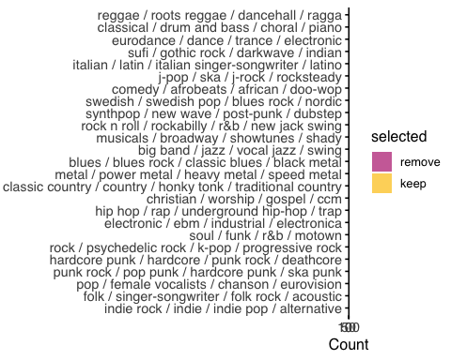
Note. “Remove” indicates songs excluded due to screening criteria.
make_apa_freq_table(
lyrics_df|>rename(`Artist Topic Tags`=artist_topic_bin_labels),
`Artist Topic Tags`,
title = md("**Table s-5**"),
subtitle = md("*Frequencies by artist topic*")
)
Table 1: Table s-5
Frequencies by artist topic
Artist Topic Tags | Removed | Kept | Total n
reggae / roots reggae / dancehall / ragga | 49 (79.0%) | 13 (21.0%) | 62
indie rock / indie / indie pop / alternative | 44 (31.4%) | 96 (68.6%) | 140
eurodance / dance / trance / electronic | 40 (58.8%) | 28 (41.2%) | 68
rock / psychedelic rock / k-pop / progressive rock | 31 (33.3%) | 62 (66.7%) | 93
classical / drum and bass / choral / piano | 30 (52.6%) | 27 (47.4%) | 57
comedy / afrobeats / african / doo-wop | 28 (42.4%) | 38 (57.6%) | 66
sufi / gothic rock / darkwave / indian | 27 (45.0%) | 33 (55.0%) | 60
synthpop / new wave / post-punk / dubstep | 27 (40.3%) | 40 (59.7%) | 67
hip hop / rap / underground hip-hop / trap | 26 (32.5%) | 54 (67.5%) | 80
j-pop / ska / j-rock / rocksteady | 26 (43.3%) | 34 (56.7%) | 60
metal / power metal / heavy metal / speed metal | 25 (32.9%) | 51 (67.1%) | 76
electronic / ebm / industrial / electronica | 21 (28.0%) | 54 (72.0%) | 75
italian / latin / italian singer-songwriter / latino | 21 (38.9%) | 33 (61.1%) | 54
big band / jazz / vocal jazz / swing | 20 (29.9%) | 47 (70.1%) | 67
classic country / country / honky tonk / traditional country | 19 (27.1%) | 51 (72.9%) | 70
christian / worship / gospel / ccm | 18 (25.7%) | 52 (74.3%) | 70
hardcore punk / hardcore / punk rock / deathcore | 16 (20.0%) | 64 (80.0%) | 80
pop / female vocalists / chanson / eurovision | 16 (19.0%) | 68 (81.0%) | 84
punk rock / pop punk / hardcore punk / ska punk | 16 (19.3%) | 67 (80.7%) | 83
swedish / swedish pop / blues rock / nordic | 16 (29.1%) | 39 (70.9%) | 55
blues / blues rock / classic blues / black metal | 15 (23.8%) | 48 (76.2%) | 63
folk / singer-songwriter / folk rock / acoustic | 15 (16.9%) | 74 (83.1%) | 89
rock n roll / rockabilly / r&b / new jack swing | 12 (20.7%) | 46 (79.3%) | 58
musicals / broadway / showtunes / shady | 11 (19.3%) | 46 (80.7%) | 57
soul / funk / r&b / motown | 10 (15.4%) | 55 (84.6%) | 65

Topic
Topic modelling resulted in imprecise lyrical topics, which Demetriou et al. (2024) included as a further means to diversify the sample of lyrics. Although no precise definition of each topic could be derived, the team agreed on the following approximations of $8$ included lyric topics. Songs overwhelmingly fell categories relating to sadness and romance, a topic the original team felt was split into two groupings sad/romantic1 and sad/romantic2.
Figure s-4
Manual screening outcome by lyric topic
make_removed_counts(lyrics_df, topic_label)
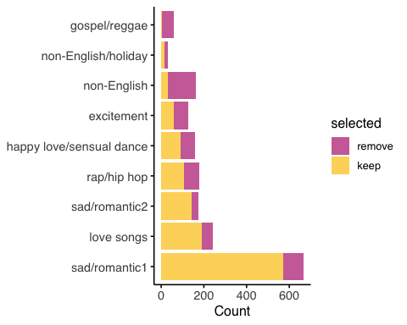

Skew Correction
Demetriou et al. (2024) observed a skew in data concentration such that songs that were recent and artists that appeared very frequently in playlists were most likely be sampled. To compensate, Demetriou et al. (2024) oversampled less populated bins by increasing the probability that songs in underpopulated bins are selected, using a maximum-a-posteriori (MAP) estimate of the categorical distribution of each stratum (Bassett & Deride, 2019). Oversampling is controlled via a concentration parameter $a$ of the symmetric Dirichlet distribution which was heuristically set to 40,000, with the aim of between 5% and 10% of the overall pool of 2200 songs being drawn from underpopulated bins.

Mislabelled ‘Kept’ Songs
We observe 19 songs in the 380 songs used by Demetriou et al. (2024), whereby 19 songs are labelled “remove” but also “wave_1”, which suggests that those 19 songs were either included erroneously, or mislabeled “remove” erroneously. We elected not to use those 19 songs.

Political Speech Stimuli
We sampled U.S. State of the Union addresses (post-1900) from the UVA Miller Center archive. Speeches were sampled across two strata: (1) President and (2) speech, both of which were labelled by the Miller center. Speeches were stratified by president and by individual address so that each president contributed a comparable number of excerpts. Presidents with fewer addresses contributed more chunks per speech, while those with many addresses contributed fewer. Each chunk yielded the first ~200 words (ending at a sentence boundary), producing an approximately balanced set of excerpts across presidents and speeches. The final pool comprised 300 excerpts for the main study and 13 each for two pilot studies. Details of the average number of excerpts by party for both the initial pool and sample are shown in Table 5. Visualization of number of speeches per president are shown in Figure 5.
Repository of sampling procedure can be found here: https://github.com/Gargant0373/PresidentialSpeechSampling/blob/master/sample.py
Figure s-5
Number of speech excerpts per President
colors <- viridis(10)
speech_df |>
filter(id %in% speech_IDs) |>
count(president, party, name = "n") |>
mutate(president = fct_reorder(president, n, .desc = T)) |>
ggplot(aes(x = president, y = n, fill = party)) +
geom_col(alpha = .75) +
coord_flip() +
labs(x = NULL, y = "Count") +
scale_fill_manual(values = c(colors[5], colors[9])) +
theme_apa()
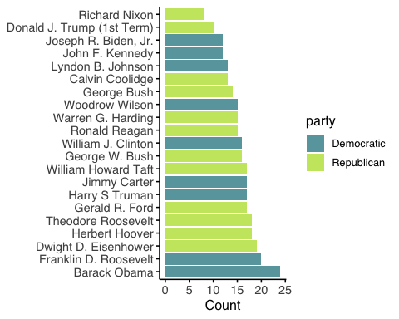
df <- speech_df
# function to summarize by party
summarise_party <- function(data) {
data %>%
group_by(party) %>%
summarise(
n_excerpts = n(),
n_speeches = n_distinct(url),
n_presidents = n_distinct(president),
.groups = "drop"
) %>%
mutate(
excerpts_per_president = n_excerpts / n_presidents,
pct_excerpts = n_excerpts / sum(n_excerpts))}
# 1) Full pool
full_summary <- summarise_party(df) %>%
mutate(sample = "Initial pool")
# 2) Annotated subsample
sub_df <- df %>% filter(id %in% speech_IDs)
sub_summary <- summarise_party(sub_df) %>%
mutate(sample = "Sample")
# 3) Combine
combined_summary <- bind_rows(full_summary, sub_summary) %>%
relocate(sample, .before = party)
# 4) Render as gt table
combined_summary %>%
gt(groupname_col = "sample") %>%
tab_header(
title = md("**Table s-6**"),
subtitle = md("*Descriptive statistics of speech excerpts by party*")) |>
cols_label(
party = "Party",
n_excerpts = "Total excerpts",
n_speeches = "Unique speeches",
n_presidents = "Unique presidents",
excerpts_per_president = "Avg. excerpts per president",
pct_excerpts = "% of all excerpts") %>%
fmt_number(columns = c(n_excerpts, n_speeches, n_presidents), decimals = 0) %>%
fmt_number(columns = excerpts_per_president, decimals = 1) %>%
fmt_percent(columns = pct_excerpts, decimals = 1) %>%
tab_options(
table.font.size = 12,
heading.align = "left",
table_body.hlines.width = px(0),
table.border.top.width = px(0),
table.border.bottom.width = px(1),
column_labels.border.top.width = px(0),
column_labels.border.bottom.width = px(1)) %>%
tab_style(
style = cell_text(align = "center", whitespace = "pre-wrap"),
locations = cells_column_labels(everything())) |>
cols_width(
party ~ px(100),
n_excerpts ~ px(100),
n_speeches ~ px(100),
n_presidents ~ (100),
excerpts_per_president ~ px(100),
pct_excerpts ~ px(100)) %>%
tab_style(
style = cell_text(align = "center"),
locations = cells_row_groups()) %>%
cols_align(align = "center", columns = everything())
Table 1: Table s-6
Descriptive statistics of speech excerpts by party
Party | Total excerpts | Unique speeches | Unique presidents | Avg. excerpts per president | % of all excerpts
Initial pool
Democratic | 499 | 63 | 9 | 55.4 | 43.0%
Republican | 662 | 66 | 12 | 55.2 | 57.0%
Sample
Democratic | 146 | 58 | 9 | 16.2 | 44.8%
Republican | 180 | 64 | 12 | 15.0 | 55.2%

Word Counts
lyrics_summary <- lyrics_df |> filter(item_ID %in% lyrics_IDs) |>
summarize(mean = mean(word_count), sd = sd(word_count))
speech_summary <- speech_df |> filter(id %in% speech_IDs) |>
summarize(mean = mean(word_count), sd = sd(word_count))
Distributions of word counts differ substantially between song lyrics and speeches. All lyrics were truncated to the first 30% as estimated by Musixmatch, the word counts vary substantially more than the speech excerpts, where our process for determining an excerpt truncated to the nearest complete sentence after 200 words. On average, speech excerpts were longer (M = 246.6, SD = 12.5 words) than lyric excerpts (M = 82.8, SD = 45.4 words).
Figure 6
Density plot of word counts in speech and lyric excerpts
df <- bind_rows(
lyrics_df |> filter(item_ID %in% lyrics_IDs) |>
select(item_ID, word_count) |> mutate(source = "Lyrics", item_ID = as.character(item_ID)),
speech_df |> filter(id %in% speech_IDs) |>
select(id, word_count) |> rename(item_ID = id) |>
mutate(source = "Speeches"))
df |>
ggplot(aes(x = word_count, fill = source)) +
geom_density(alpha = 0.7) +
scale_fill_manual(values = c("Speeches" = "#21908C", "Lyrics" = "#440154")) +
labs(
x = "Word count",
y = "Density") +
theme_apa()
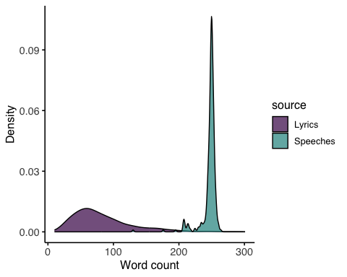

Appendix B: Survey

SSVS Instructions for participants
“In this questionnaire you are to ask yourself:
“What values are important to ME as guiding principles in MY life, and what values are less important to me?”
There is a list of values on the following page. These values come from different cultures. In the parentheses following each value is an explanation that may help you to understand its meaning. Your task is to rate how important each value is for you as a guiding principle in your life.
Use the rating scale below:
0 means the value is not at all important, it is not relevant as a guiding principle for you. 3 means the value is important. 6 means the value is very important.
The higher the number (0, 1, 2, 3, 4, 5, 6, 7), the more important the value is as a guiding principle in YOUR life.
-1 is for rating any values opposed to the principles that guide you. 7 is for rating a value of supreme importance as a guiding principle in your life; Ordinarily there are no more than two such values.
On the scale next to each value, indicate the number (-1,0,1,2,3,4,5,6,7) that indicates the importance of that value for you, personally. Try to distinguish as much as possible between the values by using all the numbers.
You may need to use numbers more than once.”

Task Instructions

Lyrics

General Instructions:
“In the main part of this survey, you will be shown parts of song lyrics from 15 songs, and asked to complete similar questions about the values you perceive them.
IMPORTANT: Lyrics can be written from different perspectives, some of which are not the same as the writer of the lyrics. In other words, the AUTHOR of the lyrics may choose a SPEAKER for their lyrics that is not themselves.
The SPEAKER of the lyrics could be a fictional character, a real person from history or the present other than the author, or even an imaginary object. And of course it could be the AUTHOR themselves. Please read the lyrics, and answer the questions while thinking about the SPEAKER.
Do not look up the lyrics elsewhere.
Ask yourself: “What values are important to the SPEAKER as guiding principles in in their life, and what values are less important to them? Use the same rating scale that you used in the questionnaire earlier: 0 means the value is not at all important. 3 means the value is important. 6 means the value is very important. -1 means the value is opposed to the principles that guide the SPEAKER. 7 means the value is of supreme importance as the guiding principle in the SPEAKER’s life.
Please start by rating the value you feel is the most important to the SPEAKER with a 6 or 7, and the value that is most opposed to their values with a -1 or 0, (green arrows).Then complete the scales for the remainder of the values. Indicate NA (red arrow) if you feel the SPEAKER doesn’t describe how they feel about that value. Try to distinguish as much as possible between the values by using all the numbers. You may need to use numbers more than once, but try not to.”

Post-Quiz Final Instructions:
“Thanks! We’ll now ask you to respond to our questions about 15 song lyrics. Please read only the lyrics between the quotes, do not search them on the internet or look them up elsewhere. Think about the SPEAKER of the lyrics, and answer the questions with them in mind.
Please click on the arrow below when you are ready.
WARNING: These lyrics are randomly selected from popular music, some of which use offensive language or describe offensive situations.”

Question Instructions:
“Between the quotation marks below are some song lyrics. Please take a moment to read them and think about the SPEAKER the lyrics. Please remember that this SPEAKER might be a the AUTHOR themselves, or someone or something else:”

Attention Test
“This song lyric is actually a test to see if you are paying attention Please indicate that the Speaker and Author are the same person, That you are not familiar with this song, indicate that this Speaker values STIMULATION at 7, and please set all other values to 0”

Speeches

General Instructions:
“You will now be shown 15 pieces of U.S. Presidential Speeches, and asked to complete similar questions about the values you perceive in them.
IMPORTANT: Some speeches were delivered in written form, and some were delivered as speeches. Sometimes, the transcript refers to dialogue from people other than the U.S. President, laughter, or contains other indications. In our questions, we refer to the SPEAKER, which is always the U.S. President delivering the speech.
Please read the piece of the speech, and answer the questions while thinking about the SPEAKER and their words.
Please do not look up the speeches elsewhere.
Ask yourself: “What values are important to the SPEAKER as guiding principles in in their life, and what values are less important to them? Use the same rating scale that you used in the questionnaire earlier: 0 means the value is not at all important. 3 means the value is important. 6 means the value is very important. -1 means the value is opposed to the principles that guide the SPEAKER. 7 means the value is of supreme importance as the guiding principle in the SPEAKER’s life.
Please start by rating the value you feel is the most important to the SPEAKER with a 6 or 7, and the value that is most opposed to their values with a -1 or 0, (green arrows). Then complete the scales for the remainder of the values. Indicate NA (red arrow) if you feel the SPEAKER doesn’t describe how they feel about that value.
Try to distinguish as much as possible between the values by using all the numbers. You may need to use numbers more than once.”

Post-Quiz Final Instructions:
“Thanks! We’ll now ask you to respond to our questions about 15 parts from U.S. Presidential speeches. Please read only the parts of the speeches between the quotes, do not search them on the internet or look them up elsewhere. Think about the SPEAKER of the speech, the U.S. president, and answer the questions with them in mind.
Please click on the arrow below when you are ready.
WARNING: These speeches were randomly selected, some of which use language that might have been acceptable at the time, but would be considered offensive today.”

Question Instructions:
“Between the quotation marks below are parts of a U.S. Presidential Speech. Please take a moment to read them and think about the SPEAKER of the speech.”

Attention Test:
“This speech part is actually a test to see if you are paying attention. Please indicate that you are not familiar with this president, that the president is a Republican. Indicate that this Speaker values STIMULATION at 7, and please set all other values to 0.”

Debrief

Lyrics
“Thanks for completing the survey!
Our research group, and other scientists like us, are interested in perceived personal values in song lyrics.
By ‘values’, we mean the abstract concepts or beliefs that we feel are important as life-guide principles. They have been shown to be related to our behaviors and goals at the most abstract level, above and beyond any specific situation. According to Shalom Schwartz, there are 10 main values that all people share, and each person has their own ranking of these values. In more recent work, these are broken up further into 19 values, but we used a shorter 10-item version.
This study is helping us learn how to gather data from people about the values that they think song lyrics express. Our questionnaire about values is based on one that was a part of the European Social Survey, and later shortened. You responded to it about yourself at the start of the study. Respondents like yourself then also completed it about what they thought of the values of the ‘speaker’ of each song lyric. We will analyze the data to see whether our version of this questionnaire is also useful for gathering information on song lyrics.
We expect that different people will interpret the values of lyrics differently. People might have a preference for different genres of music or prioritize different values in their lives. People with different backgrounds (e.g. ethnicity, gender, level of education, age) or who prioritize different values might also interpret song lyrics differently. We used various options on the Prolific platform to screen respondents like yourself, and also asked a number of questions, to explore whether any of these factors make a difference in the way people interpret the values of song lyrics.
Knowing our reasons for the study might have changed the way you would answer the questions in this survey. For this reason, we only explain the reasons for our study at the end.
Some songs have lyrics that are difficult or impossible to interpret. We asked about your confidence in your ratings, to see if some songs are more vague, or ambiguous than others. We also asked about how subjective you thought the task was overall, to help us estimate how many participants we might need for future studies.
De-identified data from this study may be part of published academic work in the future. We will not include personally identifying information (e.g. your Prolific ID), but it will include your responses to questions about the song lyrics, your music preferences, demographics, and values. We’d like to remind you that you can request to withdraw your data at any time by emailing a.m.demetriou@tudelft.nl. Please be aware that as time passess this will become more challenging especially if work from this study has been published. We will make all necessary efforts to remove it, but there is always a risk that we will not recover every instance of it after it has been published.
Thanks again for participating! Please let us know if you have any feedback for us below. NOTE: Please do not enter any identifying or sensitive information in the field.”

Speeches
“Thanks for completing the survey!
Our research group, and other scientists like us, are interested in perceived personal values in text, like political speeches. By ‘values’, we mean the abstract concepts or beliefs that we feel are important as life-guide principles. They have been shown to be related to our behaviors and goals at the most abstract level, above and beyond any specific situation. According to Shalom Schwartz, there are 10 main values that all people share, and each person has their own ranking of these values. In more recent work, these are broken up further into 19 values, but we used a shorter 10-item version.
This study is helping us learn how to gather data from people about the values that they think political speeches express. Our questionnaire about values is based on one that was a part of the European Social Survey, and later shortened. Respondents like yourself completed it about what they thought of the values of the ‘speaker’ in song lyrics in a prior study. In this study, we will analyze the data to see whether our version of this questionnaire is also useful for gathering information on political speeches. We expect that diﬀerent people will interpret the values of speeches diﬀerently. People with diﬀerent backgrounds (e.g. ethnicity, gender, level of education, age), or political aﬃliations might also interpret speeches diﬀerently. We used various options on the Prolific platform to screen respondents like yourself, to explore whether any of these factors make a diﬀerence in the way people interpret the values in speeches.
Knowing our reasons for the study might have changed the way you would answer the questions in this survey. For this reason, we only explain the reasons for our study at the end. Some parts of speeches taken out of context are diﬃcult or impossible to interpret. We asked about your confidence in your ratings, to see if some excerpts are more vague, or ambiguous than others. We also asked about how subjective you thought the task was overall, to help us estimate how many participants we might need for future studies.
De-identified data from this study may be part of published academic work in the future. We will not include personally identifying information (e.g. your Prolific ID), but it will include your responses to questions about the song lyrics, your music preferences, demographics, and values. We’d like to remind you that you can request to withdraw your data at any time by emailing a.m.demetriou@tudelft.nl. Please be aware that as time passess this will become more challenging especially if work from this study has been published. We will make all necessary eﬀorts to remove it, but there is always a risk that we will not recover every instance of it after it has been published.
Thanks again for participating! Please let us know if you have any feedback for us below. Please do not enter any identifying or sensitive information in the field.”

Letters of approval #: 4011, 4024, 4152, & 4507
https://www.musixmatch.com/
https://en.wikipedia.org/wiki/Comparison_of_music_streaming_services
https://research.atspotify.com/2020/09/the-million-playlist-dataset-remastered/
http://millionsongdataset.com/
https://millercenter.org/the-presidency/presidential-speeches
https://faroutmagazine.co.uk/how-many-number-one-instrumental/?utm_source=chatgpt.com
prolific.com
https://www.census.gov/quickfacts/fact/table/US
Qualtrics.com
Retrieved from https://scholarworks.gvsu.edu/orpc/vol2/iss2/9/ March, 2024

