3D Game Programming: Programming Assignment One
YOU WILL RECEIVE ZERO POINTS IF YOU COPY and PASTE THE MATERIALS OF OTHER! LATE SUBMISSION WILL BE DEDUCTED BY
30 points a day.
In this assignment, you must implement the program individually. You must use the template to do this assignment. Rename the folder name to hw01_student ID.
You can refer to the demo program. The demo content may not be consistent with the instruction. Thus, you always follow the instructions to do the assignment.
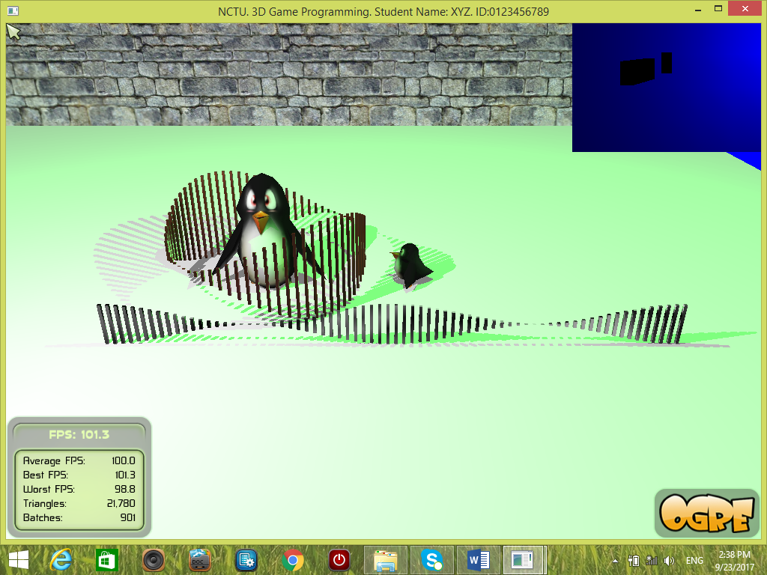
Penalties: File organization is wrong [-20%]; program crashes [-20%], No student ID [-30%]. The program cannot be compiled on .NET2010 [-30%]. And something that is not similar to the demo.

The guideline may not be consistent with the instruction. Always follow the instruction to do the assignment.
Task One:
1. Create a scene manager. Use it to create its own camera and viewport.
The camera must be:
setPosition(Ogre::Vector3(120,300,600));
lookAt(Ogre::Vector3(120,0,0));
2. The viewport occupies the entire screen space. Background color must be BLUE, e.g., color = (0, 0, 1).
3. Ambient light and shadow:
mSceneMgr->setShadowTechnique(
SHADOWTYPE_STENCIL_ADDITIVE);
4. Create a plane and two penguins.

To create a plane object:
Plane plane(Vector3::UNIT_Y, 0);
MeshManager::getSingleton().createPlane(
"ground",
ResourceGroupManager::DEFAULT_RESOURCE_GROUP_NAME,
plane,
1500,1500, // width, height
20,20, // x- and y-segments
true, // normal
1, // num texture sets
5,5, // x- and y-tiles
Vector3::UNIT_Z // upward vector
);
Scale up the first penguin by a factor (2, 3, 2).
Set the position of the first penguin (large) at (0, 50, 0).
Make the second penguin (small) face to the first penguin. Set the position of the second penguin properly.
5. Create two set of objects by scaling cube objects. One set of objects form a circle around a large penguin. Another set of objects form a row.
Scale the cubes accordingly.
The cube model: cube.mesh
To model a circle: PI = 3.141592654
numCubes = 72;
L = 255;
for (int i = 0; i < numCubes; ++i) {
String name;
genNameUsingIndex("c", i, name);
Entity *ent = mSceneMgr->createEntity(name, "cube.mesh");
ent->setMaterialName("Examples/SphereMappedRustySteel");
AxisAlignedBox bb = ent->getBoundingBox();
cubeSize = bb.getMaximum().x - bb.getMinimum().x;
x = 0, y = 0, z = -125;
SceneNode *snode = mSceneMgr
->getRootSceneNode()
->createChildSceneNode();
snode->attachObject(ent);
fx = i/(double) (numCubes-1); // in range [0,1]
h = (1+sin(fx*PI*4))*50; // height
circle_radius = 100;
x1 = circle_radius*cos(fx*PI*2);
z1 = circle_radius*sin(fx*PI*2);
unitF = 1.0/cubeSize/numCubes*L*0.8;
snode->scale(unitF, h/cubeSize, unitF);
snode->setPosition(x1, 50, z1);
}
You MUST use
setMaterialName("Examples/SphereMappedRustySteel")
and apply it to all the objects in the circle.

To model a row of objects, we use the height function:
fx = 2*i/(double) (numCubes-1); //i from 0 to numCubes-1
x = fx*L - L/2.0;
h = (1+cos(fx*3.1415*2.0))*20; // height
Real unitF = 1.0/cubeSize/numCubes*L*0.8;
snode->scale(unitF, h/cubeSize, unitF);
snode->setPosition(x, 20, z);
You MUST assign the material:
setMaterialName("Examples/Chrome");
to all the objects (modeled by cubes) in the row.

6. Create two lights.
light = createLight("Light1"); //error
light->setType(Light::LT_POINT);
light->setPosition(Vector3(150, 250, 100));
light->setDiffuseColour( color1 );
light->setSpecularColour( color2 );

light = createLight("Light2"); //error
setType(Light::LT_POINT); //error
setPosition(Vector3(-150, 300, 250)); //error
light->setDiffuseColour(color3);
light->setSpecularColour(color4);
7. Enable shadows.
8. Show the mouse cursor.
In void BaseApplication::createFrameListener(void)
Use mTrayMgr->showCursor();
9. Show your name and ID on the top bar of the window.
Change the following in bool BaseApplication::configure(void):
mWindow = mRoot->initialise(true, "NCTU. 3D Game Programming. Student Name: XYZ. ID:0123456789");

Task Two:
- Create a scene manager. Use it to create its own camera and viewport.
Set the camera position to (0,350,0.001). Set the camera to look at (0, 0, 0).

- The viewport occupies the upper left corner.
X = ?; Y = ?; Width =0.25; Height = 0.25
Set the background color.
- Create a plane.
- Ambient color: ColourValue( color )
- One Light:
light->setType(Light::LT_POINT);
light->setPosition(Vector3(100, 150, 250));
light->setDiffuseColour(0.0, 0.0, 1.0); //blue, use the right color
light->setSpecularColour(0.0,0.0, 1.0); //blue, use the right color

- Shadow type:
mSceneMgr->setShadowTechnique(
SHADOWTYPE_STENCIL_ADDITIVE);
- Create an object such as a cube or sphere. Scale it and place it at the center and above the plane.
- Edit your own material (pure green color).
Add the material in ./media/materials/scripts/ Examples.material.
material Examples/green
{
technique
{
pass
{
ambient 0.0 0.0 0.0
diffuse 0.0 0.7 0.7 // set the right color on your own
specular 0.0 1.0 1.0 // set the right color on your own
}
}
}
Make sure that the color setting is correct.
- Disable overlays.
Ogre::Viewport* vp
vp->setOverlaysEnabled(false);
Task Three
- Press ‘1’, ‘2’, ‘3’, ‘4’, and ‘5’ to set the camera at different positions and directions. Check the demo for details.
Implement in bool keyPressed( const OIS::KeyEvent &arg )
‘1’: position: (98.14, 450.69, 964.20); direction: (-0.01, -0.30 ,-0.95)
‘2’: position: (-1463.00, 606.45, -513.24); direction: (0.88, -0.47, 0.10)
‘3’: position: (-1356.16, 634.32, -964.51); direction: (0.71, -0.44, 0.55)
‘4’: position: (40.39, 155.23, 251.20); direction: (-0.02, -0.41, -0.91)
‘5’: position: (19.94, 822.63, 30.79); direction: (0.00, -0.99, -0.11)
- Press ‘M’ to make the second viewport at the bottom level (z-order = 0) and the first viewport at the top level (z-zero = 1). The first viewport is at the upper left corner. Disable the overlay in the second viewport. Check the demo for details.
You must remove the existing viewports first. For example:
mWindow->removeViewport(mViewportArr[0]->getZOrder());
mWindow->removeViewport(mViewportArr[1]->getZOrder());
After that create new viewports as usual.

- Press ‘N’ to make the first viewport at the bottom level (z-order = 0) to cover the entire screen and the second viewport at the top level (z-order = 1). The second viewport is at the right middle portion of the screen. Disable the overlay in the second viewport. Set the background color of the first viewport to other color (not blue).

- Press ‘P’ to toggle the animation (i.e., turn on or off). First part: The large penguin stays at the same position but it looks at the small penguin. Second part: The small penguin moves around a circle around the large penguin in clockwise at the beginning. The angular speed of the small penguin is zero when a new cycle starts. The small penguin is accelerated to a maximum angular speed while it moves. Once it finishes a cycle, its motion path is reversed and it starts a new cycle. That is, if it rotates in clockwise in the previous cycle, then it rotates in counter-clockwise in the new cycle and vice versa. The process is repeated.

Update the penguins in
bool frameStarted(const Ogre::FrameEvent& evt)

Approach: Use a variable (or more variables) to keep track of the animation states of the objects in keyPressed function. The variables (e.g., position, speed, angle) of the objects should be stored properly. And then update the objects based on the variables. We need to use frameStarted function to implement animation because the object states are updated regularly.

To make an object look at a target_position:
obj->lookAt(target_position, Node::TransformSpace::TS_WORLD);

To make an object moving around a circle, use the parametric form of a circle.
// x = r cos( angle )
// z = r sin( angle )
//
Vector3 pos = mMovableObj->getPosition();
pos.x = mRadius*cos(mAngle);
pos.z = mRadius*sin(mAngle);
mMovableObj->setPosition(pos); // note: keep the y-coordinate

Compute the new angular speed of an object based on angular acceleration:
mAngularSpeed += mAngularAcceleration*evt.timeSinceLastFrame;
mAngle += mAngularSpeed*evt.timeSinceLastFrame;
// Make sure that mAngle is not larger than the maximum angular speed

Task Four: Use doxygen to make documentation of the program. Briefly describe each function and each class that you have implemented. The Mode should be “Documented entities only”. You should document at least FOUR functions. Do not copy and paste the solutions of the teacher.

//If you write down something that is irrelevant to the content of this assignment, your score will be deducted.

Report format
Name: __________________________ Student ID: __________Assignment:_____
Email:___________________________
THIS MUST BE YOUR OWN WORK! YES (Please Tick Yes)
***BONUS: The best report(s) has at most 13 bonus points.
[10%] Introduction (At least 100 words)
WORD COUNT: ___________ //must fill this blank.
// describe the purpose of this assignment
// describe the tasks that you have to finish

[10%] System architecture
-[5%] Draw a diagram of the system. At least FIVE components.
-[5%] Describe in words about the system. At least 50 words.
WORD COUNT: ___________ //must fill this blank.

[30%] Methods (At least 300 words)
WORD COUNT: ___________ //must fill this blank.
//describe how you finish the tasks one by one.
//You must state clearly how to implement each item!

[40%] Discussion (At least 400 words)
WORD COUNT: ___________ //must fill this blank.
You must include the following items!
//1. Describe what you see on the screen, e.g. shadows, etc.
//2. Explain why the object in the second task is black.
//3.In Task Two. What happen if you change the position of the camera to Vector3(0,350,0)? Why?
//4. Try other different parameters and describe what you see or the effects.
//Extra bonus points will be given here if you could raise up some interesting ideas.

[10%] Conclusion (At least 100 words)
WORD COUNT: ___________ //must fill this blank.
// what have you learnt? What are the problems that you encounter? How to solve the problems? What do you think about this assignment?

