3D Game Programming: Programming Assignment Three
YOU WILL RECEIVE ZERO POINTS IF YOU COPY and PASTE THE
MATERIALS OF OTHER! LATE SUBMISSION WILL BE DEDUCTED BY
30% a day.
In this assignment, you must implement the program individually. You should refer to the source code in the Template folder to do this assignment. If you don’t like the template, you can implement everything from scratch.

Note that the demo program may not demo all the tasks and it has bugs.

This is your first step to develop a flexible framework for a simple game. You will realize that it is important to design reusable classes, singletons, and managers for maintaining different resources, e.g. weapons, monsters and particle systems. Please strengthen your C++ skill from now on. You will also learn how to manipulate vectors and the orientation of objects.

Deduction: File organization is wrong [-20%]; program crashes [-20%], No
student ID [-100%]. The program cannot be compiled on .NET2010 [-30%].

There are FOUR tasks. You must finish all of them.
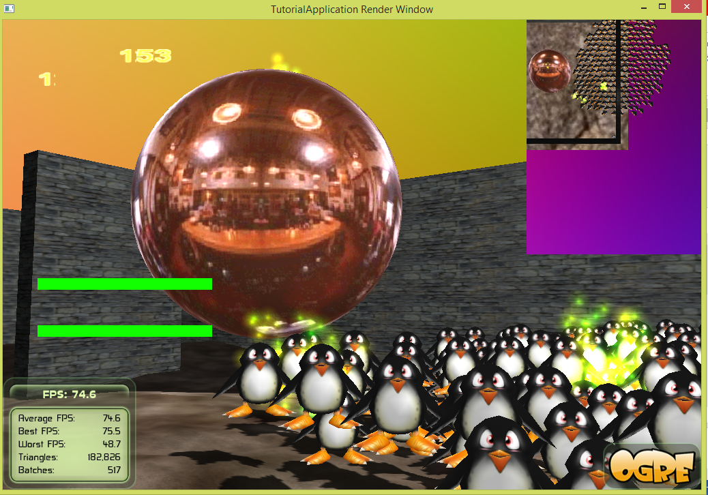
Always refer to the instruction. Don’t rely on the demo program because it has bugs and is incomplete.

Task One [65%]:
A.1 [0%] Show your student name and ID as the title of the application window. MUST DO or receive zero point of score for this assignment.
In BaseApplicaiton::configure,
mRoot->initialize(true, “Name: X Y Z; ID: 0123456789”);
A.2 [1%] Create a scene manager which can handle a terrain. Use it to create its own camera and viewport. See BasicTutorial_00::chooseSceneManager().
A.3 [1%] The viewport occupies the entire screen space. See BasicTutorial_00::createViewport_00(void).
A.4 [1%] Setup an ambient light and a spot light. Set the diffuse and specular component properly. See BasicTutorial_00::createLights().
A.5 [2+2%] Enable exponential fog and shadow. The fog density and the status of shadow are stored in a data file. See BasicTutorial_00::createScene_00( ).
A.6 [1%] Draw a height map and use it to create a terrain. Create a skybox. See BasicTutorial_00::createScene_00( ).
A.7 [2%] Create a plane and it is used for modeling the surface of water. It is assigned a water material. The material name is stored in a data file. See BasicTutorial_00:: createWaterSurface().
A.8 [5%] Create a main character “robot” and control it to move around. The main character can be animated based on pre-defined animations. The key “W” is used for walking forward (AddTime(+)) and the key “S” for walking backward (AddTime(-)). If it is idle, its motion should be “Idle”. See MAIN_CHAR::walkForward(const Ogre::FrameEvent& evt) and other methods, e.g., MAIN_CHAR::walkBackward(const Ogre::FrameEvent& evt). Make the main character move on the terrain surface. See bool clampToEnvironment(const Vector3& cur_pos, Real offset, Vector3& new_pos).
A.9 [3%] The camera should follow the main character. See void MAIN_CHAR::update(const Ogre::FrameEvent& evt).
A.10 [2%] The main character should be invisible in this viewport. Need to set flags in setVisibilityMask( ) and setVisibilityFlags( ) properly.
A.11 [2%] Create some monsters. The number of monsters is stored in a data file. Assume the MAX number = 512. See MONSTER_MANAGER::MONSTER_MANAGER( ).
A.12 [3%] The monsters should be collision free. You can use spheres to bound the objects and use sphere-based method to detect collisions. See MONSTER_MANAGER::resolveMonsterCollision( ).
A.13 [3%] The monsters chase the main character if they are too far from it. Also, make the monsters move up and down vertically. Use the sine or cosine function. See MONSTER::update(const Ogre::FrameEvent& evt).
A.14 [2%] The monsters do not collide with the main character if they are too close to the main character. See MONSTER_MANAGER::resolveMonsterTargetCollision( ).
A.15 [3%] For each monster close to the main character, attach a particle system to it. There should be at least 10 monsters and each is attached with a particle system. See MONSTER_MANAGER::setParticleSystem( … ).
A.16 [5%] The monsters should look at the main character. But they can rotate about only the y-axis, i.e. yaw( ). See MONSTER::updateViewDirection( ).
A.17 [1%] The spot light should follow the main character. You can simply add an offset to the position of the main character for computing the light position. See frameStarted(const Ogre::FrameEvent& evt).
A.18 [3%] Use mouse move event for controlling the view direction of the main character. See BasicTutorial_00::mouseMoved( const OIS::MouseEvent &arg ) and MAIN_CHAR::updateViewDirection().
A.19 [5%] Press the “SPACE_BAR” key to shoot balls. The trajectory of a ball is based on the projectile motion equation. The cool down time MUST be 0.1 second for shooting the next ball. The number of balls is less than or equal to a predefined number that is defined in a data file. The life time of a ball is 5 seconds. Use sphere.mesh for modeling balls (or bullets). Assume the MAX number = 128. See MAIN_CHAR::setFireAction_Normal( ), MAIN_CHAR::fireWeapon( ), WEAPON_MANAGER::fire_Normal( ); and bool projectScenePointOntoTerrain_NegDirection(Ogre::Vector3 &p).
A. 20 [1%] Play a voice clip when the main character levels up. For every 10 shoots of bullets, the main character levels up. See MAIN_CHAR::setFireAction_Normal( ).
A.21 [1%] If a ball hits the terrain, it should bounce off and its energy is reduced by a certain amount. If a ball hits the big target, i.e., the sphere, it should bounce off. See WEAPON::update(const Ogre::FrameEvent& evt).
A.22 [1%] If a ball hits the big sphere, play a sound and also play a particle system at the hit position. See WEAPON::hitTarget_Sphere(
const Vector3 &p,
Real r,
WeaponParticleSystemManager *wpsMgr
).
Implement
WeaponParticleSystemManager::play(const Vector3 &p). Do you know when an emitter of a particle system should be turned off?

A.23 [5%] Create walls based on bitmap. See
WAGO_OGRE_MESH_OBJ::createWallsBasedOnBitmap(
const String &imageName
).
A.24 [5%] The main character must not go through the walls. Perform collision response when the main character collides with the walls. Also, compute the suitable tangential velocity for the main character. Read MAIN_CHAR::update(const Ogre::FrameEvent& evt) and MAP_MANAGER::movePosition(const Vector3 &p0, const Vector3 &p1, Vector3 &p).
In task one, you may need to modify
bool projectScenePointOntoTerrain_NegDirection(Ogre::Vector3 &p)

Task Two [5%]:
B.1 [1%] Create another camera C1. BasicTutorial_00::createCamera_01(void).
B.2 [1%] Use camera C1 to create another viewpoint which occupies the upper right corner. BasicTutorial_00::createViewport_01( ).
B.3 [1%] The main character “robot” should be visible in this viewport.
B.4 [1%] The camera C1 is placed above the main character and it follows the main character so that a top down view is shown. Press “Z” to zoom-in and press “X” to zoom-out.
B.5 [1%] Disable overlays.
Task Three [20%]:
C. Implement a data reader for the game. See read_data.h and read_data.cpp.
Read the following items:
- Maximum number of monsters
- Maximum number of balls (bullets)
- The initial water level, i.e. y-coordinate of the plane. The plane is used for modeling the surface of water
- Material name for the plane
- Enable exponential fog or not, and the fog density.
- Enable shadow or not.
- Sound files
The file name should be in the form of STUDENT_ID_game_data.txt. For example, if your student ID is 123456789, then the file name MUST be 123456789_game_data.txt. If your student ID is wrong. Deduct all points.

Task Four [10%]
D.1 [2%] Press ‘P’ to toggle particle systems. Hint: the emitters of the particle systems must be turned on or off.
D.2 [3%] Show a 3-digit string moving from left to right and then right to left in a repetitive manner. You must draw your own images for the digit numbers.
D.3. [2%] Show an energy bar. The energy of the robot restores when the robot does not move. If the robot moves, the energy decreases.
D.4. [3%] Show a speed bar which controls the walking speed of the robot. Let e be the normalized energy of the robot, i.e., e in [0, 1], then the speed s of the robot is computed as a function of s = k*sqrt(e), where k is a speed factor.
Use BAR_2D *mBar2D_Energy; and BAR_2D *mBar2D_2_Speed.

File organization:
Make sure that your folder STUDENT_ID_NAME_03 must be organized as follows:
\lib : contains the precompiled libraries
\programs contains the assignment program
Inside \programs, it contains \assign_03.
Inside assign_03, we have the following items:
\bin : contains the executable, materials, dll, etc.
\media :contain media files
\docs : documentation, such as \html generated by doxygen
\source : contains all the .cpp and .h
\release
.sln : the project file for .NET2010
Submission:
1. Upload your source code to the E3 platform.
2. Submit a hardcopy report to describe the way how you finish the assignment.
File format example:
AVATAR_EYE_POSITION_Y 120
AVATAR_MESH robot.mesh
AVATAR_WALKING_MAX_SPEED 1.5

NUM_BULLETS 128
NUM_MONSTERS 256
WATER_Y_COORD 30
WATER_MATERIAL Examples/WaterStream
MESH_NAME penguin.mesh
MESH_SCALE 1.15
EXP_FOG_ENABLED 0 0.0009
SHADOW_ENABLED 1

SOUND_WAVE_FILE_EXPLOSION explosion.wav
#SOUND_WAVE_FILE_FIRE missle.wav
SOUND_WAVE_FILE_FIRE cannon.wav
#SOUND_WAVE_FILE_FIRE Fireball.wav
SOUND_WAVE_FILE_STAMINA warning_not_enough_stamina.wav
SOUND_WAVE_FILE_LEVEL_UP level_up.wav

The keywords, such as MAX_BULLETS and MAX_MONSTERS and etc., must be the same.
You can assume that there is no syntax error.
Report format
Name: __________________________ Student ID: __________Assignment:_____
Email:___________________________

I CLAIM THAT THIS IS MY OWN WORK! YES PLEASE TICK YES.

[10%] Introduction [___________] // WORD COUNT. Must fill.
// At least 100 words.
// describe the purpose of this assignment
// describe the tasks that you have to finish

[20%] System Architecture [___________] // WORD COUNT. Must fill.
// [10%] At least 20 components. Be specific to the game content.
// [10%] Describe the system. At least 100 words.

[20%] Methods [___________] // WORD COUNT. Must fill.
//At least 400 words.
//Describe how you finish the tasks one by one.
//You must state clearly how to implement the program.

[40%] Discussion [___________] // WORD COUNT. Must fill.
//At least 400 words.
//You should discuss what you find the most interesting programming issues here.
//Also you may include some of the extra items that you implement
//Do you find any bugs in the demo program? Explain clearly.
//How to solve the bugs, etc…

[10%] Conclusion [___________] // WORD COUNT. Must fill.
//At least 100 words.
//What you have learnt, any problems, difficulties, the assignment tough or easy for
you?

***BONUS: The best report(s) will be received at most 13% extra points.

