# Installing Kubewatch on IBM Cloud

**Step 1 provision Kubernetes Cluster**

* Click the **Catalog** button on the top
* Select **Service** from the **Catalog**
* Search for **Kubernetes Service** and click on it

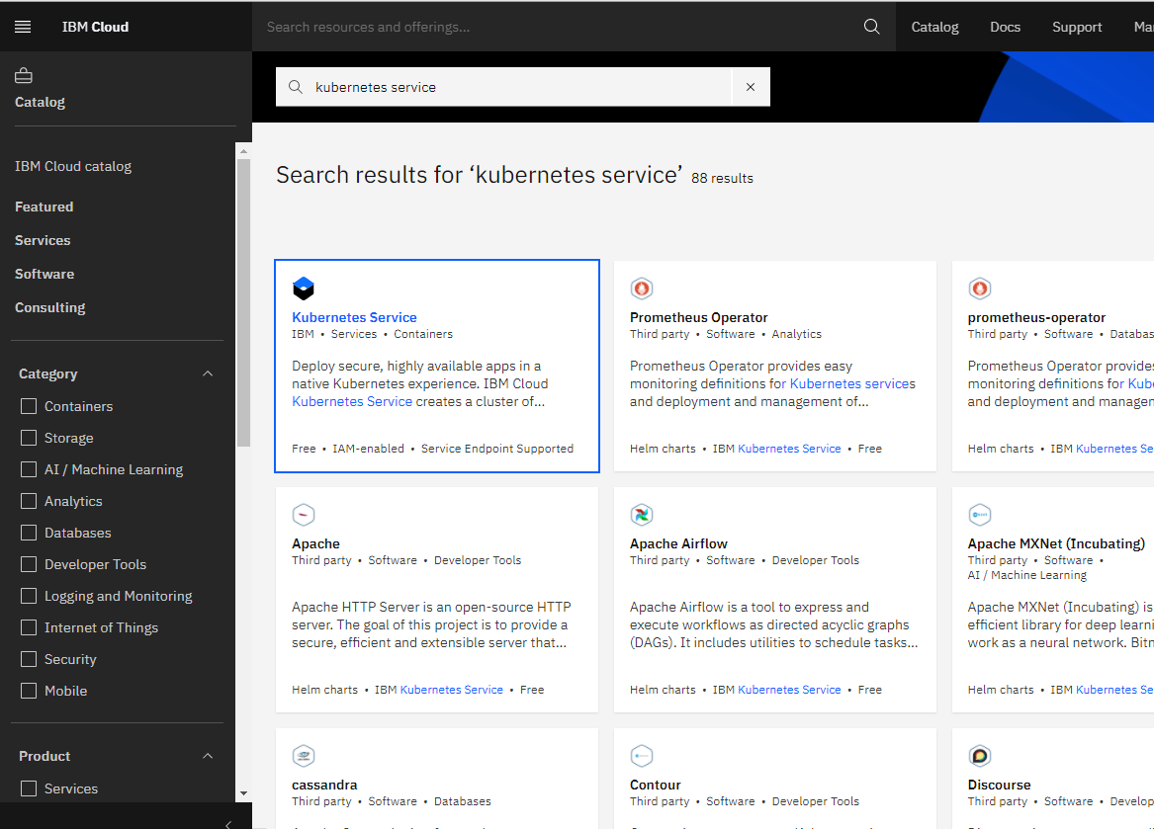

* You are now at the Kubernetes deployment page. You need to specify some details about the cluster
* Choose a plan **standard** or **free** , the free plan only has one worker node and no subnet, to provision a standard cluster, you will need to upgrade your account to Pay-As-You-Go
* To upgrade to a Pay-As-You-Go account, complete the following steps:
* In the console, go to Manage > Account.
* Select Account settings; and click Add credit card.
* Enter your payment information, click Next, and submit your information
* Choose **classic** or **VPC** , read the docs and choose the most suitable type for yourself

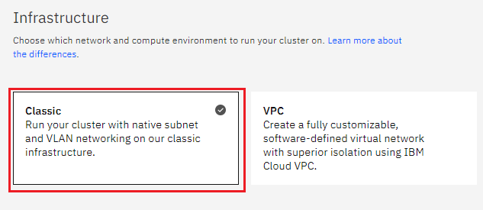

* Now choose your location settings,
* Choose **Geography** (continent)

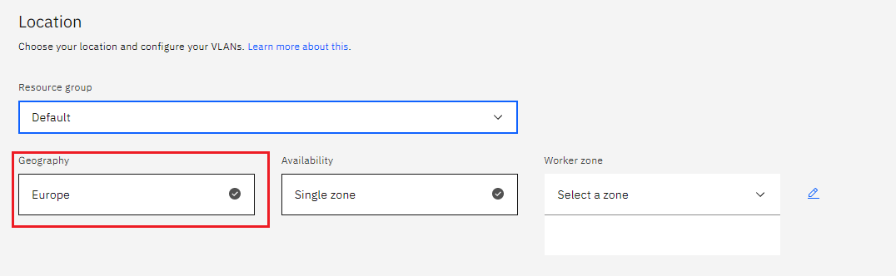

* + Choose Single or Multizone, in single zone your data is only kept in on datacenter, on the

other hand with Multizone it is distributed to multiple zones, thus safer in an unforeseen

zone failure

* If you wish to use Multizone please set up your account with[VRF
* If at your current location selection, there is no available Virtual LAN, a new Vlan will be created for you
* Choose a Worker node setup or use the preselected one, set Worker node amount per zone
* Choose **Master Service Endpoint** , In VRF-enabled accounts, you can choose private-only to make your master accessible on the private network or via VPN tunnel. Choose public-only to make your master publicly accessible. When you have a VRF-enabled account, your cluster is set up by default to use both private and public endpoints.  
  Give desired **tags** to your cluster, for more information visit tags
* Click **create**  
  • Wait for your cluster to be provisioned  
  • Your cluster is ready for usage

**Step 2 Deploy IBM Cloud Block Storage plug-in**

The Block Storage plug-in is a persistent, high-performance iSCSI storage that you can add to your apps by using Kubernetes Persistent Volumes (PVs).

* Click the **Catalog** button on the top
* Select **Software** from the catalog
* Search for **IBM Cloud Block Storage plug-in** and click on it  
  • On the application page Click in the dot next to the cluster, you wish to use  
  • Click on Enter or Select Namespace and choose the default Namespace or use a custom one (if you get error please wait 30 minutes for the cluster to finalize)
* Give a **name** to this workspace
* Click **install** and wait for the deployment

**Step 3 Installing Kubeapps on IBM Cloud**

## **Install Kubeapps**

Use the Helm chart to install the latest version of Kubeapps:

*helm repo add bitnami https://charts.bitnami.com/bitnami*

*kubectl create namespace kubeapps*

*helm install kubeapps --namespace kubeapps bitnami/kubeapps*

The above commands will deploy Kubeapps into the kubeapps namespace in your cluster. It may take a few minutes to execute.

You can check the status of the deployment using the command below:

kubectl get pods -w --namespace kubeapps

Once it has been deployed and the Kubeapps pods are running, continue to another step.

## **Create a demo credential with which to access Kubeapps and Kubernetes**

You can create a Kubernetes service account and use the API token to authenticate with the Kubernetes API server via Kubeapps:

*kubectl create serviceaccount kubeapps-operator*

*kubectl create clusterrolebinding kubeapps-operator --clusterrole=cluster-admin --serviceaccount=default:kubeapps-operator*

## **Start the Kubeapps Dashboard**

Once Kubeapps is installed, securely access the Kubeapps Dashboard from your system by running:

kubectl port-forward -n kubeapps svc/kubeapps 8080:80

# Deploy an application with Kubeapps

Once you have the Kubeapps Dashboard up and running, you can start deploying applications into your cluster.

* Start with the Dashboard welcome page
* Use the "Catalog" menu to select an application from the list of available charts
* Click the "Deploy" button
* You can customize the deployment by editing the form or YAML configuration file. Click "Deploy" to proceed
* The application will now be deployed. You will be able to track the new Kubernetes deployment directly from the browser