6COSC023W – Final Project

Project Proposal (PP)

Inventory and Stock Management System

Student: Andrew Hanna (W1816963)

**Supervisor:**  Stephen Roberts

**Degree:**  MEng Software Engineering FT [BICSS01F]

School of Computer Science & Engineering

College of Design, Creative and Digital Industries

University of Westminster

Date : 10/10/2023

**1. Problem statement, project aims and objectives**

In the area of business operations, the challenges associated with inventory management and stock tracking are often challenging, placing a substantial burden on those tasked with these crucial responsibilities. Is my proposal for a solution, a web-based platform that will be easy to use and will simplify the process of tracking and integrating new inventory.

This system will encompass many quality-of-life features. These include a quick and easy to understand borrowing and lending system, predictive stock levels and automatic ordering of low stock and a tagging system that will allow the borrowers to tag the inventory on the system as in need of repair. As this is a web-based platform it will have a great advantage of accessibility from any location that will help inventory managers locate items and be able to tag new inventory from anywhere.

The main objective of this proposal is to raise the standards and ease of use of inventory management systems within a business. We do this by streamlining the system and allowing anyone with basic knowledge and training to quickly add new inventory, find existing inventory or manage stock levels. In business efficiency is important to improve costs and how smooth the business runs.

The aim of my project is to make inventory management in a business easier and more efficient. I will aim to achieve this by making a clean and simple website that will allow anyone with the correct permissions to quickly add or manage the inventory from any device and any location via the internet. The website should also allow the tracking and availability of borrowing devices.

To achieve these goals, I will review what is currently on the market to ensure that I am not missing any key features in my website that would be typically expected. Along with this I will set myself targets and goals that I would desire to meet within a timeframe.

I will also have various people who are familiar and unfamiliar with inventory systems try to use my website to add inventory and take feedback to warrant any changes I may need to make so that the website is accessible and easy to use for anyone. To further ensure that the website is accessible from anywhere on any device I will test the website on various devices across different operating systems and resolutions to verify that the formatting is consistent.

**2. Background review: similar software/applications, or similar research**

One comparable website would be pulseway, they allow their customers to manage computers and servers on a network. Their system goes more into detail than I will with my website as it can show CPU, ram and disk usage and can kill programs on the machines added. Their design would be similar to what I plan to do as it is relatively clean and easy to understand, they also have groupings for the different computers and servers.

*https://www.pulseway.com/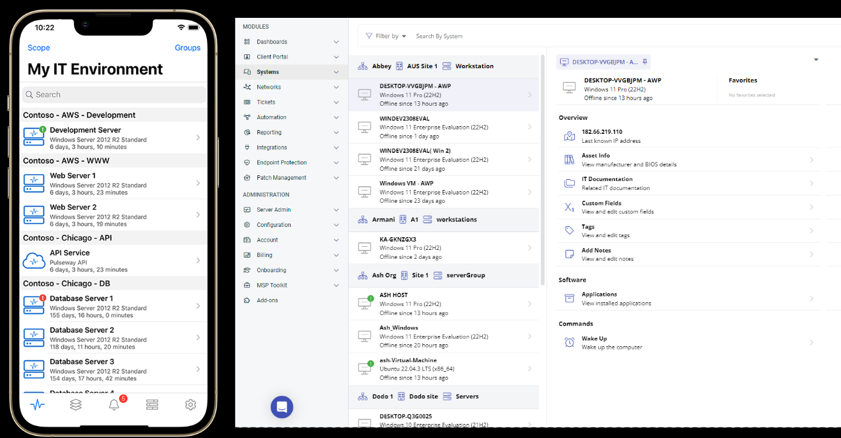*

Asset panda is another inventory management system available. This inventory system is also similar to my project as it has a borrowing system which also allows the users to report problems with the borrowed devices, they also have a groping system which I hope to add to my project. As for their design it would be closer to the look that I would like to implement as it is clean and modern.

The screenshot below has given me ideas for more options that a user could have to tag a borrowed asset as well as the information that should be on each asset such as cost, brand and purchase date, among others.

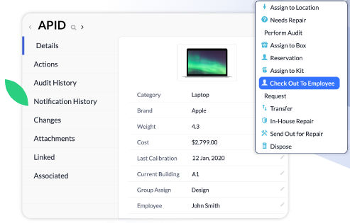

[*https://www.assetpanda.com/our-technology/*](https://www.assetpanda.com/our-technology/)

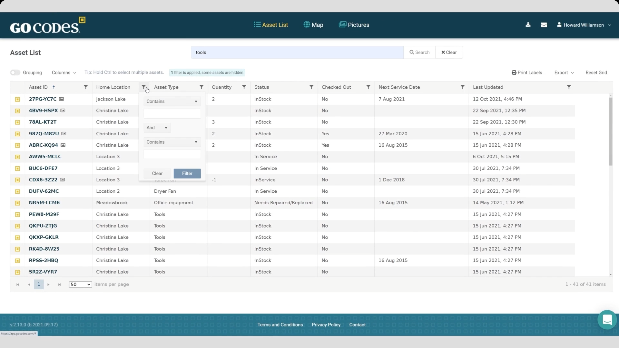The third website / software that I have looked at is GoCodes, this system has similar luxury features as the ones I would like to add such as showing the assets on a map, while theirs would be on a world map I would be aiming more for floor maps and room maps. The also have pictures of the assets that a user / admin can take as the image for the asset, this has given me the idea to add images for the assets in my system as it would make locating the devices easier if a person is less familiar with the device name.

[*https://gocodes.com/*](https://gocodes.com/)

The final inventor system that I have researched is ServiceDesk plus, this is very advanced software that can manage assets, programs, windows updates and much more. My project will be simpler but will have the same basic premise as the asset tracking that they do. As for their design I feel ServiceDesk plus has a dated and crowded look, I will hope that my design should be a more modern and tidier look.

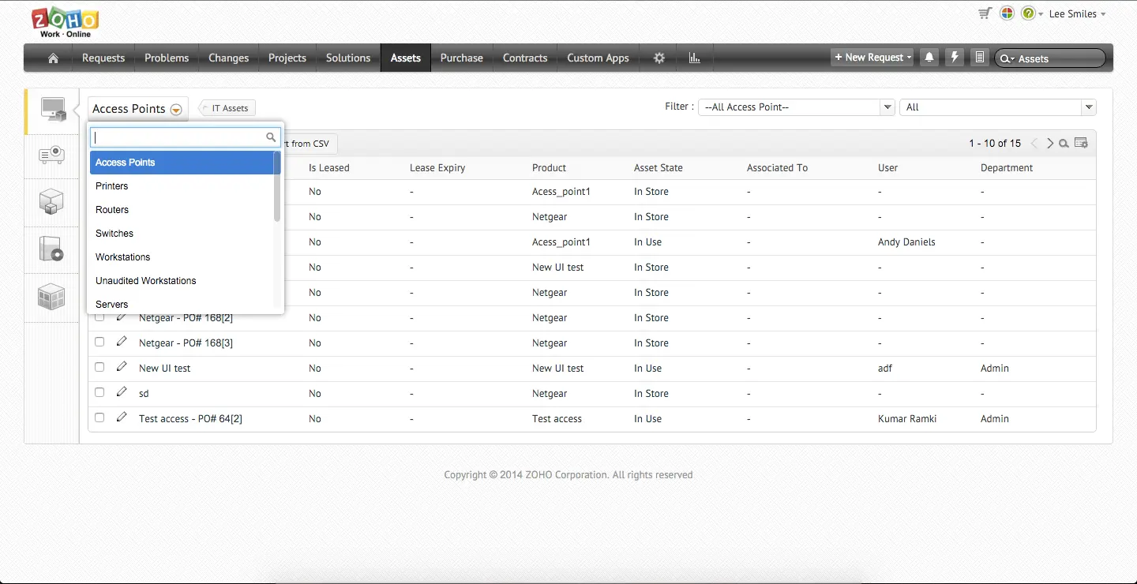

*https://www.manageengine.com/uk/products/service-desk/it-asset-management/inventory-management-software.html*

**3. Tools and skills**

My project only requires two pieces of hardware, any computer and a server that runs phpMyAdmin for the database, if I run into problems with the phpMyAdmin university server I will keep a backup of my SQL code and can host my own phpMyAdmin server on my computer. As for software I can use and IDE, assuming it will let me code in HTML, PHP, SQL and Python. My IDE of choice will be Microsoft’s Visual Studio. To upload my webpages to the university server for web connectivity I will be using WinSCP which allows me to host my pages on a server that I can access from any device.

For this project I will need to learn and vastly improve my skills and knowledge of every language I will need to use for the development of the website. I will especially have to improve my PHP, SQL and python skills to integrate the features I want on my website. Along with the programming languages I will also have to improve my skills for simple and accessible design for the website while ensuring that the website remains clean and tidy. I anticipate that I will need to do a lot of learning and research for the coding for my website that will be vital in improving my problem solving, understanding and skills.

**4. Initial list of requirements**

Functional – essential

The most essential functional part of the website is the log in system which will allow the users and admins to use an email and password to access the website. Along with the login the input and management of the different assets and inventory is essential to the website.

Functional – Advanced

A functional but advanced feature of the website will be the asset code generator, along with the asset code generator I would like to implement different types of barcodes such as the standard barcode and qr code. These codes should be printable to be put on the asset and should be scannable to add or get to the asset on the system.

Another advanced feature would be a grouping system which would allow a business to group inventory by building, floor and rooms this would help locate assets if needed. A further feature would be the automatic ordering of stock if the stock levels get low. The final advanced feature would be a different view depending on access such as low level members of staff that are only allowed to view the inventory or only allowed to access the borrowing system.

Functional – Luxury

A floor and room map which would allow the users to easily view where each asset would physically be in a room would be a potential luxury feature that I would like to add.

Non-Functional – Essential

A non-functional but essential part of the website would be the clean and easy to use design of the website. An easy to understand and use website is paramount.

Non-Functional – Advanced

Accessibility features for users with potential bad sight or other sight issues that may need them to use a high contrast view or a website reader would be an advanced feature.

Non-Functional – Luxury

A final luxury feature would be smooth animations that add to the feel and look of the website but don’t cause the website to be slower, harder to use or harder to understand.

**5. Challenges**

For this project I will need to extend and develop my skills in PHP and html to make a fully functional website. While creating my website I will need to do a lot of research and learning on how to ensure that my website is fast and easy to use while keeping the layout tidy and clean. Along with this I will need to develop new skills, specifically the potential use of Python on my website.

For my requirements gathering I will use my research of other software on the market and during my testing stages I will take feedback from the users on what they like and would like me to change about the website, while also observing them using the website to check that it is as easily usable as possible.

**6. Project timeline**

**7. References / bibliography**

www.manageengine.com. (n.d.). *IT inventory management software - ManageEngine asset mgmt.* [online] Available at: https://www.manageengine.com/uk/products/service-desk/it-asset-management/inventory-management-software.html [Accessed 25 Oct. 2023].

‌Tool Tracking Software. (n.d.). *Tool Tracking Software*. [online] Available at: <https://gocodes.com/>.

Asset Panda. (n.d.). *Cloud-Based Asset Tracking that Works The Way You Do*. [online] Available at: https://www.assetpanda.com/our-technology/.

‌

www.pulseway.com. (n.d.). *Remote Monitoring and Management - RMM Software | Pulseway*. [online] Available at: https://www.pulseway.com/.

‌