aasdfasfasdf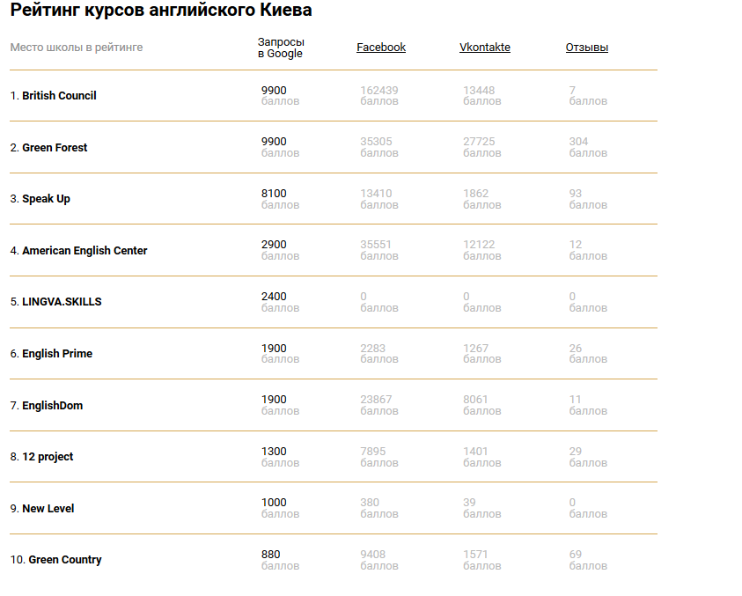

asd

fasf

asd

f

asf

as

f

as

fareqtgq

e

rgq

erg

qer

g

eqrg

agqa erfgqergqaerfgfgdsfgd