Synthesis Summary

Area-Delay Product
Table 1 shows the different values of clock period and corresponding area, and area-delay products.
Area (µm2) | Delay (ns) | Area*Delay (ns ·µm2)
926598.6 | 2.56 | 2372092.372
845136.6 | 2.7 | 2281868.694
845136.6 | 2.7 | 2281868.694
926598.6 | 2.56 | 2372092.372
817226.8 | 3.12 | 2549747.653
813349 | 3.71 | 3017524.741
815359.9 | 4.17 | 3400050.93
773002.8 | 4.53 | 3501702.674
753269.2 | 5 | 3766346.014
745961.7 | 5.51 | 4110249.148
749387.2 | 6 | 4496322.921
730186.2 | 6.57 | 4797323.423
Table 1 – Area*Delay products
Fig-1 shows a graph for the values listed in Table 1.
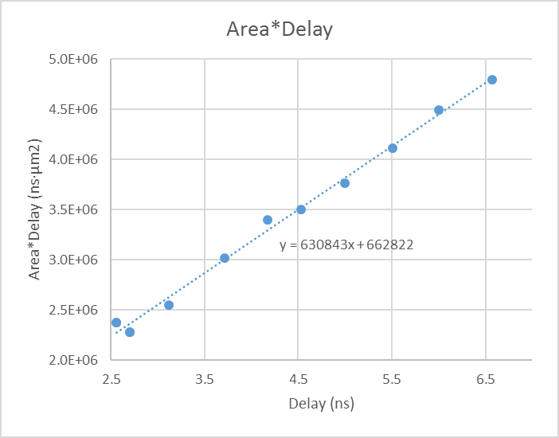
Fig-1 – Delay vs. Area*Delay product
- The delay as reported by Synopsys PrimeTime was 2.7 ns
- The area reported by Synopsys DC Compiler was 845,136.55 µm²
- The power reported by Synopsys DC Compiler was 79.4254 mW
When optimizing the area-delay product, we were able to achieve a good reduction in this product by trying several different options within design compiler. By using the compile -map_effort high -area_effort high command, we noticed that design compiler is able to automatically map operators within our alu such that unused blocks within one operation are shared with another operation, thus reducing area. Using a for loop within the design compiler tcl script, we obtained the above results for optimizing our area delay product.

STA
The critical path reported was from node0_d_in[15] to proc_0/WB_alu_result_reg[0].
The histograms generated from PrimeTime are shown in Fig. 2 and 3. Fig-2 shows the details for the worst group for path slack, and Fig-3 shows the details for endpoint slack.
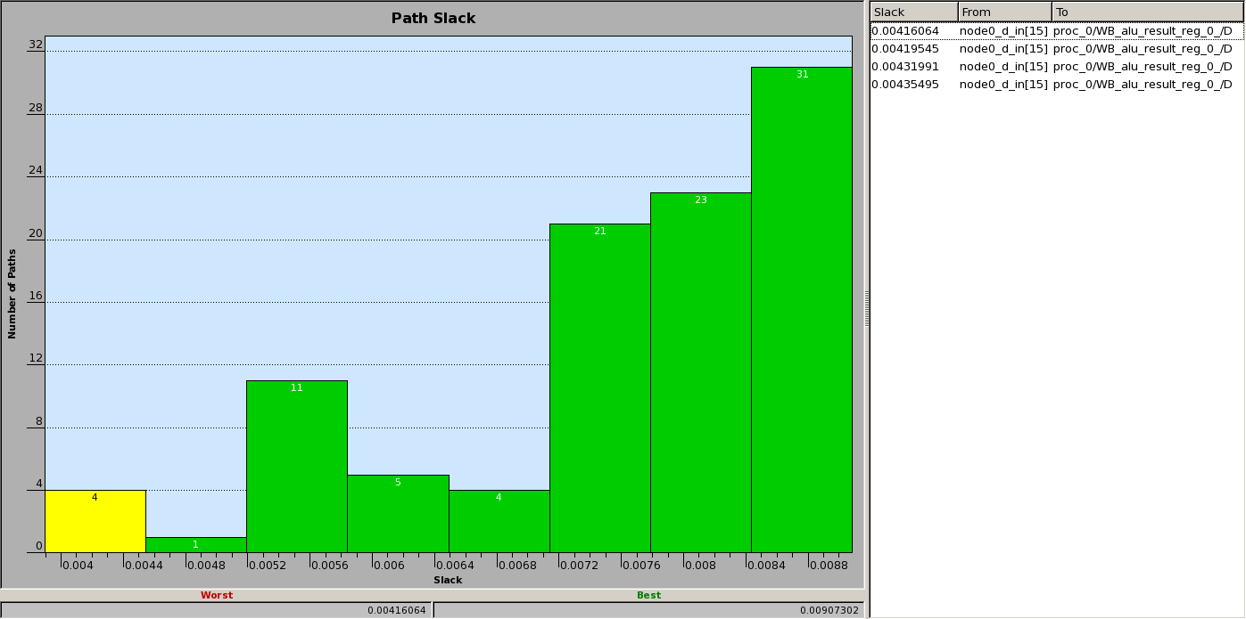
Fig-2 – Path slack histogram from PrimeTime
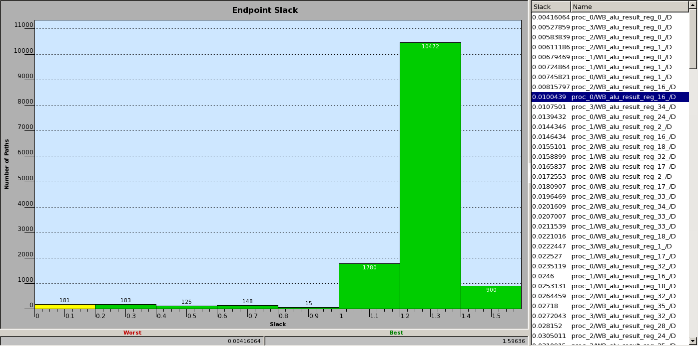
Fig-3 – Endpoint slack histogram from PrimeTime

