My Article
Andrew Cashner
September 21, 2021

Abstract
This is an article with sections, including different kinds of floats and whatnot with cross references and bibliography.

1 Introduction
This is the introduction. It will not remind you of the preface to Moby-Dick. Or perhaps it will. “Call me a document” (Kircher 1650, 1). It’s up to you.
What you’ll see when you look at figure 1 is a lot of squares. They’re all nested inside each other and get infinitely smaller. I made it in LaTeX using a loop. You’ll find it is different from what I will show you in section 2.

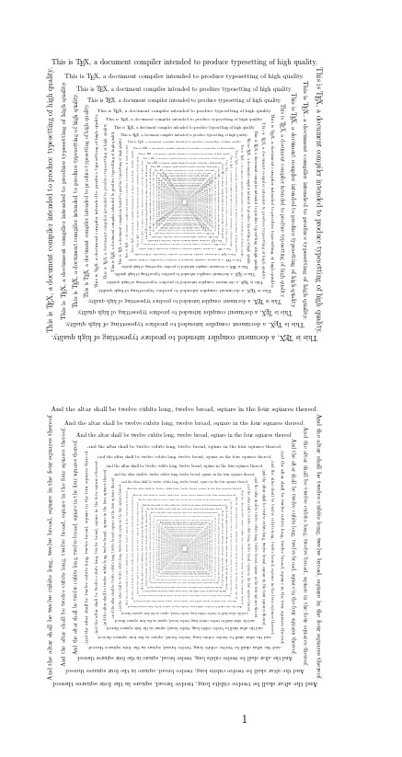

Figure 1: Infinite squares

2 Next part
What’s different about these squares from the next thing I’ll talk about is that next thing isn’t squares at all. It’s notated music (example 2). It shows crotchets, which is the British term for quarter notes, I think. Anyway, Benjamin Britten in Billy Budd would like you to make sure they keep “gently flowing.” They don’t have anything to do with crocheting, which is a handicraft not frequently featured in British opera.

Example 1: “Gently flowing crotchets”

References
Kircher, Athanasius. 1650. Musurgia universalis, sive Ars magna consoni et dissoni in X. libros digesta. Rome.

Follow the hermeneutic circle all the way to the end.
But why not?

