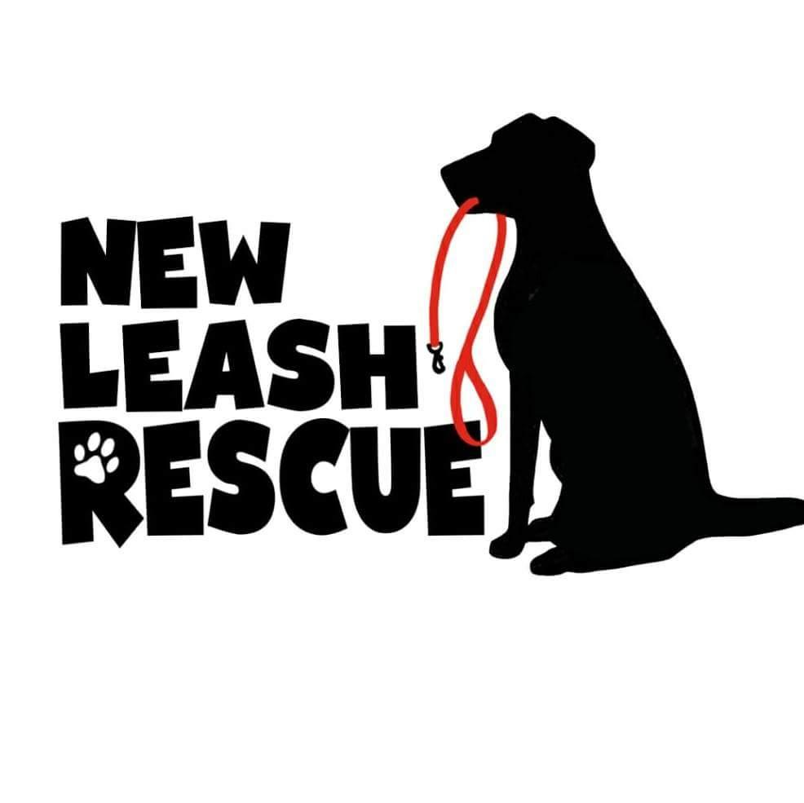

Cat Adoption Application

Date:
Name:
Address:
Apt or Unit #:
City: State: Zip:

Date of Birth:
Phone number:
Email:

Occupation:

Which cat are you interested in?

Type of home: Apartment, Condo, Mobile Home, Town House, Single Family

Do you own or rent your home?

Length of time at current residence?

List full names, birthdate, and relationship of anyone else living in the home. (Our process includes a public records check on anyone over age 18)

Does anyone in the home have a known cat allergy?

Why are you looking for a new companion animal?

Who will be the primary caregiver of this pet?

Have you previously owned a pet? If so, what kinds?

Have you ever surrendered or rehomed a pet?
If so, what happened?

Are there any dogs, cats, or other pets currently living in your home?

If yes, please provide the following below: Age, Species/Breed, Gender

Are the pets living in your home up to date on vaccinations and surgically altered – spayed or neutered?

Please provide the name and phone number of your vet: (if you do not have a current pet, please provide the vet information for the most recent pet owned)

Are your resident pets good with other animals?

Are you aware that the average cost of owning a cat is more than $1,000 per year (including food, litter, planned and unplanned vet care)

On average, how many hours will this pet be left alone in your home per day?

Who will care for your adopted pet if you are no longer able to?
Name: Phone: Relationship:

Under what circumstances would you return this pet to New Leash Rescue?

Will your adopted cat be allowed outside?

What activity level are you looking for in a cat?

Are you aware that the lifespan for a cat could be up to 20 years?

Is there anything else you think we should know about your adoptive home?

Email document or photos of completed application to adopt@newleashrescue.org.
Applications take 3+ business days for processing dependent on application volume.

