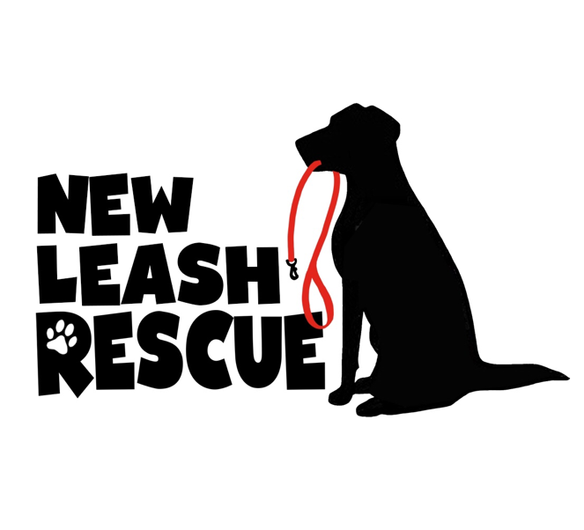

Volunteer Application

Date:
Name:
Address:
Phone:
Email Address:
Date of Birth:

How did you hear about New Leash Rescue?

Are you 18 years or older?
Type of volunteer work you would like to do?

1.) Help at adoption events (help set up and take down, Help with the animals during the
events) (Cottage Grove, Burnsville, and other locations around the twin cities) __________
2.) Animal transport (to and from vet appts, adoption centers) _________
3.) Dog training ________
4.) Fostering ________
5.) Photography __________
6.) Grooming ___________
8.) Web design __________
9.) Social Media content ____________

What is your availability during the week for volunteering? If interested in transporting, how far are you willing to drive? Our primary Vet is located in West St. Paul.

Anything you would like to share with us about why you would like to volunteer, or your
experience with animals?

I understand animals are the property of New Leash Rescue and are not allowed to remove from PetSmart adoption centers or events without the express written approval of the New Leash Rescue director. I agree to follow all instructions from PetSmart staff or New Leash Rescue leadership.

Signature:____________________________ Date:_________________

Please feel free to reach out if you have any questions!

Thank you,
New Leash Rescue

