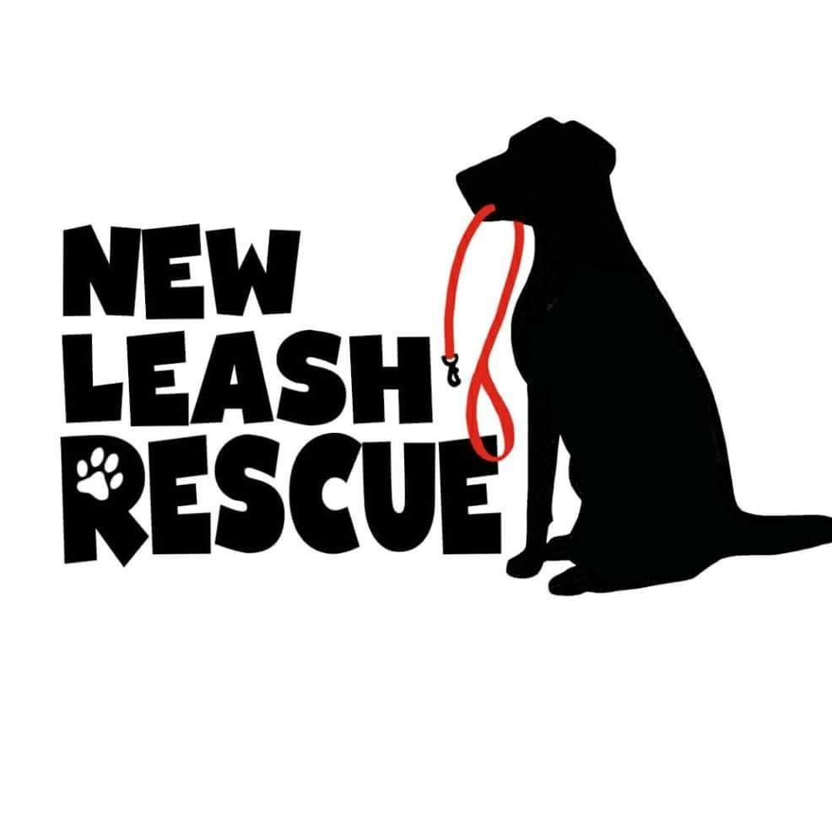

**Adoption Application**

Date:

Name:

Address:

City: State: Zip:

Phone number:

Email:

Occupation:

Which animal are you interested in?

Type of home: Apartment, Condo, Mobile Home, Town House, Single Family

Do you have a yard, and if so, is it fenced?

How will you keep your pet on your property?

Do you own or rent your home?

Length of time at current residence?

Do you plan to move within one year? If so, will you rent or own?

List names, ages, and relationship of anyone else living in the home.

Why are you looking for a new companion animal?

Who will be the primary caregiver of this pet? All

Have you previously owned pets? If so, what kinds?

Have you ever surrendered or given away a pet?

If so, why were you unable to keep the pet?

Are there any dogs, cats, or other pets living in your home?

If yes, please provide the following below: Age, Breed, Gender

Are your resident pets spayed or neutered?

Are your resident pets current on vaccinations?

Please provide the name and phone number of your vet:

Are your resident pets good with other animals?

Are you aware that the average cost of owning a dog is at a minimum $1,000 per year?

On average, how many hours will this pet be left alone in your home per day?

Where will this pet be kept when unsupervised? (kennel, free roam)

Are you familiar with: Crate training

House training

How will you exercise your pet?

Where will this pet sleep at night?

Under what circumstances would you return this pet to New Leash Rescue?

What characteristics are you looking for in a new companion?

Are you looking for an indoor or outdoor companion?

What activity level would you like your pet to have?

Are you committed to providing this pet with the necessary medical care and obedience training to ensure his/her well-being in your home for his/her lifetime?

Are you committed to keeping this pet socialized by meeting new people, other animals, and new situations to keep them well-rounded?

What types of socialization opportunities will your new dog/puppy have?

Have you previously trained a dog or puppy?

What training methods have you used and/or will you use with your new dog or puppy?

Will you be enrolling your dog/puppy in obedience classes? If no, please explain.

Is there anything else you think we should know about your adoptive home?

Please email completed application to: Newleashrescue2018@gmail.com

There is always an adjustment period each time a new pet comes into your home. There can be accidents as a pet adjusts to a new routine, so all animals will need a housetraining refresher. Every time new pets are introduced into a home, they need to figure out the new pack order of the group. Pets that move into new situations (new foster, new adopter, etc) are the most at risk of getting away and becoming lost due to stress. Double leashing along with other safety precautions are recommended. Adjustment can take time – up to a week or more. Every time a pet moves to a new place, their world is turned upside down and they’ve lost all the things that used to give them comfort.

Our fosters will explain as much as we know about the background history of the pet, as well as any interactions the pet has had with them while at their home. We cannot guarantee that we have tested out every pet to every type of situation that could come up. Your home dynamics and home set up is always going to be different than the foster home. It also can take up to 2-3 months for a dog to settle into a home and finally realize they aren’t moving around anymore and show you more of their true personality. Sometimes you might see a behavior come up that you did not see in the beginning.

Please be patient with your new pet and do not hesitate to reach out to the foster home if you have any questions.