Andrew Alferman

CS 575 Spring 2017

Project #1

1. Tell what machine you ran this on.
   * The machine was a
2. What do you think the actual volume is?
   * For most calculations, the volume was approximately 25.3. When large numbers of nodes were used (greater than 4096), the volume calculation started to decrease. A plot of the volume versus the number of nodes for 1, 2, and 4 threads is shown below. The

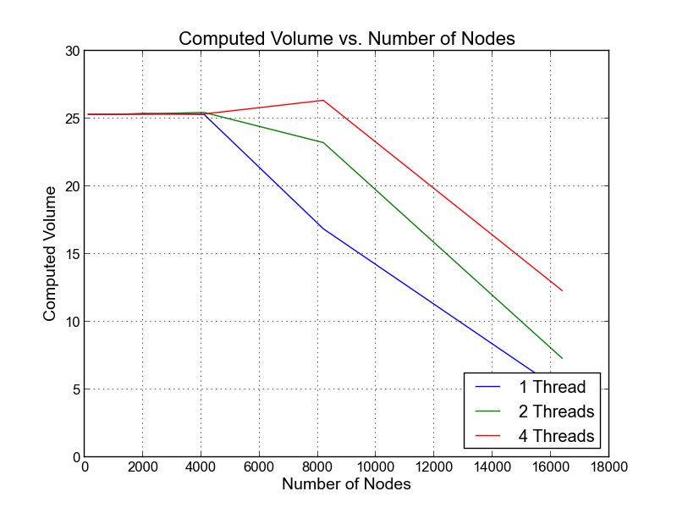

1. Show the performances you achieved in tables and graphs as a function of NUMNODES and NUMT.
   * Using 1 thread:

The peak performance was

* + Using 2 threads:

The peak performance was

* + Using 4 threads:

The peak performance was

1. What patterns are you seeing in the speeds?
2. Why do you think it is behaving this way?
3. What is the Parallel Fraction for this application, using the Invers Amdahl equation?
4. Given that Parallel Fraction, what is the maximum speed-up you could ever get?