Andrew Alferman

CS 575 Spring 2017

Project #1

1. Tell what machine you ran this on.
   * The machine was a MacBook Pro (Retina, 13-inch, Early 2015) with a 2.9 GHz Intel Core i5 processor running macOS Sierra Version 10.12.3 with 8 GB 1867 MHz DDR3.
2. What do you think the actual volume is?
   * For most calculations, the volume was approximately 25.3. When large numbers of nodes were used (greater than 4096), the volume calculation started to decrease. A plot of the volume versus the number of nodes for 1, 2, and 4 threads is shown below. The decrease in the calculated volume is likely erroneous, possibly resulting from an integer overflow, etc.

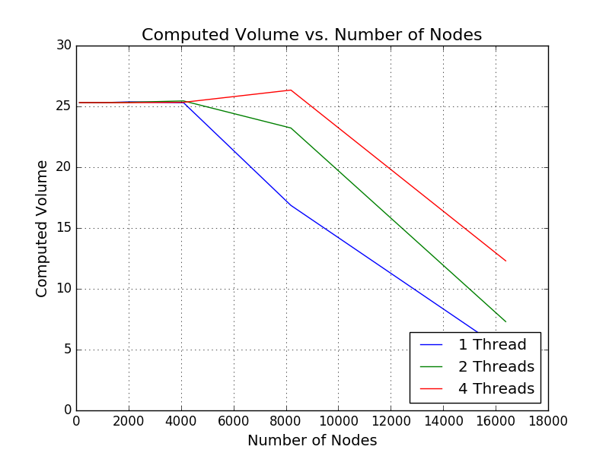

1. Show the performances you achieved in tables and graphs as a function of NUMNODES and NUMT.
   * The requested graphs can be found below. Lists of the numbers used to create the graphs can be found in the code output at the end of this document. Note that the speedup for two threads appears to be erroneously high, and may be the result of one background processes slowing the performance of the one 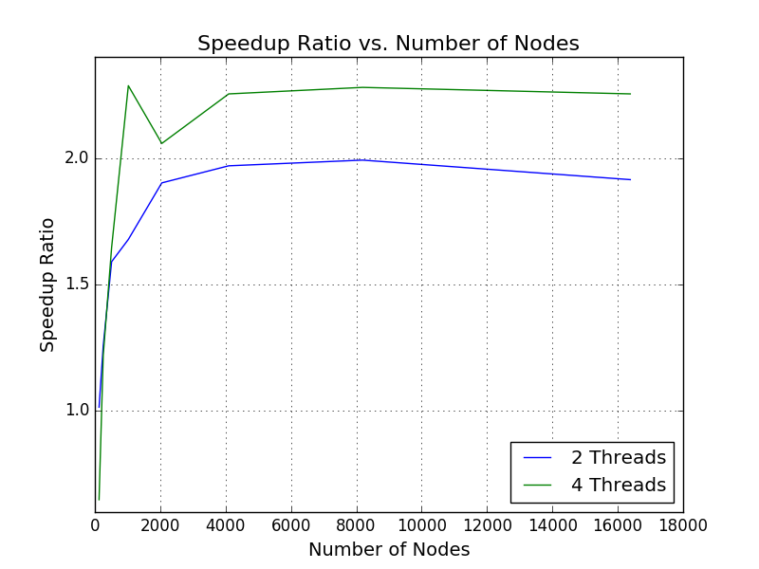thread runs, or possibly some sneaky behind-the-scenes programming by Apple.

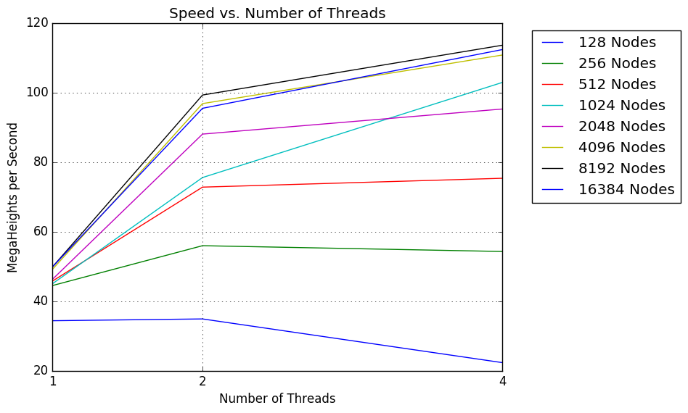

1. What patterns are you seeing in the speeds?
   * The computation generally speeds up when more threads are in use and when more nodes are used, but only to a point. When a very large number of nodes are used (i.e. 16384 nodes), the computation begins to slow.
2. Why do you think it is behaving this way?
   * The computation speeds up initially as more nodes are used because a greater portion of the work is being done in parallel due to the larger data set (i.e. Gustafsen’s Observation). However, when a large enough data set is being used, the data set may be larger than the lower level cache can handle, thus requiring the data to be cached further away from the processor and slowing the computation.
   * With smaller numbers of nodes, the data exhibits large fluctuations. These fluctuations may be due to inaccuracies in the clock times, which are comparatively large when the overall computation time is very small.
   * For most selections of the number of nodes, the speed increases as more threads are being used. This is because more work can be done in parallel. However, when a small number of nodes are being used, the extra processing needed to set up the parallel processing and divide the work between the threads is comparatively larger, which causes the speed to slow down as the number of threads is increased.
3. What is the Parallel Fraction for this application, using the Inverse Amdahl equation?
   * The parallel fraction was 74.8%. This value computed using the four thread speedup (which was in turn computed using the maximum speed exhibited by four threads divided by the maximum speed exhibited by one thread) because the parallel fraction computed using two threads appeared to be erroneous, as discussed earlier.
4. Given that Parallel Fraction, what is the maximum speed-up you could ever get?
   * Given a parallel fraction of 74.8%, the maximum speedup that could ever be achieved with a hypothetically infinite number of threads/cores is 3.97.

Note that all of the information used to generate the plots as well as all of the information given in the answers above can be found in the code output below.

Python Wrapper Code Output:

SPEED INFORMATION ------------

One thread speeds:

[34.348, 44.4613, 45.7574, 44.9975, 46.2733, 49.1404, 49.8214, 49.8368]

Two thread speeds:

[34.8596, 55.9181, 72.7571, 75.5132, 88.0047, 96.7745, 99.2363, 95.4203]

Four thread speeds:

[22.2912, 54.2517, 75.3071, 102.8722, 95.2212, 110.7465, 113.5646, 112.3184]

Two thread speedups:

['1.0149', '1.2577', '1.5901', '1.6782', '1.9018', '1.9693', '1.9918', '1.9147']

Two thread speedup: 1.99

Four thread speedups:

['0.6490', '1.2202', '1.6458', '2.2862', '2.0578', '2.2537', '2.2794', '2.2537']

Four thread speedup: 2.28

Two thread parallel fractions:

['0.0294', '0.4098', '0.7422', '0.8082', '0.9484', '0.9844', '0.9959', '0.9554']

Overall 2 thread parallel fraction: 0.9956

Four thread parallel fractions:

['-0.7212', '0.2406', '0.5232', '0.7501', '0.6854', '0.7417', '0.7484', '0.7417']

Overall 4 thread parallel fraction: 0.7482

Max speedup possible: 3.97

VOLUME INFORMATION------------

One thread volumes:

[25.313, 25.3126, 25.3125, 25.3109, 25.3725, 25.3046, 16.858, 4.8536]

Two thread volumes:

[25.313, 25.3126, 25.3126, 25.3126, 25.341, 25.4501, 23.2235, 7.3]

Four thread volumes:

[25.313, 25.3126, 25.3125, 25.3126, 25.3071, 25.3371, 26.3424, 12.3]