Andrew Alferman ME540 Intermediate Thermodynamics April 7, 2017

Homework 1 Executive Summary

Summary

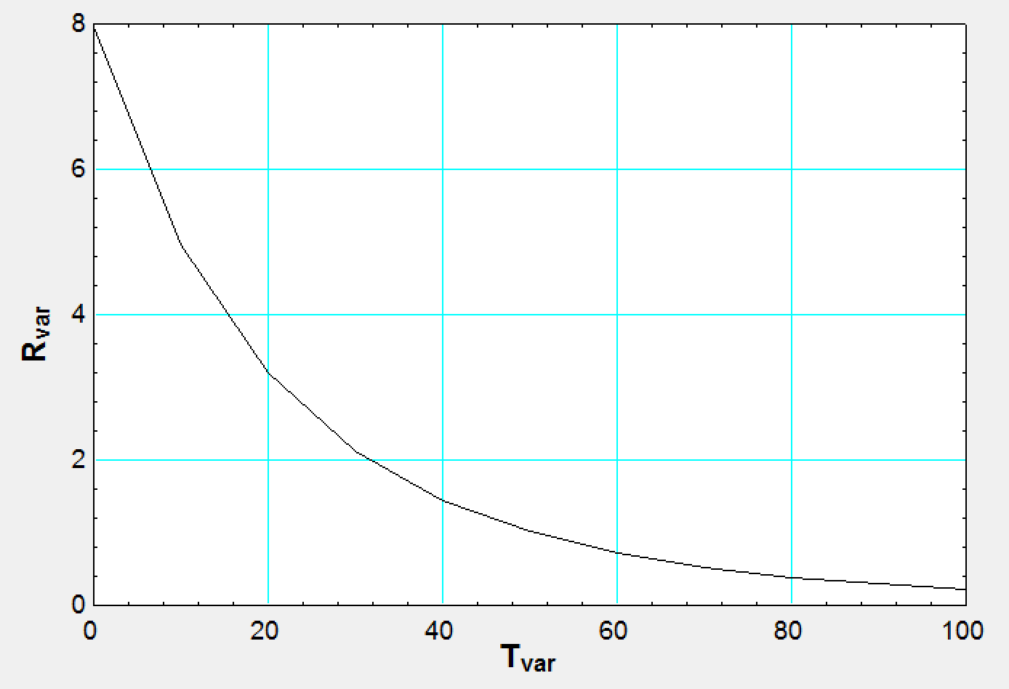Three separate problems were solved to gain familiarity with the functionality of the EES software. The performance of a thermistor was investigated in the first problem. The material constant α was found to be approximately 3644 K. It was also found that the thermistor is most sensitive (i.e. works best) towards the lower range of temperature values given, with 0 to 20 degrees C being most sensitive. The sensitivity curve of the thermistor can be found in Figure 1.

Figure : Resistance vs. Temperature of Thermistor

The deceleration of a fighter jet landing on an aircraft carrier was investigated in the second problem. It was found that the pilot was subjected to an acceleration of 33.53 m/s^2 in the direction opposite the aircraft’s travel, which is equivalent to 3.421 g’s. While landing, the aircraft travels 67.06 meters. The tailhook exerted 821234 N of force on the aircraft to decelerate it as described. The change in kinetic energy of the plane was 5.507 \* 10^7 J. It was found that a stop time of less than 2 seconds caused the pilot to be subjected to over 4 g’s during landing, and therefore the flight deck must not be much shorter than 67.06 meters.

The third problem involved determining properties of R134a contained in a tank. A

Assumptions

It was assumed in the first problem that the sensitivity of the measurement is based off of the resistance of the thermistor, and that there is no other equipment that needs to be considered (i.e. amplifier, filter, etc.). It was assumed in the second problem that air resistance was negligible, and that the only force acting upon the aircraft was that of the tailhook. Furthermore, the engines were assumed to be producing no thrust in either the forwards or backwards direction.

Approach

The first problem was solved by running a parametric table with the given equation which related resistance to temperature. The second problem was solved by integrating velocity with respect to time in order to obtain distance. An integral table had to be used to obtain values for each stop time. The third problem was solved by varying the temperature of the R134a across a range, and plotting the state of the R134a at each point.