ME540 Homework Week 9 Andrew Alferman, Mike Prier

This homework focused on calculating the most probable macrostate of a system based on the thermodynamic probability. The total energy of the system, or internal energy is defined as

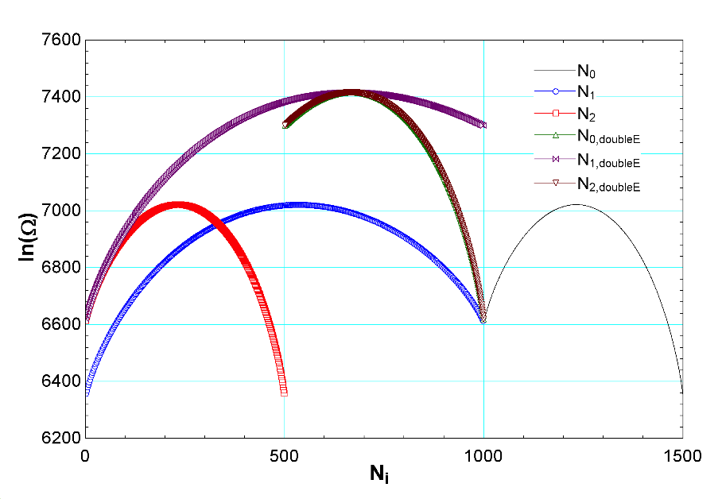

Figure 1: thermodynamic probability as a function of all three particle distributions. Curves are shown for N1, N2, and N3 with internal energies at both 1000 and 2000 units to demonstrate trends of increasing energy. Note that each curve for a given energy level has the same maximum value of Ω, which corresponds to the macrostate with the greatest number of possible microstates which is therefore the most probable macrostate.

$$U=\sum_{i=1}^{\# levels}{N_{i}ϵ_{i}}$$

Where $N_{i}$ is the number of particles in energy state $ϵ_{i}$. Similarly, the total number of particles is as follows:

$$N=\sum_{i=1}^{\# levels}{N_{i}}$$

The thermodynamic probability function is a measure of the most likely macrostate present in a system, where a macrostate is a specification of the number of particles in each energy level that satisfies the above two equations. The macrostate, or arrangement of $N_{i}$, that can be made up of the greatest number of microstates (greatest $Ω$) is the most likely macrostate. The value of $Ω$ was calculated as follows:

$$\ln\left(Ω\right)=\sum_{i=1}^{\# levels}{N_{i}\ln\left(\frac{g_{i}}{N_{i}}\right)}+N$$

With an internal energy of 1000 units, number of particles N=2000, degeneracy $g_{i}=10,000$, and available energy levels of 0,1,2 the most probable macrostate consisted of $N_{0}=1232, N_{1}=536, N_{2}=232$ with a thermodynamic probability $Ω=\exp\left(7021\right)J/ost likely macrostate is coincident with the macrostate with the highest entropy and was found to be here a macrostate cons$. This was found by iteration over all possible combinations of $N_{i}$, and each combination was found using the first two equations of this summary. To calculate the entropy of the most likely macrostate Boltzmann’s Law was used:

$$S=k ln⁡(Ω)$$

The most likely macrostate is coincident with the macrostate with the highest entropy and was found to be $S=9.694*{10}^{-23}kJ/K$

If the total energy of the system is increased then we would expect the distribution of particles in each energy level to shift toward the higher energy levels; the percentage increase of $N_{2}$ would increase significantly, $N_{1}$ would increase to a lesser extent, and $N_{0}$ would decrease. At the same time, the number of possible microstates $Ω$ that correspond to the most likely macrostate would increase, as seen in Figure 1.