My Pharmacy

**SRS**

Submitted by:

Group ***7***

# 

# Table of contents

**Table of contents** **1**

**Introduction** **3**

Executive Summary 3

Document Overview 3

References 3

**System Description** **4**

Introduction 4

Users 7

Modules 7

**System Users** **9**

End Users(normal user): 9

Administrator (pharmacy owner/pharmacists) 10

**System Modules** **11**

**Patients ordering drugs** **14**

**System Functions** **15**

Functional requirements 15

**System Models** **19**

Register 19

Login 20

Sequence Diagrams 21

**Non-Functional Requirements** **23**

Availability 23

Security 23

Usability 23

Performance 23

Technology 24

Development 24

Delivery 24

**Domain Requirements** **25**

**System Interfaces** **26**

User Interfaces 26

Communication Interfaces 27

Hardware Interfaces 27

# 

# Introduction

## 

## Executive Summary

My pharmacy is offering new solutions for finding your suitable drugs and getting it easily either by buying it online and delivering it to your home or to know where you can buy it from.

My pharmacy can be used by doctors,pharmacists or patients in need of some medicine, where they can build their own profiles and ease themselves to reach to each other and get their medical prescription the fastest way possible.

## Document Overview

This document introduces “My pharmacy” product study plan. It introduce general description, technical description, development plan, operation plan, cost analysis and marketing study.

## References

**Drug table:**

http://apps.who.int/medicinedocs/documents/s22355en/s22355en.pdf

# 

# 

# 

# System Description

## Introduction

The system consists of 5 sub-systems aside to the main system “Pharmacy System”. Each sub-system has its functionalities to which the system responds.

The five subsystems are:

1. Administrator

2. End user

3. Marketing

4. Finance

5. Delivery team

* **The Administrator:**

The administrator functionalities are:

1. Signup into the page.

System response: save administrator’s data into database for later sign in

2. Sign in into the page.

System response: log the administrator in the page.

3. Access user account.

System response: Display user account’s info for viewing or editing.

4. Adding products or medicine.

System response: Adds the item inserted into the database.

5. Editing products or medicine.

System response: Display products or medicine for updating or deleting.

6. Adding price to products or medicine.

System response: Adds the price to the item.

7. Editing price for products or medicine.

System response: Display item’s price for editing.

8. Adding info about the product or medicine.

System response: Adds the information to the desired product or medicine.

9. Edit info about the product or medicine.

System response: Displays the items info for editing.

10. Check product or medicine availability.

System response: Display status of that item.

11. Post onto Homepage.

System response: Displays a text area for the administrator to write the desire text in.

* **The End-user:**

The End user functionalities are:

1. Create account.

System response: Display new account forum.

2. Log in.

System response: Logs user into the system.

3. Edit profile.

System response: allows user to perform changes to his profile

4. Search for product or medicine.

System response: allows user to enter a text to search and displays the search results.

5. View product and medicine list.

System response: Display product and medicine list.

6. View product or medicine price.

System response: displays the price of the product or medicine.

7. Selecting item to buy.

System response: adds item selected to the basket

8. Purchasing an item.

System response: enables user to enter his location & phone number then confirm the purchase

9. Give feedback.

System response: Display feedback forum and enables user to enter feedback.

10. Contacting and help.

System response: Displays text area to write the desired enquiry.

* **The Finance team:**

The Pharmacy System sends its financial reports to the finance team.

* **The Marketing:**

The Pharmacy System sends its full report to the marketing team.

* **The Delivery team:**

The Pharmacy System sends its full report to the Delivery team.

## 

## Users

End-users (normal user): They can signup and login into the page, edit their profiles including their accounts’ info ,access the medicine and product list , buy a medicine/product , contact for enquiries or personal help.

Administrators (pharmacy owner/pharmacists): They can access the medicine and product list as well as entering new data , changing prices , accessing users’ accounts , giving important alerts and news.

## Modules

**1. Sign up and login for Administrator**

**Description:** Administrator fills up a form with his info when he first sign ups then he logs in whenever he needs to use the system

**2. Sign up and login for End user**

**Description**: user fills up a form with his info when he first sign ups then he logs in whenever he needs to use the system

**3. Search for Drug and check its availability in pharmacy**

**Description**: On writing drug name in search grid it’s name and same drugs appear, On clicking on one of them, system displays drug page which contains its price , sort of drug(tablets,syrup,..etc) and availability in pharmacy branches or inform that the drug is missing.

**4. Online purchasing and shipping**

**Description:** When user search for a drug and click on it and it appears to be available ,he can choose the quantity and type then, “add to cart” button can be clicked which are in drug page, the site takes the user to cart page where he can decide the payment method, whether he wants to pay in cash or by using a credit card in this case he need to give his card info behind his name, address and mobile number in both cases

**5. Drug prescription**

**Description:** Display all the informations the customer need to know about the drug(ingredients, uses, side-effects,…etc) when customer click on “drug prescription” button found in drug page.

# 

# System Users

## End Users(normal user):

The system shall provide the user the ability to sign up for the system.

The system shall provide the user the ability to log in.

The system shall provide the user the ability to edit their profiles including their info.

The system shall enable user to enter the search text on the screen.

The system shall display all the available components of the product.

The system shall display detailed information of the selected products.

The system shall provide browsing options to see product details.

The system shall display to the user the product’s prescription.

The system shall display to the user the product’s price and further info.

The system shall provide the user the option to buy single or multiple products.

The system provides the user the option to add products to the basket to be purchased.

The system shall provide support to the user by contacting or sending emails.

The system provides the user the ability to see news feed of the system.

The system shall display all the matching products based on the search.

## 

## Administrator (pharmacy owner/pharmacists)

The system shall provide the admin the ability to sign up for the system.

The system shall provide the admin the ability to log in.

The system shall provide the admin the option of adding products to the database.

The system shall provide the admin the ability to add info about the product.

The system shall provide the admin the ability to add or update the products’ prices.

The system shall provide the admin the ability to post in the home page of the system.

The system shall provide the admin the ability to update the database.

The system shall provide the admin the option of posting missing products.

The system shall provide the admin the ability to access the normal users’ profiles.

The system shall provide the admin the ability to add and remove products.

The system displays to the admin the number of users having accounts in the system.

# 

# System Modules

* **The pharmacy System**

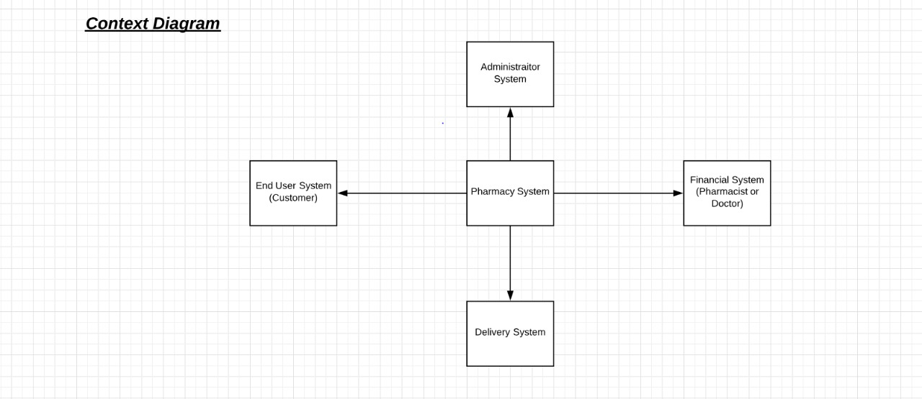

**1. Sign up and login for Administrator**

**Description:** Administrator fills up a form with his info when he first sign ups then he logs in whenever he needs to use the system.

**2. Sign up and login for End user**

**Description**: user fills up a form with his info when he first sign ups then he logs in whenever he needs to use the system.

**3. Financial System**

**Description**: The doctors or pharmacists determine the prices of the products in the system and change it whenever they want.

**4. Delivery System**

**Description**: System considering the delivery staff and their profiles and their phone numbers.

* **System login and purchasing items**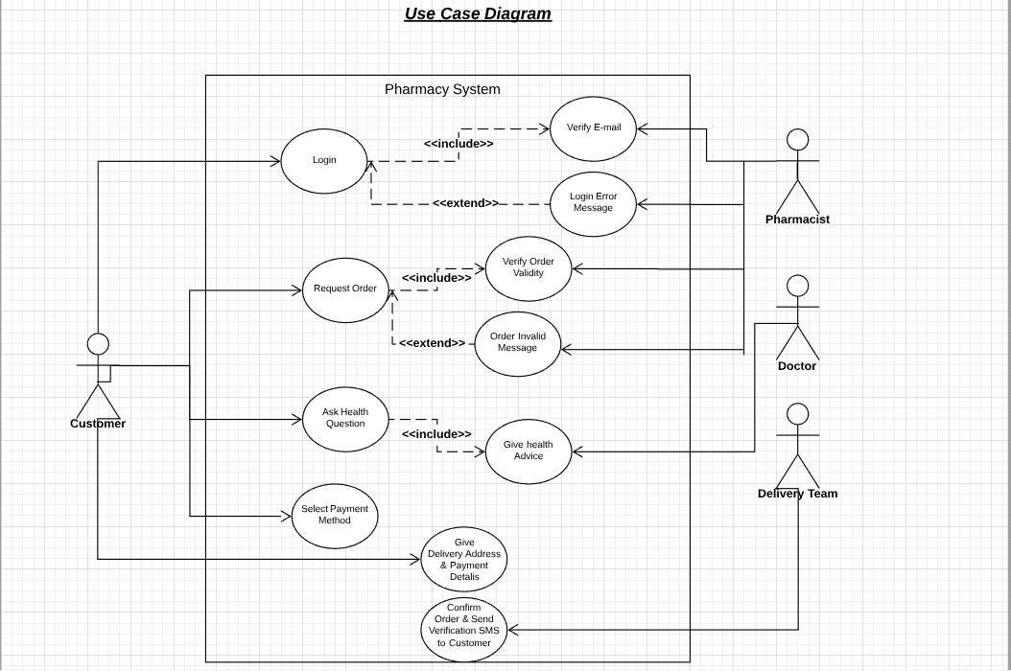

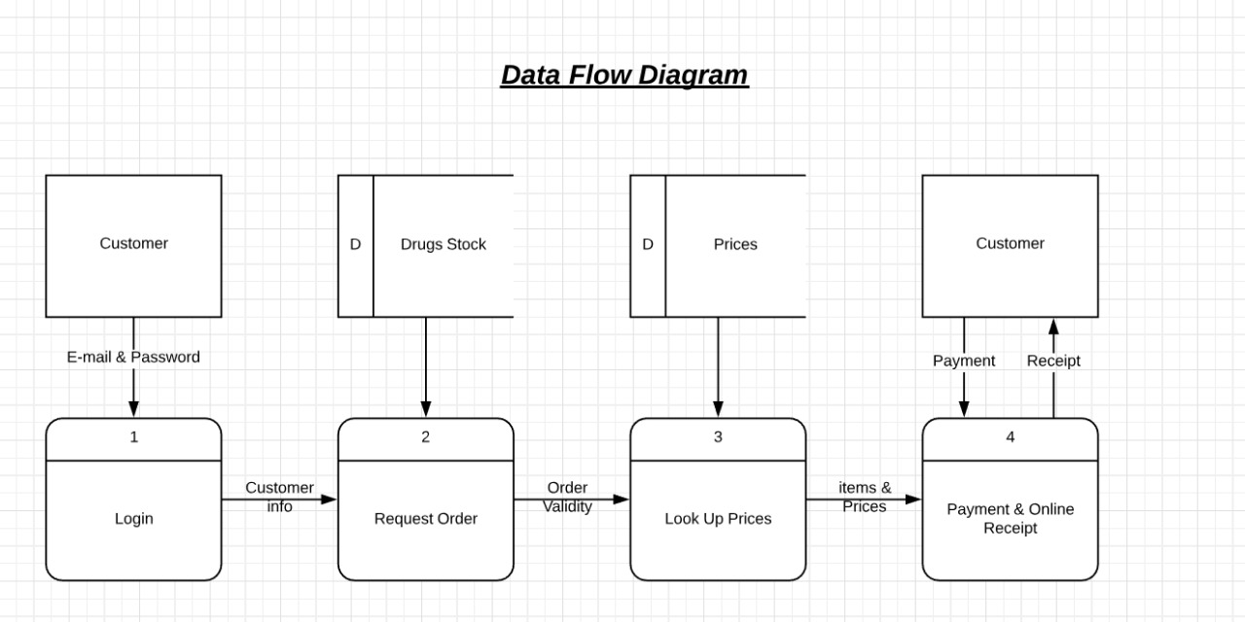

**1. Login**

**Description**: Where user login to the system.

**2. Online purchasing and shipping**

**Description:** When user search for a drug and click on it and it appears to be available ,he can choose the quantity and type then, “add to cart” button can be clicked which are in drug page, the site takes the user to cart page where he can decide the payment method, whether he wants to pay in cash or by using a credit card in this case he need to give his card info behind his name, address and mobile number in both cases.

* **Login to the system and search for items**

**1. Login**

**Description**: Where user login to the system.

**2. Search for Drug and check its availability in pharmacy**

**Description**: On writing drug name in search grid it’s name and same drugs appear, On clicking on one of them, system displays drug page which contains its price , sort of drug(tablets,syrup,..etc) and availability in pharmacy branches or inform that the drug is missing.

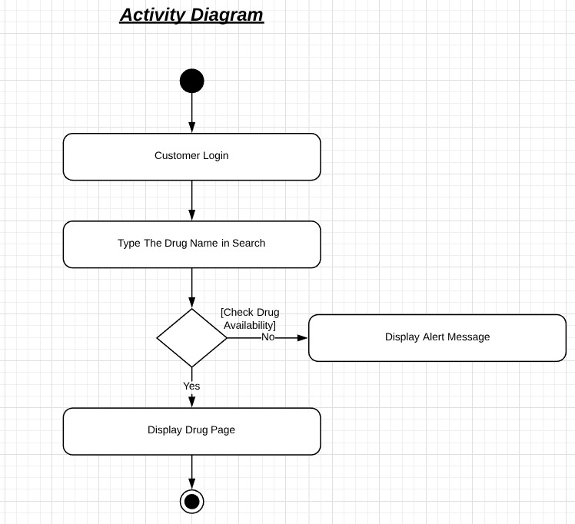

* **View Drug info:**

**Description:** Display all the informations the customer need to know about the drug(ingredients, uses, side-effects,…etc) when customer click on “drug prescription” button found in drug page.

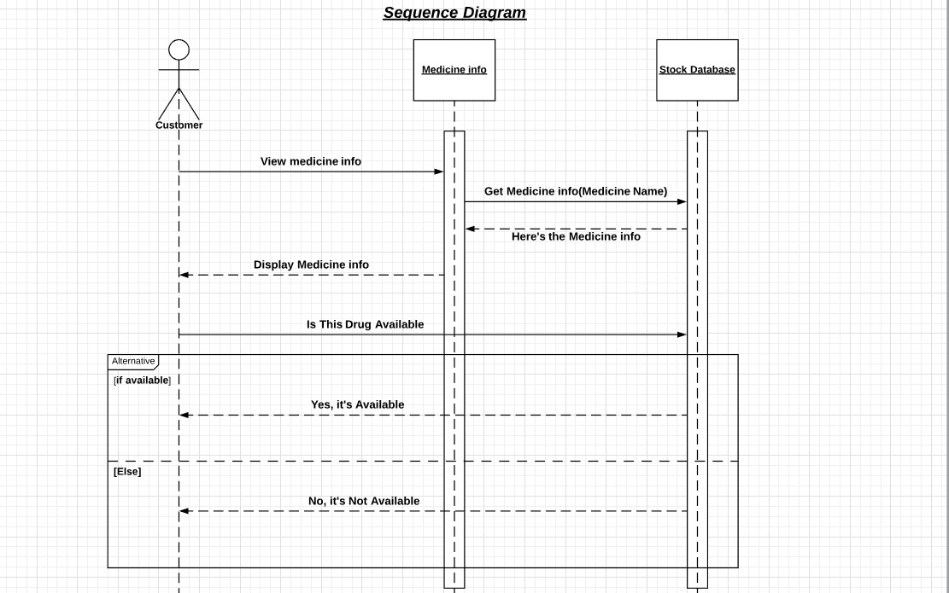

# System Functions

## Functional requirements

**[FR_SD_01] Search for Drugs**

**Description:** On writing drug name in search grid it’s name and same drugs appear, On clicking on one of them, system displays drug page which contains its price , sort of drug(tablets,syrup,..etc) and availability in pharmacy branches or inform that the drug is missing.

**Inputs**: Drug name.

**Outputs:** Drug price, type and availability or missing alert.

**Pre-conditions**: The website is displayed with grids for searching.

**Post-conditions:** The drug name is added to search history.

**[FR_PI_02] Purchasing Items**

**Description:** When user search for a drug and click on it and it appears to be available ,he can choose the quantity and type then, “add to cart” button can be clicked which are in drug page, the site takes the user to cart page where he can decide the payment method, whether he wants to pay in cash or by using a credit card in this case he need to give his card info behind his name, address and mobile number in both cases.

**Inputs:** Drug name, payment method and user info.

**Outputs:** Drug price, type and availability.

**Pre-conditions:** The website is supported by Search grid, add to cart button, Cart page and database to hold customer’s info.

**Post-conditions:** The delivery man takes the drug to the customer.

**[FR_DINFO_03] Drug Information**

**Description:** Display all the informations the customer need to know about the drug(ingredients, uses, side-effects,…etc) when customer click on “drug prescription” button found in drug page.

**Inputs**: Drug name, choose drug prescription

**Outputs**: The website displays all informations about the drug.

**Pre-conditions**: Drug page and Drug prescription button.

**Post-conditions**: All information about the drug is displayed.

**[FR_DISPLAY_04] Display stock**

**Description**: Display all the available items in the pharmacy.

**Inputs:** Display items button.

**Pre-conditions:**  1-the user is logged in.

2-the user clicked the button display items.

**Outputs:** void.

**Post-conditions:** The items are displayed on the screen.

**[FR_DELETE_05] Delete items from cart**

**Description**: Deletes a desired item from the cart in order not to purchase it.

**Inputs:**  1-selected item.

2-click the delete button.

**Pre-conditions:**  1-the user is in the cart page.

2-the user has selected an item to delete.

3-the user has clicked the delete button.

**Outputs:** void

**Post-conditions:** The item is deleted from the cart

# 

# System Models

## Log in and purchasing an item



## 

## Sequence Diagrams

* **Offer effective way of searching and knowing whether it’s available or not.**

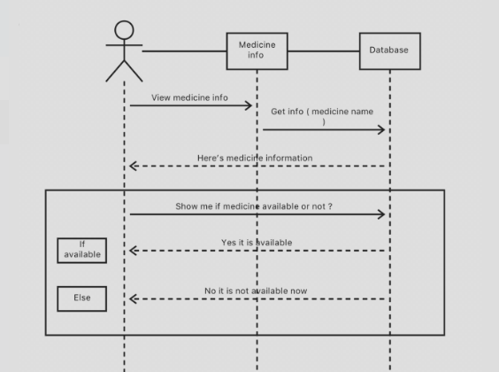

* **Offer a free personal consultation with a pharmacist or doctor.**

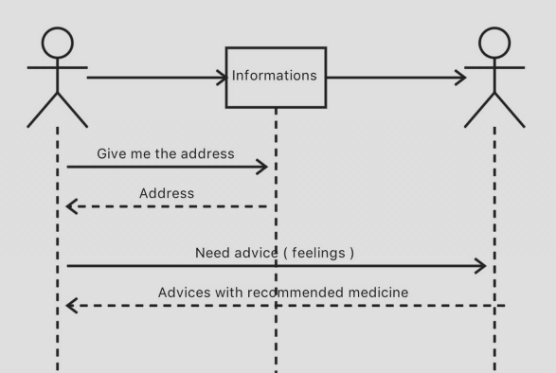

* **Offer an easy delivery service with the covered location .**

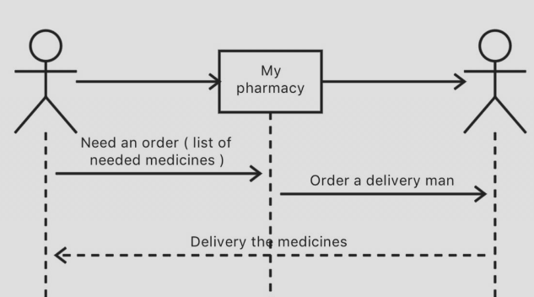

# 

# Non-Functional Requirements

## NFR_1 Availability

The system is fully available for the users working for 24 hours a day and 365 days a year so that the users can go to the system anytime they want.

## 

## NFR_2 Security

The system is secure due to the huge importance of the data and the possible damages that can be caused by incorrect or incomplete data.

The security validations and process will all be a part in our coding techniques. So no need for any external program or tool.

## NFR_3 Usability

The system allow the users to access the system from the Internet through any browser like google chrome or Firefox. The system is user friendly which makes it easy using system does not need a sort of external help or tutorial to know how to use.

## NFR_4 Performance

-The product shall be based on web and has to be run from a web server.

-The product shall take initial load time depending on internet connection strength which also depends on the media from which the product is run.

-The performance shall depend upon hardware components of the client/customer.

## NFR_5 Technology

The webpage doesn’t depend on a specific OS or browser. So any of them won’t be a problem to run our webpage

We’ll use different types of technologies and methods to achieve the most neat, easy usable final form .

We’ll use :

* MySQL database for the different information
* Php , Ajax and any other side tool if needed for backend coding
* HTML , CSS and any other side tool if needed for frontend coding

## NFR_6 Development

A development team of 10 developers will work on this web page. Four of them will be responsible for the web page’s design and style , those are the front end developers. They will be using HTML , CSS , JQuery mostly but they can use other methods if they need to.

The other six will be responsible for the functionality and usability of the page , those are the back end developers. They will be using Php and Ajax mostly but they can use other methods if they need to. They will be working with a MySQL database to save the accounts’ info , all tables and data entering the web page.

## NFR_7 Delivery

The delivery of each version depends on an agreed time period that will suit the development time of the functions of this web page.

# 

# Domain Requirements

The provider should be familiar with the types of the medicines :

1) OTC (Over the counter), which doesn't need doctor's description.

2) Described medicines, which should have doctor's description.

3) Restricted medicines, which can't be medicated.

Also we will feature an online doctor facility, which allows customers to complete an online consultation with a doctor and obtain a private prescription for a wide range of conditions.

The site will also have a professional pharmacist that will read the customers medicine's descriptions to make explanation of it and assure that it's not restricted.

# 

# System Interfaces

## User Interfaces

When user first signs up to the page they’re asked to enter their firstname,lastname,username desired ‘as long as it’s not previously taken’ , a valid email , an acceptable password , then confirm it .Then they should click on sign up to confirm the process if everything went fine.

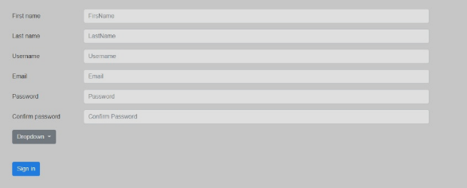

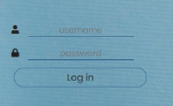

When the user clicks on sign in they’ll see this two input panels where they can enter their username and password.

When the user enters the web page they’ll be able to choose from one of these and it’ll send them to the desired destination. 

## 

## 

## Communication Interfaces

The communication between the different parts of the system is important since they depend on each other. However, in what way the communication is achieved is not important for the system and is therefore handled by the underlying operating systems and the web page.It supports all kind of web browsers.

## Hardware Interfaces

Since web portal doesn’t have any designated hardware, it does not have any direct hardware interfaces. The physical web page is managed by the web server and the hardware connection to the database server is managed by the underlying operating system on the web server.

## 