**Team: Let’s Get Wrecked!**

**Chicago Crash Data**

**Data source:** <https://catalog.data.gov/dataset/traffic-crashes-crashes>

**Goal:** To analyze the Chicago crash data for any trends that might help in the development of strategies to mitigate future crashes and injury.

***What factors impact crash type?***

*What crash types are most common?*

We first analyzed which types of crashes have occurred most frequently since 2015. Rear-end crashes and crashes into parked motor vehicles were the most prevalent, followed by sideswipes of cars going the same direction and crashes during turns.

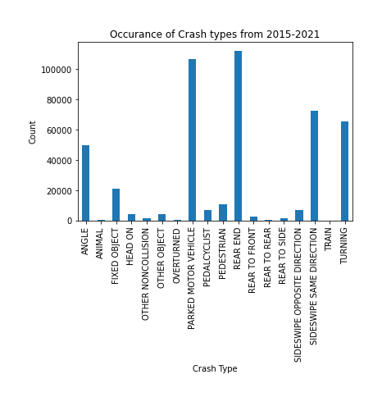

Having established what types of crashes are most prevalent, we next investigated what factors might lead to these crashes occurring.

*Does road lighting play a role in crashes?*

We first expected that many crashes were due to poor road lighting. We plotted the breakdown of lighting conditions for crashes within each crash type and found that most crashes occur during the day. The second highest lighting category is a night on lighted roads. It seems that poor lighting is probably not causing these crashes.

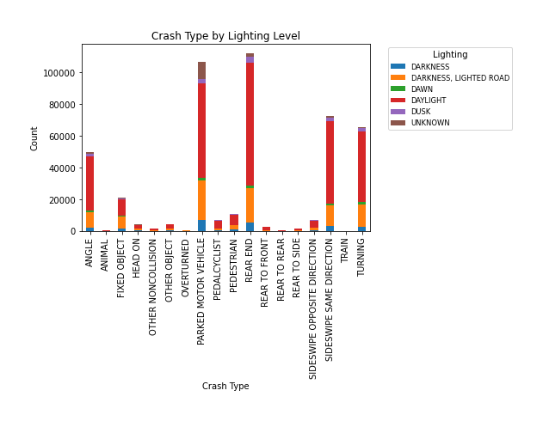

*At what time of day are most crashes occurring?*

Since we know that most crashes are occurring during the day, we next plotted the number of crashes that occur within each hour of the day (i.e., 4:30 pm would fall within the bar at 16). Crashes begin to rise in the morning, likely around morning rush hour. Crashes peak at 3-5pm before beginning to decline again.

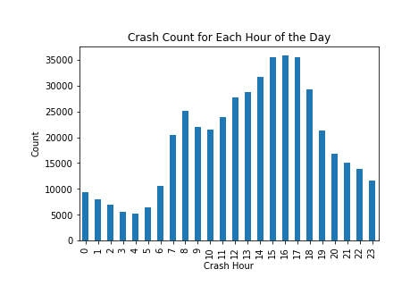

*At what time of year are most crashes occurring?*

In search of some adverse condition that could be influencing the number of crashes, we next looked at what time of year most crashes occur. Crashes seem to increase during the summer and peak in October, remaining high through the end of the year. We thought this might be related to the holidays.

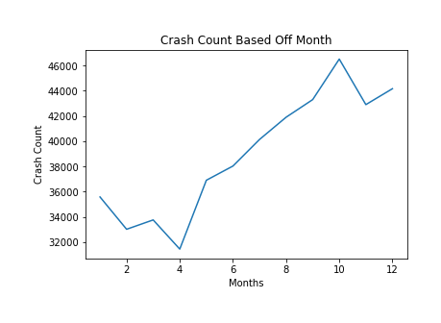

*Are more crashes occurring near holidays?*

We plotted the number of crashes on each day from October 1st through December 31st. While October 31st had the most crashes overall, many other days were near similar numbers, and the other holidays often had relatively low crash numbers. The other possibility is that re-introduction of cold, icy conditions is causing more crashes.

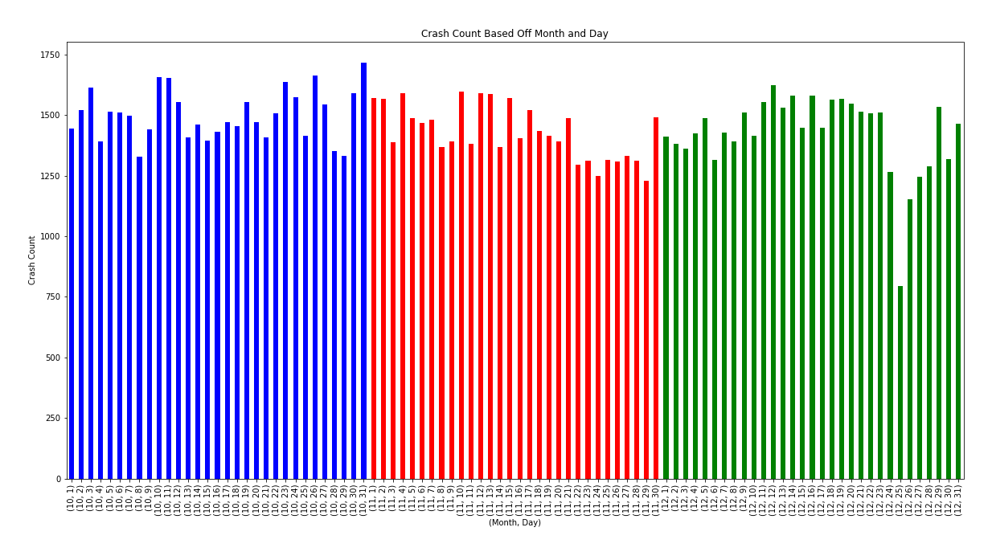

*Are adverse weather conditions associated with more crashes?*

We plotted the number of crashes associated with each type of weather condition and found that by far most crashes actually occur under clear skies. Poor weather conditions do not seem to be affecting the number of crashes. We also checked roadway conditions, since it was possible to have snow/ice overnight followed by clear skies. We found that most crashes occur on dry roads, suggesting that poor roadway conditions are not causing crashes. We next focused on narrowing down which roads have the most crashes.

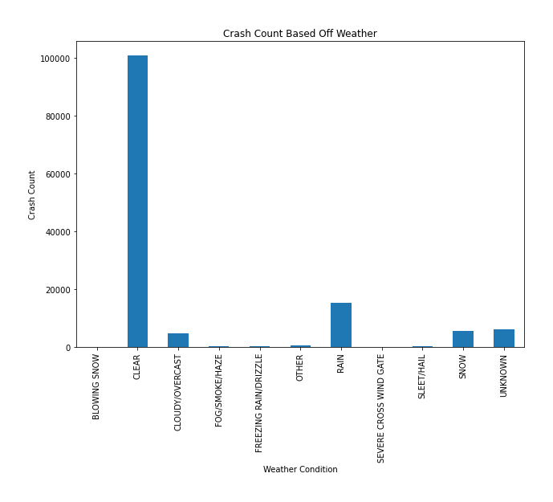 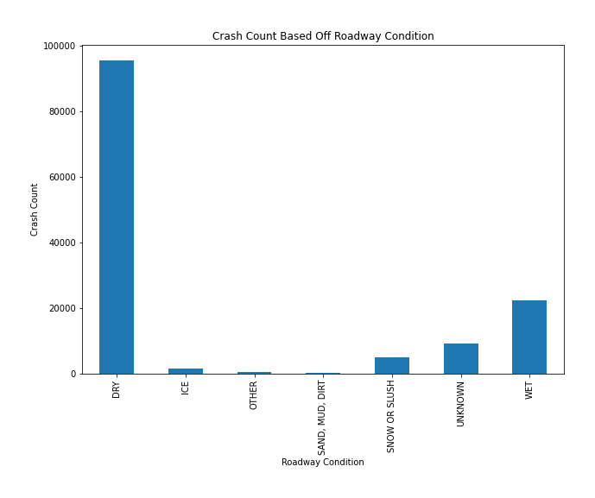

*What effect does driving direction have on the number of crashes?*

We plotted the number of crashes in each direction and found that most crashes occur while driving West, followed closely by South. We also looked at this driving direction effect at each hour of the day, which is displayed in a gif file in our repository’s “output_data” folder, and observed that West has the most crashes at nearly every hour. We expected West to dominate only in the evening before sunset.

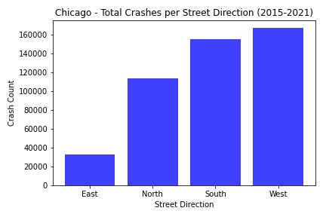

*What effect do roadways/intersections have on the types of crashes that occur?*

In multiple types of trafficways, crashes seem to be dominated by: crashes with parked motor vehicles, rear end crashes, sideswipes of cars driving the same directions, and crashes during turns. This was observed above looking at crashes in general. The graph also suggests that certain trafficway types are associated with more crashes than others. The most frequent crash types could occur anywhere, but the trafficway types can be pinpointed by location. We continued to analyze trafficway types and other factors for influence on injuries.

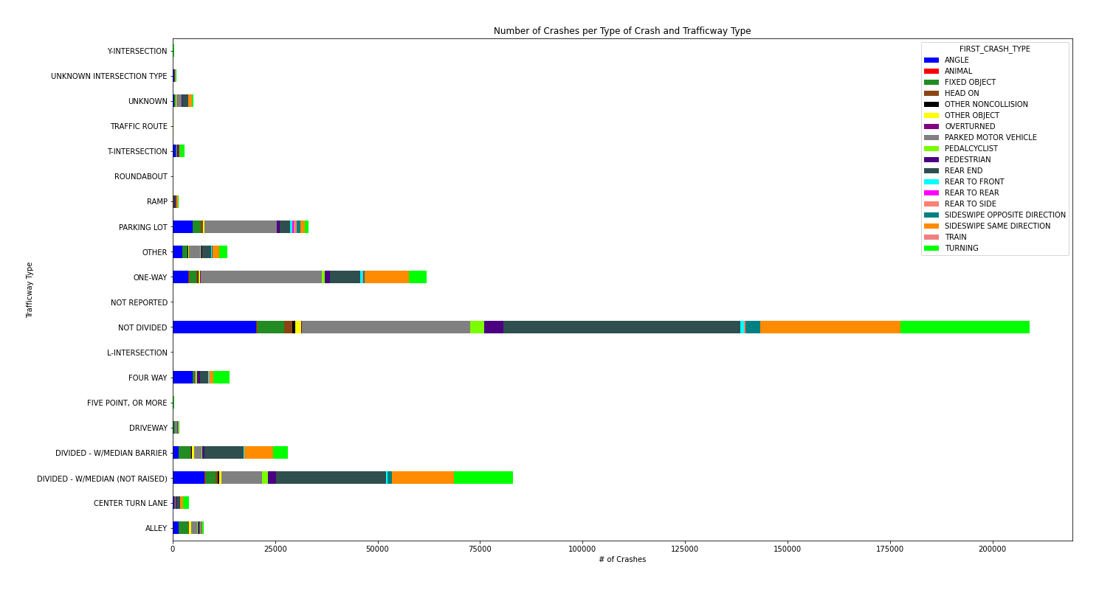

**(next page)**

***What factors impact the amount of injuries and fatalities?***

*Does trafficway type impact the number of crash-related injuries?*

Most injuries occur on roads that are not divided or divided with an unraised barrier. This would suggest that these trafficways are more dangerous. However, the previous graph also showed that these trafficways have the most crashes (regardless of whether injury is considered). We also looked at the percentage of crashes that lead to injury at each trafficway type. Crashes at intersections seem to have the greatest percentage involving injury, which might be expected as the impact on passengers is more direct and the forces are likely greater than if the cars are moving in the same direction.

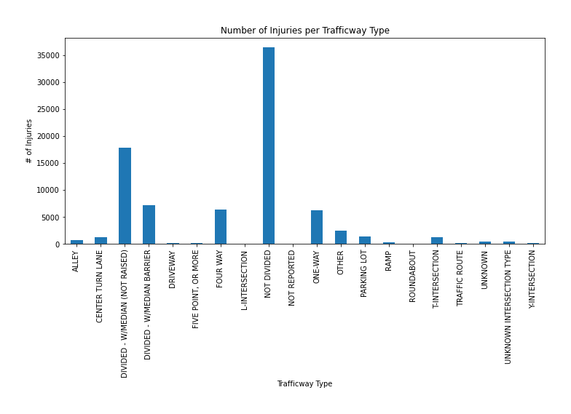

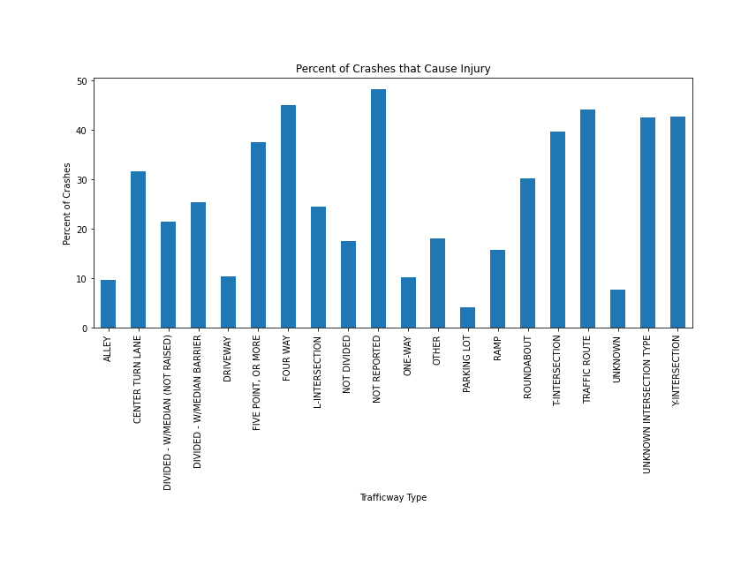

*Are certain trafficway types more associated with crash-related fatalities?*

Most fatalities occur on roads that are not divided or divides with an unraised barrier. This would suggest that these trafficways are more dangerous. However, the previous graph also showed that these trafficways have the most crashes (regardless of whether injury is considered). Injuries at intersections seem to have the greatest percentage involving fatality. One-way roads appeared as the third highest even though it had a relatively low percentage of crashes associated with injury. This would suggest that when a crash does occur on a one-way road, it tends to be fatal more often than other trafficway types. We next tried to narrow down the roads on which these fatal injuries were occurring.

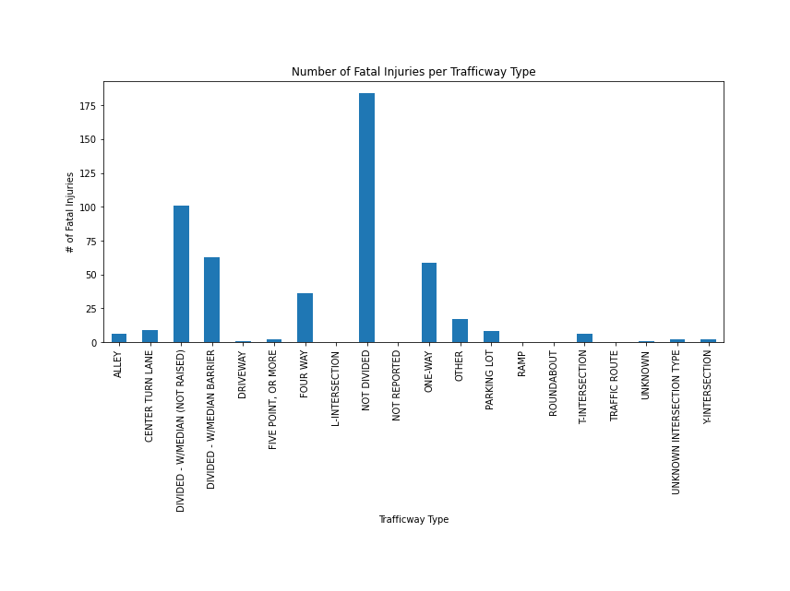

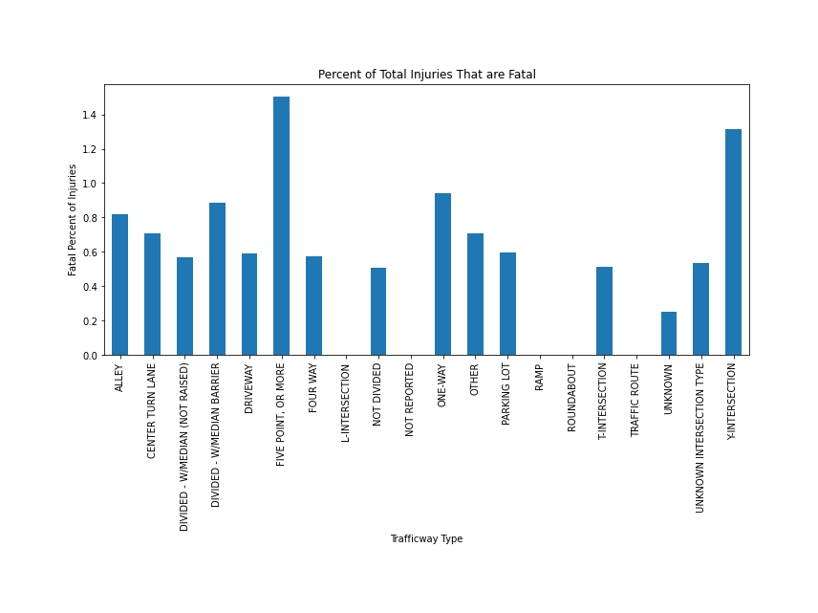

*What is the posted speed limit where most fatalities occur?*

We plotted the number of fatalities at each posted speed limit and found that the vast majority of fatalities occur on roadways where the posted speed limit is 30 mph. This would suggest surface, residential roads rather than high-speed highways are places to focus on in reducing crash-related fatalities. We next looked at whether the amount of damage to the car is a possible predictor of injury.

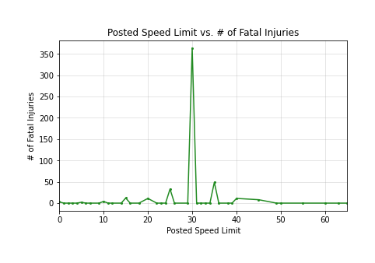

*Are crash-related injury/fatality more associated with higher levels of car damage?*

We plotted the percentage of injury-related crashes that are associated with the following levels of car damage (less that $500, $501-1500, over $1500). We found that 74.1% of crash-related injuries occur when of $1500 of car damage occur. A similar trend was seen when we plotted the number of fatalities associated with each level of car damage. The fact that the highest amount of car damage predominates suggests that excessive speed might be involved.

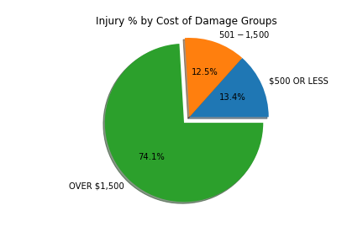 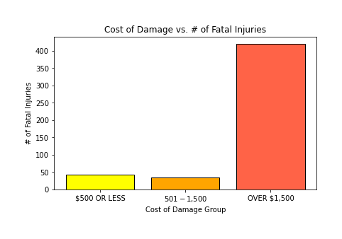

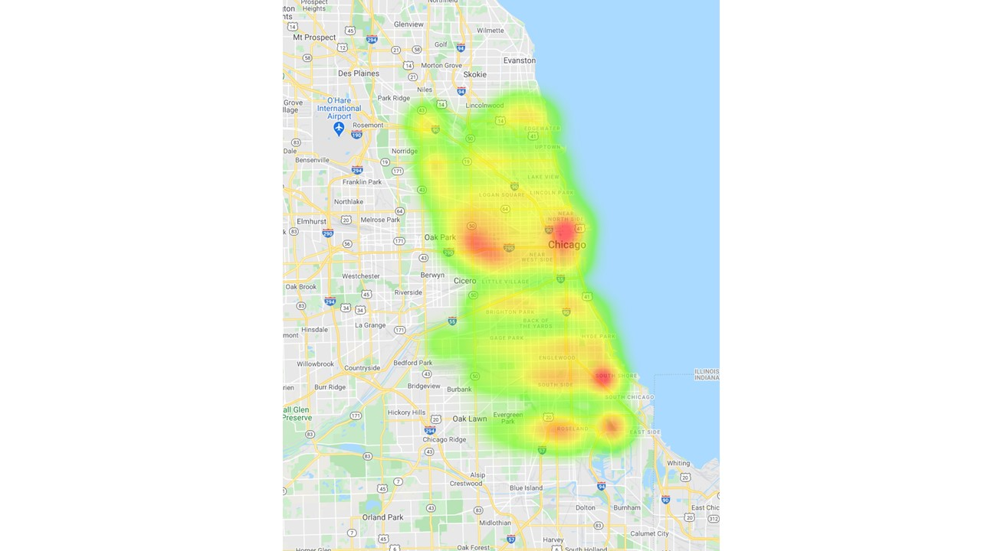***Can we narrow down which areas of the city have the most crashes?***

*Do certain parts of Chicago have more injury-related crashes?*

The heatmap shows that there do appear to be “hot-zones” for injury-related crashes in Chicago. This could be used to narrow the problematic trafficway types to just these sections of the city (or prioritize these areas of the city first).

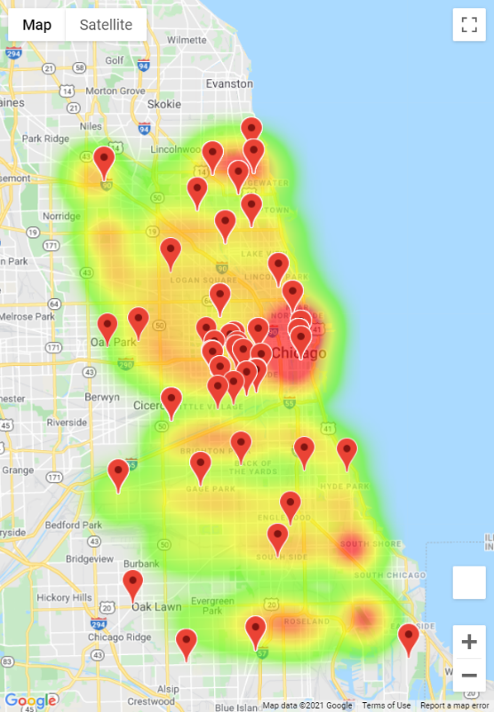

*Do more accidents occur close to local high schools?*

Many people begin to learn to drive in high school. We sought to examine a potential correlation between location of high schools and crash counts in Chicage. A heatmap of crash counts by location paired with the location of local high schools shows that although plenty of crashes occur near high schools, there are plenty of locations that experience a high frequency of accidents without a local high school nearby.

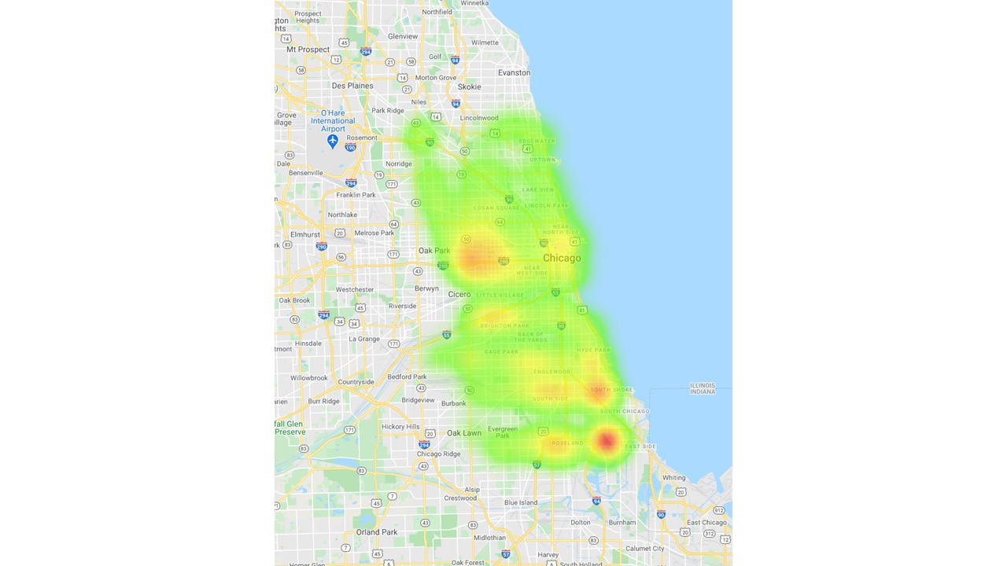*Do certain parts of Chicago have more fatality-related crashes?*

The heatmap shows that the same “hot-zones” appear for fatality-related crashes in Chicago, but one specific area stands out for fatalities. This could be the first area of the city on which to focus. We next asked what the association between trafficway type and fatality looks like specifically in that part of Chicago.

*What is the association between trafficway type and fatality in the part of Chicago with the highest percentage of crashes involving fatalities?*

Within this area of Chicago, it appears that non-divided roads are most associated with fatalities, well above other trafficway types. Non-divided roads within this area of Chicago would be a good first area of focus to try and reduce crashes and crash-related injuries/fatalities.

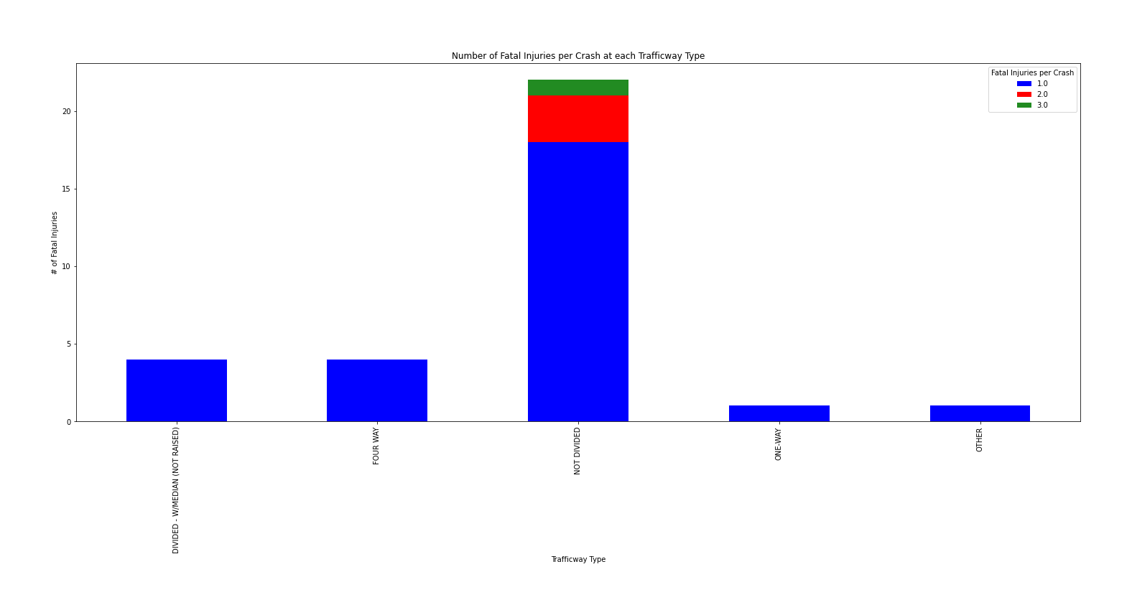

**(Conclusions on next page)**

In conclusion, it seems that a good place to start in tackling crash-related injuries/fatalities would be roads that are some combination of:

* West-directed
* Posted speed limit of 30 mph
* Not divided, divided by a non-raised median, or one-way
* Within the area near East Side that is the brightest hotspot on the fatalities heatmap

These efforts could also be focused:

* Between the months of October and December
* During the day
* Under clear skies