**Bankston section:**

*What effect do roadways/intersections have on the types of crashes that occur?*

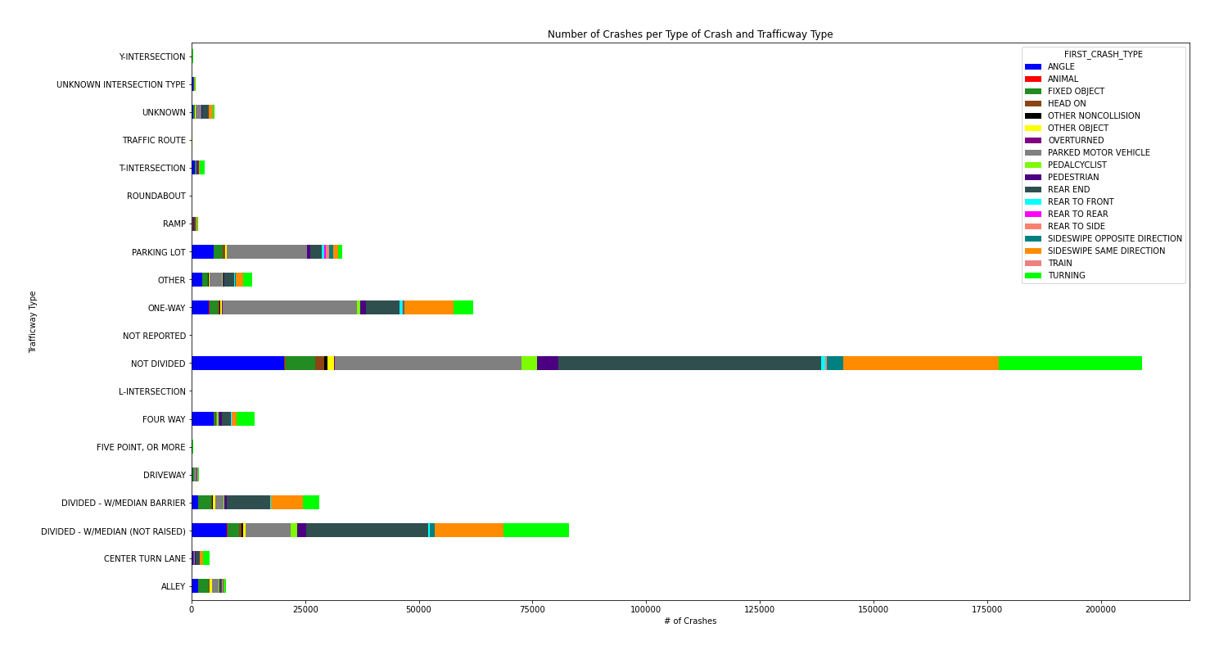

In multiple types of trafficways, crashes seem to be dominated by: crashes with parked motor vehicles, rear end crashes, sideswipes of cars driving the same directions, and crashes during turns. This would suggest that those types of crashes are the most commonly occurring in general. The graph also suggests that certain trafficway types are associated with more crashes than others. Since the more frequent crash types could occur anywhere, but the trafficway types can be pinpointed by location, we continued to analyze trafficway types for injuries.

**(next page)**

*Does trafficway type impact the number of crash-related injuries?*

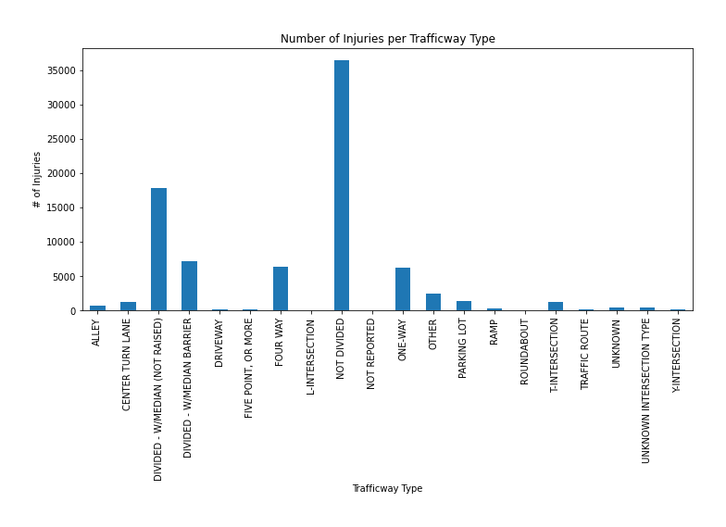

Most injuries occur on roads that are not divided or divides with an unraised barrier. This would suggest that these trafficways are more dangerous. However, the previous graph also showed that these trafficways have the most crashes (regardless of whether injury is considered). We next looked at the “severity” of these crashes.

**(next page)**

*What percentage of crashes lead to injury at the different trafficway types?*

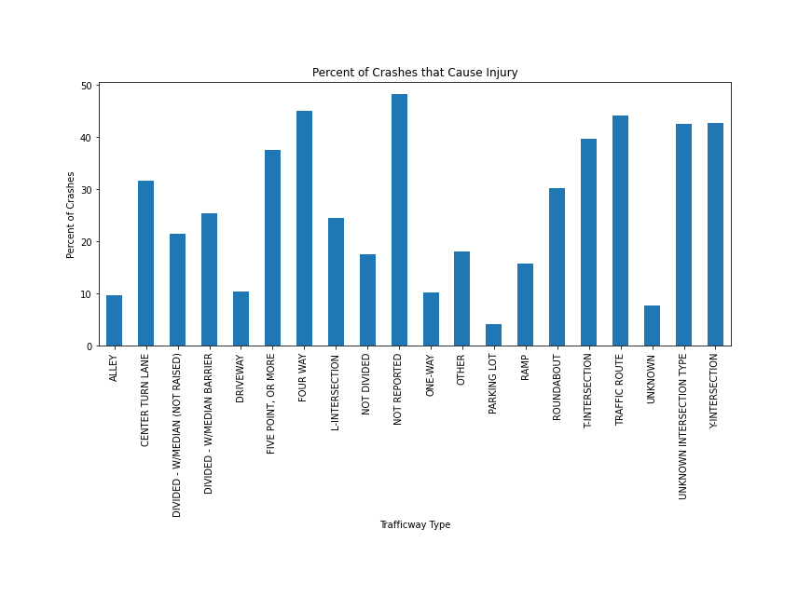

Crashes at intersections seem to have the greatest percentage involving injury, which might be expected as the impact on passengers is more direct and the forces are likely greater than if the cars are moving in the same direction.

**\*\*\*Note: We might also want to look at amount of damage per trafficway type as another measure of severity.**

**(next page)**

*Are certain trafficway types more associated with crash-related fatalities?*

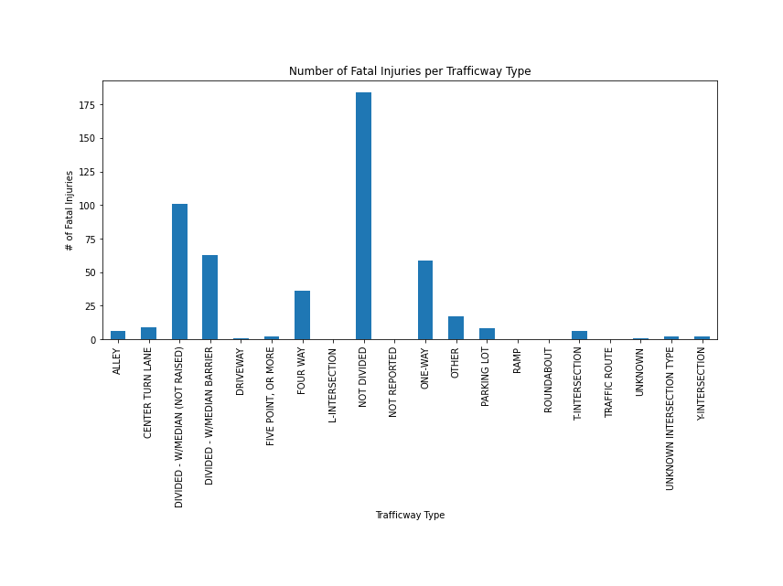

Most fatalities occur on roads that are not divided or divides with an unraised barrier. This would suggest that these trafficways are more dangerous. However, the previous graph also showed that these trafficways have the most crashes (regardless of whether injury is considered). We next looked at whether certain trafficways have a higher percentage of injuries which are fatal.

**(next page)**

*What percentage of injuries are fatal at the different trafficway types?*

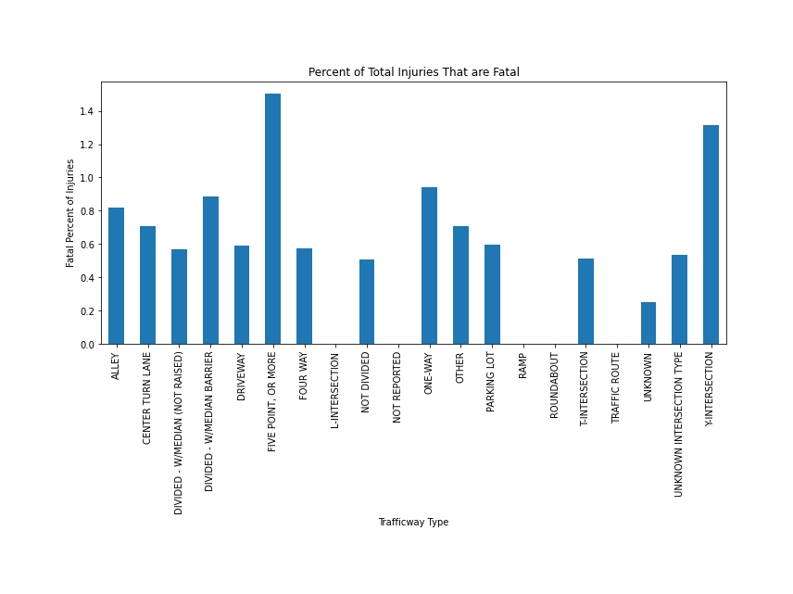

Injuries at intersections seem to have the greatest percentage involving fatality. One way roads appeared as the third highest even though it had a relatively low percentage of crashes associated with injury. This would suggest that when a crash does occur on a one-way road, it tends to be fatal more often than other trafficway types.

**(next page)**

*Do certain parts of Chicago have more injury-related crashes?*

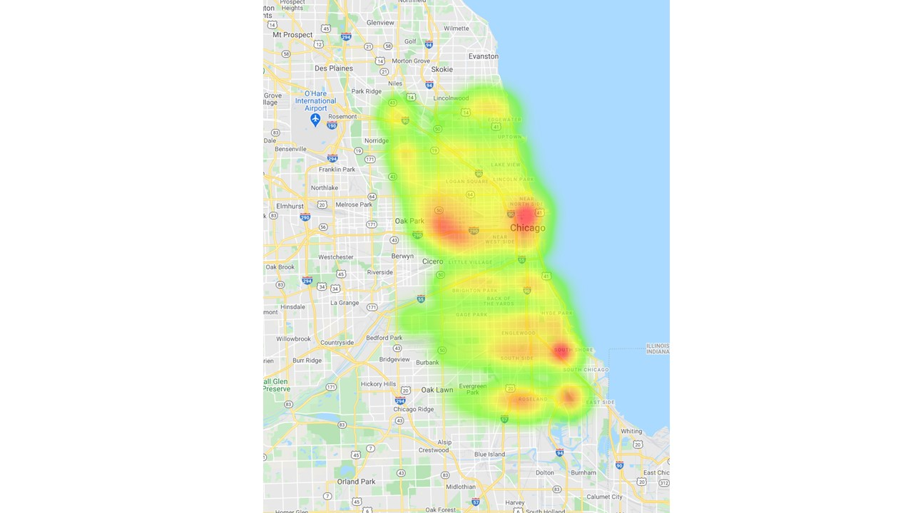

The heatmap shows that there do appear to be “hot-zones” for injury-related crashes in Chicago. This could be used to narrow the problematic trafficway types to just these sections of the city (or prioritize these areas of the city first).

**(next page)**

*Do certain parts of Chicago have more injury-related crashes?*

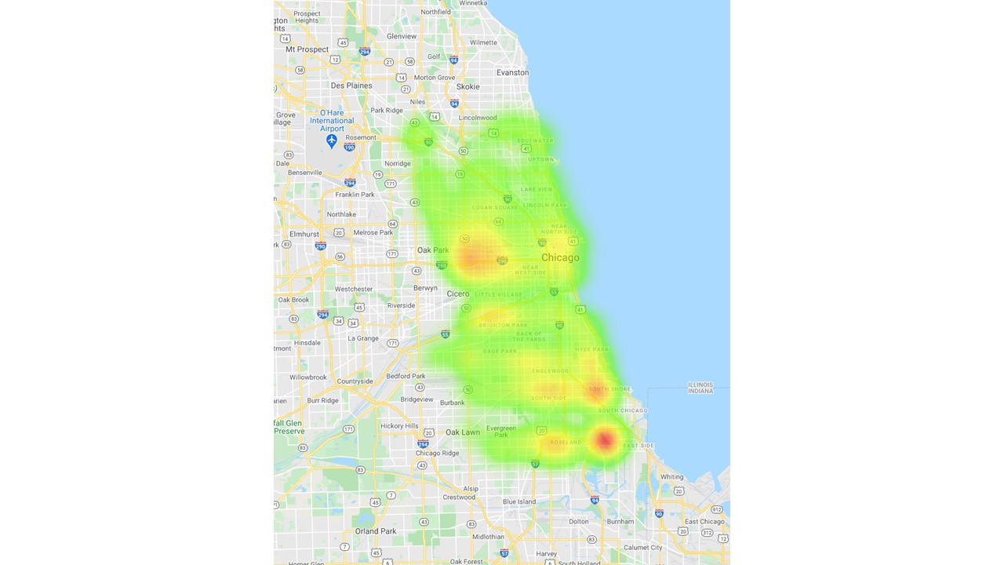

The heatmap shows that the same “hot-zones” appear for fatality-related crashes in Chicago, but one specific area stands out for fatalities. This could be the first area of the city on which to focus. We next asked what the association between trafficway type and fatality looks like specifically in that part of Chicago.

**(next page)**

*What is the association between trafficway type and fatality in the part of Chicago with the highest percentage of crashes involving fatalities?*

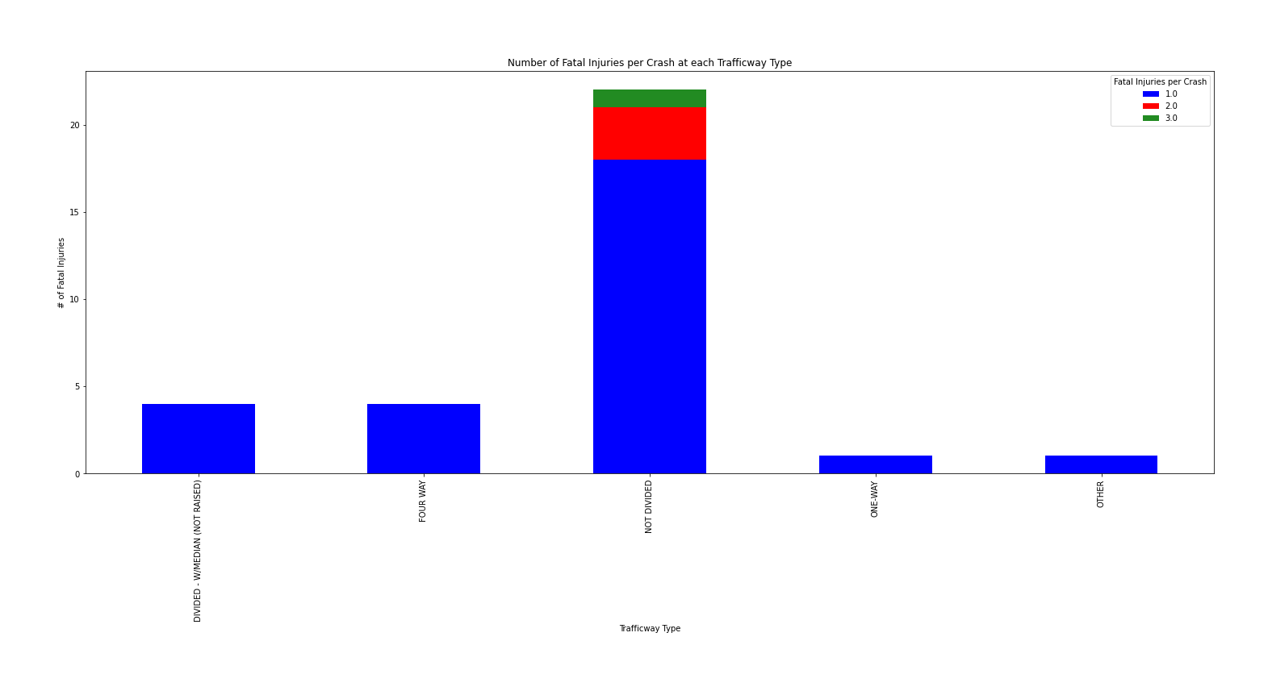

Within this area of Chicago, it appears that non-divided roads are most associated with fatalities, well above other trafficway types. Non-divided roads within this area of Chicago would be a good first area of focus to try and reduce crashes and crash-related injuries/fatalities.