**Lab2**

**Prepared by Andrew Auxier**

**Prepared for Professor Carl Eyler**

**SDEV 300 6383 Building Secure Python Applications (2235)**

**University of Maryland Global Campus**

**2023-06-01 (UTC+9)**

# Test Table

| **Test Case** | **Input** | **Expected**  **Output** | **Actual**  **Output** | **Pass**  **(yes/no)** |
| --- | --- | --- | --- | --- |
| **0** | !, fish, 0, 10, 1 | Reprompts the user for valid input | Reprompts the user for valid input | yes |
| **1** | No input | Scrolls through the list on timed release of entries | Scrolls through the list on timed release of entries | yes |
| **2** | !, fish, 1, florida, FLORIDA, fl, FL | Validates input so only state or 2 digit code is allowed then prints correct entry with picture | Validates input so only state or 2 digit code is allowed then prints correct entry with picture | yes |
| **3** | 3 | Shows top 5 states and graph | Shows top 5 states and graph | yes |
| **4** | 10000000000 | Enter chooses state and shows value, then enter changes state | Shows what is expected plus values for entry and total dictionary for verification | yes |
| **5** | 5 | Exits program | Exits program | yes |

| **Author’s Notes** | | | | |
| --- | --- | --- | --- | --- |
| **2** | Item 2 contains several screenshots showing passing with both state name values “florida” and “FLORIDA” and 2-digit name values “fl” and “FL”. | | | |
| **4** | Item 4 also has several screenshots showing debug values and normal user operations in that order | | | |

# Screenshots

## 0

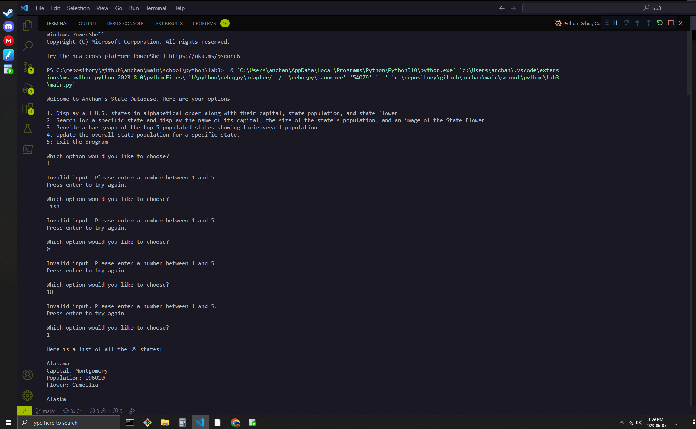

## 1

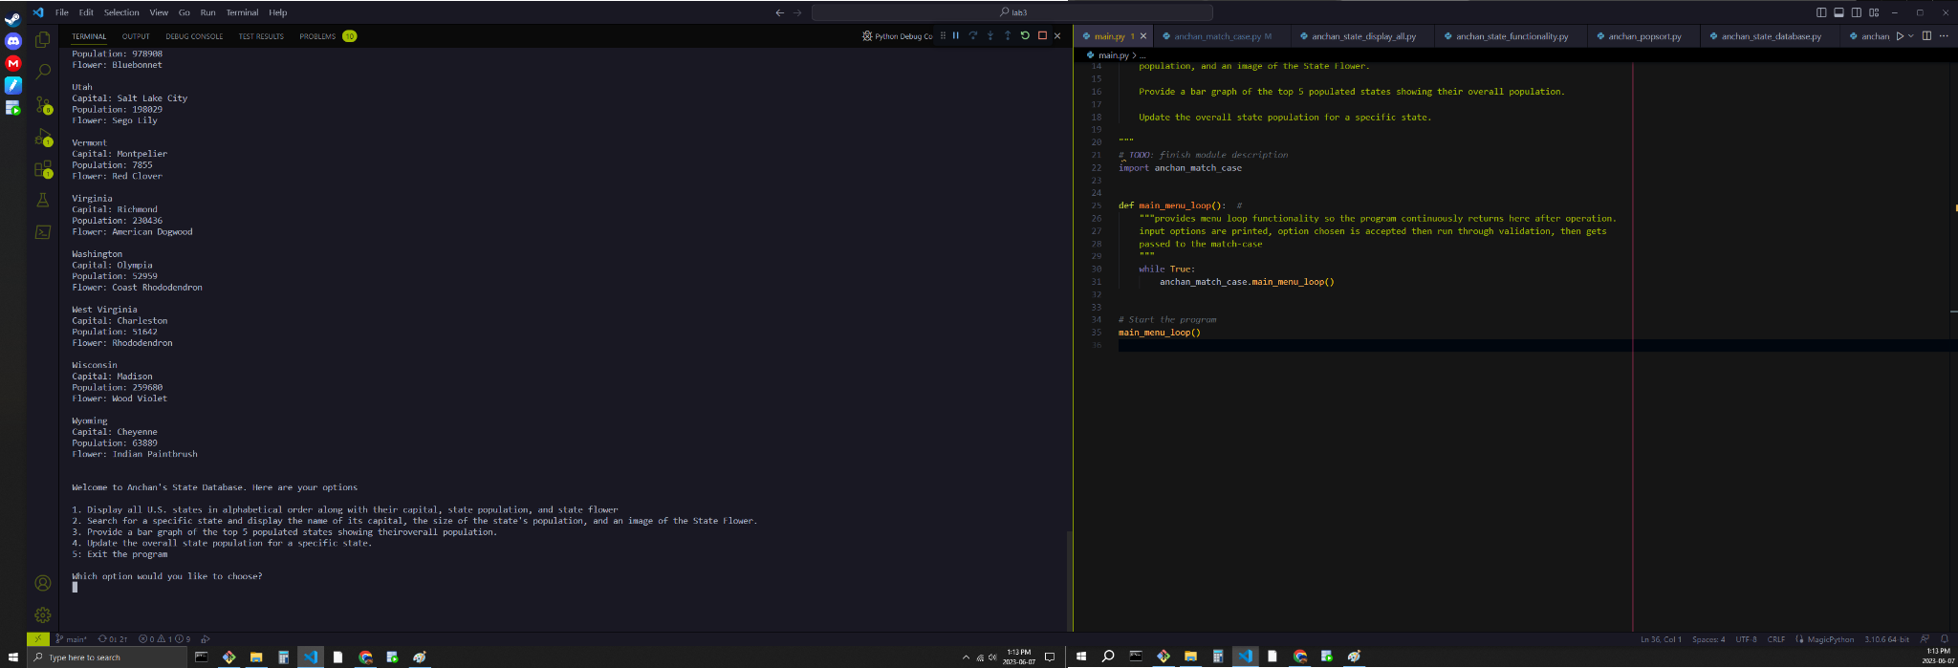

## 2

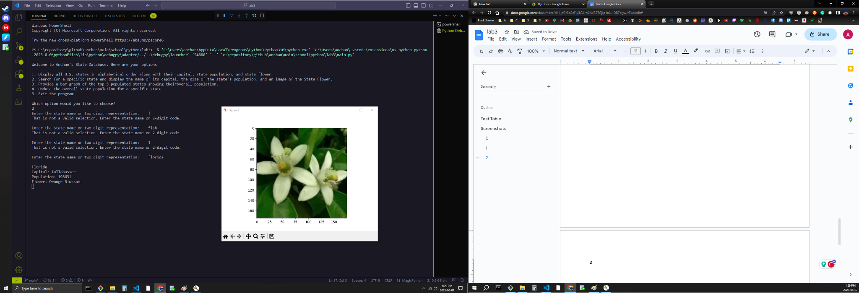

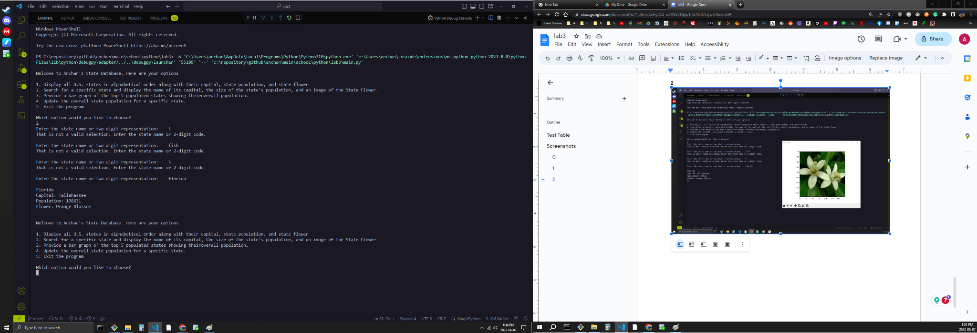

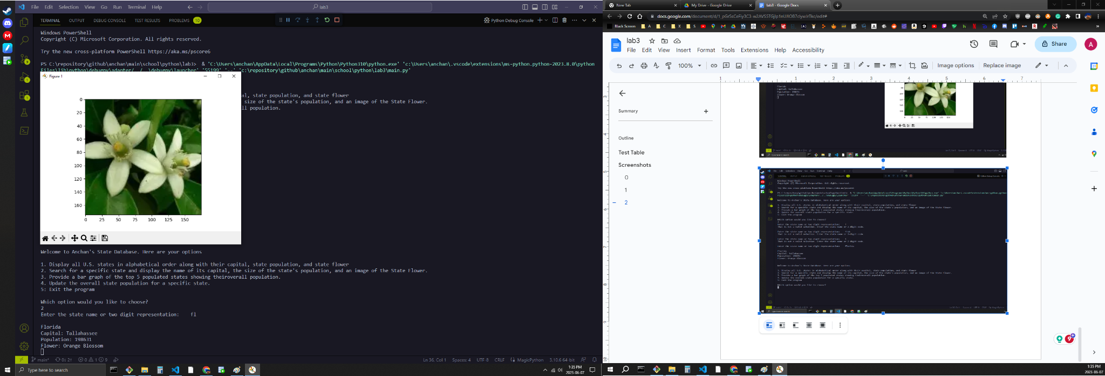

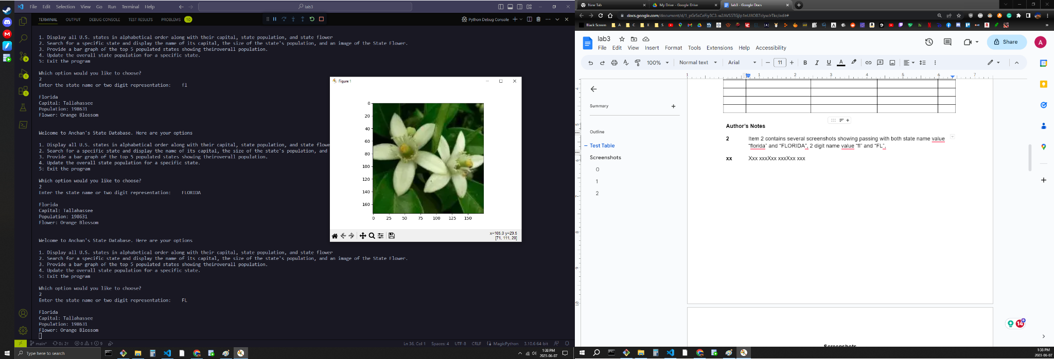

## 3

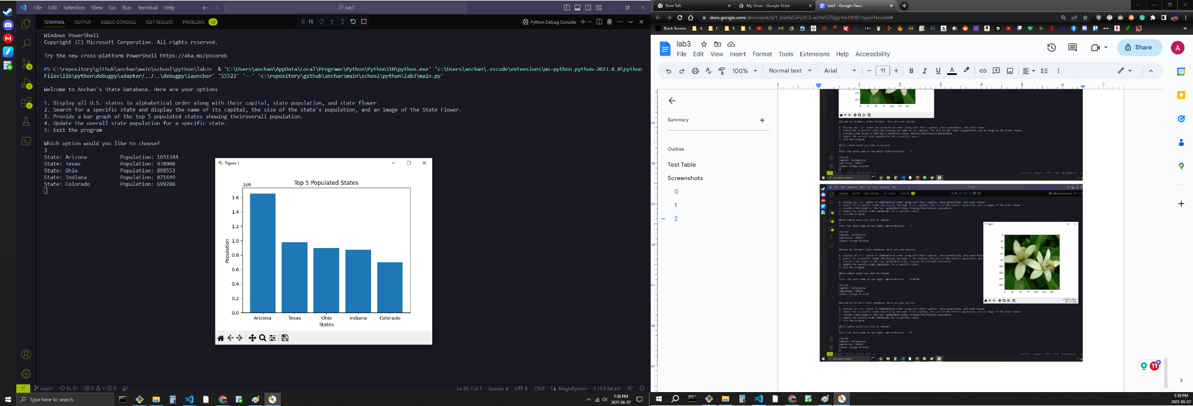

## 4

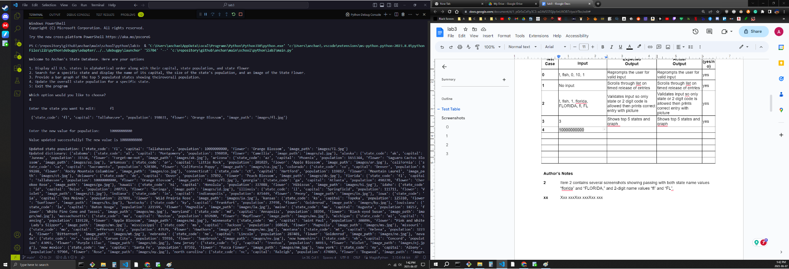

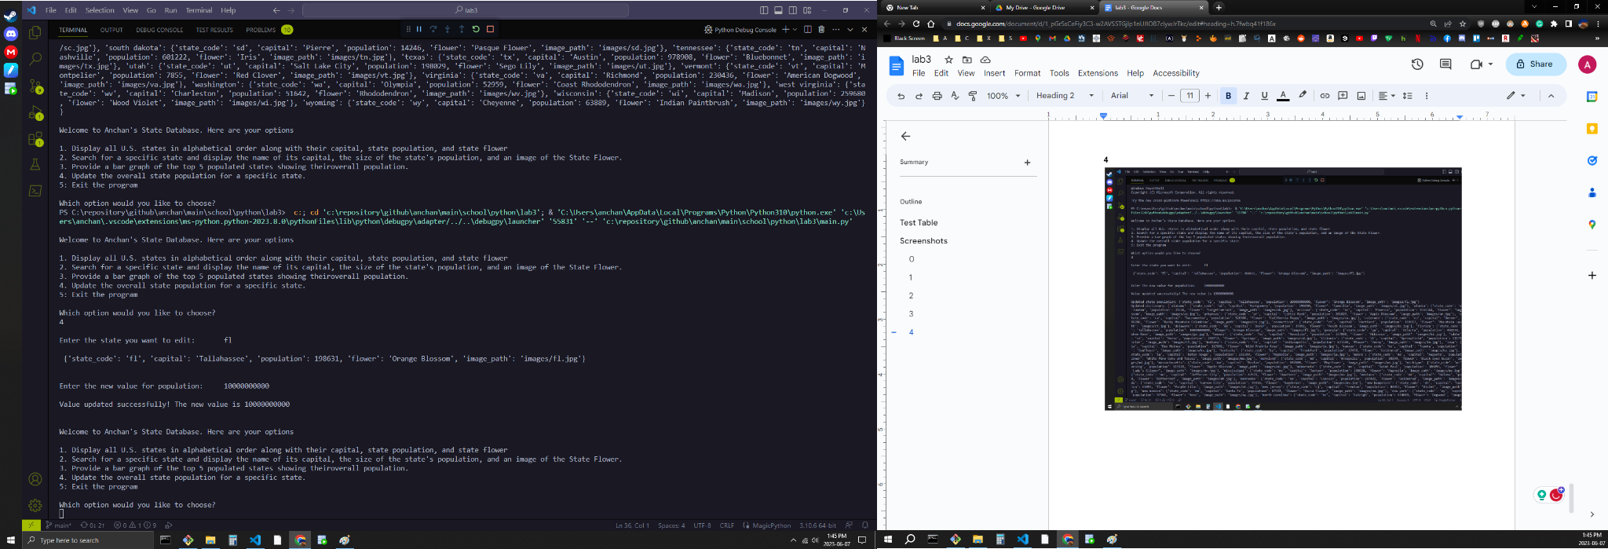

## 5

