37000259 report

Andy Baxter

25/03/2022

# HBSC report update for [37000259]

## Eating breakfast on weekdays

How often do you usually have breakfast (more than a glass of milk or fruit juice)?

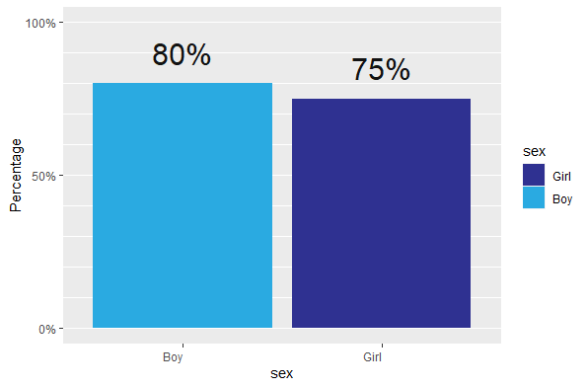

## Eat fruit every day

Percentage who eat fruit every day

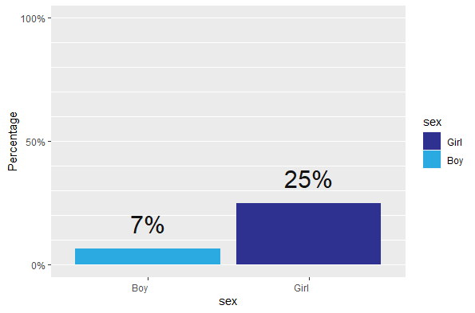

# Smoking in last 30 days

% who have smoked in last 30 days

