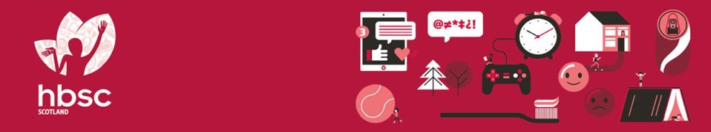

**HEALTH BEHAVIOUR IN SCHOOL-AGED CHILDREN STUDY**

**Scotland Pilot Study 2021**

**Health and Wellbeing survey results for**

**Contents**

**Introduction 2**

**Your school’s survey results**

1. **General health and sleep 4**
2. **Mental health and wellbeing 7**
3. **Eating habits 13**
4. **Physical activity and leisure activities 16**
5. **Experience of bullying 20**
6. **Substance use 23**
7. **Electronic media use 25**
8. **Impact of COVID-19 29**
9. **Social relationships and support 31**
10. **The school environment 35**

**Challenge Questions 38**

**References 39**

**Acknowledgements**

This survey was conducted as part of the Health Behaviour in School-aged Children (HBSC) Scotland study, led by the MRC/CSO Social and Public Health Sciences Unit, University of Glasgow in collaboration with the School of Medicine, University of St Andrews. The HBSC study is funded by Public Health Scotland. The HBSC Scotland research team includes Dr Jo Inchley, Dorothy Currie, Dr Judith Brown, Judith Mabelis and Dr Malachi Willis. We would like to thank all the pupils who took part in the survey, as well as the teachers for their support and assistance.

# **Introduction**

**The Health Behaviour in School-aged Children (HBSC) study**

HBSC is a World Health Organisation (WHO) cross-national study which aims to increase our understanding of young people’s health and wellbeing, health behaviours and the social context. HBSC monitors the health and health behaviour of young people over time and across countries as well as the wider context in which they live. This includes important aspects such as family and peer relationships, the school experience and the socio-economic environment in which they are growing up. This helps us to understand better what factors shape and influence health and health behaviours.

The first national HBSC study in Scotland was conducted in 1990 and it has been repeated every four years since then, providing a unique insight into how health and health behaviours have changed over the last 30+ years. HBSC involves 51 countries across Europe and North America and therefore allows us to see how young people in Scotland are doing compared with young people in other countries. The 2021/22 survey round has a special focus on mental health and wellbeing, and new questions to measure the impact of COVID-19 on children’s wellbeing.

**Pilot study**

As part of our preparations for the 2022 survey, we piloted the survey questionnaire in 3 schools in November and December 2021. This report presents the survey data from your school, on the following health topics:

1. General health and sleep
2. Mental health and wellbeing
3. Eating habits
4. Physical activity and leisure activities
5. Experience of bullying
6. Substance use
7. Electronic media use
8. Impact of COVID 19
9. Social relationships and support
10. The school environment

As well as the data, we have included notes and research evidence along with suggested resources to help promote pupil health and wellbeing. We hope you will find the report useful in reviewing the health and wellbeing of your pupils, and in identifying key targets for health improvement action planning in your school. The report is confidential, and only provided to the HBSC contact at your school. However, we would strongly encourage you to share the report more widely with your pupils, staff and parents.

**Understanding the data in this report**

* Generally, we provide results split by gender.
* Most data are presented as a cut-off, for example, two answers to a question are combined, such as feeling ‘often’ or ‘always’ confident.
* Some measures combine responses to a series of questions to create a mean score, for example, sleep quality, teacher support.
* Some of the same measures were also used in the 2018 HBSC Scotland survey. To see the 2018 Scotland HBSC national report: [Media_707475_smxx.pdf (gla.ac.uk)](https://www.gla.ac.uk/media/Media_707475_smxx.pdf)

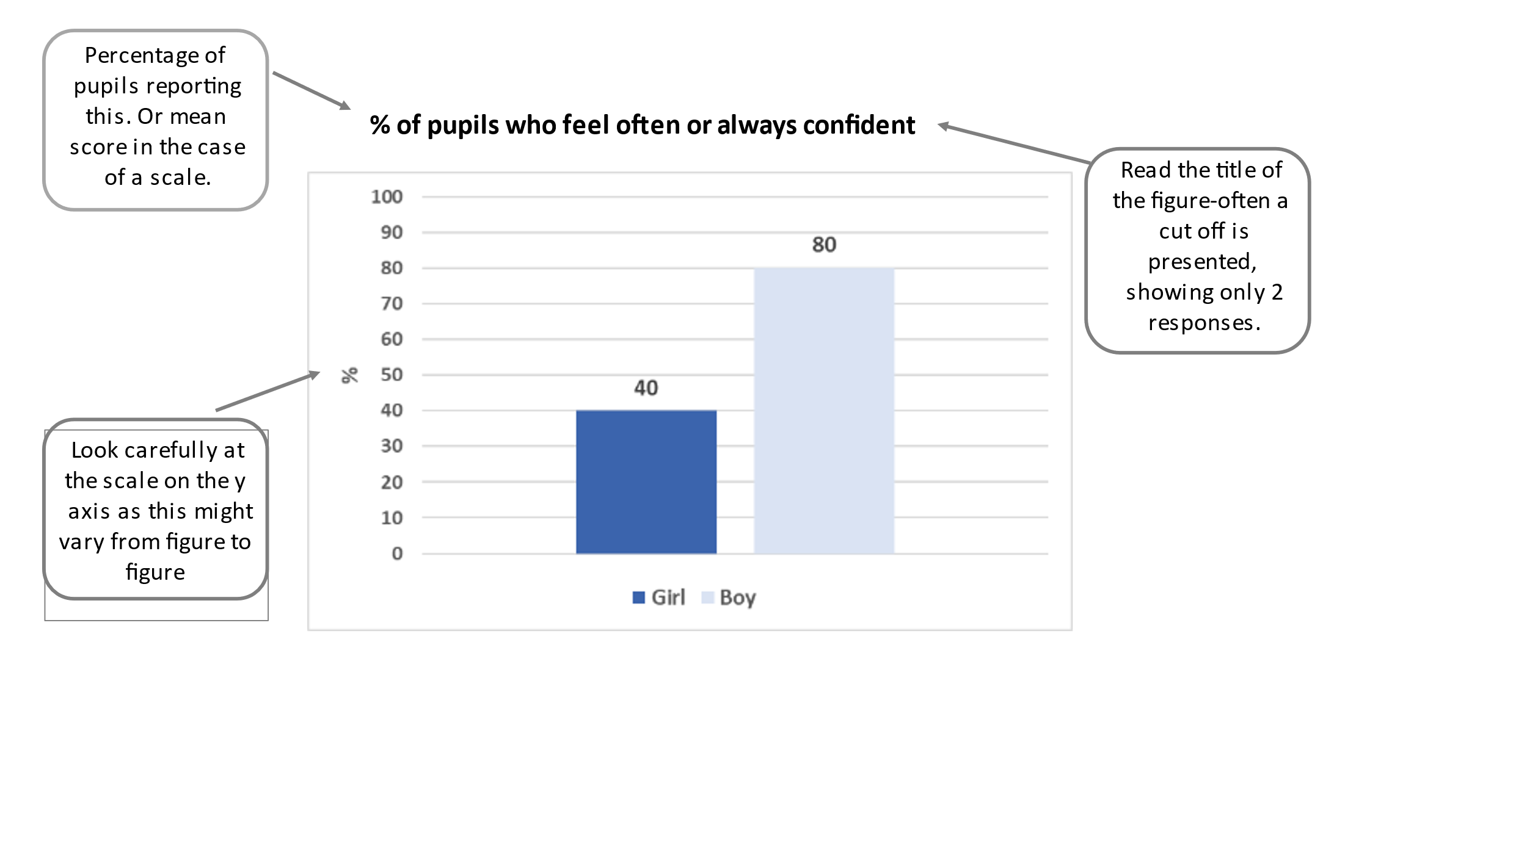**Your school’s participation in the survey**

Pupils in three P7 classes in your school took part in the survey during November and December 2021. The number of P7 pupils invited to take part and the number who participated is shown in Table 1. Table 2 shows the number of pupils participating by gender. Two pupils did not provide their gender.

**Table 1: Number of P7 pupils invited to take part**

|  |  |
| --- | --- |
| **Total invited** | **Number participating** |
| 67 | 62 |

**Table 2: Overview of P7 survey respondents**

|  |  |
| --- | --- |
| **Girls** | **Boys** |
| 30 | 30 |

# **General Health and Sleep Quality**

This chapter reports data on general health and sleep. It includes the following measures:

* Self-reported health
* Health complaints
* Three dimensions of sleep quality (i) bedtime behaviours (ii) sleep efficiency (iii) better morning wakefulness

General health is closely related to mental health, with stress and poor mental wellbeing sometimes causing physical symptoms. The HBSC measure of self-reported health captures a global view of health. This is close to the World Health Organisation definition of health as a resource for living which goes beyond simply the absence of disease or the presence of wellbeing.1

Adolescents with poor self-rated health have been found to have more health complaints, lower life satisfaction, take part in less physical activity and find it harder to make friends.2 Subjective health is also related to wider aspects of young people’s lives. For example, research in Norway found a close relationship between school-related stress and levels of support at school with headache, backache, abdominal pain and dizziness. 3

Sleep is a key contributor to adolescent wellbeing.4 Recent research has found that longer sleep duration is associated with better emotional regulation and a healthier body composition in children aged 0-17.5-7 In school-aged children, higher levels of sleep, in combination with high levels of physical activity, are associated with better cardiometabolic health.6 Longer sleep duration is also associated with better academic attainment and overall wellbeing.7

The quality of sleep is just as important as amount of sleep for improving wellbeing, since even managing to get the recommended hours of sleep each night will not refresh a child if the quality of the sleep is poor.8,9 The Scottish #Sleepyteens project found that sleep quality is poorer for those adolescents who use social media very intensively at night-time.10 Experts recommend that use of screens should be avoided in the hour before planned bedtime to avoid disruption to sleep. The Royal College of Paediatrics and Child Health have produced guides for parents to help them to negotiate the right amount of screen time for their children.11

**Self-reported health**

Pupils were asked to rate their own health. Figure 1 shows the proportion of pupils reporting their health to be either ‘excellent’ or ‘good’.

**Figure 1: % pupils who report good or excellent health**

**Multiple Health Complaints**

Pupils were asked ‘In the last 6 months how often have you had the following…?’ and presented with a list of eight physical and psychological symptoms: headache, stomach-ache, backache, dizziness, feeling low, feeling nervous, feeling irritable and sleep difficulties. We looked at the proportion of young people who experience this symptom, once a week or more. The three most common health complaints reported by pupils were:

* Sleep difficulties: 29% (29% girls, 30% boys,)
* Feeling nervous: 28% (43% girls, 11% boys)
* Feeling irritable: 18% (21% girls) (17% boys)

Figure 2 shows the percentage of pupils who report two or more symptoms, once a week or more.

**Figure 2: % pupils who report two or more health complaints once a week or more**

**Sleep quality**

Pupils were asked ten questions about sleep quality, covering three different aspects: (i) bedtime behaviours, (ii) sleep efficiency and (iii) morning wakefulness. For each aspect of sleep, scores range from 1 to 6. A higher score indicates better sleep quality in that aspect.

**Figure 3: Pupils’ mean sleep quality scores**

**Who can help?**

|  |  |
| --- | --- |
| **Organisation** | **Description** |
| Sleep Scotland  https://www.sleepscotland.org/  Sleep Support Line: 0800 138 6565 | Sleep Scotland aims to provide the most appropriate intervention for families of children with sleep problems. They offer a range of resources including, a Sleep Support Line and a Sound Sleep programme-training day and teaching resource for professionals in schools. |

1. **Mental Health and Wellbeing**

This chapter presents data on mental health and wellbeing, and includes the following measures:

* Life satisfaction
* Feeling left out
* Feeling confident
* Happiness with life
* Loneliness
* WHO 5 Wellbeing Index -Low mood
* Perception of bodyweight

Mental wellbeing is one of the Scottish Government’s six public health priorities and is defined as: “…feeling good and functioning effectively, maintaining positive relationships and living a life that has a sense of purpose”.12 Mental health and wellbeing is therefore more than the absence of mental illness but also about emotional wellbeing and functioning well in everyday life. It incorporates many components – both positive and negative - such as stress, anxiety, self-confidence, self-esteem, social isolation, body image, life satisfaction and happiness. Together these factors can have an effect on academic and social development 13, leading to longer-term impacts on health, employment and social outcomes in adult life. 14-16

In recent years levels of mental wellbeing among young people have been declining in Scotland17 and there is international evidence to suggest that emotional disorders are increasing, particularly amongst adolescent girls. 18,19

An individual’s mental health and wellbeing is influenced by a wide variety of factors including environmental, social and individual factors and the interaction between these. 20 Contextual factors may influence or be a consequence of mental health and also serve as a risk or protective factor. They operate at different levels: individual, family, learning environment, community and structural.21 Deprivation is a key risk factor for mental health; a systematic review showed that children and adolescents from socio-economically deprived backgrounds were two to three times more likely to develop mental health problems.22

In terms of promoting wellbeing, positive relationships with family, friends and school staff are consistently linked with health and wellbeing during adolescence.23 The school environment also plays a key role, with perceived academic ability, teacher support and school satisfaction linked to levels of life satisfaction and happiness.24,25 Research has also found that sleep and eating behaviours have stronger associations with adolescent wellbeing than bullying, physical activity and screen time.26

**Life satisfaction**   
Pupils were asked about their life satisfaction, using the ‘Cantril Ladder’. This shows a ladder with rungs numbered from 0 (‘worst possible life’) to 10 (‘best possible life’). Pupils were asked to mark where on the ladder they feel they stand at the moment. Here we show the proportion of pupils who report high life satisfaction (gave a rating of 6 or more out of 10).

**Figure 4: % pupils who report high life satisfaction (6 or more out of 10)**

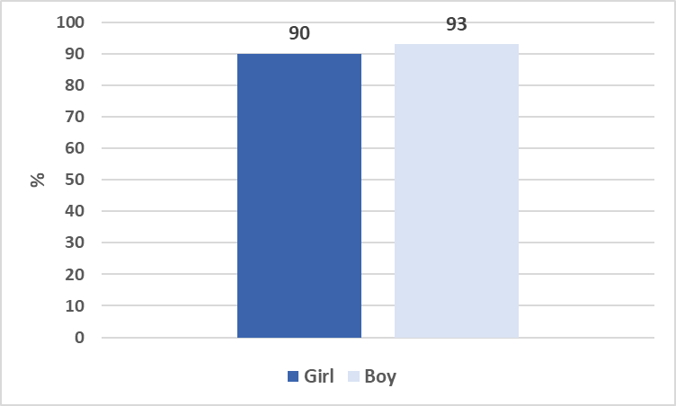

**Feeling left out**

Pupils were asked “how often do you feel left out of things?”. This figure shows the percentage of young people who say they ‘often’ or ‘always’ feel left out.

**Figure 5: % pupils who feel often or always feel left out**

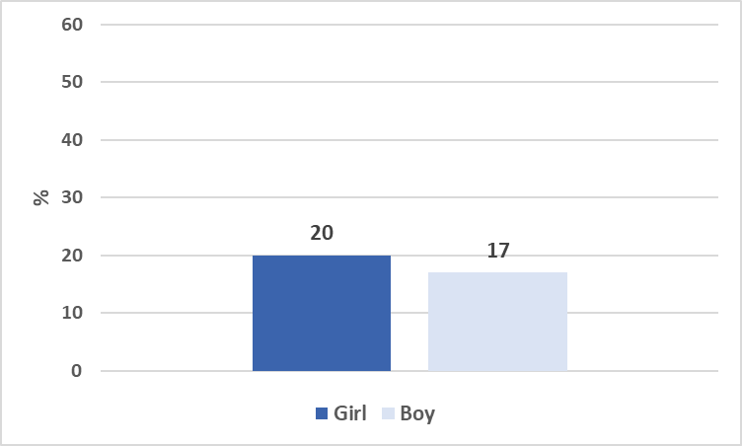

**Confidence**

Pupils were asked ‘how often do you feel confident in yourself?’. Here we show the proportion of pupils who responded that they ‘often’ or ‘always’ feel confident.

**Figure 6: % pupils who feel often or always confident**

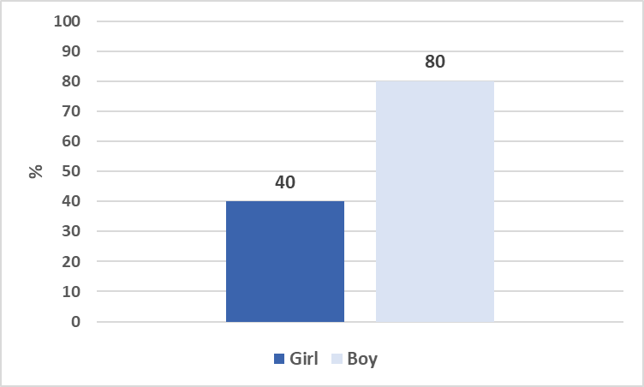

**Happiness**

To gauge levels of happiness, pupils were asked “In general, how do you feel about your life at present?” Here we show those pupils that feel ‘very’ happy with their life.

**Figure 7: % pupils who feel very happy with life**

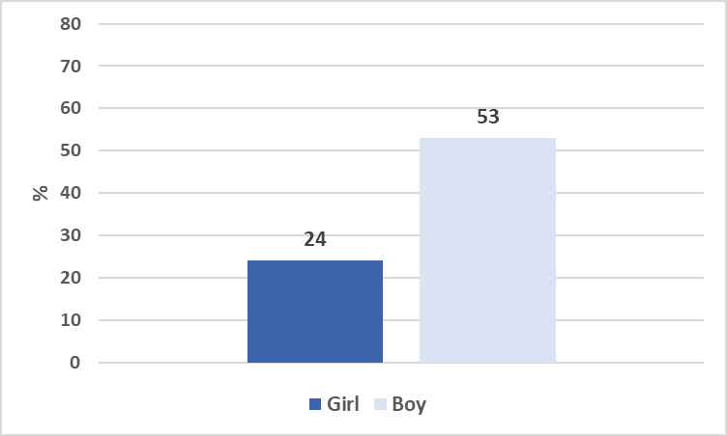

**Loneliness**

Pupils were asked how often they had felt lonely in the past 12 months. Here we show the percentage of pupils who report rarely or never feeling lonely.

**Figure 8: % pupils who report rarely or never feeling lonely**

**WHO 5 Wellbeing Index**

The WHO–5 Wellbeing Index is a five-item scale which provides a measure of emotional functioning. Items are summed to create a score ranging from 0 to 100. A score of 50 or less indicates low mood.

**Figure 9: % pupils with low mood (WHO 5 Index)**

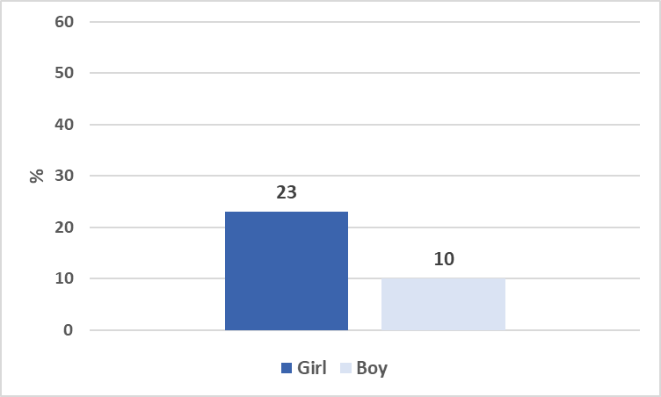

**Perception of bodyweight**

Pupils were asked whether they thought they were underweight, overweight or neither under- nor overweight. This figure shows the proportion of young people who felt they were about the right weight, that is neither over- nor underweight.

**Figure 10: % pupils who think they are neither over- nor underweight**

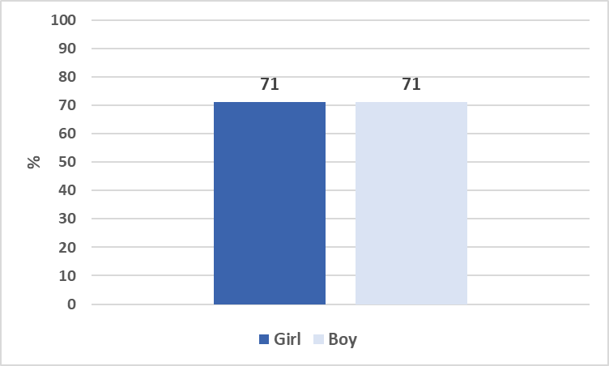

**Who can help?**

|  |  |
| --- | --- |
| **Organisation** | **Description** |
| MIND for better mental health  https://www.mind.org.uk/  information-support/for-childrenand-  young-people/ | MIND provides advice and support to empower anyone experiencing a mental health problem. They have information dedicated to  supporting children and young people. |
| Anna Freud National Centre for  Children and Families  https://www.annafreud.org/on-mymind/ | These resources, co-produced with young people, aim to provide information to young people on mental health and wellbeing to help  make informed choices about their health. |
| Mental Health Foundation  https://mentalhealthfoundation.org/ | The Mental Health Foundation’s mission is to raise awareness of mental health through education, community and support and thereby reduce the stigma associated with mental health. The website provides information on different mental health conditions. |
| Barnado’s Scotland  https://www.barnardos.org.uk/whatwe-  do/supporting-young-people | Barnado’s Scotland has put together a film for everyone involved in educating children and young people, highlighting the importance of  relationships in the school setting. It provides practical examples and tips that education staff can build into their everyday practice to  support positive relationships with young people. |
| **Organisation** | **Description** |
| See Me Scotland  https://www.seemescotland.org/ | See Me is passionate about ending mental health stigma and discrimination. The organisation works with individuals, groups, communities, workplaces, and education. |
| Samaritans Scotland  https://www.samaritans.org/scotland  /how-we-can-help/schools/ | Samaritans supports schools, college communities and other youth  settings through our postvention services, lesson plans and school talks. |
| Breathing Space  https://www.breathingspace.scot/  Call: 0800 838587 | Provides a free national phoneline service to address serious concerns about the mental wellbeing of people in Scotland. |
| Moodcafé  http://www.moodcafe.co.uk/ | Resources for a range of mental health issues and learning disabilities developed for young people, adults and families by NHS Fife. |
| Young Minds  https://youngminds.org.uk/ | Resources and information for young people experiencing Mental Health difficulties |

1. **Eating habits**

This chapter presents data about eating habits. It includes the following measures:

* Eating habits
* Breakfast
* Family meals

Unhealthy eating has been found to be one of the biggest contributors to poor adolescent wellbeing.26 Healthy dietary behaviours can prevent obesity, eating disorders and tooth decay, and may help prevent coronary heart disease, cancer and stroke in adulthood.27,28 Skipping breakfast is common among young people, especially older adolescents and girls, and is linked with health-compromising behaviours.29 Research shows that regularly eating breakfast is linked to better quality of diet in school-aged children30-32 and is linked to lower BMI and bodyweight.30,32,33 Family meals promote positive family interactions.34 Regular family meals are associated with healthier diets in children and adolescents, may reduce the risk of obesity,35,36and are also linked to better mental health, lower levels of depression, stress, suicidal thoughts, and risk behaviours.37-39

**Eating habits**

Pupils were asked how many days a week they consumed various types of food and drink. Figure 11 shows the percentage of boys and girls who consumed each type of food or drink at least once a day.

**Figure 11: % pupils who consume food/drink daily**

**Breakfast**

Pupils were asked how often they usually have breakfast on weekdays (“more than a glass of milk or fruit juice”). Here we show the percentage of pupils who report eating breakfast every weekday.

**Figure 12: % pupils who eat breakfast every weekday**

**Family meals**

Pupils were asked “how often do you and your family usually have meals together?”. Here we show the percentage who responded that they have a family meal most days or every day.

**Figure 13: % pupils who eat a meal with family most days or everyday**

**Who can help?**

|  |  |
| --- | --- |
| **Organisation** | **Description** |
| Beat (eating disorders)  <https://www.beateatingdisorders.org.uk/> | Beat help people with eating disorders and provide support for those with emotional overeating and difficulties with food, weight and shape. They provide support services such as helplines, website, self help and support groups and online support. |
| Resources for Schools from the British Nutrition Foundation  <http://www.foodafactoflife.org.uk/> | Food - a fact of life provides a wealth of free resources about healthy eating, cooking, food and farming for children and young people aged 3 to 18 years. The resources are progressive to support the curriculum throughout the UK. All resources are designed to ensure that consistent and up-to-date messages are delivered. |
| Eco Schools Scotland – Food and the Environment Topic  <https://www.keepscotlandbeautiful.org/education-and-learning/food-and-the-environment/> | Resources, information and projects that can be implemented in schools to help school-aged children learn about the production of food, making healthy choices and considering the impact of food production on the environment |

1. **Physical activity and leisure time**

This chapter presents data about physical activity and leisure time activities. The chapter includes the following measures:

* Moderate-to-vigorous physical activity
* Vigorous exercise in leisure time
* Participation in organised leisure activities
* Feeling safe in neighbourhood

The World Health Organisation recommends that children should participate in at least 60 minutes of moderate-to-vigorous activity every day.40 The WHO guidelines also state that vigorous intensity physical activities, including those to strengthen muscle and bone, should be included on at least 3 days per week.1 As well as protecting from physical health conditions, physical activity also contributes to higher life satisfaction and improved mental wellbeing.41-44 Organised leisure-time activities are linked to healthy youth development 45 and are an important aspect in the positive social and psychological development of young people.46 Links have been found between participation in organised activities and higher school wellbeing and better school performance. 47 In addition, a recent international study demonstrated that involvement in organised activities was associated with improved subjective wellbeing regardless of age, gender and other socio-economic factors.48

**Physical activity**

Pupils were asked two questions about the amount of physical activity they usually engage in each week. The first asked, in the previous 7 days, how many days did they spend 60 minutes or more in physical activity which increased their heart rate and made them out of breath some of the time. We present here the percentage of pupils who participated in moderate-to-vigorous activity for at least 60 minutes every day.

**Figure 14: % pupils who do 60 minutes of physical activity every day**

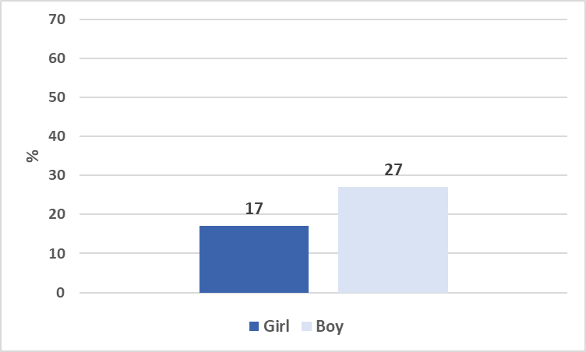

**Leisure time physical activity**Pupils were also asked about how often they take part in vigorous exercise in their free time. Vigorous exercise is defined as any activity which makes you get out of breath and sweat. This figure shows the percentage of pupils who reported doing vigorous exercise at least 4 times a week in their leisure time.

**Figure 15: % pupils who do vigorous exercise at least 4 times per week in their leisure time**

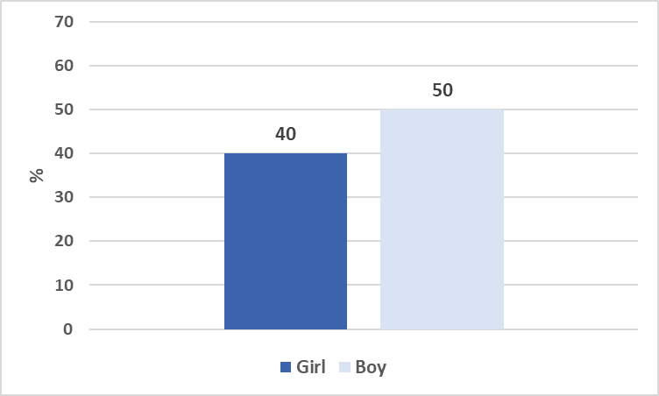

**Participation in organised leisure activities**

Pupils were asked how often they took part in different types of organised leisure activities such as team sports (e.g. football, netball), organised individual sports (e.g. tennis, gymnastics, swimming), artistic activities (e.g. art and music school, playing a musical instrument), children’s and youth organisations (e.g. Scouts or Guides), club in a leisure centre or at school (e.g. board games, model-making, language or debating club), or religious activities (e.g. going to church, mosque, synagogue).

Figure 16 shows the percentage of young people who take part in at least one organised activity every week.

Figure 17 shows the types of activities that young people undertake, at least once a week.

**Figure 16: % pupils who do at least one organised activity at least once a week**

**Figure 17: % pupils who do this type of activity at least once a week**

**Feeling safe in neighbourhood**

Pupils were asked to think about how often they feel safe in their neighbourhood. Here we present the percentage of pupils who report feeling safe ‘all’ or ‘most of the time’.

**Figure 18: % of pupils who feel safe all or most of the time in neighbourhood**

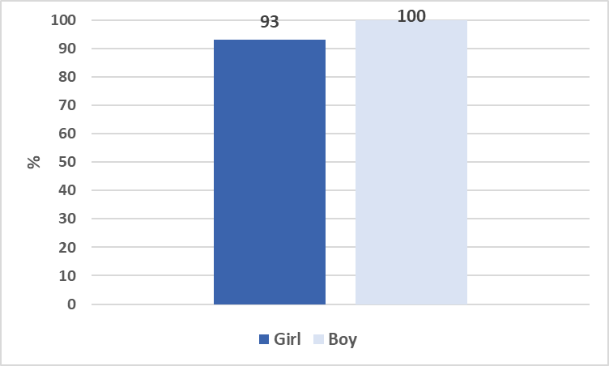

**Who can help?**

|  |  |
| --- | --- |
| **Organisation** | **Description** |
| Sustrans  <https://www.sustrans.org.uk/our-blog/projects/?location=Scotland&topic=Schools&p=1> | Resources supporting children and families to become more active through providing information about walking and cycling routes locally. Information for schools about national campaigns and activities. |
| Sport Scotland - schools  <https://sportscotland.org.uk/schools/> | Resources and information for schools on how to promote physical activity for young people. |
| Play Scotland  <https://www.playscotland.org> | Scotland provide a range of resources and ideas for keeping children active through play both indoors and outdoors. |

1. **Experience of bullying**

This chapter reports the following measures relating to bullying and discrimination:

* Bullying at school-perpetration and victim
* Experience of different types bullying behaviour
* Cyberbullying victimisation

Being a victim of bullying at school can have a serious impact on young people and is linked to loneliness, depression and low self-esteem in adulthood. Victims of bullying may experience a range of problem behaviours, psychological and psychosomatic issues, anxiety, depression and even suicide.49-54 The link between being bullied and poor mental health is strongest in late adolescence.55

Cyberbullying is defined as intentional behaviour aimed at harming another person or persons through computers, cell phones, and other electronic devices, and perceived as distressing by the victim.56 Cyberbullying is on the increase, with some studies reporting victimisation rates as high as 53%.57 The risk of being bullied online is higher for socially vulnerable adolescents suffering social anxiety or social isolation, and this group are also less capable of defending themselves online.58

A review of different types of bullying intervention programmes has identified key features which are most effective: Intensive programmes (20 hours plus), parent meetings, teacher training, clear disciplinary practices and improved playground supervision. 59 NHS Scotland has produced an evidence review on what works to prevent and reduce school bullying.60

**Bullying at school - bullying perpetration and victimisation**

Pupils were asked how often they had bullied someone else at school in the past couple of months, at school and been a victim of bullying.

Figure 19 presents the percentage of pupils who bullied others at least once or twice over the past couple of months and the percentage of pupils who report being bullied at least once or twice over the past couple of months.

**Figure 19: % pupils who report bullying others or being bullied at school in the past couple of months**

**Experience of types of bullying behaviour**Pupils were asked how often they had experienced various types of bullying behaviour at school in the past couple of months. The top three most common types of bullying behaviour experienced by pupils (boy and girls combined) at least 2 or 3 times or more are:

* Being left out, excluded or ignored – 17%
* Being called names, made fun of or teased- 10%
* Other pupils told lies or spread rumours about them – 5%

**Cyberbullying**Pupils were also asked how often they had been cyberbullied in the past couple of months. We present the percentage of pupils who were cyberbullied at least once or twice over past couple of months. Very few pupils reported carrying out cyberbullying (not shown in figure).  
  
**Figure 20: % pupils reporting being cyberbullied in past couple of months**

**Who can help?**

|  |  |
| --- | --- |
| **Organisation** | **Description** |
| Respectme  [www.respectme.org.uk](http://www.respectme.org.uk) | Respectme envisage a respecting, just, equal and inclusive Scotland in which all children and young people can live free from bullying and harassment and are encouraged to reach their full potential. Their work is driven by a focus on children’s rights. |
| The Children and Young People’s Commissioner Scotland [www.cypcs.org.uk](http://www.cypcs.org.uk) | Protecting and promoting the human rights of children and young people. |
| UNICEF - Rights Respecting  <https://www.unicef.org.uk/rights-respecting-schools/resources/teaching-resources/> | A framework and resources for use in schools to teach children about rights. |

1. **Substance use**

This chapter presents the following measures relating to substance use:

* Alcohol
* Smoking
* Vaping

The use of smoking, alcohol and drugs by school pupils and the impact on their health is a key area of concern, though data from HBSC and the Schools Adolescent Lifestyle and Substance Use Survey (SALSUS) surveys show encouraging downward trends in tobacco and alcohol use among Scottish adolescents. Data from the international HBSC study showed that adolescents across a large part of Europe are drinking less than they used to.60

Nonetheless, frequent and excessive drinking is associated with a range of problems such as future alcohol and drug use, academic problems, risky sexual behaviour, and various physical and emotional problems.61-65 Similarly, early drug use is predictive of dropping out of school, unsafe sex and delinquent behaviours.66

School environment factors have been shown to be crucial in reducing smoking amongst pupils. Research has shown that exposure to teachers smoking on school grounds is linked to higher smoking among older adolescents.67 A zero-tolerance approach to smoking in school, both for pupils and staff, has been found to be effective in reducing tobacco use in adolescents.68 Identifying with media messages and peer pressure are shown to be risk factors for substance use in adolescence. The ability to think critically about media messages and good parental influences have both been shown to reduce substance use.69

**Alcohol use**

Pupils were asked if they had ever drunk alcohol. The majority of pupils (70%) in your school had *never* drunk alcohol and 20% reported they had drunk alcohol just once or twice in their lifetime.

**Smoking and vaping**

Pupils were asked if they had ever smoked tobacco or used e-cigarettes in their lifetime. Rates for both were very low in your school so cannot be reported; however, they were in line with results from the HBSC national 2018 results, with 1% of 11-year-olds reported ever trying tobacco.

**Who can help?**

|  |  |
| --- | --- |
| **Organisation** | **Description** |
| Alcohol Focus Scotland  <https://www.alcohol-focus-scotland.org.uk/> | AFS want to reduce the impact of alcohol on individuals, families, communities and Scotland as a whole, through the implementation of effective alcohol control policies and legislation. Searching the ‘resource’ section brings up fact sheets about adolescent drinking. |
| ADEPIS (The Alcohol and Drug Education and Prevention Information Service)  <http://mentor-adepis.org/planningeffective-education/> | The Alcohol and Drug Education and Prevention Information Service (ADEPIS) was established by the prevention charity Mentor UK to share information and resources with schools and practitioners working in drug and alcohol prevention. |
| Talk to Frank  <https://www.talktofrank.com/> | Talk to Frank offers a comprehensive set of information on drugs, alcohol and tobacco, including where to get help, support centres and helplines |
| ASH Scotland - Children, young people and families  <https://www.ashscotland.org.uk/what-we-do/children-young-people-and-tobacco/> | Action on Smoking and Health (ASH) Scotland is the independent Scottish charity taking action to reduce the harm caused by tobacco. Their vision is that everyone has the right to good health and to live free from the harm and inequality caused by smoking. |
| Drink wise age well  <https://drinkwiseagewell.org.uk/> | Support centre based in Glasgow. Information and advice for those affected by harmful alcohol intake. (Primarily aimed at adults, but may be useful for adolescents and their carers too). |

1. **Electronic Media Use**

This chapter reports data relating to electronic media use. It includes the following measures:

* Technology in bedroom
* Screen time use
* Contact with close friends
* Problematic social media use

Although some studies have suggested that screen time and electronic media may be linked to poor mental wellbeing, the evidence is not yet clear that screen time causes poor mental wellbeing. A 2019 review of research into the impact of the use of television, computers, videos, mobile phones and other screen time found strong links between screen time and obesity, lack of exercise, depression and poor diet. However, only weak links were found between screen time and behavioural problems, low self-esteem, poor wellbeing, low educational attainment, and anxiety.70

Several studies have suggested that use of social media may have a positive effect on self-esteem, friendship closeness, social competence and empathy,71,72 though other studies have found that online social interactions are only beneficial when communicating with existing friends, rather than relationships with strangers which have been created online.72,73

There are concerns that socially vulnerable adolescents may use online interaction to compensate for a lack of real-life interactions, which may put them at greater risk of developing unhealthy, compulsive use of social media.74 The #Sleepyteens project in Scotland found that children who were very emotionally invested in social media and used it the most had poorer sleep quality, lower self-esteem, and higher levels of anxiety and depression.75 Compulsive social media use has been linked to depression, poor sleep quality, low life satisfaction, anxiety and aggressive behaviour.76-79

The Royal College of Paediatrics and Child Health have produced guides for parents to help negotiate the right amount of screen time for their own children.80

**Technology in bedroom**  
Here we present the percentage of pupils who have a smartphone which they keep in their bedroom at night and those that have a TV in their bedroom.

**Figure 21 : % of pupils with smartphone in bedroom at night and a TV in bedroom**

**Contact with close friends**Pupils were asked to think about ‘online contact’ and ‘online communication’, defined as ‘sending and receiving text messages, emoticons, and photo, video or audio messages through instant messaging, social networking sites or video calling (e.g. Zoom)’. Then they were asked to report how frequently they keep in online contact with people in their life. The figure shows the percentage of pupils who are in online contact with close friends either several times a day or almost all the time during the day.

**Figure 22: Pupils reporting online contact with close friends several times/almost all the time during the day**

**Screen time**Pupils were asked to estimate how many hours a day in their free time they spend: watching TV/DVDs/videos; playing games on a computer/console/tablet/phone; and using electronic devices for other purposes such as homework, email, messaging, surfing the internet or social media. Here we present the mean number of hours spent on each type of activity as well as the mean number of hours spent across all these screen activities each day.

**Figure 23: Mean time (hours) spent per day using a screen**

**Problematic social media use**We used the Social Media Disorder (SMD) Scale to measure ‘problematic’ social media use. This scale examines a number of different aspects of social media use, for example, whether young people are preoccupied with social media, lose interest in other activities due to social media, have arguments with others due to their social media use or use social media to cope with unpleasant experiences.

In your school, the number of pupils scoring as problematic social media users was extremely low and cannot be reported.

**Who can help?**

|  |  |
| --- | --- |
| **Organisation** | **Description** |
| Royal College of Paediatrics and Child Health (RCPCH)  <https://www.rcpch.ac.uk/resources/health-impacts-screen-time-guide-clinicians-parents> | The RCPCH has provided a set of factsheets and guidance to better help parents negotiate setting limits on screen time with their children. |
| Childnet International  [www.childnet.com](http://www.childnet.com) | Childnet International’s website aims to help make the internet a safe place for children and young people and provides up-to-date information about mobiles, gaming, downloading, social networking and more. |
| UK Safer Internet Centre  [www.saferinternet.org.uk](http://www.saferinternet.org.uk) | UK Safer Internet Centre provides online safety tips, advice and resources to help children and young people stay safe online. |
| Scottish Government  <https://www.gov.scot/publications/national-action-plan-internet-safety-children-young-people/pages/9/> | Summary of Scottish Government’s national action plan and links to other organisations and resources |
| Thinkuknow  [www.thinkuknow.co.uk](http://www.thinkuknow.co.uk) | The Thinkuknow site provides a range of free education resources and advice targeted at specific age groups, parents and those working with children, around keeping children safe online. (Part of CEOP) |
| Child Exploitation and Online Protection (CEOP) reporting  <https://www.ceop.police.uk/safety-centre/> | Help making a report if you are worried about online sexual abuse or the way someone has been communicating online with a child. |

1. **Impact of COVID-19 pandemic**

This chapter is about the COVID-19 pandemic and contains the following measures:

* Perceived impact of COVID 19 pandemic on different aspects of life

In March 2020, the World Health Organisation (WHO) declared COVID-19 a pandemic. The pandemic and its associated health protection measures such as lockdowns, school closures, home learning and social distancing have had a significant impact on day-to-day life.

A review carried out by Public Health Scotland81 looked at the possible positive and adverse consequences of the first lockdown on young people’s development. In terms of family relationships, it found that young people may have experienced ‘stressors’ including parental mental wellbeing, changing family financial situations and limited access to services. However, most young people (aged 12-14 years old) enjoyed spending time with their family during lockdown.

Another important aspect impacted by the pandemic is mental health and wellbeing. Feelings of loneliness (particularly amongst girls) increased during the first lockdown 82. Girls have also been more likely to report lower levels of mental wellbeing and higher levels of anxiety than boys. 81-83 Older adolescents also reported feeling concerned about the impact of lockdown on their education and future careers.81

It is argued that many existing health issues have been exacerbated by the pandemic and that inequalities have also deepened; there is an urgent need to address these issues and provide support to young people who may have been disproportionately affected by the pandemic.

**Impact of COVID-19**

Young people were asked about their experiences of COVID-19 and its associated restrictions. Pupils were asked to say how they felt various aspects of their life had been impacted by the COVID-19 pandemic choosing from the options: very negative/ quite negative/ neutral, no impact/quite positive and very positive.

The figures show the percentage of pupils who reported either a negative (very/quite) or a positive (very/quite) impact on that aspect of their life. There are two figures, Figure 24 shows the results for girls and Figure 25 shows the results for boys.

**Figure 24: Perceived impact of the COVID-19 pandemic on GIRLS**

**Figure 25: Perceived impact of the COVID-19 pandemic on BOYS**

1. **Social Relationships and Support**

This chapter is about social relationships and support, and includes the following measures:

* Family communication
* Family support
* Peer support
* Trusted adult

Supportive family relationships are vital for adolescent development, socialisation, health and

wellbeing. 84, 85 Good support leads to improved mental health and better educational outcomes. 86,87 Family support reduces risky health behaviours in adolescents88 and provides a buffer against adverse life events and bullying, especially for girls. 89 Developing such resilience and reducing distress in childhood are crucial to promoting mental wellbeing and reducing health-harming behaviours. 90 Family communication is also important for health, wellbeing and life satisfaction. 91 Studies have shown that family communication is important for reducing risk behaviours such as illegal substance use, smoking, drinking, early sexual behaviour and suicidal behaviour. 92-93

Another important source of support is that offered by peers, which is also linked to better health in adolescents. 94 Support from classmates has a positive effect on mental wellbeing by helping to boost self-efficacy and building a sense of school community.95

The negative effects of adverse childhood experiences on mental and physical health across the lifespan can be reduced by having the support of a trusted adult in childhood.96 A review by NHS Scotland demonstrates the importance of having an adult that young people trust and can talk to, with young people reporting this adult can help with educational attainment, optimism, self-efficacy and reducing internalising symptoms (depression and anxiety).97

**Family communication**Pupils were asked how easy they find it to communicate with a parental figure. Figure 26 presents the percentage of pupils who say they find it easy or very easy to talk to their mother and father figure (this includes step-parents).

**Figure 26: % pupils who say it’s *easy or very easy* to speak to the mother and father figure**

**Family support**The HBSC survey includes the Family Support Scale. This consists of four questions about how much support the young person feels they get from their family, for example, listening to their problems and help with decision making. The figure shows the percentage of pupils who reported high family support.  
 **Figure 27: % pupils who report high family support**

**Peer Support**

The Peer Support Scale include four questions about support received from friends, for example, how easy young people find it to talk to friends about their problems and the extent to which they can count on their friends and their friends try to help them. The figure shows the percentage of pupils who report high peer support.

**Figure 28: % pupils who report high peer support**

**Trusted adult**Pupils were asked ‘do you have an adult in your life who you can trust and talk to about any personalproblems?’ with response options including Yes always/Yes, sometimes/ No.The figure shows the percentage of pupils who report ‘always’ having a trusted adult to talk to.

**Figure 29: % pupils who *always* have a trusted adult to talk to**

**Who can help?**

|  |  |
| --- | --- |
| **Organisation** | **Description** |
| Parenting Across Scotland  <https://www.parentingacrossscotland.org/info-for-families/> | Parenting across Scotland is a partnership of charities which offers support to children and families in Scotland. |
| <https://www.parentclub.scot/> | The Scottish Government website for parents covering everything from online safety, food and eating to raising a teenager. |
| Children1st  <https://www.children1st.org.uk/help-for-families/> | Parenting First helps families in Scotland to put children first, with practical advice and with support in difficult times. |
| One parent Families Scotland  <https://opfs.org.uk/> | A free helpline providing impartial and confidential advice to single-parent families. |
| Carerstrust Scotland  [www.carers.org/country/carers-trust-scotland](http://www.carers.org/country/carers-trust-scotland) | Carers Trust Scotland is the largest provider of support services for carers in Scotland. |
| LGBT Youth Scotland  <https://www.lgbtyouth.org.uk> | LGBT Youth Scotland provides advice and support for young people and their families around LGBTI+ issues, as well as guidance for schools on making schools more LGBTI+ inclusive. |

1. **School Environment**

This chapter reports data relating to the school environment and includes these measures:

* Liking school
* Schoolwork pressure
* Teacher and pupil support

The school environment has many effects on pupil wellbeing and a positive school experience can bring many benefits in terms of both health and education. Students who feel they are able to handle their work, have good teacher support and are satisfied with school are more likely to report high life satisfaction98. Good teacher support is linked to better mental health and lower use of alcohol, cigarettes and cannabis,99-102 and the positive link between teacher support and emotional wellbeing has been shown to be strong regardless of pupil demographics or perceived school performance.103 High classmate support is also linked to improved mental health,104 lower drunkenness, and for males is linked to lower rates of smoking.105

In contrast, high levels of school pressure are associated with higher levels of risky behaviour and poorer mental health.106-108  For young adolescents in high-stress school environments, increased academic expectations can lead to them having higher stress levels and poorer academic performance as they get older.109 Low school satisfaction is linked to health behaviours such as smoking, alcohol and cannabis use, and gambling,111,112 as well as poorer self-rated health and increased physical and psychological symptoms.113, 114

**Liking school**Pupils were asked how much they like school at present. The figure shows the percentage of pupils who say they like school ‘a lot’ or ‘a bit’.

**Figure 30: % pupils who like school *a lot* or *a bit***

**Schoolwork pressure**Pupils were asked how pressured they feel about the schoolwork they have to do. This figure shows the percentage of pupils who feel ‘some’ or ‘a lot’ of pressure from schoolwork.

**Figure 31: % pupils who feel *some* or *a lot* of pressure from schoolwork**

**Teacher and pupil support**

Pupils were asked to say how much they feel their teachers accept and care about them as a person, and how much they trust their teachers. They were also asked to say how much other pupils accept them, how kind and helpful they are and whether the pupils in their classes enjoy being together. Below we show the percentage of pupils who report high levels of support from teachers and from classmates.

**Figure 32: % pupils who report *high* teacher support and *high* classmate support**

**Who can help?**

|  |  |
| --- | --- |
| **Organisation** | **Description** |
| NHS Inform Scotland -Coping with exam stress  <https://www.nhsinform.scot/healthy-living/mental-wellbeing/stress/coping-with-exam-stress> | Information for parents/carers on how to support children when they are coping with exam stress. |
| Young Scot-Advice on dealing with exam stress  <https://young.scot/get-informed/national/how-you-can-survive-the-stress-of-exams> | Advice and information on coping with exam stress for young people. |
| Eco Schools Scotland – School Grounds  <https://www.keepscotlandbeautiful.org/education-and-learning/eco-schools/green-flag-award/ten-topics/school-grounds/> | Research by Learning Through  Landscapes finds that well designed school  grounds can improve behaviour, reduce bullying and cut vandalism. Improving your school’s outdoor space enhances pupils’ self-esteem and improves both attainment and attitudes towards learning. Eco Schools offer practical advice to schools on how to make the most of their school grounds to support student wellbeing. |
| Mental Health Foundation  campaign-“Mental Health in Schools: Make it Count”  <https://www.mentalhealth.org.uk/projects/peer-education-projectpep/schools-resources> | Campaign for schools to take action on Mental Health. Links to  resources and guidance. |

**Challenge Questions**

The aim of these challenge questions is to support interpretation of the data report so that it can be shared confidently among the key stakeholders in the school community. It is hoped that the discussions and whole-school collaborations in response to the data report will support improvements in pupil wellbeing.

**Approaching the data: Consider the context:**

* How confident are staff, parents and pupils at interpreting health and wellbeing data?
* If using more than one data source to track and monitor health and wellbeing in your school, are they compatible and do staff confidently understand the purpose of each data source? I.e. is one diagnostic; for identifying individuals struggling and another one to provide evidence of the pupil wellbeing context in order to understand the environment in which individual pupils operate?
* Is there an already established meeting cycle in which to discuss this data with the relevant key stakeholders? Or is a new group required?
* Will a smaller group be responsible for working on the whole report in order to pull out the key themes for already established working groups in the school or will the whole report be shared with everyone fully?
* How representative are the data of the school roll, or the year group(s) surveyed?
* Have you considered the number of pupils taking part? If a small number of pupils participate, a small difference in numbers can translate to large differences in percentages. For example, if you survey 10 pupils, 1 pupil’s response will account for 10%.

**Reflecting on the data:**

* To what extent do the data provide evidence of key issues for your school or reveal specific priorities? Are there areas of success to celebrate as well as areas of concern for focus?
* Are there any results that surprise you? Are there any results that confirm what you know?
* Have you considered the gender split in the data to identify different HWB strategies for different groups?
* Are there particular patterns in your school’s data? For example, is one gender group tending to score more negatively across a number of measures?

**Working together:**

* Have you shared the HBSC data with the wider school community to include staff, pupils and parents to underpin a whole-school approach to HWB?
* Remember, pupils may be best placed to explain and interpret the data they provided.
* When considering the HBSC data, do a committee of stakeholders from different parts of the school community take part in identifying HWB priorities to take forward?

***We also recommend you also consult the Scottish Government guidance "Mental health and wellbeing: whole school approach: Framework".***

[***https://www.gov.scot/publications/whole-school-approach-mental-health-wellbeing/***](https://www.gov.scot/publications/whole-school-approach-mental-health-wellbeing/)

**References**

1. WHO | The Ottawa Charter for Health Promotion. (n.d.). Retrieved January 18, 2019,

from http://www.who.int/healthpromotion/conferences/previous/ottawa/en/

1. Kelleher, C. C., Tay, J., & Gabhainn, S. N. (2007). Influence on self-rated health of socio-demographic, lifestyle and affluence factors: an analysis of the Irish and International Health Behaviours Among School-Aged Children (HBSC) datasets 1998. Irish Medical Journal, 100(8), suppl 43-46.
2. Torsheim, T., & Wold, B. (2001). School-Related Stress, School Support, and Somatic Complaints: A General PopulationStudy. Journal of Adolescent Research, 16(3), 293–303. <https://doi.org/10.1177/0743558401163003>
3. Gireesh, A., Das, S., & Viner, R. M. (2018). Impact of health behaviours and deprivation on well-being in a national sample of English young people. BMJ Paediatrics Open, 2(1), e000335. <https://doi.org/10.1136/bmjpo-2018-000335>
4. Chaput, J.-P., Gray, C. E., Poitras, V. J., Carson, V., Gruber, R., Birken, C. S., … Tremblay, M. S. (2017). Systematic review of the relationships between sleep duration and health indicators in the early years (0–4 years). BMC Public Health, 17(5), 855. <https://doi.org/10.1186/s12889-017-4850-2>
5. Chaput, J.-P., Gray, C. E., Poitras, V. J., Carson, V., Gruber, R., Olds, T., … Tremblay, M. S. (2016). Systematic review of the relationships between sleep duration and health indicators in school-aged children and youth. Applied Physiology, Nutrition, and Metabolism, 41(6 (Suppl. 3)), S266–S282. <https://doi.org/10.1139/apnm-2015-0627>
6. Ghekiere, A., Van Cauwenberg, J., Vandendriessche, A., Inchley, J., Gaspar de Matos, M., Borraccino, A., De Clercq, B. (2018). Trends in sleeping difficulties among European adolescents: Are these associated with physical inactivity and excessive screen time? International Journal of Public Health. <https://doi.org/10.1007/s00038-018-1188-1>
7. Pilcher, J. J., Ginter, D. R., & Sadowsky, B. (1997). Sleep quality versus sleep quantity: Relationships between sleep and measures of health, well-being and sleepiness in college students. Journal of Psychosomatic Research, 42(6), 583–596. <https://doi.org/10.1016/S0022-3999(97)00004-4>
8. Dewald, J. F., Meijer, A. M., Oort, F. J., Kerkhof, G. A., & Bögels, S. M. (2010). The influence of sleep quality, sleep duration and sleepiness on school performance in children and adolescents: A meta-analytic review. Sleep Medicine Reviews, 14(3), 179–189. <https://doi.org/10.1016/j.smrv.2009.10.004>
9. Woods, H. C., & Scott, H. (2016). #Sleepyteens: Social media use in adolescence is associated with poor sleep quality, anxiety, depression and low self-esteem. Journal of Adolescence, 51, 41–49. <https://doi.org/10.1016/j.adolescence.2016.05.008>
10. Royal College of Paediatrics and Child Health. (n.d.). The health impacts of screen time - a guide for clinicians and parents | RCPCH. Retrieved February 11, 2019, from <https://www.rcpch.ac.uk/resources/health-impacts-screen-timeguide-clinicians-parents>
11. <https://www.gov.scot/publications/scotlands-public-health-priorities/>
12. Deighton, J., Humphrey, N., Belsky, J., Boehnke, J., Vostanis, P., & Patalay, P. (2018). Longitudinal pathways between mental health difficulties and academic performance during middle childhood and early adolescence. British Journal of Developmental Psychology, 36(1), 110–126. <https://doi.org/10.1111/bjdp.12218>
13. Cohen, S., Janicki-Deverts, D., & Miller, G. E. (2007). Psychological Stress and Disease. JAMA,98(14), 1685–1687. https:// doi.org/10.1001/jama.298.14.1685
14. Kaplan, D.S., Liu, R.X. & Kaplan, H.B. (2005). School related stress in early adolescence and academic performance three years later: the conditional influence of sel expectations. Social Psychology of Education, 8(1), 3–17. <https://doi.org/10.1007/s11218-004-3129-5>
15. Middlebrooks, J. S., & Audage, N. C. (2008). The Effects of Childhood Stress on Health Across the Lifespan. Retrieved January 18, 2019, from http://www.cdc.gov/ncipc/pub-res/pdf/ Childhood_Stress.pdf
16. Scottish Government. (2017). Scottish Schools Adolescent Lifestyle and Substance Use Survey 2015: mental wellbeing report - gov.scot. Retrieved March 12, 2019, from <https://www.gov.scot/publications/scottish-schools-adolescentlifestyle-substance-use-survey-salsus-2015-mental-9781786529626/>
17. Bor W, Dean A.J., Najman J., Hayatbakhsh R. (2014) Are child and adolescent mental health problems increasing in the 21st century? A systematic review. Aust N Z J Psychiatry. 48(7), 606–616.
18. Patalay, P., Gage, S, H. (2019). Changes in millennial adolescent mental health and health-related behaviours over 10 years: a population cohort comparison study. International Journal of Epidemiology. 48 (5), 1650–1664.
19. Scottish Government (2017). Mental Health Strategy 2017–2027. Edinburgh: Scottish Government. Accessed at: <https://www.gov.scot/publications/mental-health-strategy-2017-2027/>
20. Parkinson, J., (2012). Establishing a core set of national, sustainable mental health indicators for children and young. NHS Health Scotland.
21. Reiss, F., (2013). Socioeconomic inequalities and mental health problems in children and adolescents: A systematic review. *Social science & medicine,* 90 (1982), 24–31.
22. Moore, G.F., Cox, R., Evans, R.E. et al.(2018). School, Peer and Family Relationships and Adolescent Substance Use, Subjective Wellbeing and Mental Health Symptoms in Wales: a Cross Sectional Study. *Child Indicators Research.* 11, 1951–1965.
23. Cheng, H., & Furnham, A. (2002). Personality, peer relations, and self-confidence as predictors of happiness and loneliness. Journal of Adolescence, 25(3), 327–339. <https://doi.org/10.1006/jado.2002.0475>
24. Suldo, S. M., Riley, K. N., & Shaffer, E. J. (2006). Academic Correlates of Children and Adolescents’ Life Satisfaction. School Psychology International, 27(5), 567–582. <https://doi.org/10.1177/0143034306073411>
25. Gireesh A., Das S., Viner RM. (2018) Impact of health behaviours and deprivation on wellbeing in a national sample of English young people. *BMJ Paediatrics Open.* 2:e000335.
26. Centers for Disease Control and Prevention. (1997). Guidelines for School Health Programs to Promote Lifelong Healthy Eating. Retrieved from <https://www.cdc.gov/mmwr/pdf/rr/rr4509.pdf>
27. Story, M., Neumark-sztainer, D., & French, S. (2002). Individual and Environmental Influences on Adolescent Eating Behaviors. Journal of the American Dietetic Association, 102(3, Supplement), S40–S51. <https://doi.org/10.1016/S0002-8223(02)90421-9>
28. Vereecken, C., Dupuy, M., Rasmussen, M., Kelly, C., Nansel, T. R., Al Sabbah, H., the HBSC Eating & Dieting Focus Group. (2009). Breakfast consumption and its socio-demographic and lifestyle correlates in schoolchildren in 41 countries participating in the HBSC study. International Journal of Public Health, 54(2), 180–190. <https://doi.org/10.1007/s00038-009-5409-5>
29. Affenito, S. G. (2007). Breakfast: A Missed Opportunity. Journal of the American Dietetic Association, 107(4), 565–569. <https://doi.org/10.1016/j.jada.2007.01.011>
30. Pedersen, T. P., Meilstrup, C., Holstein, B. E., & Rasmussen, M. (2012). Fruit and vegetable intake is associated with frequency of breakfast, lunch and evening meal: cross-sectional study of 11-, 13-, and 15-year-olds. International Journal of Behavioral Nutrition and Physical Activity, 9(1), 9. <https://doi.org/10.1186/1479-5868-9-9>
31. Rampersaud, G. C., Pereira, M. A., Girard, B. L., Adams, J., & Metzl, J. D. (2005). Breakfast Habits, Nutritional Status, Body Weight, and Academic Performance in Children and Adolescents. Journal of the American Dietetic Association, 105(5), 743–760. <https://doi.org/10.1016/j.jada.2005.02.007>
32. Deshmukh-Taskar, P. R., Nicklas, T. A., O’Neil, C. E., Keast, D. R., Radcliffe, J. D., & Cho, S. (2010). The Relationship of Breakfast Skipping and Type of Breakfast Consumption with Nutrient Intake and Weight Status in Children and Adolescents: The National Health and Nutrition Examination Survey 1999-2006. Journal of the American Dietetic Association, 110(6), 869–878. <https://doi.org/10.1016/j.jada.2010.03.023>
33. Neumark-Sztainer, D., Larson, N. I., Fulkerson, J. A., Eisenberg, M. E., & Story, M. (2010). Family meals and adolescents: what have we learned from Project EAT (Eating Among Teens)? Public Health Nutrition, 13(7), 1113–1121. <https://doi.org/10.1017/S1368980010000169>
34. Berge, J. M., Wall, M., Hsueh, T.-F., Fulkerson, J. A., Larson, N., & Neumark-Sztainer, D. (2015). The Protective Role of Family Meals for Youth Obesity: 10-Year Longitudinal Associations. The Journal of Pediatrics, 166(2), 296–301. <https://doi.org/10.1016/j.jpeds.2014.08.030>
35. Hammons, A. J., & Fiese, B. H. (2011). Is Frequency of Shared Family Meals Related to the Nutritional Health of Children and Adolescents? Pediatrics, 127(6), e1565–e1574. <https://doi.org/10.1542/peds.2010-1440>
36. Elgar, F. J., Craig, W., & Trites, S. J. (2013). Family Dinners, Communication, and Mental Health in Canadian Adolescents. Journal of Adolescent Health, 52(4), 433–438. <https://doi.org/10.1016/j.jadohealth.2012.07.012>
37. Harrison, M. E., Norris, M. L., Obeid, N., Fu, M., Weinstangel, H., & Sampson, M. (2015). Systematic review of the effects of family meal frequency on psychosocial outcomes in youth. Canadian Family Physician, 61(2), e96–e106. Retrieved from <http://www.cfp.ca/content/61/2/e96>
38. Skeer, M. R., & Ballard, E. L. (2013). Are Family Meals as Good for Youth as We Think They Are? A Review of the Literature on Family Meals as They Pertain to Adolescent Risk Prevention. Journal of Youth and Adolescence, 42(7), 943–963. <https://doi.org/10.1007/s10964-013-9963-z>
39. World Health Organization. (2010). Global recommendations on physical activity for health. Genève: WHO. Retrieved from <https://www.who.int/dietphysicalactivity/publications/9789241599979/en/>
40. Anderson, P. M., & Butcher, K. F. (Kristin F. (2006). Childhood Obesity: Trends and Potential Causes. The Future of Children, 16(1), 19–45. <https://doi.org/10.1353/foc.2006.0001>
41. Hallal, P. C., Victora, C. G., Azevedo, M. R., & Wells, J. C. K. (2006). Adolescent Physical Activity and Health. Sports Medicine, 36(12), 1019–1030. <https://doi.org/10.2165/00007256-200636120-00003>
42. Janssen, I., & LeBlanc, A. G. (2010). Systematic review of the health benefits of physical activity and fitness in school aged children and youth. International Journal of Behavioral Nutrition and Physical Activity, 7(1), 40. <https://doi.org/10.1186/1479-5868-7-40>
43. Strong, W. B., Malina, R. M., Blimkie, C. J. R., Daniels, S. R., Dishman, R. K., Gutin, B., … Trudeau, F. (2005). Evidence Based Physical Activity for School-age Youth. The Journal of Pediatrics, 146(6), 732–737. <https://doi.org/10.1016/j.jpeds.2005.01.055>
44. Badura, P., Geckova, A.M., Sigmundova, D. *et al.* When children play, they feel better: organized activity participation and health in adolescents. BMC Public Health **15,**1090 (2015). <https://doi.org/10.1186/s12889-015-2427-5>
45. Leversen, I., Danielsen, A.G., Birkeland, M.S. *et al.* (2012). Basic Psychological Need Satisfaction in Leisure Activities and Adolescents’ Life Satisfaction. J Youth Adolescence **41,**1588–1599 <https://doi.org/10.1007/s10964-012-9776->
46. Eccles, J. S., Barber, B. L., Stone, M., & Hunt, J. (2003). Extracurricular activities and adolescent development. Journal of Social Issues*,* *59*(4), 865–889
47. Badura P, Hamrik Z, Dierckens M*, et al* (2021)After the bell: adolescents’ organised leisure-time activities and well-being in the context of social and socioeconomic inequalities J Epidemiol Community Health;75:628-636.
48. Due, P., Hansen, E. H., Merlo, J., Andersen, A., & Holstein, B. E. (2007). Is Victimization From Bullying Associated With Medicine Use Among Adolescents? A Nationally Representative Cross-sectional Survey in Denmark. Pediatrics, 120(1), 110–117. <https://doi.org/10.1542/peds.2006-1481>
49. Due, P., Holstein, B. E., Lynch, J., Diderichsen, F., Gabhain, S. N., Scheidt, P., & Currie, C. (2005). Bullying and symptoms among school-aged children: international comparative cross sectional study in 28 countries. European Journal of Public Health, 15(2), 128–132. <https://doi.org/10.1093/eurpub/cki105>
50. Kaltiala-heino, R., Rimpelä, M., Rantanen, P., & Rimpelä, A. (2000). Bullying at school—an indicator of adolescents at risk for mental disorders. Journal of Adolescence, 23(6), 661–674. <https://doi.org/10.1006/jado.2000.0351>
51. Kuntsche, E. N., & Klingemann, H. K.-H. (2004). Weapon-carrying at Swiss schools? A gender-specific typology in context of victim and offender related violence. Journal of Adolescence, 27(4), 381–393. <https://doi.org/10.1016/j.adolescence.2004.02.003>
52. Craig, W. M., & Pepler, D. J. (1998). Observations of Bullying and Victimization in the School Yard. Canadian Journal of School Psychology, 13(2), 41–59. <https://doi.org/10.1177/082957359801300205>
53. Scottish Schools Health and Wellbeing Improvement Research Network (SHINE). (2018a). Bullying Victimisation and Mental Wellbeing in Scottish Schoolchildren (SHINE Research Briefs No. 1). University of Glasgow, University of St Andrews. Retrieved from <http://shine.sphsu.gla.ac.uk/wp-content/uploads/2019/01/SHINE-research-brief-1-bullyingvictimisation-v2.pdf>
54. Schoffstall, C. L., & Cohen, R. (2011). Cyber Aggression: The Relation between Online Offenders and Offline Social Competence. Social Development, 20(3), 587–604. <https://doi.org/10.1111/j.1467-9507.2011.00609.x>
55. Kiriakidis, S. P., & Kavoura, A. (2010). Cyberbullying: A Review of the Literature on Harassment Through the Internet and Other Electronic Means. Family & Community Health, 33(2), 82. <https://doi.org/10.1097/FCH.0b013e3181d593e4>
56. Melzer, W., Oertel, L., Ottova, V., & Deutschland, und das H.-T. (2012). Mobbing und Gewalt an Schulen. Entwicklungstrends von 2002 bis 2010. Das Gesundheitswesen, 74(S 01), S76–S83. <https://doi.org/10.1055/s-0032-1312643>
57. Ttofi, M. M., & Farrington, D. P. (2011). Effectiveness of school-based programs to reduce bullying: a systematic and meta-analytic review. Journal of Experimental Criminology, 7(1), 27–56. <https://doi.org/10.1007/s11292-010-9109-1>
58. White, D. J. (2019). Addressing school violence and bullying: Evidence review (p. 51). Evidence for Action Team, NHS Scotland. Retrieved from <http://www.healthscotland.scot/media/2316/addressing-school-violence-and-bullyingevidence-review.pdf>
59. World Health Organization, & HBSC. (2018, September 26). Adolescent alcohol-related behaviours: trends and inequalities in the WHO European Region, 2002–2014 (2018). Retrieved January 23, 2019, from <http://www.euro.who.int/en/publications/abstracts/adolescent-alcohol-related-behaviours-trends-and-inequalities-in-thewho-european-region,-20022014-2018>
60. Brown, S. A., McGue, M., Maggs, J., Schulenberg, J., Hingson, R., Swartzwelder, S., … Murphy, S. (2008). A Developmental Perspective on Alcohol and Youths 16 to 20 Years of Age. Pediatrics, 121(Supplement 4), S290–S310. <https://doi.org/10.1542/peds.2007-2243D>
61. Cooper, M. L. (2002). Alcohol use and risky sexual behavior among college students and youth: evaluating the evidence. Journal of Studies on Alcohol, Supplement, (s14), 101–117. <https://doi.org/10.15288/jsas.2002.s14.101>
62. Eaton, D. K., Kann, L., Kinchen, S., Ross, J., Hawkins, J., Harris, W. A., … Wechsler, H. (2006). Youth Risk Behavior Surveillance—United States, 2005. Journal of School Health, 76(7), 353–372. <https://doi.org/10.1111/j.1746-1561.2006.00127.x>
63. Grunbaum, J. A., Kann, L., Kinchen, S., Ross, J., Hawkins, J., Lowry, R., … Collins, J. (2004). Youth risk behavior surveillance--United States, 2003. Morbidity and Mortality Weekly Report. Surveillance Summaries (Washington, D.C.:2002), 53(2), 1–96. Retrieved from <http://europepmc.org/abstract/MED/15152182>
64. Guo, J., Collins, L. M., Hill, K. G., & Hawkins, J. D. (2000). Developmental pathways to alcohol abuse and dependence in young adulthood. Journal of Studies on Alcohol, 61(6), 799–808. <https://doi.org/10.15288/jsa.2000.61.799>
65. Kokkevi, A., Gabhainn, S. N., & Spyropoulou, M. (2006). Early Initiation of Cannabis Use: A Cross-national European Perspective. Journal of Adolescent Health, 39(5), 712–719. <https://doi.org/10.1016/j.jadohealth.2006.05.009>
66. Poulsen, L. H., Osler, M., Roberts, C., Due, P., Damsgaard, M. T., & Holstein, B. E. (2002). Exposure to teachers smoking and adolescent smoking behaviour: analysis of cross sectional data from Denmark. Tobacco Control, 11(3), 246–251. <https://doi.org/10.1136/tc.11.3.246>
67. Øverland, S., Aarø, L. E., & Lindbak, R. L. (2010). Associations between schools’ tobacco restrictions and adolescents’ use of tobacco. Health Education Research, 25(5), 748–756. <https://doi.org/10.1093/her/cyq023>
68. Scull, T. M., Kupersmidt, J. B., Parker, A. E., Elmore, K. C., & Benson, J. W. (2010). Adolescents’ Media-related Cognitions and Substance Use in the Context of Parental and Peer Influences. Journal of Youth and Adolescence, 39(9), 981–998. <https://doi.org/10.1007/s10964-009-9455-3>
69. Stiglic, N., & Viner, R. M. (2019). Effects of screentime on the health and well-being of children and adolescents: a systematic review of reviews. BMJ Open, 9(1), e023191. <https://doi.org/10.1136/bmjopen-2018-023191>
70. Beyens, I., Frison, E., & Eggermont, S. (2016). “I don’t want to miss a thing”: Adolescents’ fear of missing out and its relationship to adolescents’ social needs, Facebook use, and Facebook related stress. Computers in Human Behavior, 64, 1–8. <https://doi.org/10.1016/j.chb.2016.05.083>
71. Valkenburg, P. M., & Peter, J. (2011). Online Communication Among Adolescents: An Integrated Model of Its Attraction, Opportunities, and Risks. Journal of Adolescent Health, 48(2), 121–127. <https://doi.org/10.1016/j.jadohealth.2010.08.020>
72. Valkenburg, P. M., & Peter, J. (2013). The Differential Susceptibility to Media Effects Model. Journal of Communication, 63(2), 221–243. <https://doi.org/10.1111/jcom.12024>
73. Caplan, S. E. (2002). Problematic Internet use and psychosocial well-being: development of a theory-based cognitive–behavioral measurement instrument. Computers in Human Behavior, 18(5), 553–575. <https://doi.org/10.1016/S0747-5632(02)00004-3>
74. Woods, H. C., & Scott, H. (2016). #Sleepyteens: Social media use in adolescence is associated with poor sleep quality, anxiety, depression and low self-esteem. Journal of Adolescence, 51, 41–49. <https://doi.org/10.1016/j.adolescence.2016.05.008>
75. Boniel-Nissim, M., Tabak, I., Mazur, J., Borraccino, A., Brooks, F., Gommans, R., … Finne, E. (2015). Supportive communication with parents moderates the negative effects of electronic media use on life satisfaction during adolescence. International Journal of Public Health, 60(2), 189–198. <https://doi.org/10.1007/s00038-014-0636-9>
76. De Cock, R., Vangeel, J., Klein, A., Minotte, P., Rosas, O., & Meerkerk, G.-J. (2013). Compulsive Use of Social Networking Sites in Belgium: Prevalence, Profile, and the Role of Attitude Toward Work and School. Cyberpsychology, Behavior, and Social Networking, 17(3), 166–171. <https://doi.org/10.1089/cyber.2013.0029>
77. Ko, C.-H., Yen, J.-Y., Chen, C.-S., Yeh, Y.-C., & Yen, C.-F. (2009). Predictive Values of Psychiatric Symptoms for Internet Addiction in Adolescents: A 2-Year Prospective Study. Archives of Pediatrics & Adolescent Medicine, 163(10), 937. <https://doi.org/10.1001/archpediatrics.2009.159>
78. Vernon, L., Barber, B. L., & Modecki, K. L. (2015). Adolescent Problematic Social Networking and School Experiences: The Mediating Effects of Sleep Disruptions and Sleep Quality. Cyberpsychology, Behavior, and Social Networking, 18(7), 386–392. <https://doi.org/10.1089/cyber.2015.0107>
79. Royal College of Paediatrics and Child Health. (n.d.). The health impacts of screen time - a guide for clinicians and parents | RCPCH. Retrieved February 11, 2019, from <https://www.rcpch.ac.uk/resources/health-impacts-screen-timeguide-clinicians-parents>
80. Public Health Scotland (2021). The impact of COVID-19 on children and young people in Scotland: 10 to 17-years-olds. Edinburgh: Public Health Scotland.
81. Edinburgh University (2021). TeenCovidLife Survey 2 - General Report Health and wellbeing in young people during COVID-19.
82. Cowie, H., & Myers, C. A. (2020). The impact of the COVID-19 pandemic on the mental health and well-being of children and young people. Children & society, 10.1111/chso.12430. Advance online publication. <https://doi.org/10.1111/chso.12430>
83. Collins, W., & Laursen, B. (2004). Parent-adolescent relationships and influences. In R. M. Lerner & L. Steinberg (Eds.),Handbook of Adolescent Psychology. John Wiley & Sons.
84. Collins, W., & Steinberg, L. (2007). Adolescent Development in Interpersonal Context. In W. Damon, R. M. Lerner, C. A. Nelson, K. M. Thomas, & M. de Haan (Eds.), Handbook of Child Psychology. Hoboken, NJ, USA: John Wiley & Sons, Inc. https://doi.org/10.1002/9780470147658.chpsy0201
85. Keijsers, L., Frijns, T., Branje, S. J. T., & Meeus, W. (20090824). Developmental links of adolescent disclosure, parental solicitation, and control with delinquency: Moderation by parental support. Developmental Psychology, 45(5), 1314.https://doi.org/10.1037/a0016693
86. Wilkinson, R. B. (2004). The Role of Parental and Peer Attachment in the Psychological Health and Self-Esteem of Adolescents. Journal of Youth and Adolescence, 33(6), 479–493. https://doi.org/10.1023/B:JOYO.0000048063.59425.20
87. Wills, T. A., Vaccaro, D., & McNamara, G. (1992). The role of life events, family support, and competence in adolescent substance use: A test of vulnerability and protective factors. American Journal of Community Psychology, 20(3), 349– 374. https://doi.org/10.1007/BF00937914
88. Granado, M. A., & Pedersen, J. M. (2001). Family as a child development context and smoking behaviour among schoolchildren in Greenland. International Journal of Circumpolar Health, 60(1), 52–63. Retrieved from http:// europepmc.org/abstract/med/11428223
89. Bellis, M. A., Hardcastle, K., Ford, K., Hughes, K., Ashton, K., Quigg, Z., & Butler, N. (2017). Does continuous trusted adult support in childhood impart life-course resilience against adverse childhood experiences - a retrospective study on adult health-harming behaviours and mental well-being. BMC Psychiatry, 17(1), 110. <https://doi.org/10.1186/> s12888-017-1260-z
90. Currie, C., & Levin, K. A. (2010). Family structure, mother‐child communication, father‐child communication, and adolescent life satisfaction: A cross‐sectional multilevel analysis. Health Education, 110(3), 152–168. https://doi.org/10.1108/09654281011038831
91. Lenciauskiene, I., & Zaborskis, A. (2008). The effects of family structure, parent—child relationship and parental monitoring on early sexual behaviour among adolescents in nine European countries. Scandinavian Journal of Public Health, 36(6), 607–618. https://doi.org/10.1177/1403494807088460
92. Zaborskis, A., & Sirvyte, D. (2015). Familial determinants of current smoking among adolescents of Lithuania: a crosssectional survey 2014. BMC Public Health, 15(1), 889. https://doi.org/10.1186/s12889-015-2230-3
93. .Zaborskis, A., Sirvyte, D., & Zemaitiene, N. (2016). Prevalence and familial predictors of suicidal behaviour among adolescents in Lithuania: a cross-sectional survey 2014. BMC Public Health, 16(1), 554. https://doi.org/10.1186/ s12889-016-3211-x
94. Corsano, P., Majorano, M., & Champretavy, L. (2006). Psychological Well-Being in Adolescence: The Contribution of Interpersonal Relations and Experience of Being Alone. Adolescence, 41(162), 341–353. Retrieved from http:// search.ebscohost.com/login.aspx?direct=true&AuthType=sso&db=a9h&AN=22251599&site=edslive&authtype=sso&custid=s3011414
95. Vieno, A., Santinello, M., Pastore, M., & Perkins, D. D. (2007). Social support, sense of community in school, and selfefficacy as resources during early adolescence: an integrative model. American Journal of Community Psychology, 39(1), 177. https://doi.org/10.1007/s10464-007-9095-2
96. Whitehead, R, Pringle, J, Scott, E, Milne, D, & McAteer, J. (2019). The relationship between a trusted adult and adolescent health and education outcomes (p. 29). Edinburgh: NHS Health http:// [www.healthscotland.scot/media/2325/the-relationship-between-a-trusted-adult-and-adolescent-healthoutcomes_6588.pdf](http://www.healthscotland.scot/media/2325/the-relationship-between-a-trusted-adult-and-adolescent-healthoutcomes_6588.pdf)
97. Suldo, S. M., Riley, K. N., & Shaffer, E. J. (2006). Academic Correlates of Children and Adolescents’ Life Satisfaction. School Psychology International, 27(5), 567–582. <https://doi.org/10.1177/0143034306073411>
98. Guo, H., Yang, W., Cao, Y., Li, J., & Siegrist, J. (2014). Effort-Reward Imbalance at School and Depressive Symptoms in Chinese Adolescents: The Role of Family Socioeconomic Status. International Journal of Environmental Research and Public Health, 11(6), 6085–6098. <https://doi.org/10.3390/ijerph110606085>
99. Ottova, V., Erhart, M., Vollebergh, W., Kökönyei, G., Morgan, A., Gobina, I., … Ravens-Sieberer, U. (2012). The Role of Individual- and Macro-Level Social Determinants on Young Adolescents’ Psychosomatic Complaints. The Journal of Early Adolescence, 32(1), 126–158. <https://doi.org/10.1177/0272431611419510>
100. Arguera, N. (2015). The Effects of School Work Pressure on Depression and Substance Use: A Cross-National Study of School-Aged Children in Canada and Finland (Thesis). University of Calgary. <http://dx.doi.org/10.11575/PRISM/28116>
101. Rossen, F. V., Lucassen, M. F. G., Fleming, T. M., Sheridan, J., & Denny, S. J. (2016). Adolescent gambling behaviour, a single latent construct and indicators of risk: findings from a national survey of New Zealand high school students.Asian Journal of Gambling Issues and Public Health, 6(1), 7. <https://doi.org/10.1186/s40405-016-0017-9>
102. Vogel, M., Rees, C. E., McCuddy, T., & Carson, D. C. (2015). The Highs That Bind: School Context, Social Status and Marijuana Use. Journal of Youth and Adolescence, 44(5), 1153–1164. <https://doi.org/10.1007/s10964-015-0254-8>
103. Joyce, H. D., & Early, T. J. (2014). The impact of school connectedness and teacher support on depressive symptoms in adolescents: A multilevel analysis. Children and Youth Services Review, 39, 101–107. <https://doi.org/10.1016/j.childyouth.2014.02.005>
104. Langille, D. B., Asbridge, M., Cragg, A., & Rasic, D. (2015). Associations of School Connectedness with Adolescent Suicidality: Gender Differences and the Role of Risk of Depression. The Canadian Journal of Psychiatry, 60(6), 258–267. <https://doi.org/10.1177/070674371506000604>
105. García-Moya, I., Brooks, F., Morgan, A., & Moreno, C. (2015). Subjective well-being in adolescence and teacher connectedness: A health asset analysis. Health Education Journal, 74(6), 641–654. https://doi.org/ 10.1177/0017896914555039
106. McCarty, C. A., Rhew, I. C., Murowchick, E., McCauley, E., & Vander Stoep, A. (20111010). Emotional health predictors of substance use initiation during middle school. Psychology of Addictive Behaviors, 26(2), 351. <https://doi.org/10.1037/> a0025630
107. Perra, O., Fletcher, A., Bonell, C., Higgins, K., & McCrystal, P. (2012). School-related predictors of smoking, drinking and drug use: Evidence from the Belfast Youth Development Study. Journal of Adolescence, 35(2), 315–324. <https://doi.org/10.1016/j.adolescence.2011.08.009>
108. Kaplan, D. S., Liu, R. X., & Kaplan, H. B. (2005). School related stress in early adolescence and academic performance three years later: the conditional influence of self expectations. Social Psychology of Education, 8(1), 3–17. https:// doi.org/10.1007/s11218-004-3129-5
109. Tennant, J. E., Demaray, M. K., Malecki, C. K., Terry, M. N., Clary, M., & Elzinga, N. (20141222). Students’ ratings of teacher support and academic and social–emotional well-being. School Psychology Quarterly, 30(4), 494. <https://doi.org/10.1037/spq0000106>
110. Chapman, R. L., Buckley, L., Sheehan, M., & Shochet, I. (2013). School-Based Programs for Increasing Connectedness and Reducing Risk Behavior: A Systematic Review. Educational Psychology Review, 25(1), 95–114. <https://doi.org/10.1007/> s10648-013-9216-4
111. Torsheim, T., & Wold, B. (2001). School-Related Stress, School Support, and Somatic Complaints: A General PopulationStudy. Journal of Adolescent Research, 16(3), 293–303. <https://doi.org/10.1177/0743558401163003>
112. Hargreaves, D. S. (2012). Country-level correlations between school experience and health behaviour: the Health Behaviour in School-aged Children survey 2005-6. Archives of Disease in Childhood, 97(Suppl 1), A63–A64. https://doi.org/10.1136/archdischild-2012-301885.153