**HEALTH** BEHAVIOUR **IN SCHOOL-AGED CHILDREN STUDY**

**Scotland Pilot** Study **2021**

**Health and Wellbeing survey results for**

[37000259]

Image nowrap

###### Contents

Introduction 3

Your school’s survey results 6

1. General Health and Sleep 6

2. Mental Health and Wellbeing 8

redundant code 13

3. Eat fruit every day 13

Smoking in last 30 days 14

###### Acknowledgements

This survey was conducted as part of the Health Behaviour in School-aged Children (HBSC) Scotland study, led by the MRC/CSO Social and Public Health Sciences Unit, University of Glasgow in collaboration with the School of Medicine, University of St Andrews. The HBSC study is funded by Public Health Scotland. The HBSC Scotland research team includes Dr Jo Inchley, Dorothy Currie, Dr Judith Brown, Judith Mabelis and Dr Malachi Willis. We would like to thank all the pupils who took part in the survey and the teachers who supported the pilot.

# Introduction

#### The Health Behaviour in School-aged Children (HBSC) study

HBSC is a World Health Organisation (WHO) cross-national study which aims to increase our understanding of young people’s health and wellbeing, health behaviours and the social context. HBSC monitors the health and health behaviour of young people over time and across countries as well as the wider context in which they live. This includes important aspects such as family and peer relationships, the school experience and the socio-economic environment in which they are growing up. This helps us to understand better what factors shape and influence health and health behaviours.

The first national HBSC study in Scotland was conducted in 1990 and it has been repeated every four years since then, providing a unique insight into how health and health behaviours have changed over the last 30+ years. HBSC involves 51 countries across Europe and North America and therefore allows us to see how young people in Scotland are doing compared with young people in other countries. The 2021/22 survey round has a special focus on mental health and wellbeing, and new questions to measure the impact of COVID-19 on children’s wellbeing.

#### Pilot study

As part of our preparations for the 2022 survey, we piloted the survey questionnaire in 3 schools in November and December 2021. This report presents the survey data from your school, on the following health topics:

1. General health and sleep
2. Mental health and wellbeing
3. Eating habits
4. Physical activity and leisure activities
5. Experience of bullying
6. Substance use
7. Electronic media use
8. Impact of COVID 19
9. Social relationships and support
10. The school environment

As well as the data, we have included notes and research evidence along with suggested resources to help promote pupil health and wellbeing. We hope you will find the report useful in reviewing the health and wellbeing of your pupils, and in identifying key targets for health improvement action planning in your school. The report is confidential, and only provided to the HBSC contact at your school. However, we would strongly encourage you to share the report more widely with your pupils, staff and parents.

### Understanding the data in this report

* Generally, within the same figure, we provide results by gender (in blue) and also by year group (in green)
* Most data are presented as a cut-off, for example, two answers to a question are combined, such as feeling ‘often’ or ‘always’ confident.
* Some measures combine responses to a series of questions to create a mean score, for example, sleep quality, teacher support.
* Some of the same measures were also used in the 2018 HBSC Scotland survey. To see the 2018 Scotland HBSC national report: [Media_707475_smxx.pdf (gla.ac.uk)](https://www.gla.ac.uk/media/Media_707475_smxx.pdf)

This is a paragraph to keep with the graph below it.

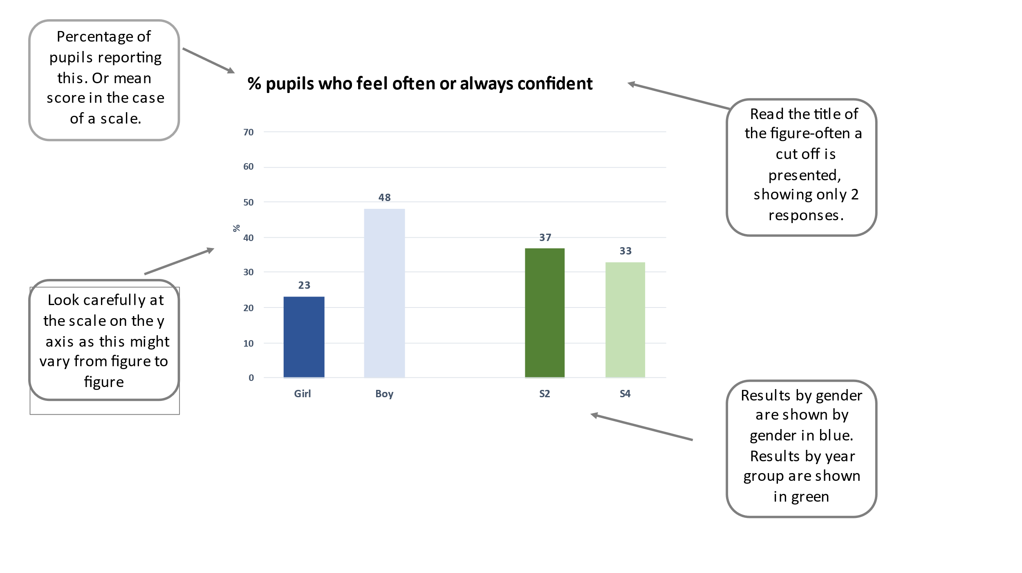

# Your school’s participation in the survey

Trying to not split here

Pupils in S2 and S4 classes in your school took part in the survey during November and December 2021. Table 1 shows the number of pupils participating by year group and gender. One pupil did not provide their year group and three pupils did not provide their gender.

Table 1: Overview of survey respondents

**Table** **1**: economics table

| sex | 15 year-olds |
| --- | --- |
| Boy | 15 |
| Girl | 4 |

And another table

|  |  |  |
| --- | --- | --- |
|  | S2 | S4 |
| **Girls** | 10 | 144 |
| **Boys** | 1959 | 8 |

Figure 1 - test caption

Figure 1: % pupils who report good or excellent health

And some more text

## Heading 2 with split

# References example format

Example text for smaller references,

No spaces between paragraphs