Data Representation

Lab 1: Create HTML page

Lecturer: Andrew Beatty

Create a html page that looks like this:

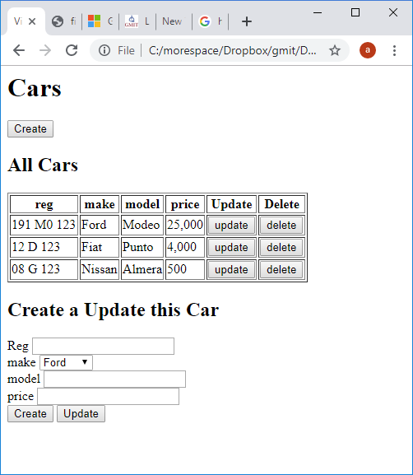

1. Create a web page called carviewer.html, and put in the standard head and body tags, Test your code, by opening up in a web browser

<html>

    <head>

        <title>View cars</title>

    </head>

    <body>

    </body>

</html>

1. Put a header and three <div> tags, one for each section;
   1. The create button
   2. The table
   3. The form

        <h1>Cars</h1>

        <div>create button</div>

        <div>

           table

        </div>

        <div>

           form

        </div>

1. Write the code for the create button

<button>Create</button>

1. Write the code for the table,
   1. you can do just the header first

<table border="1">

                    <tr>

                            <th>reg</th>

                            <th>make</th>

                            <th>model</th>

                            <th>price</th>

                            <th>Update</th>

                            <th>Delete</th>

                    </tr>

            </table>

* 1. and then all each row (same html just different data)

                    <tr>

                            <td>191 M0 123</td>

                            <td>Ford</td>

                            <td>Modeo</td>

                            <td>25,000</td>

                            <td><button>update</button></td>

                            <td><button>delete</button></td>

                    </tr>

1. Write the code for the Form <div> we won’t need the form tag for this just the inputs

                    Reg <input type="text" name="reg"><br/>

                    Make <select name="make">

                            <option value="Ford">Ford</option>

                            <option value="Fiat">Fiat</option>

                            <option value="Nissan">Nissan</option>

                        </select><br/>

                    Model <input type="text" name="model"><br/>

                    Price <input type="number" name="price"><br/>

1. Create the two buttons, I have put these in a span tag because only one will be displayed later (when we put in functionality)

  <span><button>Create</button></span>

  <span><button>Update</button></span>

1. And the same for the title.

<h2><span>Create a</span> <span>Update this</span> Car</h2>

## Extra:

Make it look nicer by including bootstrap,

The documentation for is at [https://getbootstrap.com](https://getbootstrap.com/)

1. Put this “magic” line in your header (this is called CDN), cut and paste this line from here, or [https://getbootstrap.com](https://getbootstrap.com/)

<link rel="stylesheet" href="https://stackpath.bootstrapcdn.com/bootstrap/4.3.1/css/bootstrap.min.css" integrity="sha384-ggOyR0iXCbMQv3Xipma34MD+dH/1fQ784/j6cY/iJTQUOhcWr7x9JvoRxT2MZw1T" crossorigin="anonymous">

1. Add a class attribute to the table with value “table”, and take away the border=”1” attribute, details about this are on <https://getbootstrap.com/docs/4.3/content/tables/>

<table class="table">

1. You can explore how to make forms look nice here <https://getbootstrap.com/docs/4.3/components/forms/>. You make need to add the CDNs for jquery and javascript that were on the first page

We could spend the whole course looking at bootstrap, don’t get too lost down this rabbit hole 😊