|  |
| --- |
|  |
| RoboDactyl Escape |
| Group: G8 |
| Final Project |
| **Andrew Berls:** andrew.berls@gmail.com  **Billy Galarpe:** billygalarpe@yahoo.com  **Bryce Filler:** bfiller23@gmail.com |
| **3/16/2012** |

|  |
| --- |
|  |

## Vision

To combat the ever-growing problem of world boredom and listlessness, we will create a hosted browser-based game accessible to anybody with internet access and a compatible browser. The game will take the popular form of a side-scrolling platformer, constantly scrolling through a variety of scenes and levels. The user controls a flying character and attempts to scroll to the end of the game without being defeated by various enemies.

# Description

RoboDactyl Escape is a side-scrolling videogame in which the player controls a flying robot pterodactyl with the keyboard. As the game scrolls through the various levels, the player is under constant attack by ground-based enemies such as scientists and hunters. The player has a set number of lives and the ability to drop projectiles as a weapon. There are two levels implemented: the lab where RoboDactyl was created, and the jungle surrounding the lab.

# Story

The military has recruited the best scientists in the world in an attempt to create an augmented cyborg-pterodactyl superweapon. However, the experiment has gone awry – the RoboDactyl creation has gained sentience and free will and is now making a mad dash for freedom. Can you escape the confines of the high-security lab and survive the densely packed jungle to live in sunny tropical peace?

Sequence Diagram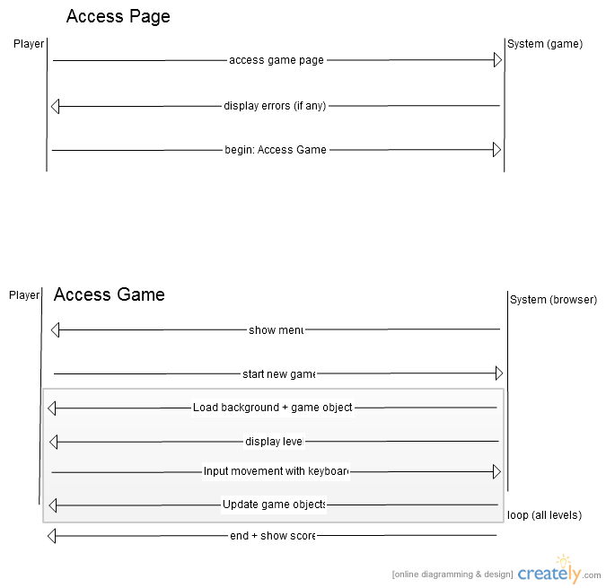

## State Diagram

## Contracts: Access Page

**Contract**: Access Page

**Preconditions**: User has a browser and an internet connection

**Postconditions**: System checks browser compatibility, e.g., HTML5 and JavaScript support

**Contract**: Display browser errors

**Preconditions**: User has accessed the game page and system has determined browser incompatibilities

**Postconditions**: Page display appropriate error message if necessary

## Contracts: Access Game

**Contract**: Show menu

**Preconditions**: No errors have been detected in the user’s browser

**Postconditions**: A menu with options is displayed to the user to choose from

**Contract**: Start game

**Preconditions**: Player has chosen to start the game from the menu

**Postconditions**: The first level has been loaded and rendered

**Contract**: Load level

**Preconditions**: The player has either chosen to start the game or begin the next level in an existing game

**Postconditions**: The background and all level objects (enemies, powerups, etc) have been drawn to the screen

**Contract**: Track user input

**Preconditions**: There is an existing game not in a menu or endgame state, and the player has control of the sprite

**Postconditions**: The system tracks keyboard input from the player and updates game objects accordingly

**Contract**: End and show score

**Preconditions**: The player character has died or reached the end of the game

**Postconditions**: A menu object is rendered displaying the player’s attained score and an option to restart the game

(Class Diagram on following page)Class Diagram

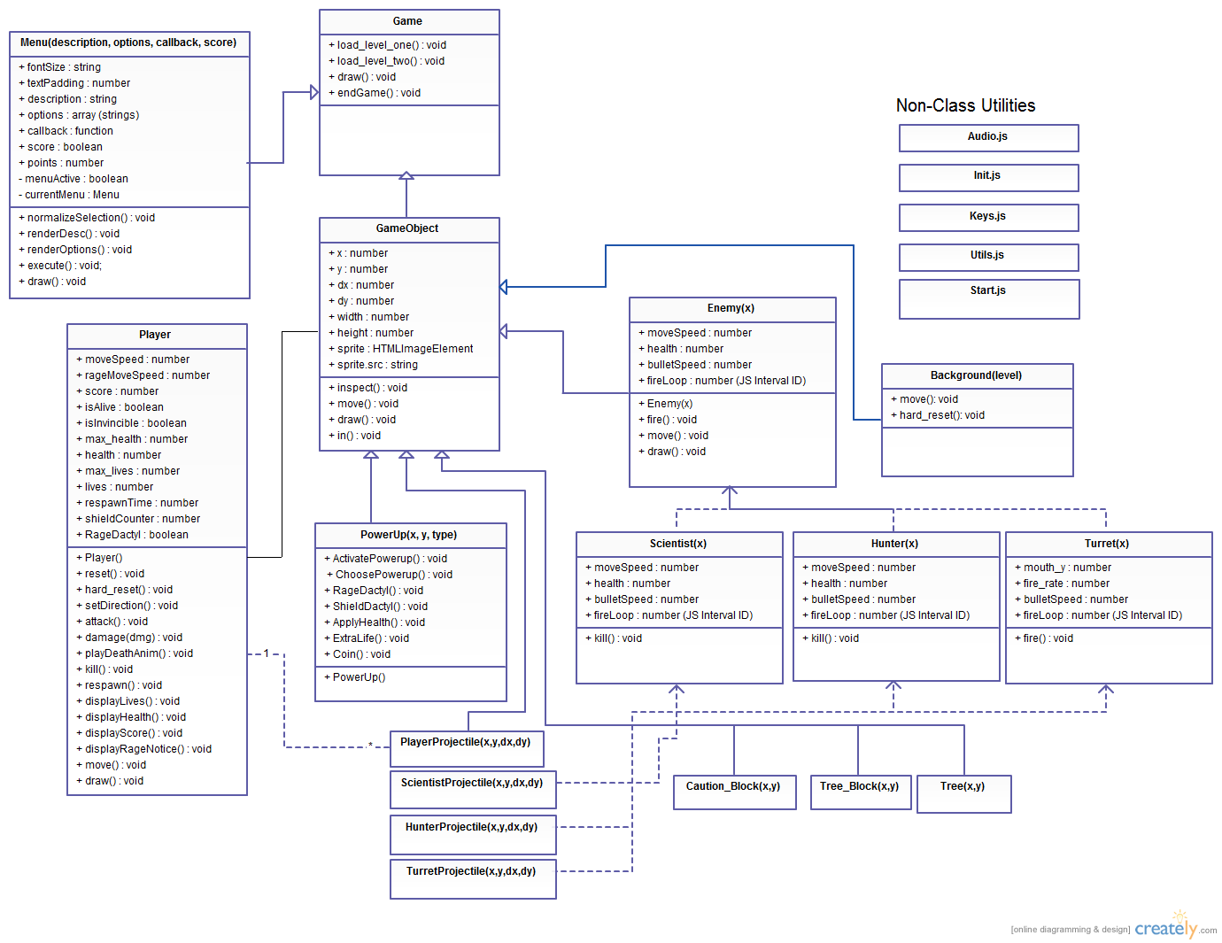

State Diagram

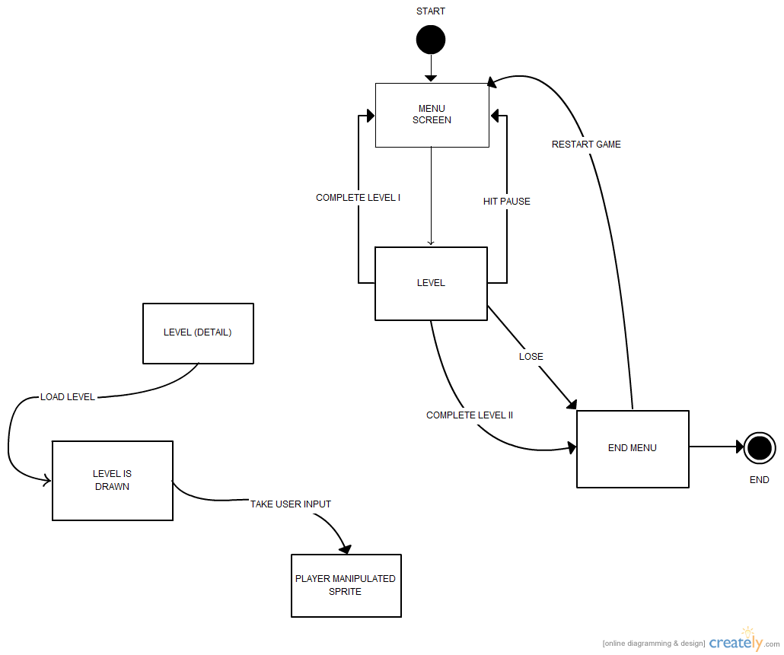

**Glossary**

* **Player**: Synonymous with user; the person accessing the game page
* **Game**: Wrapper for browser-based interactions with the canvas element and its display
* **Control**: The ability of the user to input predefined game actions using the keyboard
* **RoboDactyl**: The game entity controlled by the player
* **RageDactyl**: An infuriated state in which RoboDactyl is able to shoot fireballs and destroy enemies simply by running over them for extra points
* **Enemies**: Game entities who attempt to "kill" the player character, such as Scientists or Hunters
* **Turret**: A stationary enemy that fires a steady stream of projectiles in one direction
* **Level:** A discrete portion of the game with a certain theme (for example, the lab or the jungle)
* **Projectile:** The weapon the player uses to fight game enemies
* **Block (obstacle):** A fixed terrain point that the player can run into, causing either a life to be lost, or the end of the game if all lives depleted
* **Powerup:** Objects that the player can 'pick up' by flying through to temporarily enhance abilities or restore health points. Powerups include extra health/lives, “RageDactyl” mode, shields, and coins for extra points.
* **Hitpoints/Health Points:** Each life has a fixed number of "health points", which are reduced or lost completely when the user takes damage from enemy attacks or obstacles
* **Life (lives):** Each game consists of a fixed number of lives that are lost when the player loses a defined number of hitpoints. If all lives are lost during gameplay, the game ends and the player is given the option to restart the game.
* **Respawn**: If a player dies during a level and still has lives remaining, they will reappear at predetermined previous checkpoint with one less life and continue with gameplay as normal
* **Score**:A metric to track player’s success in defeating enemies and grabbing powerups, which increases as the player progresses further and further through the game levels.
* **Menu** – A screen presenting various choices for the user, such as “Begin Level” or “Restart Game”
* **HUD** - A persistent display on the screen that displays information such as the player’s health, current active powerups, and lives remaining