

Betavine Mobile Connect Concepts - 2009 -2010

Building Repositories For Linux - (Reloaded)

In the short to medium term we want to extend the 'repository' model for all of the best selling Linux Netbooks. This includes the Acer Aspire One, Lenevo and MSI Wind.

In the near future we believe we should also be involved in the Moblin project which is an open source venture funded mainly by Intel. And also the ARM initiative to push an ARM Netbook running Linux.
Both projects have the backing of large blu-chip companies, and our guess is this is a safe option for those industries to establish a relationship with the end customer as opposed to building a piece of hardware that run's Windows. In a way it's 'full cycle' in that the manufacturer is now clawing his way back into the sale loop, and gives the possibility to improve a margin on what is already a commodity product.

By engaging both these projects we may be able to get the Betavine Mobile Connect connection manager application into the 'repositories' controlled by the respective groups. It will also foster a bridge to the Linux communities working on those projects, let them know Betavine exists, let us know what is active and current, and give us the possibility to push other Linux applications.

At a business level, it would mean we could utilise a Linux platform and easily customise sections of the stack making it our own. Hence if the MID market was to grow as analysts are predicting we would not depend on pushing a Microsoft or Symbian platform and the extra cost that this incurs. This could either be reflected in the profit margin in the device to Vodafone or by total cost to us in cross funding them.
I believe there may be some political sensitivity around this due to Vodafone's current strategy with LiMo, however this should not really be a worry since we are talking about Netbooks and MID's.

Building Repositories for POLD

We see it as one of our priorities to create repositories for 'Plain Old Linux Distributions' (POLD) having now overwhelming evidence of people on the Linux forums and even contact from our retail outlets with users taking standard machines and installing Linux on them, then attempting to install our VMC application.
Linux is now being used by a growing number of users who are not that familiar with the operating system, warts and all! We should take this as an opportunity, this market is 'up for grabs' and currently Betavine is the world leader in connecting Linux to wireless.

Communities and Engagement

Again as we progress and feel our way with Open Source we are now seeing a growing number of users eager to help in the project. This has been mainly in the testing of new builds, requesting of new features, and the creation of plugins to work with new cards.
We believe that this section of our site should have a greater percentage of 'how to' type pages, guides and 'get up and running' type content. We have already created a good make file system to allow building of the VMC for different target architectures, and allowed anonymous checkout . This information should be easily accessible to encourage open source development in the future, we are considering a good WIKI.
Betavine also think we need to work with developers and small companies who are close to the coal face in connectivity type applications. This is one of the reasons why we are working with Warp in a project to include 'Wader' core. This will allow the Mobile Connect application to use D-Bus, and involve us more with the Linux MID projects (see first point on Mobilin) by Mobilin.
Furthermore, by working directly with Open Source developers it allows us to steadily build up credibility. What is important to stress however is that we don't take a 'hands off' approach. We have to have 'developers' who can code to work on these types of projects. To have a project, product, or technical manager to fire some money at a project and produce a pretty gannt chart, some slides and a spread sheet will not cut'it in the Open Source arena. You have to be equally as technically competent and willing to get dirt under your finger nails in helping to solve problems and contribute. It's the 'Open Source Way' I suppose!

Creation Of SMS API's

One of the areas that can be improved is to allow other applications to access messaging capabilities of our Network. Typically in the WEB 2.0 world this has been done by an App accessing a web service via HTTP to allow it to directly send SMS.
However, in our 'Connected Netbook' world why bother! You have a device that can inject SMS into an SS7 network at your disposal. We see it as a fundamental shift in mind set that the app on the host uses our API's we expose to send the SMS. Reasons why this could be a good thing for us:
- We would be driving innovation by pushing this technology.
- It would put SMS messaging back at the centre of how people 'chat'. I.e. A use case would be an IM client using SMS rather than a Microsoft, Google, or Yahoo IM server to send and deliver messages.
- It could provide us with some valuable IP in this area. Betavine are currently investigating this at the minute.
- It reduces network traffic in IM. A typical message send with IM as opposed to SMS is 10's of times larger. In fact the data channel is not even used to send an SMS.
- Even with bundled SMS, the profit of delivering and sending an SMS is greater than the respective IM. However in a use case where SMS is a replacement we would have to be 'creative' in how we bundled such a service. In a 'use-case' where the user is using SMS as the preferred method (e.g. The person you are sending a message to is not on line, but does have a mobile.) we don't really care about the billing.

Creation of a New GUI Concept

The connection manager has been seen as an application which like any other has a typical window interface and which like any other can be minimized or maximized. All of the functions and features of the data card are delivered through that interface – even though it might not be the way a user normally interacts or wishes to interact with that feature (e.g. Messaging).

We believe that the interface can be overhauled to provide a much more intuitive model for the user. I've chosen to represent this as a desktop widget on KDE-4. I'd like to make it clear to the reader this is not in any way the same as a Mobile Widget being pushed for mobiles.
The 'widget' analogy is being used because it represents a real world device on the desktop. The user can interact with the virtual object, and should intuitively know how to get to the attributes and functions it exposes.

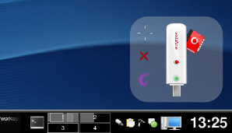
In this example the datacard is represented by the SVG object. I can see that it is connected via GPRS due to the green light and that I have an active profile.

By selecting the profile I'll be able to change it. The object does not take up a large amount of real estate, but can convey a lot of information at a glance and does not require me to open up a task bar icon.

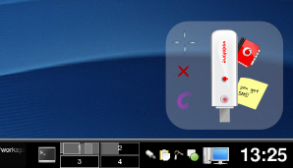
My datacard now has received an SMS and is in off line mode.

To read my SMS I can select my SMS icon to get an interface to the SMS app.

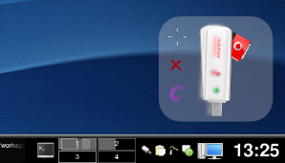
Other visual clues can be expressed in such an interface such as a vibrating card to indicate an SMS arriving.

This can be extended to show a usage bar, duration limits and power levels which I've not shown.

It is clear that the interface has and does exhibit the same form factor, and show in a graphical way some of the features and functions that a user would expect to use.

Even to display something like multiple SMS messages in the inbox can be done by a single 'sticky-note' metaphor shown below. Using an interface in such a way reduces screen real estate which can be important on devices like 'Netbooks', and allows the user to control connectivity easily. It's a new way of thinking about our interface, but not new to many desktop widgets already available. It's between a full blown window app with menu system and miniature background task tray application.

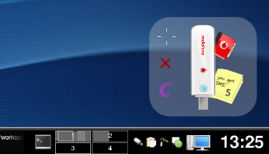

Betavine do not believe that this should be a widget built exclusively for Linux or on the KDE4 desktop. However, it may be a good starting point to prototype such an app. Longer term the inclusion of Wader core will mean that the VMC application will work on OSX (Mac) this will allow us to further explore building this interface to work across Operating Systems.

