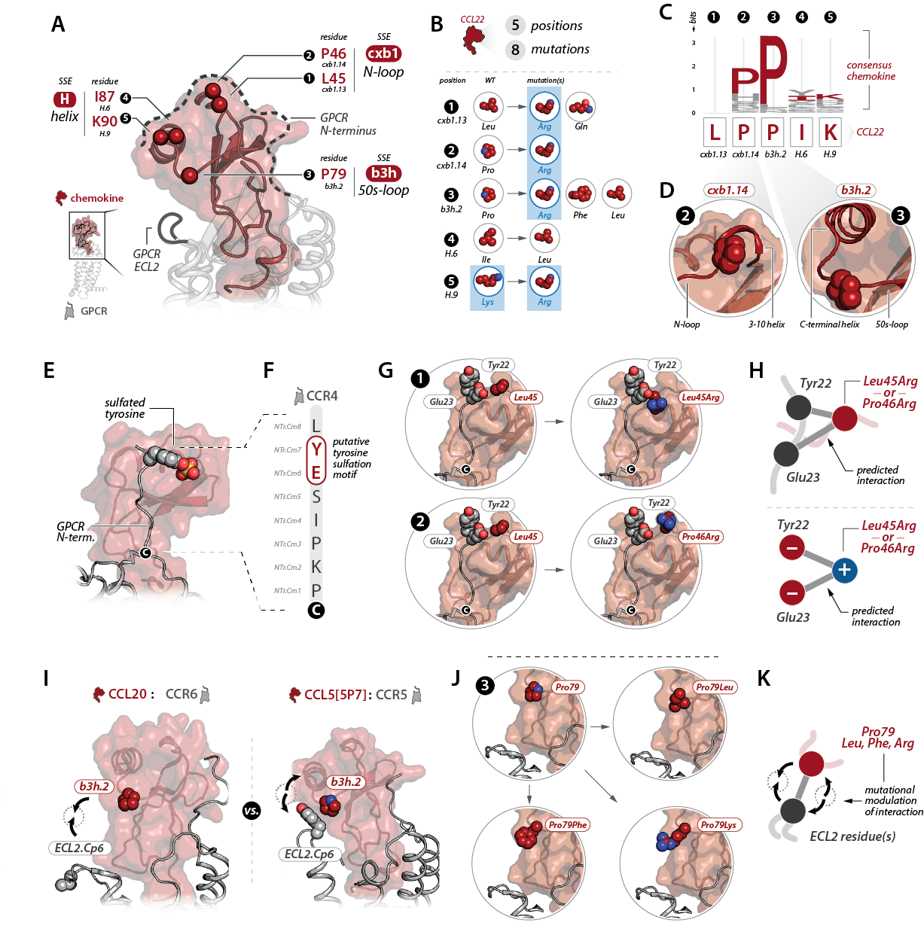

Figure 1. Inferring functional roles for mutated residues in CCL22-CCR4 interactions.

Figure 1. Inferring functional roles for mutated residues in CCL22-CCR4 interactions. (A) A representative chemokine-GPCR complex (PDB 5UIW) depicting the positions of the mutated residues on the chemokine structure as spheres. Residues are labeled by number as well as with their corresponding Common Chemokine Numbering (CCN) nomenclature (e.g., cxb1.13). Residue secondary structural elements (SSEs) are labeled with common names below. (B) 8 mutations were identified in CCL22 at 5 positions (top). The positions at which each mutation occurs are indicated with numbers 1-5 as well as CCN designations, WT residues, and mutated residues. Basic residues are highlighted with blue. (C) Sequence logo depicting residue conservation among human chemokine paralogs at the five mutated positions. (D) Structural context of the two conserved Proline residues; both occur in loops adjacent to alpha helices. (E) Chemokine-GPCR model of the CCL5-CCR5 complex (Zheng, et al. 2017. Immunity) depicting sulfated chemokine receptor N-terminus. (F) CCL4 N-terminus with CCN designations on the left and putative sulfotyrosine motif labeled. (G) Structural depiction of L45R (top) and P46R (bottom) mutations relative to positions of the putative CCR4 sulfotyrosine motif (made using Zheng, et al. 2017 model). (H) Mutations to basic residues at CCL22 residues 45 or 46 would likely enhance CCL22 interactions with CCR4 N-terminus via electrostatic interactions with E23 and sulfated Y22. (I) Comparison of CCL20-CCR6 and CCL5[5P7]-CCR5 chemokine-GPCR complexes reveals that the residue at CCN position b3h.2 interacts with the receptor residue at position ECL2.Cp6 in the CCL5[5P7]-CCR5 complex but not the CCL20-CCR6 complex due to different orientations of the chemokine and receptor to one another (arrows). (J,K) Mutation of the CCL22 residue at position b3h.2 may promote or disrupt interactions with residues in ECL2 of CCR4 depending on the residue mutation.

Inferring functional roles for mutated residues in CCL22-CCR4 interactions.

Identified CCL22 mutations were mapped onto chemokine-GPCR complexes to infer functional roles for mutations in CCR4 recognition. Broadly, mutations cluster into three secondary structural elements (SSEs), including the N-loop (i.e. cxb1 using the Common Chemokine Nomenclature, CCN), the 50s-loop (i.e. b3h), and the C-terminal alpha helix (i.e. H) (Figure 1A). In these regions, identified CCL22 mutations are likely to impact CCR4 recognition through altered interactions with the CCR4 N-terminus and extracellular loop 2 (ECL2) based upon the known architecture of chemokine-GPCR complexes (Figure 1A).

Eight distinct mutations were identified at five sites, including two mutations at Leu45 (CCN position cxb1.13), one mutation at Pro46 (CCN cxb1.14), three mutations at Pro79 (CCN b3h.2), one mutation at Ile87 (CCN H.6), and one mutation at Lys90 (CCN H.9) (Figure 1B). Notably, mutations at all but one of these sites include substitutions of basic residues. Importantly, chemokines are enriched in basic residues, which facilitates interactions with negatively charged glycosaminoglycans (GAGs) in the formation of chemokine gradients.

Comparison of residue conservation among human chemokine paralogs reveals that two of the five sites mutated are comprised of conserved prolines (Figure 1C). Both prolines occur in chemokine loop regions, and closer inspection suggests that they form structural roles by facilitating sharp turns, which, in both cases, precede alpha helices (Figure 1D).

Chemokine receptors are known to undergo sulfation at tyrosine residues in the receptor N-terminus, and sulfated tyrosine residues (sTyr) help form key interactions for chemokine recognition (Figure 1E). sTyr modifications occur at tyrosines adjacent to acidic residues. Examination of the CCR4 N-terminus reveals a Tyr-Glu motif in the receptor N-terminus, suggesting that this motif may undergo sTyr modification (Figure 1F). The location of the putative sTyr motif was mapped onto an existing chemokine-GPCR complex (i.e. CCL5-CCR5; see Zheng, et al. 2017) and compared with that of the identified CCL22 mutations. Of note, mutations at chemokine positions cxb1.13 and cxb1.14 to basic residues would be likely to place these basic residues in close proximity to positively charged

