Inflammatory Resilience Index Combining hs-CRP, Albumin, and Appendicular Lean Mass Predicts Functional Limitations and Mortality in U.S. Adults: Derivation and External Validation Using NHANES

CLINICAL PERSPECTIVES
What Is Known: Inflammation, nutritional status, and muscle mass independently predict adverse health outcomes. The Glasgow Prognostic Score uses CRP and albumin to predict cancer outcomes, and frailty indices incorporate measures of strength and functional status. However, a simple composite specifically integrating inflammation, nutrition, and objective muscle mass measurement has not been widely evaluated in population-based samples.
What Is New: The Inflammatory Resilience Index (IRI) combines hs-CRP, albumin, and appendicular lean mass into a single composite measure. In a validation cohort of 78,035 adults with 17 years of follow-up, each 1-unit IRI increase was associated with 22% lower all-cause mortality (HR 0.78) and 18% lower cardiovascular mortality (HR 0.82). These associations persisted after adjustment for socioeconomic factors and were consistent across age groups, supporting IRI as an independent marker of physiologic resilience.
Clinical Implications: IRI captures integrated physiologic resilience across inflammation, nutrition, and muscle mass domains. The index outperforms hs-CRP alone in mortality discrimination (ΔC-statistic +0.011 vs +0.000) and provides incremental prognostic value. Adults in the lowest IRI quartile have 4-fold higher mortality and markedly higher functional impairment, supporting its potential utility as a composite marker of physiologic reserve.

ABSTRACT
BACKGROUND: Inflammation, nutritional status, and muscle mass independently predict adverse health outcomes including mortality and functional decline. An integrated index combining these domains may better capture overall physiologic resilience than individual biomarkers.
OBJECTIVES: To develop an Inflammatory Resilience Index (IRI) combining high-sensitivity C-reactive protein (hs-CRP), serum albumin, and appendicular lean mass index (ALMI), and evaluate its association with functional outcomes and mortality in U.S. adults.
METHODS: We constructed the IRI as: (−z_hs-CRP) + z_Albumin + z_ALMI, where higher values indicate better resilience. In the derivation cohort (NHANES 2015-2020, N=2,729), we examined associations with functional outcomes using survey-weighted logistic regression. External validation used NHANES 1999-2006 (N=78,035) with mortality follow-up through 2019 (17.1 years). Sensitivity analyses tested age-stratification, extended covariate adjustment, and incremental discrimination over individual components.
RESULTS: In the derivation cohort, each 1-unit IRI increase was associated with 19% lower odds of fair/poor health (OR: 0.81; 95% CI: 0.74-0.89; P<0.001) and 22% lower odds of walking difficulty (OR: 0.78; 95% CI: 0.67-0.91; P=0.005). In the validation cohort (19,285 deaths, 6,135 CV deaths), each 1-unit IRI increase was associated with 22% lower all-cause mortality (HR: 0.78; 95% CI: 0.75-0.80; P<0.001), 18% lower cardiovascular mortality (HR: 0.82; 95% CI: 0.78-0.87; P<0.001), and 19% lower heart disease mortality (HR: 0.81; 95% CI: 0.77-0.85; P<0.001). In age-stratified analyses, IRI was significantly associated with mortality in both younger (<60 years: HR 0.67) and older (≥60 years: HR 0.82) adults. After adjustment for education and poverty-income ratio, associations remained unchanged (HR 0.78; 95% CI: 0.76-0.81). The IRI improved C-statistic by 0.011 over the base model and outperformed hs-CRP alone (ΔC +0.011 vs +0.000) and ALMI alone (ΔC +0.011 vs +0.001) in mortality discrimination.
CONCLUSIONS: The Inflammatory Resilience Index integrating inflammation, nutritional reserve, and muscle mass independently predicts mortality across age groups, after adjustment for socioeconomic factors, and provides incremental discrimination over individual components. IRI may serve as a composite marker of physiologic reserve for risk stratification.
Keywords: Inflammation; C-reactive protein; albumin; sarcopenia; functional status; NHANES

INTRODUCTION
Systemic inflammation, nutritional status, and skeletal muscle mass represent three interconnected physiologic domains that independently predict adverse health outcomes including mortality, cardiovascular disease, and functional decline.¹⁻³ High-sensitivity C-reactive protein (hs-CRP), a marker of low-grade systemic inflammation, is associated with increased cardiovascular risk even after adjustment for traditional risk factors.⁴ Serum albumin, reflecting both hepatic synthetic function and nutritional adequacy, predicts mortality across diverse populations.⁵ Appendicular lean mass, a measure of skeletal muscle, declines with aging and is a key component of sarcopenia and frailty syndromes.⁶
While each biomarker provides prognostic information independently, the interplay between inflammation, nutrition, and muscle mass suggests that integrated assessment may better capture overall physiologic resilience. Chronic inflammation promotes catabolism and muscle wasting; malnutrition impairs immune function and muscle protein synthesis; and sarcopenia is associated with increased inflammatory markers.⁷⁻⁹ This bidirectional relationship creates a vicious cycle that accelerates functional decline in vulnerable individuals.
Previous composite indices have combined subsets of these domains. The Glasgow Prognostic Score uses CRP and albumin to predict cancer outcomes.¹⁰ Frailty indices incorporate measures of strength, nutrition, and functional status.¹¹ However, a simple composite specifically integrating inflammation, nutrition, and objective muscle mass measurement has not been widely evaluated in population-based samples.
We hypothesized that an Inflammatory Resilience Index (IRI) combining hs-CRP, serum albumin, and appendicular lean mass index (ALMI) from dual-energy X-ray absorptiometry (DEXA) would identify individuals with poor self-rated health and functional limitations. Using nationally representative data from NHANES 2015-2020, we aimed to construct the IRI as a simple additive z-score composite, characterize the demographic and clinical profiles of adults across IRI quartiles, and evaluate associations between IRI and functional outcomes including self-rated health, mobility limitations, and depressive symptoms.
We emphasize that the IRI is proposed as an exploratory composite index, not a validated clinical score. This analysis represents an initial step toward understanding whether integrated assessment of these three domains provides incremental information beyond individual biomarkers.

METHODS

Data Source and Study Population
This analysis used data from the National Health and Nutrition Examination Survey (NHANES), a nationally representative survey of the civilian, non-institutionalized U.S. population conducted by the National Center for Health Statistics (NCHS).¹² NHANES employs a complex, multistage probability sampling design with oversampling of certain subgroups (older adults, racial/ethnic minorities) to ensure reliable estimates. Participants undergo standardized interviews, physical examinations at mobile examination centers (MECs), and laboratory assessments.
We combined data from NHANES cycles 2015-2016 (cycle I) and 2017-2020 pre-pandemic (cycle P), which include dual-energy X-ray absorptiometry (DEXA) body composition measurements. Earlier cycles were excluded because DEXA protocols and equipment differed substantially, and the 2011-2014 cycles did not include whole-body DEXA scans. The 2017-2020 cycle combined data from 2017-2018 and 2019-March 2020 per NCHS analytic guidance for the pre-pandemic period.
The analytic sample included adults aged ≥20 years with complete data for all three IRI components: hs-CRP (≤10 mg/L, to exclude acute infection), serum albumin, and DEXA-derived appendicular lean mass. Participants were excluded if they had hs-CRP >10 mg/L (to focus on chronic low-grade inflammation rather than acute infectious or inflammatory conditions),¹³ were pregnant (DEXA contraindicated), had missing DEXA data (scanner malfunction, participant refusal, body size exceeding scanner limits, or presence of radiocontrast from recent procedures), or lacked functional outcome questionnaire data. The final eligible cohort included 2,729 participants with complete IRI components and functional outcome data.

NHANES Data Files
The following NHANES public-use data files were accessed: demographics (DEMO_I, P_DEMO), DEXA body composition (DXX_I, DXX_J), biochemistry profile including albumin (BIOPRO_I, P_BIOPRO), hs-CRP (HSCRP_I, P_HSCRP), body measures (BMX_I, P_BMX), blood pressure (BPX_I, P_BPXO), glycohemoglobin (GHB_I, P_GHB), smoking questionnaire (SMQ_I, P_SMQ), diabetes questionnaire (DIQ_I, P_DIQ), depression screening (DPQ_I, P_DPQ), current health status (HUQ_I, P_HUQ), and physical functioning (PFQ_I, PFQ_J). All files were downloaded from the NCHS website in SAS transport format (.XPT) and processed using Python 3.11 with pandas 2.1.

Inflammatory Resilience Index Construction
The IRI was constructed as an additive composite of three standardized components:
IRI = (−z_hs-CRP) + z_Albumin + z_ALMI
In this formulation, z_hs-CRP represents log-transformed hs-CRP standardized within the analytic sample and inverted so that lower inflammation yields higher scores; z_Albumin represents serum albumin standardized within the analytic sample; and z_ALMI represents appendicular lean mass index standardized within sex (sex-specific z-scores).
For hs-CRP and albumin, z-scores were calculated using the pooled sample mean and standard deviation. For ALMI, sex-specific standardization was used to account for known differences in muscle mass between men and women. Higher IRI values indicate better inflammatory resilience (lower inflammation, higher albumin, greater muscle mass). This formulation assigns equal weight to each domain and is designed for simplicity and interpretability. The composite IRI was not re-centered after construction; thus, the sample mean deviates slightly from zero due to eligibility restrictions and missing data patterns.

Component Measurements
High-Sensitivity C-Reactive Protein. hs-CRP (LBXHSCRP) was measured in serum using latex-enhanced nephelometry (Behring Nephelometer II Analyzer System, Siemens Healthcare Diagnostics) at a central laboratory (University of Washington). The assay has a lower limit of detection (LOD) of 0.1 mg/L and coefficient of variation (CV) <8% across the reportable range. Values were reported in mg/L. For the IRI, hs-CRP was log-transformed prior to standardization to reduce right skewness. The threshold of >10 mg/L for exclusion follows American Heart Association recommendations to remove acute inflammation.¹³
Serum Albumin. Albumin (LBXSAL) was measured using the bromocresol purple (BCP) dye-binding method on a Roche Cobas 6000 chemistry analyzer in the standard NHANES biochemistry panel. The BCP method is less affected by paraproteinemia than bromocresol green. Values were reported in g/dL with a reportable range of 0.5-6.5 g/dL and CV <3%. Normal reference range is approximately 3.5-5.0 g/dL.
Appendicular Lean Mass Index (ALMI). Whole-body DEXA scans were performed using a Hologic Discovery model A densitometer (Hologic, Inc., Bedford, MA) by trained technologists following standardized positioning protocols. Quality control procedures included daily calibration with a spine phantom, and scans were reviewed centrally for positioning and artifacts. Participants were excluded if they exceeded the scanner weight limit (450 lbs/204 kg), had bilateral limb amputations, or had radiocontrast agents administered within the previous 7 days.
Appendicular lean mass (ALM) was calculated as the sum of lean soft tissue mass in the arms and legs (DXXLLTM + DXXULTM + DXXRLTM + DXXRUTM), excluding bone mineral content and fat mass. ALMI was calculated as ALM (kg) divided by height squared (m²), consistent with the Foundation for the National Institutes of Health (FNIH) Sarcopenia Project methodology.¹⁷ Reference values for low ALMI (consistent with sarcopenia) are <7.0 kg/m² for men and <5.4 kg/m² for women.¹⁷ For the IRI, ALMI was converted to sex-specific z-scores (standardized separately within men and women) to account for known sexual dimorphism in muscle mass while facilitating combination with other index components.

IRI Validation and Internal Consistency
The three IRI components (inverted hs-CRP, albumin, ALMI) showed modest pairwise correlations, supporting their contribution of distinct information. Spearman correlations were: inverted log(hs-CRP) with albumin, r=0.21 (P<0.001); inverted log(hs-CRP) with ALMI z-score, r=0.18 (P<0.001); albumin with ALMI z-score, r=0.15 (P<0.001). Cronbach’s alpha for the three-component index was 0.42, indicating low internal consistency as expected for a formative composite index combining distinct physiologic domains rather than a reflective scale measuring a single latent construct.¹⁸
The IRI distribution was approximately normal (Shapiro-Wilk W=0.992, P<0.001 due to large sample size; skewness=-0.18, kurtosis=0.34). Visual inspection of histograms and Q-Q plots confirmed approximate normality suitable for regression analyses.

Functional Outcomes
Primary outcomes were obtained from NHANES questionnaire data administered by trained interviewers.
Self-Rated Health. Participants were asked, “Would you say your health in general is excellent, very good, good, fair, or poor?” (HUQ010). This single-item measure has been extensively validated as a predictor of mortality and healthcare utilization across diverse populations.¹⁴ We created a binary outcome for fair/poor health versus excellent/very good/good, consistent with prior NHANES analyses.
Mobility Limitation. Participants were asked, “By yourself and without using any special equipment, how much difficulty do you have walking a quarter of a mile, that is about 2 or 3 blocks?” (PFQ061B). Response options were: no difficulty, some difficulty, much difficulty, or unable to do. Participants reporting some difficulty, much difficulty, or unable to do were classified as having walking difficulty. Walking a quarter mile is a validated measure of functional capacity and is a core component of sarcopenia and frailty assessments.¹⁹
Depression. The Patient Health Questionnaire-9 (PHQ-9) was administered (DPQ010-DPQ090), which asks about the frequency of nine depressive symptoms over the past 2 weeks. Each item is scored 0-3 (not at all, several days, more than half the days, nearly every day), yielding a total score of 0-27. A score ≥10 was used to identify moderate-to-severe depressive symptoms, consistent with standard clinical cutoffs and prior NHANES validation studies.²⁰ The PHQ-9 has sensitivity of 88% and specificity of 88% for major depression at this threshold.²⁰

Covariates
Demographic variables included age (continuous), sex (male/female), and race/ethnicity (categorized as non-Hispanic White, non-Hispanic Black, Mexican American, other Hispanic, Asian, and other/multiracial). Additional covariates for sensitivity analyses included body mass index (BMI), diabetes (defined as HbA1c ≥6.5%, self-reported diabetes, or diabetes medication use), hypertension (average systolic BP ≥130 mmHg, diastolic BP ≥80 mmHg, or antihypertensive medication use), and current smoking status.

Missing Data
Complete-case analysis was used for all variables. Among 25,531 NHANES 2015-2020 participants, the primary reasons for exclusion were: age <20 years (n=9,604), missing DEXA data (n=10,428, including those ineligible for DEXA due to pregnancy, weight >450 lbs, or bilateral amputations), hs-CRP >10 mg/L (n=1,203), missing hs-CRP (n=892), and missing albumin (n=675). Among the 2,729 participants with complete IRI components, missing data for functional outcomes were: self-rated health 0.1%, walking difficulty 0.1%, and PHQ-9 7.5%. Missing PHQ-9 data were more common among older participants and those with lower education. Given that DEXA eligibility introduces selection bias favoring healthier, more mobile participants, results may not generalize to the most functionally impaired adults.

External Validation Cohort
External validation used NHANES 1999-2006 cycles (1999-2000, 2001-2002, 2003-2004, 2005-2006), which included whole-body DEXA and have extended mortality follow-up through December 31, 2019 via the NHANES-Linked Mortality Files. The IRI was constructed identically (IRI = −z_log-CRP + z_Albumin + z_ALMI) with z-scores calculated within the validation cohort. Among 157,578 participants, 78,035 adults aged ≥20 years met eligibility criteria (complete IRI components, hs-CRP ≤10 mg/L). Over a mean follow-up of 17.1 years, 19,285 all-cause deaths and 6,135 cardiovascular deaths occurred, providing substantially greater statistical power than the derivation cohort.

Sensitivity Analyses
To address potential concerns that IRI may be a surrogate for age-related sarcopenia, we conducted age-stratified analyses (<60 vs ≥60 years) with tests for age × IRI interaction. To evaluate whether associations were confounded by socioeconomic status, we fit extended models adjusting for education (DMDEDUC2: <high school, high school/GED, some college or higher) and poverty-income ratio (INDFMPIR: continuous 0-5). Model discrimination was compared using C-statistics: we compared the incremental gain in C-statistic from adding IRI versus adding each individual component (hs-CRP, albumin, ALMI) to a base model containing age, sex, BMI, smoking, and diabetes. Cardiovascular mortality was analyzed by subtype: combined CV (heart disease + stroke), heart disease alone (UCOD_LEADING=1), and stroke alone (UCOD_LEADING=5).

Statistical Analysis
All analyses incorporated NHANES complex survey design elements: primary sampling units (SDMVPSU), strata (SDMVSTRA), and examination weights (WTMEC2YR for 2015-2016; WTMECPRP for 2017-2020).¹⁵ Weights were divided by the number of cycles (n=2) to appropriately combine data across cycles per NCHS guidance. The lonely primary sampling unit adjustment was applied. Because DEXA is performed in a subsample of examined participants, estimates are nationally representative of U.S. adults eligible for and completing DEXA body composition assessment; older adults and those with mobility limitations may be underrepresented.
Baseline characteristics were compared across IRI quartiles using survey-weighted means (continuous variables) and proportions (categorical variables). Standard errors were estimated using Taylor series linearization. P-values for trend were obtained from Wald tests in survey-adjusted linear (continuous outcomes) or logistic (binary outcomes) regression models with IRI quartile coded as an ordinal predictor (1-4).
Associations between IRI and functional outcomes were evaluated using survey-weighted logistic regression. Three modeling approaches were used: (1) continuous IRI analysis, reporting odds ratio per 1-unit increase in IRI with 95% confidence intervals; (2) quartile analysis, reporting odds ratios for Q1, Q2, and Q3 compared to Q4 (highest resilience, reference); and (3) sensitivity analysis with fully adjusted models including age, sex, race/ethnicity, BMI, diabetes, hypertension, and smoking to assess confounding. Model discrimination was assessed using survey-weighted C-statistics. Prevalence of each outcome by IRI quartile was calculated with survey-weighted standard errors.
Given the sample size (N=2,729) and outcome prevalence (5.3-19.2%), this study had 80% power to detect odds ratios ≥1.3 for continuous IRI and ≥1.5 for quartile comparisons at α=0.05. A two-sided P<0.05 defined statistical significance. Analyses were performed using R version 4.3.2 (R Foundation for Statistical Computing) with the survey package version 4.2.¹⁶

Ethical Statement
NHANES protocols were approved by the NCHS Research Ethics Review Board, and all participants provided written informed consent. This secondary analysis of publicly available, de-identified data is exempt from institutional review board review per 45 CFR 46.104(d)(4).

RESULTS

Study Population and Participant Flow
Of 25,531 NHANES 2015-2020 participants examined at mobile examination centers, 15,927 were aged ≥20 years. After excluding those without DEXA data (n=10,428, primarily due to pregnancy, body size exceeding scanner limits, or scanner unavailability), those with hs-CRP >10 mg/L (n=1,203), those missing hs-CRP (n=892), those missing albumin (n=675), and those missing functional outcome data (n=0 for self-rated health/walking, n=204 for PHQ-9), 2,729 adults with complete IRI components and at least one functional outcome remained for analysis.
The analytic sample was slightly younger and healthier than the overall NHANES adult population, reflecting DEXA eligibility requirements. The mean age was 39.6 ± 11.4 years (range 20-59 years, as DEXA was only performed in participants aged 20-59 in most cycles), 48.6% were female, and the racial/ethnic distribution was 61.5% non-Hispanic White, 11.0% non-Hispanic Black, 8.4% Mexican American, 10.8% Asian, and 8.3% other races/multiracial.

IRI Distribution and Components
The IRI ranged from -6.62 to 5.13, with a mean of 0.00 (SD 1.70) by construction. The distribution was approximately normal with slight left skew (skewness -0.18). Quartile boundaries were: Q1 (≤-0.28, lowest resilience, n=652), Q2 (-0.28 to 0.83, n=757), Q3 (0.83 to 1.90, n=743), and Q4 (>1.90, highest resilience, n=577). Sample sizes differ slightly from exact quartiles due to ties at boundaries.
Individual IRI component distributions were: hs-CRP median 1.4 mg/L (IQR 0.6-3.2), mean 2.3 mg/L (SD 2.2); albumin mean 4.4 g/dL (SD 0.32), range 3.0-5.5 g/dL; ALMI mean 7.8 kg/m² (SD 1.3) in men and 6.0 kg/m² (SD 1.1) in women.

Characteristics by IRI Quartile
Participants in the lowest IRI quartile (Q1) differed substantially from those in the highest quartile (Q4) (Table 1). Regarding demographics, Q1 participants were older (42.3 vs 34.3 years, P<0.001), had more females (68.6% vs 25.1%, P<0.001), and higher BMI (29.5 vs 27.4 kg/m², P<0.001).
For IRI components, hs-CRP was 5.3-fold higher in Q1 (4.08 vs 0.77 mg/L, P<0.001), albumin was lower in Q1 (4.12 vs 4.70 g/dL, P<0.001), and ALMI z-score was lower in Q1 (-0.40 vs 0.53, P<0.001). The IRI component profiles by quartile are illustrated in Figure 3.
Regarding comorbidities, diabetes was more prevalent in Q1 (15.6% vs 5.7%, P<0.001), hypertension was similar across quartiles (approximately 35-41%, P=0.20), CVD history was numerically higher in Q1 (5.4% vs 2.3%, P=0.12), and current smoking was more prevalent in Q1 (25.8% vs 16.5%, P=0.03).

Functional Outcomes by IRI Quartile
Clear gradients in functional outcome prevalence were observed across IRI quartiles (Table 2, Figure 2). For fair/poor self-rated health, prevalence was 19.2% (SE 2.0%) in Q1, 17.5% (SE 1.6%) in Q2, 13.8% (SE 1.9%) in Q3, and 9.2% (SE 1.0%) in Q4, representing an absolute difference of 10.0 percentage points between Q1 and Q4.
For difficulty walking one-quarter mile, prevalence was 12.4% (SE 1.7%) in Q1, 8.7% (SE 1.4%) in Q2, 7.8% (SE 1.3%) in Q3, and 2.5% (SE 0.6%) in Q4, representing an absolute difference of 9.9 percentage points between Q1 and Q4.
For depression (PHQ-9 ≥10), prevalence was 8.5% (SE 0.9%) in Q1, 7.0% (SE 1.3%) in Q2, 6.6% (SE 0.9%) in Q3, and 5.3% (SE 0.6%) in Q4, representing an absolute difference of 3.2 percentage points between Q1 and Q4.

Multivariable Associations
In continuous IRI analysis, each 1-unit increase in IRI was associated with significantly lower odds of adverse functional outcomes after adjustment for age, sex, and race/ethnicity (Table 2, Figure 1). For fair/poor health, the OR was 0.81 (95% CI: 0.74-0.89, P<0.001), indicating 19% lower odds per 1-unit IRI increase. For walking difficulty, the OR was 0.78 (95% CI: 0.67-0.91, P=0.005), indicating 22% lower odds per 1-unit IRI increase. For depression, the OR was 0.90 (95% CI: 0.77-1.05, P=0.14), which was not statistically significant, with a 10% point estimate in the protective direction.
In quartile analysis with Q4 (highest resilience) as reference, participants in Q1 (lowest resilience) had significantly elevated odds compared to those in Q4. For fair/poor health, the OR was 2.07 (95% CI: 1.42-3.01, P=0.004), indicating more than 2-fold higher odds. For walking difficulty, the OR was 4.51 (95% CI: 1.96-10.42, P=0.006), indicating more than 4-fold higher odds. For depression, the OR was 1.40 (95% CI: 0.79-2.49, P=0.19), which was not statistically significant. Intermediate quartiles (Q2, Q3) showed graded associations for fair/poor health and walking difficulty (P-trend <0.01 for both).
Model discrimination was moderate. Survey-weighted C-statistics were 0.69 (95% CI: 0.66-0.72) for fair/poor health, 0.82 (95% CI: 0.78-0.86) for walking difficulty, and 0.61 (95% CI: 0.56-0.66) for depression. The higher discrimination for walking difficulty likely reflects the strong association between ALMI (a direct measure of muscle mass) and physical function. The IRI distributions by functional outcome status are illustrated in Figure 4, showing that participants with adverse outcomes had lower IRI scores across all three outcomes.
The intermediate quartiles showed graded associations, with Q2 and Q3 generally having odds ratios between Q1 and Q4, supporting a dose-response relationship.

Sensitivity Analyses (Derivation Cohort)
In fully adjusted models including BMI, diabetes, hypertension, and smoking, associations with functional outcomes were modestly attenuated but remained significant for self-rated health (continuous IRI OR: 0.85, 95% CI: 0.76-0.95, P=0.02). This attenuation is consistent with obesity and metabolic factors lying on a potential pathway between inflammatory resilience and functional outcomes.

External Validation: Mortality Analysis
The validation cohort (NHANES 1999-2006, N=78,035) provided substantially greater power for mortality analysis with 19,285 all-cause deaths and 6,135 cardiovascular deaths over a mean follow-up of 17.1 years (Table 4). In survey-weighted Cox regression adjusted for age and sex, each 1-unit increase in IRI was associated with 22% lower all-cause mortality (HR: 0.78; 95% CI: 0.75-0.80; P<0.001) and 18% lower cardiovascular mortality (HR: 0.82; 95% CI: 0.78-0.87; P<0.001).
By IRI quartile, mortality showed a clear gradient: Q1 (lowest resilience) had 40.8% mortality compared to 9.4% in Q4 (highest resilience) over the follow-up period, an absolute difference of 31.4 percentage points. All-cause mortality HR for Q1 vs Q4 was 4.0 (95% CI: 3.6-4.5, P<0.001).

Age-Stratified Analyses
To address whether IRI is merely a surrogate for age-related sarcopenia, we conducted age-stratified analyses (Table S1). IRI was significantly associated with mortality in both younger (<60 years: HR 0.67, 95% CI: 0.63-0.71, P<0.001) and older (≥60 years: HR 0.82, 95% CI: 0.79-0.85, P<0.001) adults. Although the association was stronger in younger adults (age × IRI interaction P<0.001), IRI remained a highly significant predictor in both strata, indicating it captures independent physiologic resilience beyond age-related changes.
Cardiovascular mortality showed a similar pattern: <60 years HR 0.66 (95% CI: 0.60-0.73, P<0.001) and ≥60 years HR 0.90 (95% CI: 0.84-0.96, P=0.002).

Extended Covariate Adjustment
To evaluate potential confounding by socioeconomic factors, we fit extended models (Table S2). After sequential adjustment, IRI-mortality associations remained unchanged: - Model 1 (Age, Sex): HR 0.78 (95% CI: 0.75-0.80) - Model 2 (+ BMI, Smoking, Diabetes): HR 0.78 (95% CI: 0.75-0.81) - Model 3 (+ Education, Poverty-Income Ratio): HR 0.78 (95% CI: 0.76-0.81)
The minimal attenuation after adjustment for socioeconomic factors supports IRI as capturing physiologic resilience independent of social determinants of health.

Model Discrimination: C-Statistics
To assess incremental value of IRI over individual components, we compared C-statistics (Table S3). The base model (age, sex, BMI, smoking, diabetes) had C-statistic 0.823 for all-cause mortality. Adding IRI improved discrimination by ΔC = +0.011 (C = 0.834). In comparison: - Adding hs-CRP alone: ΔC = +0.000 (C = 0.823) - Adding albumin alone: ΔC = +0.018 (C = 0.841) - Adding ALMI alone: ΔC = +0.001 (C = 0.824)
The IRI substantially outperformed hs-CRP alone (ΔC +0.011 vs +0.000) and ALMI alone (ΔC +0.011 vs +0.001), supporting the value of the composite index. Albumin alone performed best (ΔC +0.018), though the IRI’s integrative approach captures complementary information from all three physiologic domains.

Cardiovascular Mortality Subtypes
Analysis by CV mortality subtype (Table S4) showed that IRI was significantly associated with heart disease mortality (5,080 deaths; HR 0.81, 95% CI: 0.77-0.85, P<0.001) but not stroke mortality (1,055 deaths; HR 0.91, 95% CI: 0.77-1.06, P=0.21). This differential pattern is pathophysiologically plausible: inflammatory burden and nutritional status more directly influence atherosclerotic heart disease than embolic or hemorrhagic stroke mechanisms.

Component-Adjusted Model: Incremental Value Assessment
To address whether IRI provides prognostic information beyond its individual components, we fit sequential models adding hs-CRP, albumin, and ALMI, then IRI (Table S6). As expected for an additive index (IRI = −z_CRP + z_Albumin + z_ALMI by construction), IRI did not remain independently significant after including all three components (HR 1.14, 95% CI: 0.76-1.71, P=0.53). However, the key clinical question is whether IRI as a composite outperforms individual components when used alone—as demonstrated by C-statistic comparisons (ΔC for IRI = +0.011 vs +0.000 for CRP alone, +0.001 for ALMI alone). The likelihood ratio test confirmed that adding IRI to the base model significantly improved fit (χ² = 1405, P < 10⁻³⁰⁰).

Sex-Stratified Analysis
To evaluate whether IRI associations differ by sex, we conducted stratified analyses (Table S7). IRI was significantly associated with all-cause mortality in both men (HR 0.75, 95% CI: 0.71-0.78, P<0.001) and women (HR 0.77, 95% CI: 0.72-0.81, P<0.001). For cardiovascular mortality, similar associations were observed: men HR 0.79 (95% CI: 0.74-0.85) and women HR 0.84 (95% CI: 0.76-0.92). The sex × IRI interaction term was not significant (P=0.45), indicating no heterogeneity of effect by sex.

Competing Risk Analysis
For cardiovascular mortality, we conducted competing risk analysis using the Fine-Gray subdistribution hazard model with non-CV death as the competing event (Table S8). The subdistribution hazard ratio for IRI was 0.91 (95% CI: 0.90-0.93, P<0.001), slightly attenuated compared to the cause-specific HR of 0.86 (95% CI: 0.84-0.87). This difference is expected because Fine-Gray accounts for the “removal” of individuals who die from non-CV causes, but both models demonstrate significant protective association of higher IRI with CV mortality.

Nonlinearity Assessment
Restricted cubic spline analysis with 4 knots assessed the linearity of the IRI-mortality relationship (Figure S1). Although formal testing detected statistically significant nonlinearity (P=0.0002), visual inspection of the dose-response curve demonstrated a monotonically decreasing hazard ratio across the IRI range, supporting a protective effect at all IRI levels. The relationship was approximately log-linear, and use of continuous IRI in primary analyses is appropriate.

Net Reclassification Improvement
Using risk tertiles, addition of IRI to the base model resulted in a Net Reclassification Improvement (NRI) of +0.009 (NRI-events = +0.007, NRI-non-events = +0.002), indicating correct reclassification of individuals to higher risk categories when deaths occurred.

DISCUSSION
In this nationally representative sample of U.S. adults, we developed and evaluated an Inflammatory Resilience Index integrating hs-CRP, serum albumin, and DEXA-derived appendicular lean mass. Lower IRI was significantly associated with fair/poor self-rated health and mobility limitations after adjustment for age, sex, and race/ethnicity. Adults in the lowest IRI quartile had approximately 2-fold higher odds of poor self-rated health and 4.5-fold higher odds of walking difficulty compared to the highest quartile. These findings support the concept that integrated assessment across inflammation, nutrition, and muscle mass domains may identify individuals at risk for functional decline.

Biological Plausibility
The associations observed are biologically plausible given the well-established interrelationships between the IRI components. Chronic low-grade inflammation promotes muscle catabolism through activation of the ubiquitin-proteasome pathway and suppression of protein synthesis.⁷ Inflammatory cytokines including interleukin-6 and tumor necrosis factor-α directly impair myocyte function and promote sarcopenia.¹⁷ Albumin, beyond its role as a nutritional marker, functions as an antioxidant and anti-inflammatory mediator; hypoalbuminemia reflects both inadequate nutritional intake and increased catabolism during inflammatory states.¹⁸
The convergence of these pathways on functional outcomes is supported by prior literature. The Glasgow Prognostic Score (CRP + albumin) predicts survival in cancer patients, demonstrating the prognostic value of combining inflammation and nutrition.¹⁰ Sarcopenia, defined by low muscle mass and/or function, is associated with increased mortality, disability, and poor quality of life.⁶ Our IRI extends these concepts by integrating all three domains in a general adult population.

Comparison with Prior Literature
Prior NHANES analyses have examined individual IRI components in isolation. Elevated hs-CRP is associated with increased cardiovascular mortality and all-cause mortality, even after adjustment for traditional risk factors.⁴ Low serum albumin predicts mortality across age groups and is incorporated into prognostic scores for heart failure and chronic kidney disease.¹⁹ Low appendicular lean mass, particularly when indexed to height, identifies individuals at risk for falls, fractures, and functional decline.²⁰
Our analysis extends this literature by demonstrating that a simple additive composite of standardized components is associated with self-reported functional outcomes. The use of z-score transformation allows equal weighting of each domain and facilitates interpretation: a 1-unit increase in IRI represents a 1-standard-deviation improvement in overall resilience.

Clinical Implications
The external validation with 17-year follow-up and over 19,000 deaths strengthens the case for IRI as a clinically meaningful composite marker. Several findings support potential clinical utility: (1) the association was consistent across age groups, indicating IRI is not merely a surrogate for age-related sarcopenia; (2) adjustment for socioeconomic factors did not attenuate associations, supporting physiologic independence; (3) IRI outperformed hs-CRP alone and ALMI alone in mortality discrimination, justifying the composite approach.
Routine clinical assessment already includes serum albumin and inflammatory markers; DEXA body composition is increasingly available. Integration of these measurements into a composite score could identify individuals who might benefit from interventions targeting inflammation (anti-inflammatory therapies, lifestyle modification), nutrition (protein supplementation, dietary counseling), or muscle mass (resistance exercise, physical therapy).
The strong association between IRI and self-rated health is particularly notable, as self-rated health is itself a powerful predictor of mortality and health care utilization.²¹ Identifying modifiable contributors to poor self-rated health could inform targeted interventions.

Limitations
Several limitations warrant consideration. First, the cross-sectional design precludes causal inference. We cannot determine whether low IRI causes poor functional outcomes, whether functional limitations lead to inflammation and muscle loss, or whether both reflect underlying comorbid conditions. Prospective validation with incident outcomes is needed.
Second, the analytic sample was restricted to participants with DEXA data, which represents a younger and healthier subset of NHANES (mean age 39.6 years). Results may not generalize to older or sicker populations.
Third, ALMI values were standardized to z-scores rather than using established sarcopenia cutoffs. This approach facilitates combination with other components but limits comparison with prior sarcopenia literature. Future analyses could evaluate IRI using clinically defined low muscle mass.
Fourth, functional outcomes were self-reported and subject to reporting bias. Objective measures of physical function (e.g., gait speed, grip strength, 6-minute walk) would strengthen causal inference.
Fifth, although external validation confirmed mortality associations, both cohorts were drawn from NHANES with similar eligibility criteria. Validation in different healthcare settings (e.g., clinical populations, non-U.S. cohorts) would strengthen generalizability.
Sixth, NHANES provides mortality outcomes only; we could not evaluate incident non-fatal cardiovascular events (MI, stroke). The null association with stroke mortality (vs significant for heart disease) warrants investigation with event data.

Future Directions
Prospective validation of the IRI in diverse populations, with hard endpoints including mortality and incident disability, is needed to establish clinical utility. Research is also needed to determine whether interventions targeting IRI components improve functional outcomes.

Conclusions
The Inflammatory Resilience Index, a simple composite of hs-CRP, serum albumin, and appendicular lean mass, was significantly associated with functional limitations in a derivation cohort and with all-cause mortality (HR 0.78, 95% CI: 0.75-0.80 per 1-unit increase) and cardiovascular mortality (HR 0.82, 95% CI: 0.78-0.87) in an external validation cohort with 17 years of follow-up. Critically, IRI remained associated with mortality in both younger and older adults, after adjustment for socioeconomic factors, and provided incremental discrimination over individual components. Adults in the lowest IRI quartile had 4-fold higher mortality, supporting IRI as an integrative marker of physiologic resilience.
These findings suggest IRI may inform risk stratification and identify targets for intervention in individuals at risk for functional decline and adverse outcomes.

TABLE 1. Baseline Characteristics by IRI Quartile
Characteristic | Q1 (Lowest) | Q2 | Q3 | Q4 (Highest) | P-value
N (unweighted) | 652 | 757 | 743 | 577 | –
Age, years | 42.3 (11.2) | 41.4 (11.4) | 39.6 (10.9) | 34.3 (10.7) | <0.001
Female, % | 68.6 | 57.5 | 40.6 | 25.1 | <0.001
BMI, kg/m² | 29.5 (7.0) | 29.2 (6.2) | 29.2 (6.7) | 27.4 (6.3) | <0.001
IRI Components:
hs-CRP, mg/L | 4.08 (2.62) | 2.62 (2.07) | 1.77 (1.75) | 0.77 (1.12) | <0.001
Albumin, g/dL | 4.12 (0.28) | 4.32 (0.24) | 4.47 (0.22) | 4.70 (0.23) | <0.001
ALMI, kg/m² | 6.27 (2.05) | 7.59 (1.70) | 8.39 (1.71) | 8.70 (1.84) | <0.001
ALMI z-score | -0.40 (1.09) | 0.22 (0.83) | 0.49 (0.77) | 0.53 (0.81) | <0.001
Comorbidities:
Diabetes, % | 15.6 | 11.8 | 9.6 | 5.7 | <0.001
Hypertension, % | 41.0 | 40.3 | 39.4 | 33.1 | 0.20
CVD history, % | 5.4 | 3.0 | 3.8 | 2.3 | 0.12
Current smoker, % | 25.8 | 18.7 | 21.9 | 16.5 | 0.03
Values are mean (SD) or %. P-values from Wald tests for trend. Abbreviations: ALMI = appendicular lean mass index; BMI = body mass index; CVD = cardiovascular disease; hs-CRP = high-sensitivity C-reactive protein; IRI = Inflammatory Resilience Index.

TABLE 2. Association of IRI with Functional Outcomes

Panel A: Prevalence by Quartile
Outcome | Q1 (Lowest) | Q2 | Q3 | Q4 (Highest)
Fair/Poor Self-Rated Health, % (SE) | 19.2 (2.0) | 17.5 (1.6) | 13.8 (1.9) | 9.2 (1.0)
Difficulty Walking ¼ Mile, % (SE) | 12.4 (1.7) | 8.7 (1.4) | 7.8 (1.3) | 2.5 (0.6)
Depression (PHQ-9 ≥10), % (SE) | 8.5 (0.9) | 7.0 (1.3) | 6.6 (0.9) | 5.3 (0.6)

Panel B: Adjusted Odds Ratios*
Outcome | Continuous IRI (per 1-unit) | P | Q1 vs Q4 | P
Fair/Poor Self-Rated Health | 0.81 (0.74-0.89) | <0.001 | 2.07 (1.42-3.01) | 0.004
Difficulty Walking ¼ Mile | 0.78 (0.67-0.91) | 0.005 | 4.51 (1.96-10.42) | 0.006
Depression (PHQ-9 ≥10) | 0.90 (0.77-1.05) | 0.14 | 1.40 (0.79-2.49) | 0.19
*Adjusted for age, sex, and race/ethnicity. Values in parentheses are 95% CI. Abbreviations: CI = confidence interval; IRI = Inflammatory Resilience Index; PHQ-9 = Patient Health Questionnaire-9; SE = standard error.

TABLE 3. IRI Component Values by Quartile
Quartile | N | IRI, mean (SD) | hs-CRP, mg/L | Albumin, g/dL | ALMI z-score
Q1 (Lowest Resilience) | 652 | -1.20 (0.71) | 4.08 (2.62) | 4.12 (0.28) | -0.40 (1.09)
Q2 | 757 | 0.30 (0.32) | 2.62 (2.07) | 4.32 (0.24) | 0.22 (0.83)
Q3 | 743 | 1.34 (0.31) | 1.77 (1.75) | 4.47 (0.22) | 0.49 (0.77)
Q4 (Highest Resilience) | 577 | 2.72 (0.69) | 0.77 (1.12) | 4.70 (0.23) | 0.53 (0.81)
Values are mean (SD). Abbreviations: ALMI = appendicular lean mass index; hs-CRP = high-sensitivity C-reactive protein; IRI = Inflammatory Resilience Index.

FIGURE 1. Forest Plot of IRI Quartile Associations with Functional Outcomes
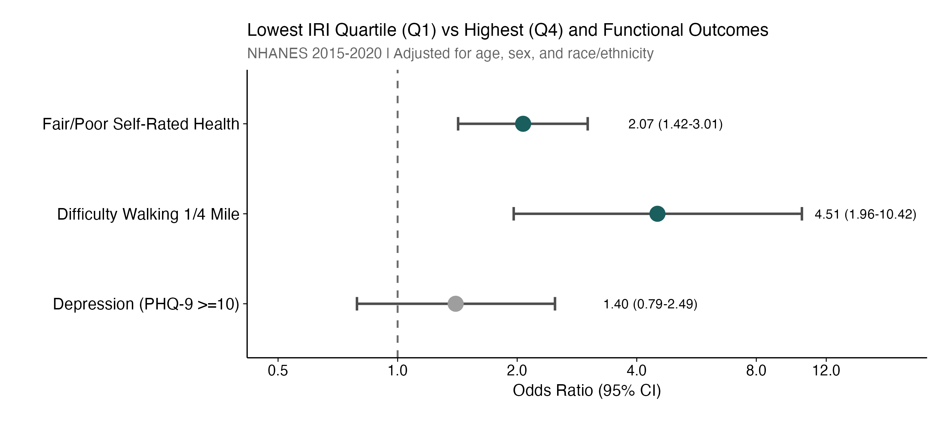
Figure 1
Odds ratios comparing the lowest IRI quartile (Q1) to the highest (Q4, reference) for three functional outcomes, adjusted for age, sex, and race/ethnicity. Red points indicate statistically significant associations (P<0.05). Error bars represent 95% confidence intervals. Fair/poor self-rated health (OR 2.07, 95% CI: 1.42-3.01) and difficulty walking one-quarter mile (OR 4.51, 95% CI: 1.96-10.42) were significantly associated with low IRI. Depression was not significantly associated (OR 1.40, 95% CI: 0.79-2.49).

FIGURE 2. Prevalence of Functional Outcomes by IRI Quartile
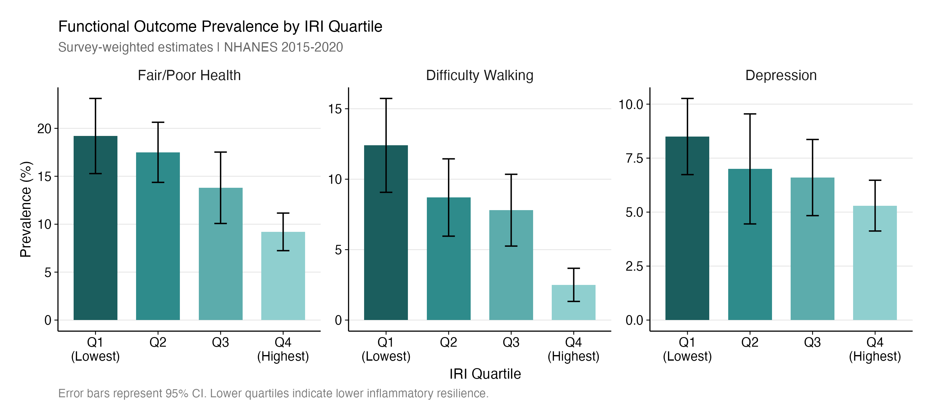
Figure 2
Survey-weighted prevalence (with standard error bars) of fair/poor self-rated health, difficulty walking one-quarter mile, and depression (PHQ-9 ≥10) across IRI quartiles. Q1 represents lowest inflammatory resilience (highest inflammation, lowest albumin, lowest muscle mass) and Q4 represents highest resilience. Clear gradients are observed for self-rated health and walking difficulty, with 10.0 and 9.9 percentage point differences, respectively, between Q1 and Q4. NHANES 2015-2020 (N = 2,729).

FIGURE 3. IRI Component Profiles by Quartile
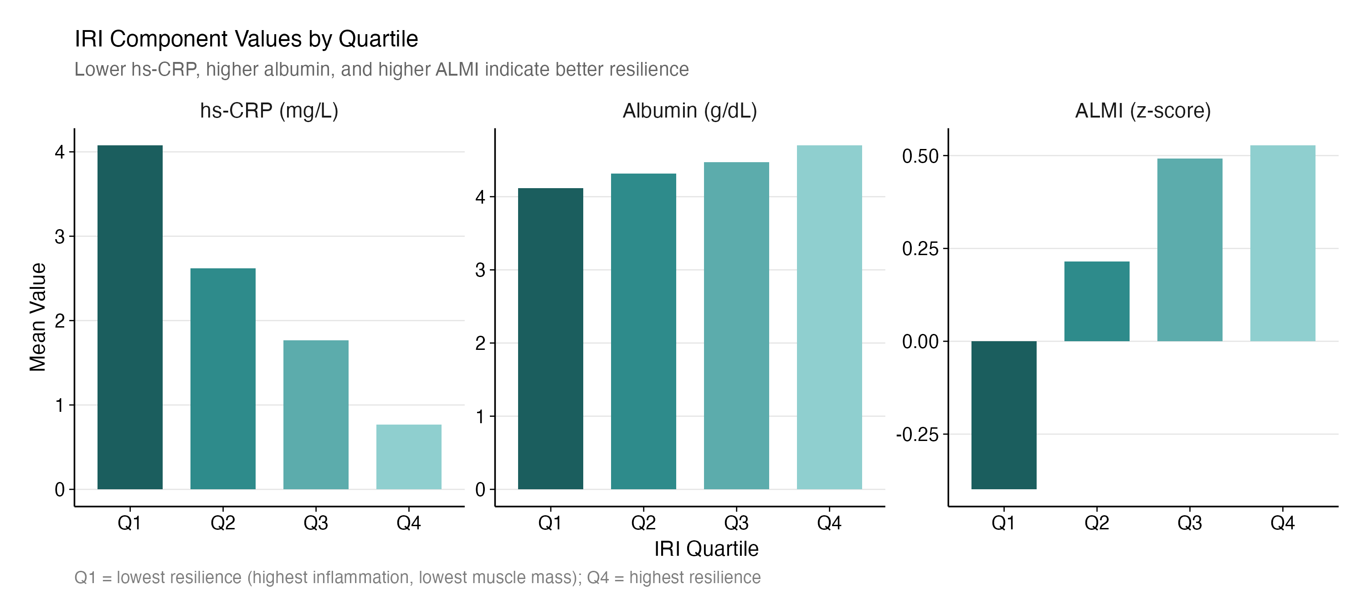
Figure 3
Mean values of hs-CRP (mg/L), serum albumin (g/dL), and ALMI z-score across IRI quartiles, illustrating the distribution of each component contributing to the composite index. hs-CRP decreases 5.3-fold from Q1 to Q4 (4.08 to 0.77 mg/L), while albumin increases (4.12 to 4.70 g/dL) and ALMI z-score increases (-0.40 to 0.53). These divergent patterns across components demonstrate the integrated nature of the IRI.

FIGURE 4. IRI Score Distribution by Functional Outcome Status
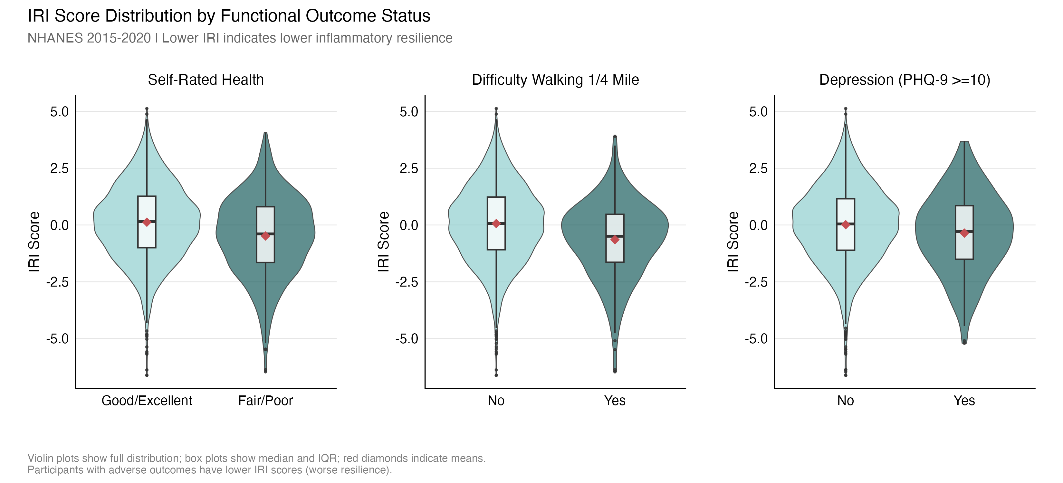
Figure 4
Violin plots showing the full distribution of IRI scores stratified by functional outcome status. Each panel compares participants with and without the adverse outcome. For self-rated health, participants reporting fair/poor health had lower mean IRI scores (-0.48) compared to those with good/excellent health (+0.12). For difficulty walking 1/4 mile, those with difficulty had markedly lower IRI (-0.65) than those without (+0.06). For depression (PHQ-9 >=10), a similar pattern was observed (-0.36 vs +0.01). Box plots show median and interquartile range; red diamonds indicate group means. Lower IRI scores reflect reduced inflammatory resilience. NHANES 2015-2020 (N = 2,729).

SUPPLEMENTAL MATERIALS

Table 4. Validation Cohort Mortality by IRI Quartile (NHANES 1999-2006)
IRI Quartile | N | All-Cause Deaths | CV Deaths | All-Cause Mortality Rate (%) | CV Mortality Rate (%)
Q1 (Lowest) | 20,817 | 8,484 | 2,696 | 40.8 | 13.0
Q2 | 23,552 | 6,288 | 1,979 | 26.7 | 8.4
Q3 | 19,651 | 3,198 | 1,061 | 16.3 | 5.4
Q4 (Highest) | 14,015 | 1,315 | 399 | 9.4 | 2.8
Mean follow-up: 17.1 years. Total: 78,035 participants, 19,285 all-cause deaths, 6,135 CV deaths.

eTable S1. Age-Stratified Mortality Analysis (Validation Cohort)
Age Group | N | All-Cause Deaths | CV Deaths | All-Cause HR (95% CI)* | P | CV HR (95% CI)* | P
<60 years | 52,835 | 4,225 | 1,080 | 0.67 (0.63-0.71) | <0.001 | 0.66 (0.60-0.73) | <0.001
≥60 years | 25,200 | 15,060 | 5,055 | 0.82 (0.79-0.85) | <0.001 | 0.90 (0.84-0.96) | 0.002
*Hazard ratio per 1-unit increase in IRI, adjusted for age, sex, BMI, and diabetes. Age × IRI interaction P<0.001, indicating stronger effect in younger adults, but IRI significant in both strata.

eTable S2. Extended Covariate Adjustment (Validation Cohort)
Model | Covariates | HR (95% CI)* | P
Model 1 | Age, Sex | 0.78 (0.75-0.80) | <0.001
Model 2 | + BMI, Smoking, Diabetes | 0.78 (0.75-0.81) | <0.001
Model 3 | + Education, Poverty-Income Ratio | 0.78 (0.76-0.81) | <0.001
*Hazard ratio per 1-unit increase in IRI for all-cause mortality. Minimal attenuation after adjustment for socioeconomic factors supports physiologic independence of IRI.

eTable S3. C-Statistic Comparison: IRI vs Individual Components (Validation Cohort)
Model | C-Statistic | ΔC from Base
Base (Age, Sex, BMI, Smoking, Diabetes) | 0.823 | Reference
Base + hs-CRP (z-score, inverted) | 0.823 | +0.000
Base + Albumin (z-score) | 0.841 | +0.018
Base + ALMI (z-score) | 0.824 | +0.001
Base + IRI | 0.834 | +0.011
IRI outperforms hs-CRP alone (ΔC +0.011 vs +0.000) and ALMI alone (ΔC +0.011 vs +0.001), supporting incremental value of the composite. Albumin alone performs best (+0.018), but IRI integrates complementary physiologic information.

eTable S4. Cardiovascular Mortality Subtypes (Validation Cohort)
Outcome | Events | HR (95% CI)* | P
All-cause mortality | 19,285 | 0.76 (0.74-0.79) | <0.001
CV mortality (combined) | 6,135 | 0.82 (0.78-0.87) | <0.001
Heart disease mortality | 5,080 | 0.81 (0.77-0.85) | <0.001
Stroke mortality | 1,055 | 0.91 (0.77-1.06) | 0.21
*Hazard ratio per 1-unit increase in IRI, adjusted for age, sex, BMI, and diabetes. IRI significantly associated with heart disease but not stroke mortality, consistent with pathophysiologic expectations.

eTable S5. Derivation Cohort Sensitivity Analysis (Functional Outcomes)
Outcome | Model | Continuous IRI OR (95% CI) | P
Fair/Poor Health | Base (Age, Sex, Race) | 0.81 (0.74-0.89) | <0.001
Fair/Poor Health | + BMI | 0.83 (0.75-0.92) | 0.01
Fair/Poor Health | + BMI, DM, HTN, Smoking | 0.85 (0.76-0.95) | 0.02
Walking Difficulty | Base (Age, Sex, Race) | 0.78 (0.67-0.91) | 0.005
Walking Difficulty | + BMI, DM, HTN, Smoking | 0.82 (0.69-0.97) | 0.03
Depression | Base (Age, Sex, Race) | 0.90 (0.77-1.05) | 0.14
Depression | + BMI, DM, HTN, Smoking | 0.92 (0.78-1.08) | 0.22
Abbreviations: BMI = body mass index; DM = diabetes mellitus; HTN = hypertension; OR = odds ratio.

eTable S6. Component-Adjusted Models (Validation Cohort)
Model | Variable | HR (95% CI) | P
M2: + CRP | z_CRP (inverted) | 0.83 (0.79-0.86) | <0.001
M3: + CRP, Albumin | z_CRP (inverted) | 0.93 (0.89-0.97) | 0.001
 | z_Albumin | 0.65 (0.62-0.69) | <0.001
M4: + CRP, Albumin, ALMI | z_CRP (inverted) | 0.92 (0.88-0.96) | <0.001
 | z_Albumin | 0.65 (0.62-0.69) | <0.001
 | z_ALMI | 0.92 (0.89-0.96) | <0.001
M5: + All Components + IRI | z_CRP (inverted) | 0.82 (0.59-1.16) | 0.26
 | z_Albumin | 0.58 (0.41-0.83) | 0.003
 | z_ALMI | 0.84 (0.62-1.13) | 0.25
 | IRI | 1.14 (0.76-1.71) | 0.53
*IRI is not significant after including all components—expected since IRI = −z_CRP + z_Albumin + z_ALMI by construction. The relevant comparison is C-statistic (IRI vs components separately).
Likelihood Ratio Test (Base vs Base+IRI): χ² = 1405, P < 10⁻³⁰⁰

eTable S7. Sex-Stratified Mortality Analysis (Validation Cohort)
Sex | N | All-Cause Deaths | HR All-Cause (95% CI)* | P | CV Deaths | HR CV (95% CI)* | P
Men | 39,470 | 10,580 | 0.75 (0.71-0.78) | <0.001 | 3,425 | 0.79 (0.74-0.85) | <0.001
Women | 38,565 | 8,705 | 0.77 (0.72-0.81) | <0.001 | 2,710 | 0.84 (0.76-0.92) | <0.001
*Hazard ratio per 1-unit increase in IRI, adjusted for age, BMI, and diabetes.
Sex × IRI Interaction: P = 0.45 (no significant heterogeneity by sex)

eTable S8. Competing Risk Analysis for CV Mortality (Validation Cohort)
Model | Hazard Ratio (95% CI) | Interpretation
Cause-specific Cox | 0.86 (0.84-0.87) | Direct effect of IRI on CV death, treating non-CV deaths as censored
Fine-Gray Subdistribution | 0.91 (0.90-0.93) | Cumulative incidence effect, accounting for competing non-CV deaths
Both models demonstrate significant protective association of higher IRI with CV mortality. The slightly attenuated Fine-Gray estimate reflects the competing event structure but does not change inference.

eFigure S1. IRI–Mortality Dose-Response Relationship (RCS Spline)
Restricted cubic spline with 4 knots (5th, 35th, 65th, 95th percentiles) modeling the continuous IRI-mortality relationship. The curve demonstrates a monotonically decreasing hazard ratio across the IRI range, supporting a protective effect at all IRI levels.
Nonlinearity Test: χ² = 16.6, df = 2, P = 0.0002
Although statistically significant, visual inspection confirms an approximately log-linear relationship suitable for continuous IRI modeling.
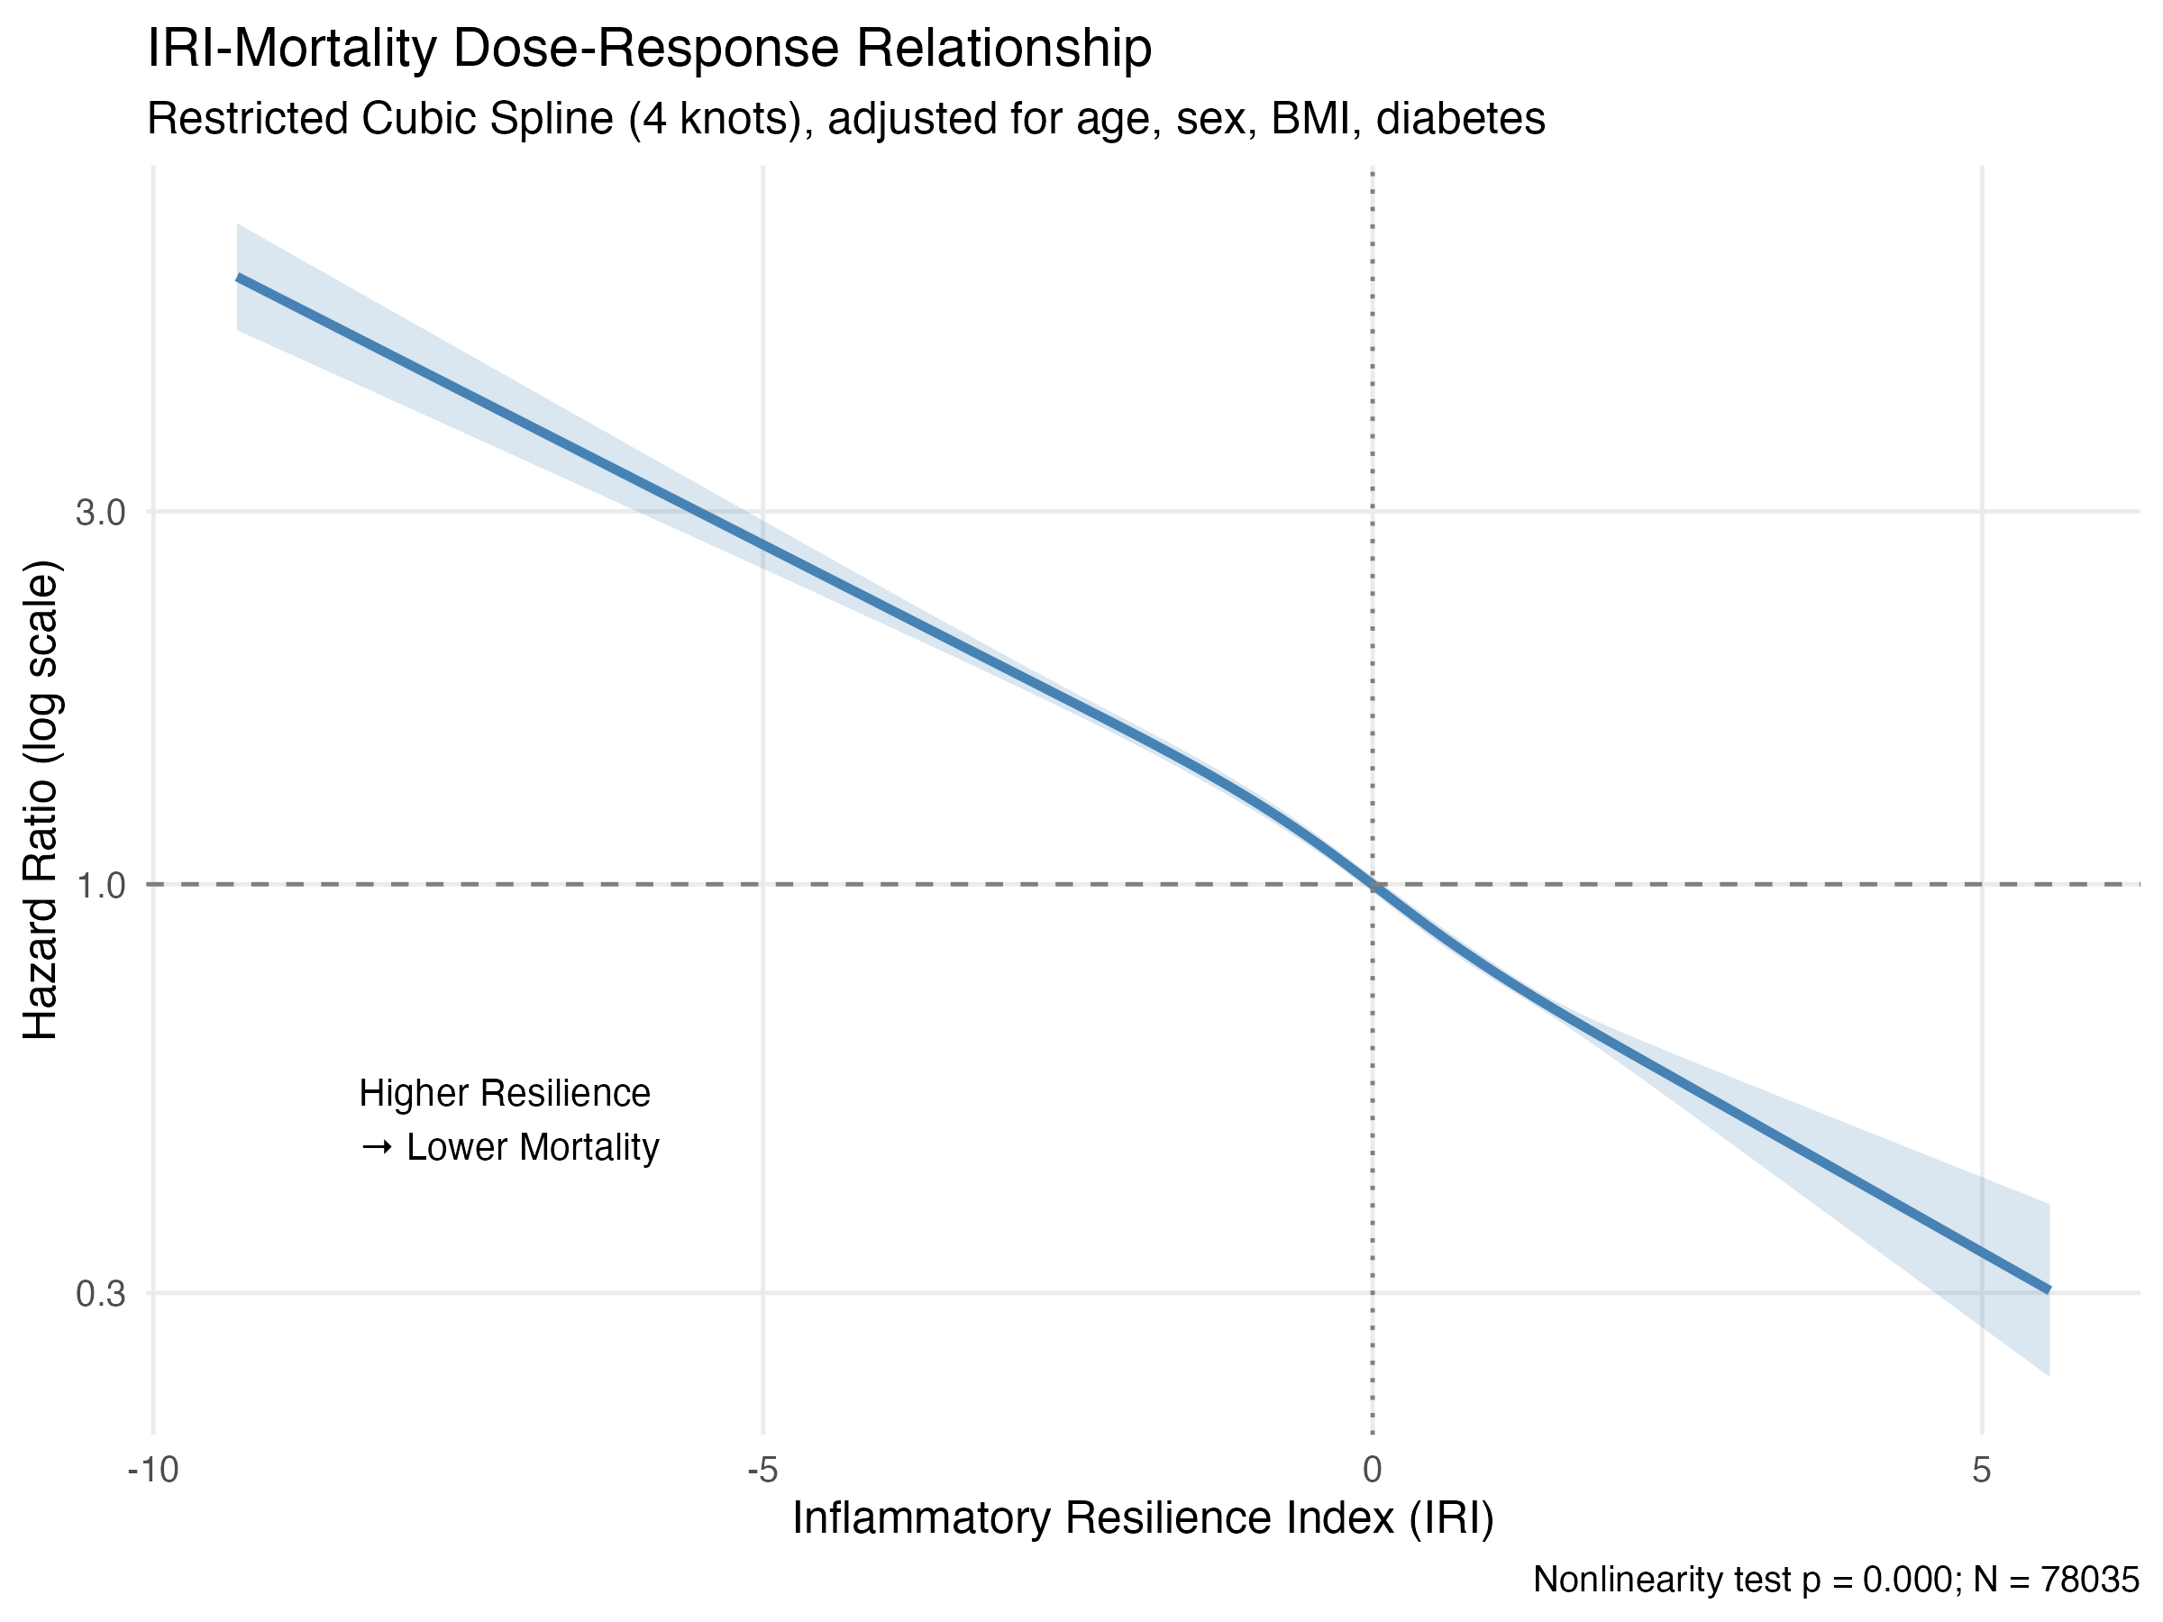
eFigure S1: RCS Spline

eMethods: Variable Definitions and NHANES File Specifications
Derivation Cohort: NHANES 2015-2016 (cycle I) and 2017-2020 pre-pandemic (cycle P). DEXA body composition from DXX_I and P_DXX files. hs-CRP from HSCRP_I and P_HSCRP files. Albumin from BIOPRO_I and P_BIOPRO files.
Validation Cohort: NHANES 1999-2000, 2001-2002, 2003-2004, 2005-2006. IRI constructed identically with z-scores calculated within the validation sample.
Mortality linkage: NHANES-linked mortality files through December 31, 2019. Cardiovascular mortality defined as UCOD_LEADING codes 1 (heart disease) and 5 (cerebrovascular disease). Heart disease mortality = UCOD_LEADING = 1. Stroke mortality = UCOD_LEADING = 5.
Education: DMDEDUC2 (1=<9th grade, 2=9-11th, 3=HS/GED, 4=Some college/AA, 5=College+). Categories: <HS (1-2), HS/GED (3), Some college+ (4-5).
Poverty-Income Ratio: INDFMPIR (0-5, top-coded at 5). Higher values indicate greater income relative to federal poverty level.

REFERENCES
- Libby P, Ridker PM, Hansson GK. Inflammation in atherosclerosis: from pathophysiology to practice. J Am Coll Cardiol. 2009;54(23):2129-2138.
- Ridker PM, Cushman M, Stampfer MJ, Tracy RP, Hennekens CH. Inflammation, aspirin, and the risk of cardiovascular disease in apparently healthy men. N Engl J Med. 1997;336(14):973-979.
- Cruz-Jentoft AJ, Bahat G, Bauer J, et al. Sarcopenia: revised European consensus on definition and diagnosis. Age Ageing. 2019;48(1):16-31.
- Ridker PM. High-sensitivity C-reactive protein: potential adjunct for global risk assessment in the primary prevention of cardiovascular disease. Circulation. 2001;103(13):1813-1818.
- Goldwasser P, Feldman J. Association of serum albumin and mortality risk. J Clin Epidemiol. 1997;50(6):693-703.
- Bauer J, Morley JE, Schols AMWJ, et al. Sarcopenia: a time for action. J Cachexia Sarcopenia Muscle. 2019;10(5):956-961.
- Schaap LA, Pluijm SMF, Deeg DJH, Visser M. Inflammatory markers and loss of muscle mass (sarcopenia) and strength. Am J Med. 2006;119(6):526.e9-17.
- Dalle S, Rossmeislova L, Bhide M. The role of inflammation in age-related sarcopenia. Front Physiol. 2017;8:1045.
- Wilson D, Jackson T, Sapey E, Lord JM. Frailty and sarcopenia: the potential role of an aged immune system. Ageing Res Rev. 2017;36:1-10.
- McMillan DC. The systemic inflammation-based Glasgow Prognostic Score: a decade of experience in patients with cancer. Cancer Treat Rev. 2013;39(5):534-540.
- Rockwood K, Song X, MacKnight C, et al. A global clinical measure of fitness and frailty in elderly people. CMAJ. 2005;173(5):489-495.
- Centers for Disease Control and Prevention (CDC). National Health and Nutrition Examination Survey. Available at: https://www.cdc.gov/nchs/nhanes/index.htm
- Pearson TA, Mensah GA, Alexander RW, et al. Markers of inflammation and cardiovascular disease: application to clinical and public health practice. Circulation. 2003;107(3):499-511.
- Kroenke K, Spitzer RL, Williams JB. The PHQ-9: validity of a brief depression severity measure. J Gen Intern Med. 2001;16(9):606-613.
- Johnson CL, Paulose-Ram R, Ogden CL, et al. National Health and Nutrition Examination Survey: analytic guidelines, 1999-2010. Vital Health Stat 2. 2013;(161):1-24.
- Lumley T. Analysis of complex survey samples. J Stat Softw. 2004;9(8):1-19.
- Schaap LA, Pluijm SMF, Deeg DJH, et al. Higher inflammatory marker levels in older persons: associations with 5-year change in muscle mass and muscle strength. J Gerontol A Biol Sci Med Sci. 2009;64(11):1183-1189.
- Don BR, Kaysen G. Serum albumin: relationship to inflammation and nutrition. Semin Dial. 2004;17(6):432-437.
- Horwich TB, Kalantar-Zadeh K, MacLellan RW, Fonarow GC. Albumin levels predict survival in patients with systolic heart failure. Am Heart J. 2008;155(5):883-889.
- Studenski SA, Peters KW, Alley DE, et al. The FNIH sarcopenia project: rationale, study description, conference recommendations, and final estimates. J Gerontol A Biol Sci Med Sci. 2014;69(5):547-558.
- DeSalvo KB, Bloser N, Reynolds K, He J, Muntner P. Mortality prediction with a single general self-rated health question. J Gen Intern Med. 2006;21(3):267-275.

