# Health, Risk, and Equity

#### Risk Heterogeneity between Black and White Individuals Insured through the ACA Marketplaces from 2018-2020

### Andrew S. Cistola, MPH

### About

Previous research have shown signficiant under-utilization of ambulatory care and signficiantly lower costs among black insured individuals 18-64 from 2014-2018. (<doi:10.1001/jamanetworkopen.2022.17383>) If these differences persist through the ACA risk adjustment program, under-utilization represents an arbitrage opportunity for insurance providers in the individual market. This would represent how a history of systematic racism and barriers to care could be used for cost-containment measures with the beenfits of overall lower health care costs transferred among the larger population. Health equity efforts should be focused on neutralizing arbitrage opporunties based on defacto discrimination and instead incentivize issuers to address disparities in access to care. With the addition of race and zip code to the EDGE server in 2025, CMS will have the ability to reform the ACA risk adjustmenr program to improve these disparities. The purpose of this study is to identify how the ACA Risk Adjustment program interacts with known health disparities in health care utilization among raical groups. This study uses publcily available data from the Medical Expenditure Panel Survey (MEPS) from Agency for Healthcare Research and Quality (AHRQ) (<https://meps.ahrq.gov/mepsweb/data_stats/download_data_files.jsp>) from 2018 to 2021 to identify differences in risk that can be attributed to racial group independent of other factors and whether the ACA risk adjustment program excacerbates these diferences. Evidence from this study can identify how racial data can be used by CMS to promote health equity within the ACA marketplaces.

#### Notes:

This analysis serves to fulfill part of the the requirements for the PhD in Public Health-Heath Services Research at the University of Florida. The author is also employed by Blue Cross Blue Shield of Florida.

#### Status:

In development

#### Reference:

github.com/andrewcistola/Health-Risk-and_Equity

#### Updated:

2022-12-16 15:26:57.640581

### Import Results

The following files were downloaded from <https://meps.ahrq.gov/mepsweb/data_files/pufs/> and saved to a local database:

##### AHRQ MEPS 2020

Household Consolidated File (h224) Medical Conditions File (h222) Prescribed Medicines File (h220a) Dental Visits File (h220b) Other Medical Expenditures File (h220c) Hospital Inpatient Stays File (h220d) Emergency Room Visits File (h220e) Outpatient Department Visits File (h220f) Office-Based Medical Provider Visits File (h220g) Home Health Visits File (h220h) Home Health Visits File (h220h) Appendix - Condition to Event File (h220if1) Appendix - Prescritpion to Condition File (h220if2)

##### AHRQ MEPS 2019

Household Consolidated File (h216) Medical Conditions File (h214) Prescribed Medicines File (h213a) Dental Visits File (h213b) Other Medical Expenditures File (h213c) Hospital Inpatient Stays File (h213d) Emergency Room Visits File (h213e) Outpatient Department Visits File (h213f) Office-Based Medical Provider Visits File (h213g) Home Health Visits File (h213h) Appendix - Condition to Event File (h213if1) Appendix - Prescritpion to Condition File (h213if2)

##### AHRQ MEPS 2018

Household Consolidated File (h209) Medical Conditions File (h207) Prescribed Medicines File (h206a) Dental Visits File (h206b) Other Medical Expenditures File (h206c) Hospital Inpatient Stays File (h206d) Emergency Room Visits File (h206e) Outpatient Department Visits File (h206f) Office-Based Medical Provider Visits File (h206g) Home Health Visits File (h206h) Appendix - Condition to Event File (h206if1) Appendix - Prescritpion to Condition File (h206if2)

See <https://datatools.ahrq.gov/meps-hc#varexpLabel> for variable explorer.

### Data Cleaning Summary

Raw data was subset for the following conditions:

##### Households

Individuals 26-64 with marketplace coverage for full year

SELECT  
 2020 AS YEAR # Repeated for each year  
 , DUPERSID AS PERSON_ID  
 , AGELAST AS AGE  
 , SEX  
 , RACETHX AS RACE  
 , POVCAT20 AS FPL_GROUP  
 , POVLEV20 AS FPL_PERCENT  
FROM h224 W # Repeated for each household year file  
WHERE  
 AGELAST > 18  
 AND AGELAST < 65  
 AND PRSTX20 = 1 # Variable name charges for each year  
 AND INSCOV20 = 1 # Variable name charges for each year

##### Events

Non-Dental events for year individual has marketpalce coverage

SELECT  
 2020 AS YEAR # Repeated for each year  
 , SQ.DUPERSID AS PERSON_ID  
 , 'OUTPATIENT' AS SETTING  
 , F.EVNTIDX AS EVENT_ID  
 , F.OPFPV20X + F.OPDPV20X AS PAID # Combined Doctor and facility payments from privtae insurers for settings that provided both (variable name changes each year)  
FROM (  
 SELECT DISTINCT Y.DUPERSID   
 FROM h224 Y # Repeated for each household year file  
 WHERE  
 Y.AGELAST > 18  
 AND Y.AGELAST < 65  
 AND Y.RACETHX IN (1, 2, 3, 4)  
 AND Y.PRSTX20 = 1 # Variable name charges for each year  
 AND Y.INSCOV20 = 1 # Variable name charges for each year  
 ) SQ  
LEFT JOIN h220f F # Repeated for each event file in year  
 ON SQ.DUPERSID = F.DUPERSID

Then paid amounts were summed by person and year and joined to household records (exclduing dental). The setting of the event for each condition was also collected for each event that documented a ICD10 code.

##### Conditions

Any for individual in same year as marketpalce coverage

SELECT  
 2020 AS YEAR # Repeated for each year  
 , SQ.DUPERSID AS PERSON_ID  
 , Z.CONDIDX AS CONDITION_ID  
 , Z.EVNTIDX AS EVENT_ID  
FROM (  
 SELECT DISTINCT DUPERSID   
 FROM h224 # Repeated for each household year file  
 WHERE  
 AGELAST > 18  
 AND AGELAST < 65  
 AND RACETHX IN (1, 2, 3, 4)  
 AND PRSTX20 = 1 # Variable name charges for each year  
 AND INSCOV20 = 1 # Variable name charges for each year  
 ) SQ  
LEFT JOIN h220if1 Z # Repeated for each appendix file  
 ON SQ.DUPERSID = Z.DUPERSID

All distinct conditions were kept and joined to household records.

##### Final Analytical Data

### Data Preparation Summary

The following Columns were derived for this analysis:

VISITS - VISITS_TOTAL, ER_VISITS, HOME_VISITS, INPATIENT_VISITS, OFFICE_VISITS, OUTPATIENT_VISITS, RX_VISITS  
PAID - PAID_TOTAL, ER_PAID, HOME_PAID, INPATIENT_PAID, OFFICE_PAID, OUTPATIENT_PAID, RX_PAID  
ICD10 - ICD10_TOTAL, ICD10 YES/NO (1/0)

##### Descriptive Statistics

The following statistics describe the population used for both analyses:

##### Research Question 1: Analytical File

##### Research Question 2: Analytical File

### Regression Modeling Result Summary

The following results were collected using R version 4.2.2 (2022-10-31 ucrt)

#### Regression Step 1: Import and Clean Data

Source: _data//Race_MEPS//alpha_dev_20221216152657//analytical_Q1.csv

W (ID variables): PERSON_ID X (Predictor variables): NON_WHITE AGE SEX FPL_PERCENT ICD10_TOTAL Y (Outcome variables): PAID_TOTAL Z (Subgroup variables): YEAR

#### Final Model: OLS on Log costs, RACE = Missing excluded, 2018-2020

##### OLS Assumption 0: Sampling (Random sample, observations > predictors, predictor is independent)

##### OLS Assumption 1: Specification (Relationship between predictor and outcome is linear)

##### OLS Assumption 2: Normality (Errors are normal with a mean = 0)

##### OLS Assumption 3: No Autocorrelation (Error terms are not correlated with each other)

##### OLS Assumption 4: Homoskedasticity (Error is even across observations)

##### OLS Assumption 5: No Colinearity (Predictors are not correlated with each other)

#### Final Model 3: Two Step Model on Costs, RACE = Missing excluded, 2018-2020

##### Logistic Regression on Presence Non-Zero Costs

##### Poisson Regression on Costs

### Machine Learning Result Summary

Various machine learning models were trained on a reference population and then used to predict values from a focus populaiton. The difference in predicted to actual values for the focus group then to reflects the impact of group identification. This is an adaptation of the Kitigawa-Oaxaca-Blinder method. The following results used the scikit-learn and keras libraries for Python version 3.9.13 (tags/v3.9.13:6de2ca5, May 17 2022, 16:36:42) [MSC v.1929 64 bit (AMD64)]

#### Machine Learning Step 1: Data Processing of Predictors and Outcomes

Source: _data//Race_MEPS//alpha_dev_20221216152657//analytical_Q2.csv

W (ID variables): PERSON_ID Z (Subgroup variables): YEAR

Reference group: Non-Hispanic White (RACETH == 2) Focus group: Not Non-Hispanic White (RACETH != 2)

##### Random Forests

AGE SEX CONDITIONS SDOH_FPL

0 -0.009398 -0.958192 0.680481 -0.00102

[‘White Average = 5.2456’, ‘Non-White Average = 4.8691’, ‘Non-White Predicted = 4.8969’, ‘Difference in Bs = 0.3765’, ‘Difference in Xs = 0.0278’, ‘R-squared + 0.196’]

Variables Importances

0 SDOH_FPL 0.587376 4 AGE 0.266137 1 SDOH_EDUCATION 0.053840 5 SEX 0.042070 2 SDOH_MARITAL 0.041809 3 SDOH_FOOD 0.008769

[‘White Average = 5.2456’, ‘Non-White Average = 4.8691’, ‘Non-White Predicted = 5.1795’, ‘Difference in Bs = 0.3765’, ‘Difference in Xs = 0.3104’, ‘R-squared + 0.5831’]

Variables Importances

0 AGE 0.107979 53 ICD10_E78 0.085185 63 ICD10_F32 0.062797 201 ICD10_M19 0.050376 66 ICD10_F41 0.029986 .. … … 283 ICD10_R50 0.000000 287 ICD10_R55 0.000000 290 ICD10_R59 0.000000 3 ICD10_A08 0.000000 22 ICD10_C55 0.000000

[338 rows x 2 columns]

[‘White Average = 5.2456’, ‘Non-White Average = 4.8691’, ‘Non-White Predicted = 5.0223’, ‘Difference in Bs = 0.3765’, ‘Difference in Xs = 0.1532’, ‘R-squared + 0.312’]

Variables Importances

5 OFFICE_VISITS 0.292638 7 RX_VISITS 0.283453 0 AGE 0.254565 6 OUTPATIENT_VISITS 0.064746 2 ER_VISITS 0.044880 1 SEX 0.034286 4 INPATIENT_VISITS 0.024618 3 HOME_VISITS 0.000815

[‘White Average = 5.2456’, ‘Non-White Average = 4.8691’, ‘Non-White Predicted = 4.448’, ‘Difference in Bs = 0.3765’, ‘Difference in Xs = -0.4211’, ‘R-squared + 0.7953’]

##### Gradient Boosting

Variables Importances

0 SDOH_FPL 0.678027 4 AGE 0.259393 1 SDOH_EDUCATION 0.025059 2 SDOH_MARITAL 0.013311 5 SEX 0.013112 3 SDOH_FOOD 0.011098

[‘White Average = 5.2456’, ‘Non-White Average = 4.8691’, ‘Non-White Predicted = 5.3885’, ‘Difference in Bs = 0.3765’, ‘Difference in Xs = 0.5194’, ‘R-squared + 0.288’]

Variables Importances

53 ICD10_E78 0.079916 63 ICD10_F32 0.063896 201 ICD10_M19 0.054125 0 AGE 0.045307 204 ICD10_M25 0.038132 .. … … 182 ICD10_L30 0.000000 183 ICD10_L40 0.000000 40 ICD10_E05 0.000000 37 ICD10_D68 0.000000 209 ICD10_M43 0.000000

[338 rows x 2 columns]

[‘White Average = 5.2456’, ‘Non-White Average = 4.8691’, ‘Non-White Predicted = 5.0454’, ‘Difference in Bs = 0.3765’, ‘Difference in Xs = 0.1763’, ‘R-squared + 0.2919’]

Variables Importances

7 RX_VISITS 0.352573 5 OFFICE_VISITS 0.349782 6 OUTPATIENT_VISITS 0.097721 0 AGE 0.092738 2 ER_VISITS 0.054606 4 INPATIENT_VISITS 0.047750 1 SEX 0.004492 3 HOME_VISITS 0.000338

[‘White Average = 5.2456’, ‘Non-White Average = 4.8691’, ‘Non-White Predicted = 4.405’, ‘Difference in Bs = 0.3765’, ‘Difference in Xs = -0.4642’, ‘R-squared + 0.5605’]

##### Ridge Regression (with Cross Validation)

Variables Coefficients

3 SDOH_FOOD 0.949891 4 AGE 0.029710 2 SDOH_MARITAL 0.014189 0 SDOH_FPL -0.001513 1 SDOH_EDUCATION -0.027184 5 SEX -0.263785

[‘White Average = 5.2456’, ‘Non-White Average = 4.8691’, ‘Non-White Predicted = 5.3842’, ‘Difference in Bs = 0.3765’, ‘Difference in Xs = 0.5151’, ‘R-squared + 0.0193’]

Variables Coefficients

21 ICD10_C50 2.258813 46 ICD10_E34 1.608116 248 ICD10_N83 1.332755 72 ICD10_F90 1.318881 224 ICD10_M79 1.302765 .. … … 29 ICD10_D04 -0.887417 184 ICD10_L50 -0.922563 274 ICD10_R25 -1.066813 155 ICD10_K25 -1.189677 198 ICD10_M10 -1.305145

[338 rows x 2 columns]

[‘White Average = 5.2456’, ‘Non-White Average = 4.8691’, ‘Non-White Predicted = 4.9248’, ‘Difference in Bs = 0.3765’, ‘Difference in Xs = 0.0557’, ‘R-squared + 0.256’]

Variables Coefficients

4 INPATIENT_VISITS 1.537182 2 ER_VISITS 0.254903 7 RX_VISITS 0.154254 6 OUTPATIENT_VISITS 0.055136 3 HOME_VISITS 0.030546 5 OFFICE_VISITS 0.008236 0 AGE -0.001154 1 SEX -0.383812

[‘White Average = 5.2456’, ‘Non-White Average = 4.8691’, ‘Non-White Predicted = 4.8877’, ‘Difference in Bs = 0.3765’, ‘Difference in Xs = 0.0186’, ‘R-squared + 0.1989’]

##### Least absolute shrinkage and selection operator

Variables Coefficients

4 AGE 0.028165 1 SDOH_EDUCATION -0.000000 2 SDOH_MARITAL 0.000000 3 SDOH_FOOD 0.000000 5 SEX -0.000000 0 SDOH_FPL -0.001536

[‘White Average = 5.2456’, ‘Non-White Average = 4.8691’, ‘Non-White Predicted = 5.3527’, ‘Difference in Bs = 0.3765’, ‘Difference in Xs = 0.4836’, ‘R-squared + 0.0163’]

Variables Coefficients

21 ICD10_C50 2.258813 46 ICD10_E34 1.608116 248 ICD10_N83 1.332755 72 ICD10_F90 1.318881 224 ICD10_M79 1.302765 .. … … 29 ICD10_D04 -0.887417 184 ICD10_L50 -0.922563 274 ICD10_R25 -1.066813 155 ICD10_K25 -1.189677 198 ICD10_M10 -1.305145

[338 rows x 2 columns]

[‘White Average = 5.2456’, ‘Non-White Average = 4.8691’, ‘Non-White Predicted = 4.9248’, ‘Difference in Bs = 0.3765’, ‘Difference in Xs = 0.0557’, ‘R-squared + 0.256’]

Variables Coefficients

4 INPATIENT_VISITS 1.537182 2 ER_VISITS 0.254903 7 RX_VISITS 0.154254 6 OUTPATIENT_VISITS 0.055136 3 HOME_VISITS 0.030546 5 OFFICE_VISITS 0.008236 0 AGE -0.001154 1 SEX -0.383812

[‘White Average = 5.2456’, ‘Non-White Average = 4.8691’, ‘Non-White Predicted = 4.8877’, ‘Difference in Bs = 0.3765’, ‘Difference in Xs = 0.0186’, ‘R-squared + 0.1989’]

##### Multi-Layer Perceptron

Loss

0 3.529949 1 3.340738 2 3.218884 3 3.123808 4 2.975870 .. … 495 0.812600 496 0.801311 497 0.721212 498 0.749604 499 0.750555

[500 rows x 1 columns]

[‘White Average = 5.2456’, ‘Non-White Average = 4.8691’, ‘Non-White Predicted = 4.6541’, ‘Difference in Bs = 0.3765’, ‘Difference in Xs = -0.215’, ‘R-squared + 0.8409’]

### Tables and Figures

Files can be found at: _fig//Race_MEPS//alpha_dev_20221216152657//

#### Descriptive Statistics

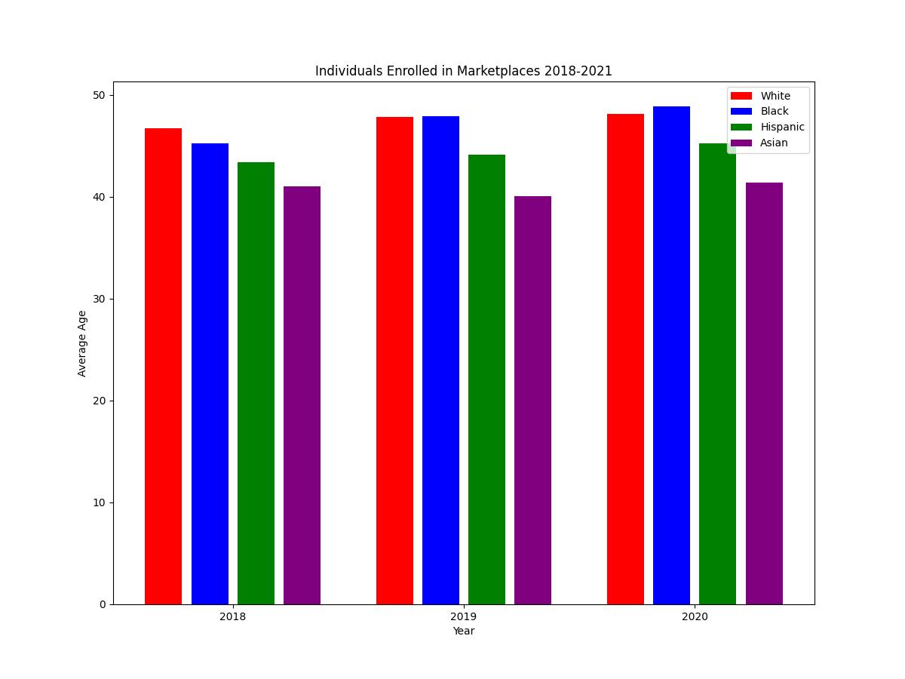 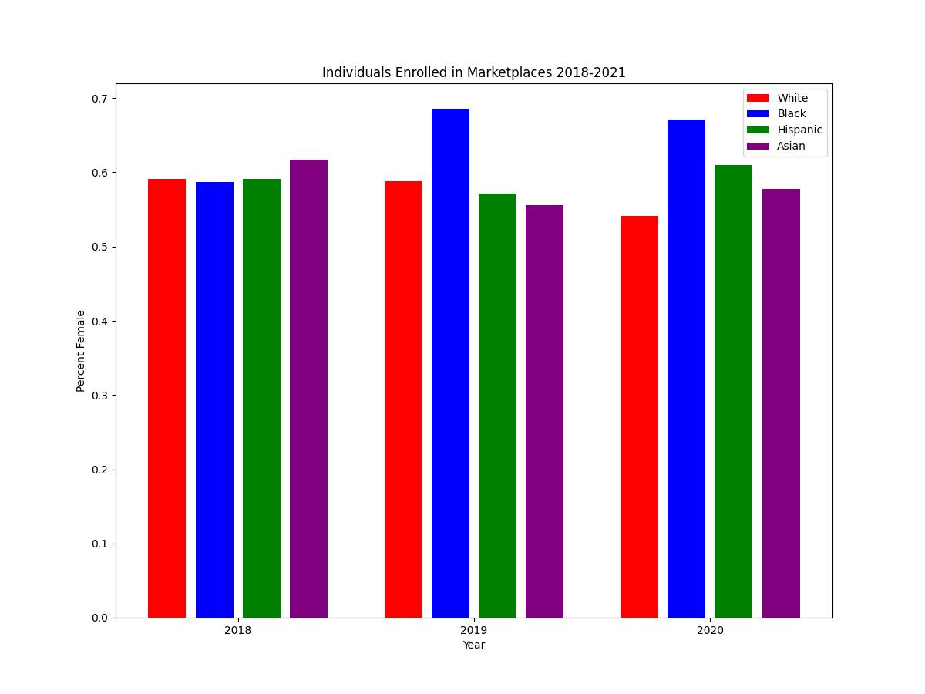 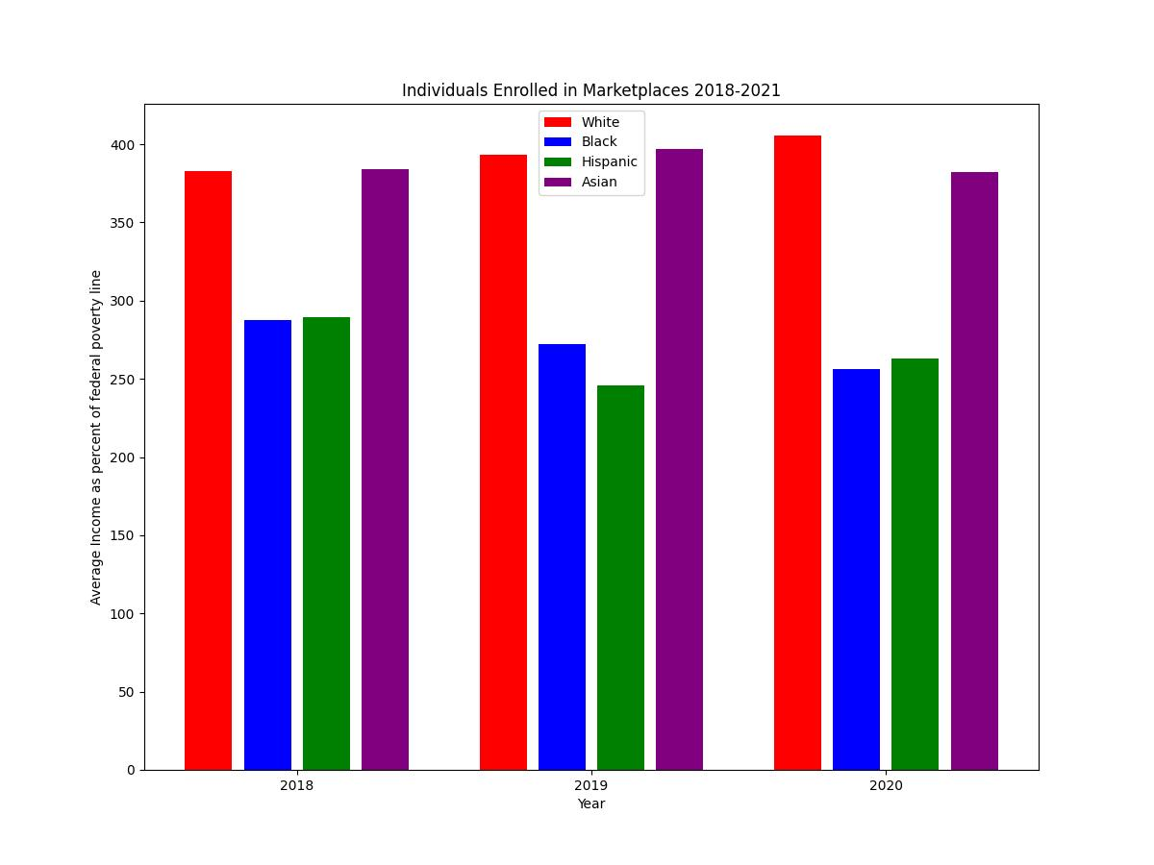 Number of Diagnoses per Person.jpeg) 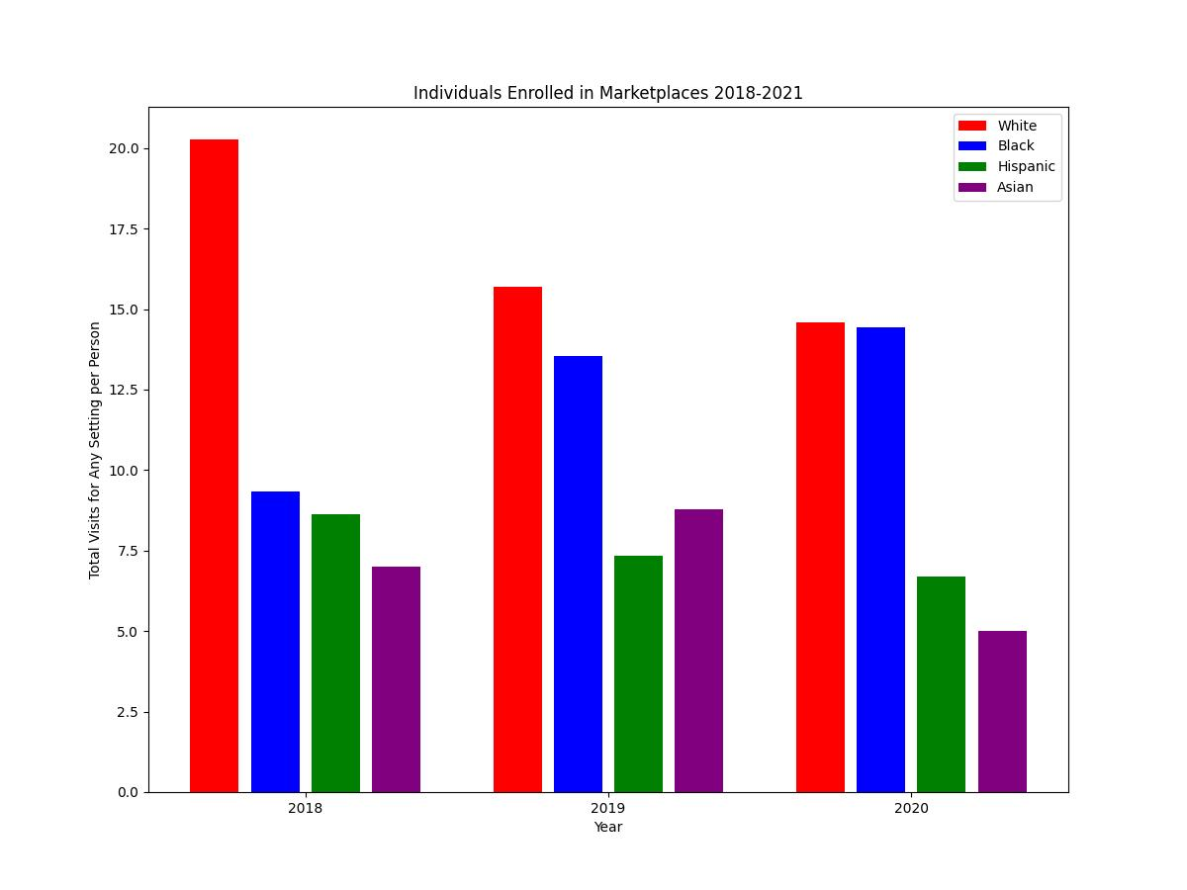 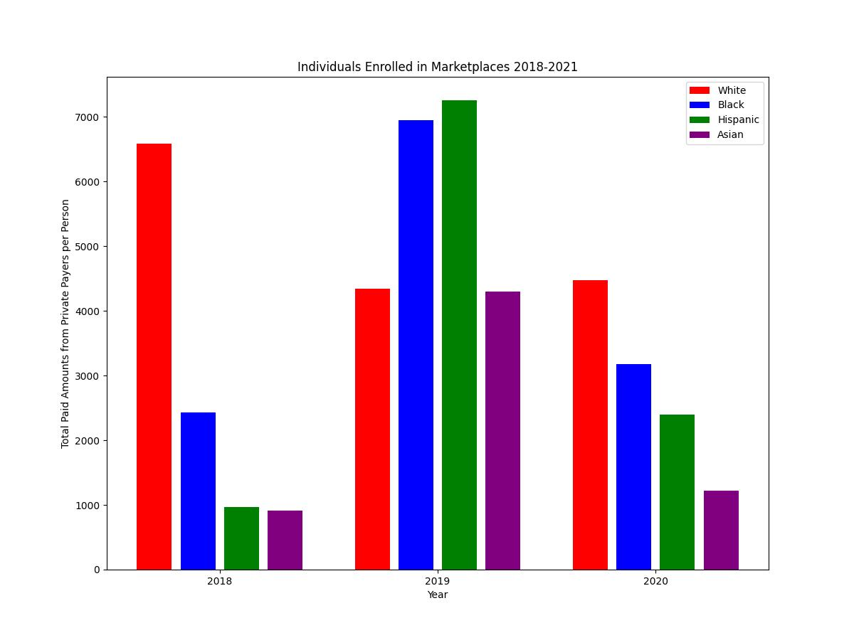

#### Regression Results

