# Health, Risk, and Equity

#### Risk Heterogeneity between Black and White Individuals Insured through the ACA Marketplaces from 2018-2020

### Andrew S. Cistola, MPH

### About

Previous research have shown signficiant under-utilization of ambulatory care and signficiantly lower costs among black insured individuals 18-64 from 2014-2018. (<doi:10.1001/jamanetworkopen.2022.17383>) If these differences persist through the ACA risk adjustment program, under-utilization represents an arbitrage opportunity for insurance providers in the individual market. This would represent how a history of systematic racism and barriers to care could be used for cost-containment measures with the beenfits of overall lower health care costs transferred among the larger population. Health equity efforts should be focused on neutralizing arbitrage opporunties based on defacto discrimination and instead incentivize issuers to address disparities in access to care. With the addition of race and zip code to the EDGE server in 2025, CMS will have the ability to reform the ACA risk adjustmenr program to improve these disparities. The purpose of this study is to identify how the ACA Risk Adjustment program interacts with known health disparities in health care utilization among raical groups. This study uses publcily available data from the Medical Expenditure Panel Survey (MEPS) from Agency for Healthcare Research and Quality (AHRQ) (<https://meps.ahrq.gov/mepsweb/data_stats/download_data_files.jsp>) from 2018 to 2021 to identify differences in risk that can be attributed to racial group independent of other factors and whether the ACA risk adjustment program excacerbates these diferences. Evidence from this study can identify how racial data can be used by CMS to promote health equity within the ACA marketplaces.

#### Notes:

This analysis serves to fulfill part of the the requirements for the PhD in Public Health-Heath Services Research at the University of Florida. The author is also employed by Blue Cross Blue Shield of Florida.

#### Status:

In development

#### Reference:

github.com/andrewcistola/Health-Risk-and_Equity

#### Updated:

2022-11-11 08:29:41.310273

### Import Results

The following files were downloaded from <https://meps.ahrq.gov/mepsweb/data_files/pufs/> and saved to a local database:

##### AHRQ MEPS 2020

Household Consolidated File (h224) Medical Conditions File (h222) Prescribed Medicines File (h220a) Dental Visits File (h220b) Other Medical Expenditures File (h220c) Hospital Inpatient Stays File (h220d) Emergency Room Visits File (h220e) Outpatient Department Visits File (h220f) Office-Based Medical Provider Visits File (h220g) Home Health Visits File (h220h) Home Health Visits File (h220h) Appendix - Condition to Event File (h220if1) Appendix - Prescritpion to Condition File (h220if2)

##### AHRQ MEPS 2019

Household Consolidated File (h216) Medical Conditions File (h214) Prescribed Medicines File (h213a) Dental Visits File (h213b) Other Medical Expenditures File (h213c) Hospital Inpatient Stays File (h213d) Emergency Room Visits File (h213e) Outpatient Department Visits File (h213f) Office-Based Medical Provider Visits File (h213g) Home Health Visits File (h213h) Appendix - Condition to Event File (h213if1) Appendix - Prescritpion to Condition File (h213if2)

##### AHRQ MEPS 2018

Household Consolidated File (h209) Medical Conditions File (h207) Prescribed Medicines File (h206a) Dental Visits File (h206b) Other Medical Expenditures File (h206c) Hospital Inpatient Stays File (h206d) Emergency Room Visits File (h206e) Outpatient Department Visits File (h206f) Office-Based Medical Provider Visits File (h206g) Home Health Visits File (h206h) Appendix - Condition to Event File (h206if1) Appendix - Prescritpion to Condition File (h206if2)

See <https://datatools.ahrq.gov/meps-hc#varexpLabel> for variable explorer or <https://meps.ahrq.gov/mepsweb/data_stats/download_data_files_codebook.jsp?PUFId=H224> for the full varibale list.

### Data Cleaning Summary

Raw data was subset for the following conditions:

##### Households

Individuals 26-64 with marketplace coverage for full year

SELECT  
 2020 AS YEAR # Repeated for each year  
 , DUPERSID AS PERSON_ID  
 , AGELAST AS AGE  
 , SEX  
 , RACETHX AS RACE  
 , POVCAT20 AS FPL_GROUP  
 , POVLEV20 AS FPL_PERCENT  
FROM h224 W # Repeated for each household year file  
WHERE  
 AGELAST > 25  
 AND AGELAST < 65  
 AND PRSTX20 = 1 # Variable name charges for each year  
 AND INSCOV20 = 1 # Variable name charges for each year

##### Events

Non-Dental events for year individual has marketpalce coverage

SELECT  
 2020 AS YEAR # Repeated for each year  
 , SQ.DUPERSID AS PERSON_ID  
 , 'OUTPATIENT' AS SETTING  
 , F.EVNTIDX AS EVENT_ID  
 , F.OPFPV20X + F.OPDPV20X AS PAID # Combined Doctor and facility payments from privtae insurers for settings that provided both (variable name changes each year)  
FROM (  
 SELECT DISTINCT Y.DUPERSID   
 FROM h224 Y # Repeated for each household year file  
 WHERE  
 Y.AGELAST > 25  
 AND Y.AGELAST < 65  
 AND Y.PRSTX20 = 1 # Variable name charges for each year  
 AND Y.INSCOV20 = 1 # Variable name charges for each year  
 ) SQ  
LEFT JOIN h220f F # Repeated for each event file in year  
 ON SQ.DUPERSID = F.DUPERSID

Then paid amounts were summed by person and year and joined to household records (exclduing dental). The setting of the event for each condition was also collected for each event that documented a ICD10 code.

##### Conditions

Any for individual in same year as marketpalce coverage

SELECT  
 2020 AS YEAR # Repeated for each year  
 , SQ.DUPERSID AS PERSON_ID  
 , Z.CONDIDX AS CONDITION_ID  
 , Z.EVNTIDX AS EVENT_ID  
FROM (  
 SELECT DISTINCT DUPERSID   
 FROM h224 # Repeated for each household year file  
 WHERE  
 AGELAST > 25  
 AND AGELAST < 65  
 AND PRSTX20 = 1 # Variable name charges for each year  
 AND INSCOV20 = 1 # Variable name charges for each year  
 ) SQ  
LEFT JOIN h220if1 Z # Repeated for each appendix file  
 ON SQ.DUPERSID = Z.DUPERSID

All distinct conditions were kept and joined to household records.

Final Data for analysis-

<class ‘pandas.core.frame.DataFrame’> Int64Index: 109428 entries, 0 to 109427 Data columns (total 12 columns): # Column Non-Null Count Dtype  
— —— ————– —–  
0 YEAR 109428 non-null int64  
1 PERSON_ID 109428 non-null object 2 AGE 109428 non-null float64 3 SEX 109428 non-null float64 4 RACE 109428 non-null float64 5 FPL_GROUP 109428 non-null float64 6 FPL_PERCENT 109428 non-null float64 7 CONDITION_ID 24750 non-null object 8 EVENT_ID 24750 non-null object 9 ICD10 24750 non-null object 10 SETTING 24750 non-null object 11 PAID 24750 non-null float64 dtypes: float64(6), int64(1), object(5) memory usage: 10.9+ MB

### Data Preparation Summary

The following Columns were derived for this analysis:

VISITS - VISITS_TOTAL, ER_VISITS, HOME_VISITS, INPATIENT_VISITS, OFFICE_VISITS, OUTPATIENT_VISITS, RX_VISITS  
PAID - PAID_TOTAL, ER_PAID, HOME_PAID, INPATIENT_PAID, OFFICE_PAID, OUTPATIENT_PAID, RX_PAID  
ICD10 - ICD10_TOTAL, ICD10 YES/NO (1/0)

##### Descriptive Statistics

The following statistics describe the population used for both analyses:

AGE   
 count mean std min 25% 50% 75% max

YEAR  
2018 636.0 47.902516 11.703822 26.0 38.0 50.0 59.0 64.0 2019 598.0 48.530100 11.704124 26.0 39.0 51.0 59.0 64.0 2020 646.0 48.780186 11.572139 26.0 39.0 51.0 59.0 64.0

AGE   
 count mean std min 25% 50% 75% max

YEAR RACE_DESC  
2018 ASIAN 52.0 44.115385 10.645175 27.0 35.50 44.5 51.00 64.0 BLACK 71.0 48.225352 11.201017 26.0 39.50 49.0 58.00 64.0 HISPANIC 143.0 46.524476 11.375680 26.0 36.50 47.0 56.00 64.0 MISSING 13.0 43.692308 11.686064 27.0 32.00 43.0 52.00 60.0 WHITE 357.0 49.095238 11.927068 26.0 39.00 52.0 60.00 64.0 2019 ASIAN 52.0 43.884615 11.380502 26.0 34.50 44.0 53.00 64.0 BLACK 62.0 51.370968 10.709631 27.0 43.50 55.0 59.75 64.0 HISPANIC 135.0 47.162963 11.553385 26.0 39.00 48.0 57.00 64.0 MISSING 10.0 45.600000 12.420413 26.0 35.00 46.5 53.50 63.0 WHITE 339.0 49.353982 11.756091 26.0 41.00 51.0 60.00 64.0 2020 ASIAN 54.0 45.129630 10.629340 26.0 36.75 45.0 54.00 63.0 BLACK 75.0 51.253333 11.259943 27.0 42.50 54.0 60.00 64.0 HISPANIC 158.0 48.082278 11.039573 26.0 39.25 50.0 58.00 64.0 MISSING 17.0 42.588235 11.230866 27.0 34.00 44.0 51.00 62.0 WHITE 342.0 49.444444 11.838905 26.0 40.00 52.0 60.00 64.0

PERCENT_FEMALE   
 count mean std min 25% 50% 75% max

YEAR  
2018 636.0 0.592767 0.491706 0.0 0.0 1.0 1.0 1.0 2019 598.0 0.588629 0.492494 0.0 0.0 1.0 1.0 1.0 2020 646.0 0.574303 0.494831 0.0 0.0 1.0 1.0 1.0

PERCENT_FEMALE   
 count mean std min 25% 50% 75% max

YEAR RACE_DESC  
2018 ASIAN 52.0 0.596154 0.495454 0.0 0.0 1.0 1.0 1.0 BLACK 71.0 0.577465 0.497479 0.0 0.0 1.0 1.0 1.0 HISPANIC 143.0 0.587413 0.494030 0.0 0.0 1.0 1.0 1.0 MISSING 13.0 0.692308 0.480384 0.0 0.0 1.0 1.0 1.0 WHITE 357.0 0.593838 0.491805 0.0 0.0 1.0 1.0 1.0 2019 ASIAN 52.0 0.557692 0.501506 0.0 0.0 1.0 1.0 1.0 BLACK 62.0 0.677419 0.471280 0.0 0.0 1.0 1.0 1.0 HISPANIC 135.0 0.562963 0.497867 0.0 0.0 1.0 1.0 1.0 MISSING 10.0 0.600000 0.516398 0.0 0.0 1.0 1.0 1.0 WHITE 339.0 0.587021 0.493097 0.0 0.0 1.0 1.0 1.0 2020 ASIAN 54.0 0.574074 0.499126 0.0 0.0 1.0 1.0 1.0 BLACK 75.0 0.666667 0.474579 0.0 0.0 1.0 1.0 1.0 HISPANIC 158.0 0.594937 0.492465 0.0 0.0 1.0 1.0 1.0 MISSING 17.0 0.705882 0.469668 0.0 0.0 1.0 1.0 1.0 WHITE 342.0 0.538012 0.499283 0.0 0.0 1.0 1.0 1.0

FPL_PERCENT   
 count mean std min 25% 50% 75% max

YEAR  
2018 636.0 351.596006 303.764140 -46.96 175.0425 267.91 428.9950 2411.90 2019 598.0 350.502525 305.634736 0.00 159.5250 267.10 448.4375 2727.94 2020 646.0 354.107043 298.758648 -58.32 159.9125 280.88 448.9600 2100.47

FPL_PERCENT   
 count mean std min 25% 50% 75% max

YEAR RACE_DESC  
2018 ASIAN 52.0 357.973077 295.067683 39.91 158.4450 247.270 444.6175 1196.25 BLACK 71.0 304.682817 241.976352 0.00 140.0700 248.180 396.2600 1011.36 HISPANIC 143.0 287.274406 221.640587 59.47 151.6300 229.640 338.9850 1753.15 MISSING 13.0 316.036154 116.260489 109.43 244.9500 324.710 372.3600 572.62 WHITE 357.0 387.056779 342.253362 -46.96 183.7100 290.910 501.3500 2411.90 2019 ASIAN 52.0 416.614231 443.571097 0.00 139.6550 238.905 545.6500 2239.65 BLACK 62.0 276.967742 198.026212 0.00 118.6825 248.300 350.5325 965.99 HISPANIC 135.0 257.040963 158.000196 42.06 142.4450 203.310 335.5600 852.80 MISSING 10.0 268.454000 196.141858 0.00 134.5075 240.685 334.9825 639.85 WHITE 339.0 393.449853 331.818213 0.00 192.6500 305.370 501.4250 2727.94 2020 ASIAN 54.0 390.962222 296.284826 0.00 192.0100 303.370 457.0700 1269.53 BLACK 75.0 269.770400 229.743673 -58.32 119.8700 208.680 304.8100 997.19 HISPANIC 158.0 266.409367 205.613912 -20.52 133.9050 193.920 350.3325 1186.10 MISSING 17.0 280.407647 189.062492 51.99 147.6000 223.970 432.7500 617.14 WHITE 342.0 410.961404 337.243111 -10.19 198.5850 311.140 519.4525 2100.47

ICD10_TOTAL   
 count mean std min 25% 50% 75% max

YEAR RACE_DESC  
2018 ASIAN 52.0 1.211538 1.600693 0.0 0.0 1.0 2.00 7.0 BLACK 71.0 2.563380 2.811875 0.0 1.0 1.0 4.00 16.0 HISPANIC 143.0 2.174825 2.993690 0.0 0.0 1.0 3.00 16.0 MISSING 13.0 1.923077 1.656379 0.0 1.0 1.0 3.00 5.0 WHITE 357.0 3.422969 3.552627 0.0 1.0 2.0 5.00 22.0 2019 ASIAN 52.0 1.538462 2.182475 0.0 0.0 1.0 2.00 8.0 BLACK 62.0 2.887097 2.716705 0.0 1.0 2.0 4.00 11.0 HISPANIC 135.0 1.985185 3.178719 0.0 0.0 1.0 2.00 24.0 MISSING 10.0 2.600000 3.438346 0.0 0.0 1.0 3.75 9.0 WHITE 339.0 3.014749 3.263990 0.0 1.0 2.0 4.00 27.0 2020 ASIAN 54.0 1.777778 2.212031 0.0 0.0 1.0 3.00 9.0 BLACK 75.0 3.133333 3.059471 0.0 1.0 2.0 5.00 15.0 HISPANIC 158.0 1.911392 2.486600 0.0 0.0 1.0 3.00 17.0 MISSING 17.0 2.941176 3.051036 0.0 0.0 2.0 4.00 10.0 WHITE 342.0 2.915205 2.947508 0.0 1.0 2.0 4.00 19.0

PAID_TOTAL   
 count mean std min 25% 50% 75% max

YEAR  
2018 636.0 4061.027028 19922.817240 0.0 0.0 176.495 1519.4175 317628.78 2019 598.0 6854.093043 48993.248496 0.0 0.0 161.515 1484.8600 788295.78 2020 646.0 3739.139195 13855.826243 0.0 0.0 168.710 1470.4350 160834.52

PAID_TOTAL   
 count mean std min 25% 50% 75% max

YEAR RACE_DESC  
2018 ASIAN 52.0 504.975385 1069.615731 0.0 0.0 2.795 418.6300 6027.37 BLACK 71.0 2729.457042 9926.147797 0.0 0.0 98.560 831.0900 66465.95 HISPANIC 143.0 1081.008462 3548.317417 0.0 0.0 41.790 800.9550 37806.36 MISSING 13.0 1952.464615 3573.377839 0.0 0.0 387.660 1229.9800 10257.76 WHITE 357.0 6114.276667 25939.141049 0.0 0.0 458.900 2660.0000 317628.78 2019 ASIAN 52.0 3701.246154 13984.270763 0.0 0.0 42.945 578.3375 93721.43 BLACK 62.0 7760.034032 38328.312639 0.0 0.0 250.215 1238.1900 289529.17 HISPANIC 135.0 8191.411704 68008.421301 0.0 0.0 17.000 606.2700 788295.78 MISSING 10.0 78420.722000 243643.719044 0.0 0.0 186.030 2086.8450 771803.24 WHITE 339.0 4528.356726 19271.133597 0.0 0.0 280.600 1882.8600 219733.64 2020 ASIAN 54.0 1403.940741 4379.576295 0.0 0.0 75.630 521.8150 27336.65 BLACK 75.0 3381.974933 9470.012240 0.0 0.0 170.860 1704.8600 51341.60 HISPANIC 158.0 2600.111329 11610.657570 0.0 0.0 23.550 612.6800 128095.73 MISSING 17.0 4140.394706 6282.551758 0.0 0.0 317.300 5749.9600 15798.61 WHITE 342.0 4692.452339 16563.907277 0.0 0.0 277.425 2173.5575 160834.52

VISITS_TOTAL   
 count mean std min 25% 50% 75% max

YEAR  
2018 636.0 13.661950 25.215553 0.0 0.0 5.0 17.0 372.0 2019 598.0 13.359532 28.080815 0.0 0.0 4.0 14.0 388.0 2020 646.0 12.495356 24.038325 0.0 0.0 4.0 15.0 255.0

VISITS_TOTAL   
 count mean std min 25% 50% 75% max

YEAR RACE_DESC  
2018 ASIAN 52.0 4.653846 11.140607 0.0 0.0 1.5 4.25 74.0 BLACK 71.0 9.661972 14.807280 0.0 1.0 4.0 11.00 80.0 HISPANIC 143.0 9.699301 19.956303 0.0 0.0 3.0 10.50 174.0 MISSING 13.0 6.461538 6.279801 0.0 2.0 5.0 11.00 18.0 WHITE 357.0 17.619048 29.565210 0.0 1.0 8.0 24.00 372.0 2019 ASIAN 52.0 6.961538 13.391483 0.0 0.0 2.0 6.25 74.0 BLACK 62.0 14.306452 20.455140 0.0 2.0 6.0 14.75 85.0 HISPANIC 135.0 8.044444 14.433515 0.0 0.0 2.0 8.50 87.0 MISSING 10.0 14.000000 21.202725 0.0 0.0 1.5 17.50 59.0 WHITE 339.0 16.265487 34.196530 0.0 1.0 6.0 17.00 388.0 2020 ASIAN 54.0 5.685185 7.475303 0.0 0.0 3.0 9.00 29.0 BLACK 75.0 15.266667 25.579412 0.0 1.0 6.0 20.50 164.0 HISPANIC 158.0 7.044304 11.133438 0.0 0.0 2.0 10.00 73.0 MISSING 17.0 22.705882 39.968370 0.0 0.0 10.0 30.00 163.0 WHITE 342.0 14.973684 27.859027 0.0 1.0 6.0 17.00 255.0

##### Research Question 1: Analytical File

<class ‘pandas.core.frame.DataFrame’> Int64Index: 1880 entries, 0 to 1879 Data columns (total 9 columns): # Column Non-Null Count Dtype  
— —— ————– —–  
0 PERSON_ID 1880 non-null int64  
1 YEAR 1880 non-null int64  
2 AGE 1880 non-null float64 3 SEX 1880 non-null float64 4 RACE 1880 non-null float64 5 FPL_PERCENT 1880 non-null float64 6 ICD10_TOTAL 1880 non-null int64  
7 PAID_TOTAL 1880 non-null float64 8 VISITS_TOTAL 1880 non-null int64  
dtypes: float64(5), int64(4) memory usage: 146.9 KB

##### Research Question 2: Analytical File

<class ‘pandas.core.frame.DataFrame’> Int64Index: 5562 entries, 0 to 5561 Data columns (total 388 columns): # Column Non-Null Count Dtype  
— —— ————– —–  
0 PERSON_ID 5562 non-null int64  
1 YEAR 5562 non-null int64  
2 AGE 5562 non-null float64 3 SEX 5562 non-null float64 4 RACE 5562 non-null float64 5 FPL_PERCENT 5480 non-null float64 6 ICD10_TOTAL 5058 non-null float64 7 ER_PAID 933 non-null float64 8 HOME_PAID 119 non-null float64 9 INPATIENT_PAID 535 non-null float64 10 OFFICE_PAID 4120 non-null float64 11 OUTPATIENT_PAID 1251 non-null float64 12 RX_PAID 3911 non-null float64 13 PAID_TOTAL 4792 non-null float64 14 ER_VISITS 1135 non-null float64 15 HOME_VISITS 148 non-null float64 16 INPATIENT_VISITS 593 non-null float64 17 OFFICE_VISITS 4543 non-null float64 18 OUTPATIENT_VISITS 1424 non-null float64 19 RX_VISITS 4763 non-null float64 20 VISITS_TOTAL 5058 non-null float64 21 ICD10_-15 199 non-null float64 22 ICD10_A04 1 non-null float64 23 ICD10_A08 3 non-null float64 24 ICD10_A09 5 non-null float64 25 ICD10_A41 1 non-null float64 26 ICD10_A49 11 non-null float64 27 ICD10_A69 2 non-null float64 28 ICD10_B00 17 non-null float64 29 ICD10_B02 5 non-null float64 30 ICD10_B07 5 non-null float64 31 ICD10_B19 4 non-null float64 32 ICD10_B34 7 non-null float64 33 ICD10_B35 9 non-null float64 34 ICD10_B37 26 non-null float64 35 ICD10_B49 2 non-null float64 36 ICD10_B99 4 non-null float64 37 ICD10_C18 2 non-null float64 38 ICD10_C34 3 non-null float64 39 ICD10_C43 6 non-null float64 40 ICD10_C44 20 non-null float64 41 ICD10_C50 18 non-null float64 42 ICD10_C55 1 non-null float64 43 ICD10_C61 1 non-null float64 44 ICD10_C64 3 non-null float64 45 ICD10_C67 1 non-null float64 46 ICD10_C73 5 non-null float64 47 ICD10_C85 4 non-null float64 48 ICD10_C95 6 non-null float64 49 ICD10_D04 1 non-null float64 50 ICD10_D17 3 non-null float64 51 ICD10_D21 4 non-null float64 52 ICD10_D22 10 non-null float64 53 ICD10_D48 2 non-null float64 54 ICD10_D49 7 non-null float64 55 ICD10_D50 3 non-null float64 56 ICD10_D64 19 non-null float64 57 ICD10_D68 1 non-null float64 58 ICD10_E03 86 non-null float64 59 ICD10_E04 8 non-null float64 60 ICD10_E05 11 non-null float64 61 ICD10_E06 6 non-null float64 62 ICD10_E07 81 non-null float64 63 ICD10_E11 152 non-null float64 64 ICD10_E28 5 non-null float64 65 ICD10_E29 1 non-null float64 66 ICD10_E34 12 non-null float64 67 ICD10_E53 4 non-null float64 68 ICD10_E55 26 non-null float64 69 ICD10_E56 2 non-null float64 70 ICD10_E58 1 non-null float64 71 ICD10_E61 6 non-null float64 72 ICD10_E66 8 non-null float64 73 ICD10_E78 274 non-null float64 74 ICD10_E83 1 non-null float64 75 ICD10_E86 5 non-null float64 76 ICD10_E87 14 non-null float64 77 ICD10_F10 7 non-null float64 78 ICD10_F11 1 non-null float64 79 ICD10_F17 1 non-null float64 80 ICD10_F19 3 non-null float64 81 ICD10_F20 7 non-null float64 82 ICD10_F31 17 non-null float64 83 ICD10_F32 149 non-null float64 84 ICD10_F34 2 non-null float64 85 ICD10_F39 3 non-null float64 86 ICD10_F41 169 non-null float64 87 ICD10_F42 8 non-null float64 88 ICD10_F43 41 non-null float64 89 ICD10_F51 1 non-null float64 90 ICD10_F80 1 non-null float64 91 ICD10_F84 2 non-null float64 92 ICD10_F90 41 non-null float64 93 ICD10_F91 1 non-null float64 94 ICD10_F99 16 non-null float64 95 ICD10_G25 23 non-null float64 96 ICD10_G35 1 non-null float64 97 ICD10_G40 9 non-null float64 98 ICD10_G43 40 non-null float64 99 ICD10_G44 1 non-null float64 100 ICD10_G45 9 non-null float64 101 ICD10_G47 100 non-null float64 102 ICD10_G54 2 non-null float64 103 ICD10_G56 6 non-null float64 104 ICD10_G57 6 non-null float64 105 ICD10_G58 3 non-null float64 106 ICD10_G62 6 non-null float64 107 ICD10_G89 15 non-null float64 108 ICD10_H00 1 non-null float64 109 ICD10_H02 3 non-null float64 110 ICD10_H04 8 non-null float64 111 ICD10_H10 4 non-null float64 112 ICD10_H18 1 non-null float64 113 ICD10_H26 16 non-null float64 114 ICD10_H33 6 non-null float64 115 ICD10_H35 9 non-null float64 116 ICD10_H40 15 non-null float64 117 ICD10_H43 5 non-null float64 118 ICD10_H44 4 non-null float64 119 ICD10_H52 28 non-null float64 120 ICD10_H53 11 non-null float64 121 ICD10_H54 4 non-null float64 122 ICD10_H57 17 non-null float64 123 ICD10_H61 3 non-null float64 124 ICD10_H65 1 non-null float64 125 ICD10_H66 18 non-null float64 126 ICD10_H72 1 non-null float64 127 ICD10_H81 1 non-null float64 128 ICD10_H91 3 non-null float64 129 ICD10_H92 12 non-null float64 130 ICD10_H93 2 non-null float64 131 ICD10_I10 405 non-null float64 132 ICD10_I20 3 non-null float64 133 ICD10_I21 25 non-null float64 134 ICD10_I25 24 non-null float64 135 ICD10_I34 5 non-null float64 136 ICD10_I38 2 non-null float64 137 ICD10_I48 8 non-null float64 138 ICD10_I49 9 non-null float64 139 ICD10_I50 4 non-null float64 140 ICD10_I51 9 non-null float64 141 ICD10_I63 2 non-null float64 142 ICD10_I72 2 non-null float64 143 ICD10_I73 6 non-null float64 144 ICD10_I74 8 non-null float64 145 ICD10_I82 1 non-null float64 146 ICD10_I83 3 non-null float64 147 ICD10_I87 1 non-null float64 148 ICD10_I89 4 non-null float64 149 ICD10_I95 1 non-null float64 150 ICD10_J00 25 non-null float64 151 ICD10_J02 24 non-null float64 152 ICD10_J03 2 non-null float64 153 ICD10_J06 9 non-null float64 154 ICD10_J09 3 non-null float64 155 ICD10_J11 46 non-null float64 156 ICD10_J18 8 non-null float64 157 ICD10_J20 4 non-null float64 158 ICD10_J30 29 non-null float64 159 ICD10_J32 37 non-null float64 160 ICD10_J34 12 non-null float64 161 ICD10_J35 1 non-null float64 162 ICD10_J39 7 non-null float64 163 ICD10_J40 20 non-null float64 164 ICD10_J42 9 non-null float64 165 ICD10_J43 7 non-null float64 166 ICD10_J44 12 non-null float64 167 ICD10_J45 95 non-null float64 168 ICD10_J98 7 non-null float64 169 ICD10_K01 3 non-null float64 170 ICD10_K02 1 non-null float64 171 ICD10_K04 11 non-null float64 172 ICD10_K05 2 non-null float64 173 ICD10_K08 17 non-null float64 174 ICD10_K21 75 non-null float64 175 ICD10_K22 3 non-null float64 176 ICD10_K25 2 non-null float64 177 ICD10_K29 12 non-null float64 178 ICD10_K30 15 non-null float64 179 ICD10_K31 9 non-null float64 180 ICD10_K37 5 non-null float64 181 ICD10_K44 3 non-null float64 182 ICD10_K46 6 non-null float64 183 ICD10_K51 2 non-null float64 184 ICD10_K52 2 non-null float64 185 ICD10_K56 1 non-null float64 186 ICD10_K57 9 non-null float64 187 ICD10_K58 12 non-null float64 188 ICD10_K59 5 non-null float64 189 ICD10_K63 6 non-null float64 190 ICD10_K64 9 non-null float64 191 ICD10_K74 2 non-null float64 192 ICD10_K76 9 non-null float64 193 ICD10_K80 3 non-null float64 194 ICD10_K82 7 non-null float64 195 ICD10_K85 5 non-null float64 196 ICD10_K92 8 non-null float64 197 ICD10_L02 5 non-null float64 198 ICD10_L03 3 non-null float64 199 ICD10_L08 6 non-null float64 200 ICD10_L21 1 non-null float64 201 ICD10_L23 7 non-null float64 202 ICD10_L29 1 non-null float64 203 ICD10_L30 20 non-null float64 204 ICD10_L40 6 non-null float64 205 ICD10_L50 4 non-null float64 206 ICD10_L57 2 non-null float64 207 ICD10_L60 7 non-null float64 208 ICD10_L65 6 non-null float64 209 ICD10_L70 16 non-null float64 210 ICD10_L71 7 non-null float64 211 ICD10_L72 4 non-null float64 212 ICD10_L73 1 non-null float64 213 ICD10_L81 3 non-null float64 214 ICD10_L84 3 non-null float64 215 ICD10_L91 3 non-null float64 216 ICD10_L98 29 non-null float64 217 ICD10_M06 29 non-null float64 218 ICD10_M10 12 non-null float64 219 ICD10_M16 2 non-null float64 220 ICD10_M17 7 non-null float64 221 ICD10_M19 98 non-null float64 222 ICD10_M21 4 non-null float64 223 ICD10_M23 1 non-null float64 224 ICD10_M25 129 non-null float64 225 ICD10_M26 1 non-null float64 226 ICD10_M32 8 non-null float64 227 ICD10_M35 6 non-null float64 228 ICD10_M41 4 non-null float64 229 ICD10_M43 6 non-null float64 230 ICD10_M46 1 non-null float64 231 ICD10_M48 3 non-null float64 232 ICD10_M50 1 non-null float64 233 ICD10_M51 19 non-null float64 234 ICD10_M53 16 non-null float64 235 ICD10_M54 115 non-null float64 236 ICD10_M62 16 non-null float64 237 ICD10_M65 3 non-null float64 238 ICD10_M67 4 non-null float64 239 ICD10_M71 2 non-null float64 240 ICD10_M72 7 non-null float64 241 ICD10_M75 6 non-null float64 242 ICD10_M76 2 non-null float64 243 ICD10_M77 13 non-null float64 244 ICD10_M79 75 non-null float64 245 ICD10_M81 6 non-null float64 246 ICD10_M85 6 non-null float64 247 ICD10_M89 1 non-null float64 248 ICD10_M99 3 non-null float64 249 ICD10_N15 3 non-null float64 250 ICD10_N18 2 non-null float64 251 ICD10_N19 1 non-null float64 252 ICD10_N20 11 non-null float64 253 ICD10_N28 14 non-null float64 254 ICD10_N30 12 non-null float64 255 ICD10_N32 5 non-null float64 256 ICD10_N39 39 non-null float64 257 ICD10_N40 2 non-null float64 258 ICD10_N41 1 non-null float64 259 ICD10_N42 8 non-null float64 260 ICD10_N50 2 non-null float64 261 ICD10_N52 4 non-null float64 262 ICD10_N60 5 non-null float64 263 ICD10_N63 10 non-null float64 264 ICD10_N64 6 non-null float64 265 ICD10_N76 5 non-null float64 266 ICD10_N80 3 non-null float64 267 ICD10_N81 3 non-null float64 268 ICD10_N83 9 non-null float64 269 ICD10_N85 2 non-null float64 270 ICD10_N89 6 non-null float64 271 ICD10_N92 9 non-null float64 272 ICD10_N93 1 non-null float64 273 ICD10_N94 6 non-null float64 274 ICD10_N95 26 non-null float64 275 ICD10_O03 3 non-null float64 276 ICD10_O80 3 non-null float64 277 ICD10_R00 16 non-null float64 278 ICD10_R01 6 non-null float64 279 ICD10_R03 1 non-null float64 280 ICD10_R04 6 non-null float64 281 ICD10_R05 19 non-null float64 282 ICD10_R06 8 non-null float64 283 ICD10_R07 16 non-null float64 284 ICD10_R09 3 non-null float64 285 ICD10_R10 20 non-null float64 286 ICD10_R11 16 non-null float64 287 ICD10_R12 8 non-null float64 288 ICD10_R13 3 non-null float64 289 ICD10_R14 1 non-null float64 290 ICD10_R19 12 non-null float64 291 ICD10_R20 4 non-null float64 292 ICD10_R21 23 non-null float64 293 ICD10_R22 14 non-null float64 294 ICD10_R25 6 non-null float64 295 ICD10_R31 6 non-null float64 296 ICD10_R32 4 non-null float64 297 ICD10_R33 3 non-null float64 298 ICD10_R35 4 non-null float64 299 ICD10_R39 3 non-null float64 300 ICD10_R41 2 non-null float64 301 ICD10_R42 29 non-null float64 302 ICD10_R47 2 non-null float64 303 ICD10_R50 5 non-null float64 304 ICD10_R51 26 non-null float64 305 ICD10_R52 33 non-null float64 306 ICD10_R53 11 non-null float64 307 ICD10_R55 1 non-null float64 308 ICD10_R56 14 non-null float64 309 ICD10_R58 1 non-null float64 310 ICD10_R59 1 non-null float64 311 ICD10_R60 30 non-null float64 312 ICD10_R63 9 non-null float64 313 ICD10_R68 3 non-null float64 314 ICD10_R73 14 non-null float64 315 ICD10_R79 4 non-null float64 316 ICD10_R87 6 non-null float64 317 ICD10_R91 4 non-null float64 318 ICD10_R94 2 non-null float64 319 ICD10_S01 6 non-null float64 320 ICD10_S02 2 non-null float64 321 ICD10_S05 6 non-null float64 322 ICD10_S06 5 non-null float64 323 ICD10_S09 4 non-null float64 324 ICD10_S13 5 non-null float64 325 ICD10_S19 3 non-null float64 326 ICD10_S20 1 non-null float64 327 ICD10_S22 5 non-null float64 328 ICD10_S32 5 non-null float64 329 ICD10_S39 13 non-null float64 330 ICD10_S42 6 non-null float64 331 ICD10_S46 1 non-null float64 332 ICD10_S49 7 non-null float64 333 ICD10_S61 7 non-null float64 334 ICD10_S62 10 non-null float64 335 ICD10_S63 3 non-null float64 336 ICD10_S69 5 non-null float64 337 ICD10_S72 2 non-null float64 338 ICD10_S73 1 non-null float64 339 ICD10_S79 3 non-null float64 340 ICD10_S80 2 non-null float64 341 ICD10_S81 3 non-null float64 342 ICD10_S82 5 non-null float64 343 ICD10_S83 5 non-null float64 344 ICD10_S86 1 non-null float64 345 ICD10_S89 5 non-null float64 346 ICD10_S91 2 non-null float64 347 ICD10_S92 8 non-null float64 348 ICD10_S93 11 non-null float64 349 ICD10_S99 8 non-null float64 350 ICD10_T07 1 non-null float64 351 ICD10_T14 20 non-null float64 352 ICD10_T15 1 non-null float64 353 ICD10_T63 7 non-null float64 354 ICD10_T78 68 non-null float64 355 ICD10_T88 2 non-null float64 356 ICD10_U07 17 non-null float64 357 ICD10_Z00 18 non-null float64 358 ICD10_Z01 14 non-null float64 359 ICD10_Z04 6 non-null float64 360 ICD10_Z09 2 non-null float64 361 ICD10_Z11 1 non-null float64 362 ICD10_Z12 26 non-null float64 363 ICD10_Z13 38 non-null float64 364 ICD10_Z20 67 non-null float64 365 ICD10_Z21 10 non-null float64 366 ICD10_Z23 3 non-null float64 367 ICD10_Z29 3 non-null float64 368 ICD10_Z30 23 non-null float64 369 ICD10_Z31 1 non-null float64 370 ICD10_Z34 20 non-null float64 371 ICD10_Z38 1 non-null float64 372 ICD10_Z46 2 non-null float64 373 ICD10_Z48 5 non-null float64 374 ICD10_Z51 4 non-null float64 375 ICD10_Z63 5 non-null float64 376 ICD10_Z71 12 non-null float64 377 ICD10_Z72 1 non-null float64 378 ICD10_Z73 5 non-null float64 379 ICD10_Z76 35 non-null float64 380 ICD10_Z79 19 non-null float64 381 ICD10_Z87 1 non-null float64 382 ICD10_Z89 2 non-null float64 383 ICD10_Z90 4 non-null float64 384 ICD10_Z91 3 non-null float64 385 ICD10_Z96 8 non-null float64 386 ICD10_Z97 1 non-null float64 387 ICD10_Z98 1 non-null float64 dtypes: float64(386), int64(2) memory usage: 16.5 MB

### Regression Modeling Result Summary

The following results were collected using R version 4.2.2 (2022-10-31 ucrt)

#### Regression Step 1: Import and Clean Data

Source: _data//Race_MEPS//alpha_dev_20221111082941//analytical_Q1.csv

W (ID variables): PERSON_ID X (Predictor variables): NON_WHITE AGE SEX FPL_PERCENT ICD10_TOTAL Y (Outcome variables): PAID_TOTAL Z (Subgroup variables): YEAR

── Data Summary ──────────────────────── Values Name df_WXYZ Number of rows 1880  
Number of columns 15  
_______________________  
Column type frequency:  
numeric 15  
________________________  
Group variables None

── Variable type: numeric ────────────────────────────────────────────────────── skim_variable n_missing complete_rate mean sd p0 1 PERSON_ID 0 1 2.39e+9 91857556. 2290112102  
2 YEAR 0 1 2.02e+3 0.826 2018  
3 AGE 0 1 4.84e+1 11.7 26  
4 SEX 0 1 1.59e+0 0.493 1  
5 RACE 0 1 2.11e+0 0.927 1  
6 FPL_PERCENT 0 1 3.52e+2 302. -58.3 7 ICD10_TOTAL 0 1 2.69e+0 3.09 0  
8 PAID_TOTAL 0 1 4.84e+3 31058. 0  
9 VISITS_TOTAL 0 1 1.32e+1 25.8 0  
10 HISPANIC 0 1 2.32e-1 0.422 0  
11 WHITE 0 1 5.52e-1 0.497 0  
12 BLACK 0 1 1.11e-1 0.314 0  
13 ASIAN 0 1 8.40e-2 0.278 0  
14 OTHER 0 1 2.13e-2 0.144 0  
15 NON_WHITE 0 1 4.48e-1 0.497 0  
p25 p50 p75 p100 hist 1 2321611101 2327305102 2464788101 2579815101 ▇▁▂▂▁ 2 2018 2019 2020 2020 ▇▁▇▁▇ 3 39 51 59 64 ▃▃▃▆▇ 4 1 2 2 2 ▆▁▁▁▇ 5 2 2 2 5 ▃▇▂▁▁ 6 165. 273. 443. 2728. ▇▂▁▁▁ 7 0 2 4 27 ▇▁▁▁▁ 8 0 167. 1490. 788296. ▇▁▁▁▁ 9 0 5 15 388 ▇▁▁▁▁ 10 0 0 0 1 ▇▁▁▁▂ 11 0 1 1 1 ▆▁▁▁▇ 12 0 0 0 1 ▇▁▁▁▁ 13 0 0 0 1 ▇▁▁▁▁ 14 0 0 0 1 ▇▁▁▁▁ 15 0 0 1 1 ▇▁▁▁▆

#### Regression Step 2: Test for OLS Assumptions

#### Regression Step 2: Test for OLS Assumptions

##### Results for Subgroup: 2018

OLS Assumption 0: Sampling (Random sample, observations > predictors, predictor is independent)

Call: lm(formula = F, data = D)

Residuals: Min 1Q Median 3Q Max -22352 -4226 -1747 535 301635

Coefficients: Estimate Std. Error t value Pr(>|t|)  
(Intercept) 3869.334 4151.198 0.932 0.3516  
NON_WHITE -2384.320 1591.573 -1.498 0.1346  
AGE 24.933 68.495 0.364 0.7160  
SEX -3204.503 1590.461 -2.015 0.0443 *  
FPL_PERCENT 2.315 2.554 0.906 0.3651  
ICD10_TOTAL 1528.564 253.589 6.028 2.83e-09 *** — Signif. codes: 0 ‘***’ 0.001 ’****’ 0.01 ’*’ 0.05 ‘.’ 0.1 ’ ’ 1

Residual standard error: 19250 on 630 degrees of freedom Multiple R-squared: 0.07401, Adjusted R-squared: 0.06666 F-statistic: 10.07 on 5 and 630 DF, p-value: 2.732e-09

OLS Assumption 1: Specification (Relationship between predictor and outcome is linear)

Rainbow test

data: OLS Rain = 0.27075, df1 = 318, df2 = 312, p-value = 1

Significant = Non-linearity

OLS Assumption 2: Normality (Errors are normal with a mean = 0)

Robust Jarque Bera Test

data: resid(OLS) X-squared = 1022871194, df = 2, p-value < 2.2e-16

Signficiant = Non-normal

Anderson-Darling test of goodness-of-fit  
Null hypothesis: uniform distribution

data: resid(OLS) An = Inf, p-value = 9.434e-07

Signficiant = Non-normal

OLS Assumption 3: No Autocorrelation (Error terms are not correlated with each other)

Durbin-Watson test

data: OLS DW = 1.9916, p-value = 0.4509 alternative hypothesis: true autocorrelation is greater than 0

Signficiant = Autocorrelation

OLS Assumption 4: Homoskedasticity (Error is even across observations)

studentized Breusch-Pagan test

data: OLS BP = 12.967, df = 5, p-value = 0.02369

Signficiant = Homoscedastic

Goldfeld-Quandt test

data: OLS GQ = 0.79538, df1 = 312, df2 = 312, p-value = 0.9782 alternative hypothesis: variance increases from segment 1 to 2

Significant = Heteroscedastic

#### Regression Step 2: Test for OLS Assumptions

##### Results for Subgroup: 2019

OLS Assumption 0: Sampling (Random sample, observations > predictors, predictor is independent)

Call: lm(formula = F, data = D)

Residuals: Min 1Q Median 3Q Max -51794 -8061 -3374 2302 762521

Coefficients: Estimate Std. Error t value Pr(>|t|)  
(Intercept) -4314.218 10793.871 -0.400 0.6895  
NON_WHITE 8851.814 4059.604 2.180 0.0296 *  
AGE 44.714 173.390 0.258 0.7966  
SEX -3239.089 4088.126 -0.792 0.4285  
FPL_PERCENT 3.266 6.551 0.499 0.6182  
ICD10_TOTAL 3479.909 661.052 5.264 1.97e-07 *** — Signif. codes: 0 ‘***’ 0.001 ’****’ 0.01 ’*’ 0.05 ‘.’ 0.1 ’ ’ 1

Residual standard error: 47930 on 592 degrees of freedom Multiple R-squared: 0.05102, Adjusted R-squared: 0.04301 F-statistic: 6.366 on 5 and 592 DF, p-value: 9.03e-06

OLS Assumption 1: Specification (Relationship between predictor and outcome is linear)

Rainbow test

data: OLS Rain = 19.56, df1 = 299, df2 = 293, p-value < 2.2e-16

Significant = Non-linearity

OLS Assumption 2: Normality (Errors are normal with a mean = 0)

Robust Jarque Bera Test

data: resid(OLS) X-squared = 8886483438, df = 2, p-value < 2.2e-16

Signficiant = Non-normal

Anderson-Darling test of goodness-of-fit  
Null hypothesis: uniform distribution

data: resid(OLS) An = Inf, p-value = 1.003e-06

Signficiant = Non-normal

OLS Assumption 3: No Autocorrelation (Error terms are not correlated with each other)

Durbin-Watson test

data: OLS DW = 2.0123, p-value = 0.5522 alternative hypothesis: true autocorrelation is greater than 0

Signficiant = Autocorrelation

OLS Assumption 4: Homoskedasticity (Error is even across observations)

studentized Breusch-Pagan test

data: OLS BP = 12.581, df = 5, p-value = 0.02764

Signficiant = Homoscedastic

Goldfeld-Quandt test

data: OLS GQ = 0.83993, df1 = 293, df2 = 293, p-value = 0.932 alternative hypothesis: variance increases from segment 1 to 2

Significant = Heteroscedastic

##### Results for Subgroup: 2020

OLS Assumption 0: Sampling (Random sample, observations > predictors, predictor is independent)

Call: lm(formula = F, data = D)

Residuals: Min 1Q Median 3Q Max -22994 -3533 -1283 675 140615

Coefficients: Estimate Std. Error t value Pr(>|t|)  
(Intercept) 4071.733 2917.896 1.395 0.1634  
NON_WHITE -938.565 1066.230 -0.880 0.3790  
AGE 2.624 45.620 0.058 0.9542  
SEX -2354.956 1062.058 -2.217 0.0269 *  
FPL_PERCENT -1.552 1.772 -0.876 0.3816  
ICD10_TOTAL 1629.610 190.098 8.572 <2e-16 *** — Signif. codes: 0 ‘***’ 0.001 ’****’ 0.01 ’*’ 0.05 ‘.’ 0.1 ’ ’ 1

Residual standard error: 13080 on 640 degrees of freedom Multiple R-squared: 0.1158, Adjusted R-squared: 0.1089 F-statistic: 16.77 on 5 and 640 DF, p-value: 1.381e-15

OLS Assumption 1: Specification (Relationship between predictor and outcome is linear)

Rainbow test

data: OLS Rain = 1.6385, df1 = 323, df2 = 317, p-value = 5.747e-06

Significant = Non-linearity

OLS Assumption 2: Normality (Errors are normal with a mean = 0)

Robust Jarque Bera Test

data: resid(OLS) X-squared = 28462243, df = 2, p-value < 2.2e-16

Signficiant = Non-normal

Anderson-Darling test of goodness-of-fit  
Null hypothesis: uniform distribution

data: resid(OLS) An = Inf, p-value = 9.288e-07

Signficiant = Non-normal

OLS Assumption 3: No Autocorrelation (Error terms are not correlated with each other)

Durbin-Watson test

data: OLS DW = 2.0337, p-value = 0.6589 alternative hypothesis: true autocorrelation is greater than 0

Signficiant = Autocorrelation

OLS Assumption 4: Homoskedasticity (Error is even across observations)

studentized Breusch-Pagan test

data: OLS BP = 19.883, df = 5, p-value = 0.001314

Signficiant = Homoscedastic

Goldfeld-Quandt test

data: OLS GQ = 1.706, df1 = 317, df2 = 317, p-value = 1.157e-06 alternative hypothesis: variance increases from segment 1 to 2

Significant = Heteroscedastic

#### Regression Step 3: Create Generalized Linear Models

##### Linear

Generalized model for DV = Y, regression = linear

Call: glm(formula = F, family = gaussian(), data = D)

Deviance Residuals: Min 1Q Median 3Q Max  
-33750 -5056 -1573 685 774132

Coefficients: Estimate Std. Error t value Pr(>|t|)  
(Intercept) -4.550e+04 1.716e+06 -0.027 0.9788  
NON_WHITE 1.735e+03 1.453e+03 1.194 0.2326  
AGE 2.377e+01 6.228e+01 0.382 0.7028  
SEX -2.908e+03 1.454e+03 -2.000 0.0456 *  
FPL_PERCENT 1.279e+00 2.364e+00 0.541 0.5886  
ICD10_TOTAL 2.207e+03 2.416e+02 9.133 <2e-16 *** YEAR 2.310e+01 8.500e+02 0.027 0.9783  
— Signif. codes: 0 ‘***’ 0.001 ’****’ 0.01 ’*’ 0.05 ‘.’ 0.1 ’ ’ 1

(Dispersion parameter for gaussian family taken to be 923091199)

Null deviance: 1.8125e+12 on 1879 degrees of freedom

Residual deviance: 1.7289e+12 on 1873 degrees of freedom AIC: 44153

Number of Fisher Scoring iterations: 2

F-Test for overdispersion: 0

##### Log Transform Y

Generalized model for DV = log(Y), regression = linear

Call: glm(formula = F, family = gaussian(), data = D)

Deviance Residuals: Min 1Q Median 3Q Max  
-12.9220 -2.1757 -0.0936 2.1275 8.7263

Coefficients: Estimate Std. Error t value Pr(>|t|)  
(Intercept) -2.006e+02 1.532e+02 -1.310 0.19037  
NON_WHITE -3.599e-01 1.297e-01 -2.775 0.00557 ** AGE 3.546e-03 5.559e-03 0.638 0.52365  
SEX -3.895e-02 1.297e-01 -0.300 0.76405  
FPL_PERCENT -2.113e-04 2.110e-04 -1.001 0.31686  
ICD10_TOTAL 7.806e-01 2.157e-02 36.195 < 2e-16 *** YEAR 1.005e-01 7.587e-02 1.325 0.18527  
— Signif. codes: 0 ‘***’ 0.001 ’****’ 0.01 ’*’ 0.05 ‘.’ 0.1 ’ ’ 1

(Dispersion parameter for gaussian family taken to be 7.354068)

Null deviance: 25131 on 1879 degrees of freedom

Residual deviance: 13774 on 1873 degrees of freedom AIC: 9095.3

Number of Fisher Scoring iterations: 2

F-Test for overdispersion: 0

##### Y Squared

Generalized model for DV = Y^2, regression = linear

Call: glm(formula = F, family = gaussian(), data = D)

Deviance Residuals: Min 1Q Median 3Q Max  
-1.181e+10 -1.863e+09 -6.896e+08 4.002e+08 6.173e+11

Coefficients: Estimate Std. Error t value Pr(>|t|)  
(Intercept) 2.017e+11 1.140e+12 0.177 0.859652  
NON_WHITE 1.923e+09 9.655e+08 1.991 0.046580 *  
AGE 3.399e+07 4.139e+07 0.821 0.411606  
SEX -9.399e+08 9.661e+08 -0.973 0.330725  
FPL_PERCENT 1.382e+06 1.571e+06 0.880 0.379155  
ICD10_TOTAL 5.481e+08 1.606e+08 3.413 0.000656 *** YEAR -1.009e+08 5.649e+08 -0.179 0.858288  
— Signif. codes: 0 ‘***’ 0.001 ’****’ 0.01 ’*’ 0.05 ‘.’ 0.1 ’ ’ 1

(Dispersion parameter for gaussian family taken to be 4.076962e+20)

Null deviance: 7.7033e+23 on 1879 degrees of freedom

Residual deviance: 7.6362e+23 on 1873 degrees of freedom AIC: 94563

Number of Fisher Scoring iterations: 2

F-Test for overdispersion: 0

##### Logistic

Generalized model for DV = Y > 0, regression = binomial

Call: glm(formula = F, family = binomial(), data = D)

Deviance Residuals: Min 1Q Median 3Q Max  
-2.409e-06 -2.409e-06 -2.409e-06 -2.409e-06 -2.409e-06

Coefficients: Estimate Std. Error z value Pr(>|z|) (Intercept) -2.657e+01 2.011e+07 0 1 NON_WHITE -2.363e-14 1.703e+04 0 1 AGE -4.780e-16 7.300e+02 0 1 SEX 2.373e-14 1.704e+04 0 1 FPL_PERCENT -2.883e-17 2.771e+01 0 1 ICD10_TOTAL -1.037e-15 2.832e+03 0 1 YEAR -1.522e-14 9.963e+03 0 1

(Dispersion parameter for binomial family taken to be 1)

Null deviance: 0.0000e+00 on 1879 degrees of freedom

Residual deviance: 1.0907e-08 on 1873 degrees of freedom AIC: 14

Number of Fisher Scoring iterations: 25

F-Test for overdispersion: 1

##### Poisson

Generalized model for DV = Y, regression = poisson

Call: glm(formula = F, family = poisson(), data = D)

Deviance Residuals: Min 1Q Median 3Q Max  
-641.98 -77.51 -64.07 -47.53 2393.53

Coefficients: Estimate Std. Error z value Pr(>|z|)  
(Intercept) -1.900e+01 8.289e-01 -22.93 <2e-16  ***NON_WHITE 1.986e-01 6.942e-04 286.02 <2e-16***  AGE 1.434e-02 3.336e-05 429.74 <2e-16  ***SEX -5.512e-01 7.238e-04 -761.55 <2e-16***  FPL_PERCENT 2.621e-04 1.066e-06 245.81 <2e-16  ***ICD10_TOTAL 1.931e-01 5.575e-05 3464.05 <2e-16***  YEAR 1.319e-02 4.106e-04 32.14 <2e-16 *** — Signif. codes: 0 ‘***’ 0.001 ’****’ 0.01 ’*’ 0.05 ‘.’ 0.1 ’ ’ 1

(Dispersion parameter for poisson family taken to be 1)

Null deviance: 45435675 on 1879 degrees of freedom

Residual deviance: 35807956 on 1873 degrees of freedom AIC: Inf

Number of Fisher Scoring iterations: 8

F-Test for overdispersion: 0

##### Negative Binomial

Generalized model for DV = Y, regression = negative binomial

Call: glm.nb(formula = F, data = D, init.theta = 0.1306871902, link = log)

Deviance Residuals: Min 1Q Median 3Q Max  
-1.8456 -1.4140 -0.7183 -0.2970 5.4447

Coefficients: Estimate Std. Error z value Pr(>|z|)  
(Intercept) -1.656e+02 1.563e+02 -1.060 0.28916  
NON_WHITE -2.908e-01 1.323e-01 -2.198 0.02792 *  
AGE -2.295e-03 5.671e-03 -0.405 0.68575  
SEX -7.836e-01 1.324e-01 -5.921 3.21e-09  ***FPL_PERCENT -6.465e-04 2.153e-04 -3.003 0.00267***  *ICD10_TOTAL 6.236e-01 2.200e-02 28.343 < 2e-16* ** YEAR 8.575e-02 7.739e-02 1.108 0.26787  
— Signif. codes: 0 ‘***’ 0.001 ’****’ 0.01 ’*’ 0.05 ‘.’ 0.1 ’ ’ 1

(Dispersion parameter for Negative Binomial(0.1307) family taken to be 1)

Null deviance: 2575.0 on 1879 degrees of freedom

Residual deviance: 2079.4 on 1873 degrees of freedom AIC: 24097

Number of Fisher Scoring iterations: 1

Theta: 0.13069   
 Std. Err.: 0.00413

2 x log-likelihood: -24080.60100

F-Test for overdispersion: 0.000544155568472759

#### Regression Step 4: Hierarchical Linear Models

##### Fixed Efects

Hierarchical model for DV = Y_log regression = linear with varying intercepts by RACE Linear mixed model fit by REML. t-tests use Satterthwaite’s method [ lmerModLmerTest] Formula: F Data: D

REML criterion at convergence: 9119.9

Scaled residuals: Min 1Q Median 3Q Max -4.7606 -0.8063 -0.0289 0.7761 3.1955

Random effects: Groups Name Variance Std.Dev. RACE (Intercept) 0.03904 0.1976  
Residual 7.35309 2.7117  
Number of obs: 1880, groups: RACE, 5

Fixed effects: Estimate Std. Error df t value Pr(>|t|)  
(Intercept) 2.112e+00 3.506e-01 2.483e+02 6.023 6.12e-09  ***AGE 4.241e-03 5.565e-03 1.866e+03 0.762 0.446***  
***SEX -4.746e-02 1.297e-01 1.874e+03 -0.366 0.714***  
***FPL_PERCENT -2.027e-04 2.109e-04 1.783e+03 -0.961 0.337***  
***ICD10_TOTAL 7.813e-01 2.152e-02 1.822e+03 36.303 < 2e-16***  — Signif. codes: 0 ‘***’ 0.001 ’****’ 0.01 ’*’ 0.05 ‘.’ 0.1 ’ ’ 1

Correlation of Fixed Effects: (Intr) AGE SEX FPL_PE AGE -0.699  
SEX -0.555 -0.024  
FPL_PERCENT -0.208 -0.047 0.052  
ICD10_TOTAL 0.114 -0.233 -0.179 0.082

npar logLik AIC LRT Df

Min. :6.00 Min. :-4562 Min. :9134 Min. :4.266 Min. :1  
1st Qu.:6.25 1st Qu.:-4562 1st Qu.:9134 1st Qu.:4.266 1st Qu.:1  
Median :6.50 Median :-4561 Median :9135 Median :4.266 Median :1  
Mean :6.50 Mean :-4561 Mean :9135 Mean :4.266 Mean :1  
3rd Qu.:6.75 3rd Qu.:-4560 3rd Qu.:9136 3rd Qu.:4.266 3rd Qu.:1  
Max. :7.00 Max. :-4560 Max. :9136 Max. :4.266 Max. :1  
NA’s :1 NA’s :1  
Pr(>Chisq)  
Min. :0.03889  
1st Qu.:0.03889  
Median :0.03889  
Mean :0.03889  
3rd Qu.:0.03889  
Max. :0.03889  
NA’s :1

# ICC by Group

## Group | ICC

RACE | 0.005

##### Random Efects

Hierarchical model for DV = Y_log regression = linear with varying coeffeicints of ICD10_TOTAL by RACE Linear mixed model fit by REML. t-tests use Satterthwaite’s method [ lmerModLmerTest] Formula: F Data: D

REML criterion at convergence: 9098.6

Scaled residuals: Min 1Q Median 3Q Max -4.3013 -0.7581 -0.0463 0.7863 3.1857

Random effects: Groups Name Variance Std.Dev. Corr RACE (Intercept) 0.19810 0.4451  
ICD10_TOTAL 0.04829 0.2198 -0.84 Residual 7.22908 2.6887  
Number of obs: 1880, groups: RACE, 5

Fixed effects: Estimate Std. Error df t value Pr(>|t|)  
(Intercept) 1.766e+00 3.990e-01 3.819e+01 4.428 7.73e-05 * **AGE 5.200e-03 5.528e-03 1.867e+03 0.941 0.34702**  
**SEX -3.167e-02 1.287e-01 1.870e+03 -0.246 0.80568**  
**FPL_PERCENT -1.910e-04 2.098e-04 1.836e+03 -0.911 0.36263**  
**ICD10_TOTAL 9.402e-01 1.054e-01 3.638e+00 8.919 0.00134**  — Signif. codes: 0 ‘***’ 0.001 ’****’ 0.01 ’*’ 0.05 ‘.’ 0.1 ’ ’ 1

Correlation of Fixed Effects: (Intr) AGE SEX FPL_PE AGE -0.615  
SEX -0.490 -0.024  
FPL_PERCENT -0.183 -0.048 0.053  
ICD10_TOTAL -0.425 -0.035 -0.029 0.020

npar logLik AIC LRT Df

Min. :7.0 Min. :-4560 Min. :9117 Min. :21.28 Min. :2  
1st Qu.:7.5 1st Qu.:-4557 1st Qu.:9121 1st Qu.:21.28 1st Qu.:2  
Median :8.0 Median :-4555 Median :9125 Median :21.28 Median :2  
Mean :8.0 Mean :-4555 Mean :9125 Mean :21.28 Mean :2  
3rd Qu.:8.5 3rd Qu.:-4552 3rd Qu.:9130 3rd Qu.:21.28 3rd Qu.:2  
Max. :9.0 Max. :-4549 Max. :9134 Max. :21.28 Max. :2  
NA’s :1 NA’s :1  
Pr(>Chisq)  
Min. :2.39e-05  
1st Qu.:2.39e-05  
Median :2.39e-05  
Mean :2.39e-05  
3rd Qu.:2.39e-05  
Max. :2.39e-05  
NA’s :1

##### Intraclass Correlation Coefficient

Adjusted ICC: 0.073

Unadjusted ICC: 0.035

### Machine Learning Result Summary

Various machine learning models were trained on a reference population and then used to predict values from a focus populaiton. The difference in predicted to actual values for the focus group then to reflects the impact of group identification. This is an adaptation of the Kitigawa-Oaxaca-Blinder method. Reference group: Non-Hispanic White (RACETH = 2) Focus group: Hispanic, Black, Asian, or Other (RACETH <> 2) The following results used the scikit-learn and keras libraries for Python version 3.9.13 (tags/v3.9.13:6de2ca5, May 17 2022, 16:36:42) [MSC v.1929 64 bit (AMD64)]

#### Mahcine Learning Step 1: Data Processing of Predictors and Outcomes

Source: _data//Race_MEPS//alpha_dev_20221111082941//analytical_Q2.csv

W (ID variables): PERSON_ID X (Predictor variables): RACE, AGE, SEX, ICD10_TOTAL, ICD10_YN, VISITS_TOTAL, VISITS_X_TYPE, PAID_X_TYPE Y (Outcome variables): PAID_TOTAL Z (Subgroup variables): YEAR

<class ‘pandas.core.frame.DataFrame’> RangeIndex: 1880 entries, 0 to 1879 Columns: 388 entries, PERSON_ID to ICD10_Z98 dtypes: float64(17), int64(371) memory usage: 5.6 MB

#### Learn Step 2: Manual Feature Selection Assisted with Unsupervised Learning

Unsupervised learning models are used to review predictors for inclusion in a regression model. The regression model is trained on the reference group and predicts values for the focus group. The difference in predicted to actual values represents what is explained by group identififcation independent of the predictors.

##### Principal Component Analysis

See _fig//Race_MEPS//alpha_dev_20221111082941//results.xlsx

##### K-Means

See _fig//Race_MEPS//alpha_dev_20221111082941//results.xlsx

##### Linear Regression using ACA Predictors and Visits by Setting

Regression Model using hand selected variables:

Rsq: 0.25890049078599486

AGE SEX FPL_PERCENT ICD10_TOTAL

0 -0.02231 -0.296159 -0.170343 1.556312

Absolute difference between groups: 0.37579456318369964 Difference attributable to groups: 0.37579456318369964

Regression Model using hand selected variables:

Rsq: 0.3449291962595249

AGE SEX ICD10_TOTAL VISITS_TOTAL ER_VISITS INPATIENT_VISITS OFFICE_VISITS

0 0.048599 -0.204612 0.852982 1.591297 -0.000205 0.578796 -0.827822

Absolute difference between groups: 0.37579456318369964 Difference attributable to groups: 0.37579456318369964

#### Learn Step 3: Automated Feature Selection Assisted with Supervised Learning

Supervised algorithms are used to automatically identify relevant features and predict outcomes. These models allow for the inclusion of more data in closer to raw form than OLS. The models are trained on the reference group and then predict values for the focus group. The difference in predicted to actual values represents what is explained by group identififcation independent of the predictors. For feature selection results, see _fig//Race_MEPS//alpha_dev_20221111082941//results.xlsx

##### Random Forests

Reference Group Rsq: 0.9941515609785894 Absolute difference between groups: 0.37579456318369964 Difference attributable to groups: 1.264368418521598

##### Recursive feature Elimination

Reference Group Rsq: 0.6344018320582205 Absolute difference between groups: 0.37579456318369964 Difference attributable to groups: 0.36390643700851655

##### Support Vector Machines

Reference Group Rsq: 0.5367151858711181 Absolute difference between groups: 0.37579456318369964 Difference attributable to groups: 0.6579334517535358

#### Learn Step 4: Deep Learning with Expanded predictors

Deep learning algorithms are used for an expanded set of predictors in raw format. These models allow for virtually all structured data without processing and can handle complex interactions not yet understood. The models are trained on the reference group and then predict values for the focus group. The difference in predicted to actual values represents what is explained by group identififcation independent of the predictors. For training results, see _fig//Race_MEPS//alpha_dev_20221111082941//results.xlsx

##### MLP Using ACA Data

Absolute difference between groups: 1.0951673001343485 Difference attributable to groups: 1.9771237706425024

##### MLP Using ACA and Diagnosis Data

Absolute difference between groups: 1.0951673001343485 Difference attributable to groups: 0.09000328533671631

##### MLP Using ACA, Diagnosis, and Office Visit Data

Absolute difference between groups: 1.7487125406269852 Difference attributable to groups: -1.646271088234733

##### MLP Using ACA, Diagnosis, and Hospital Visit Data

Absolute difference between groups: 2.6319321827268647 Difference attributable to groups: -1.4058573509679109

##### MLP Using ACA, Diagnosis, and ER Visit Data

Absolute difference between groups: 1.0013763205564947 Difference attributable to groups: -2.075921569702291

### Tables and Figures

Files can be found at: _fig//Race_MEPS//alpha_dev_20221111082941//

#### Descriptive Statistics

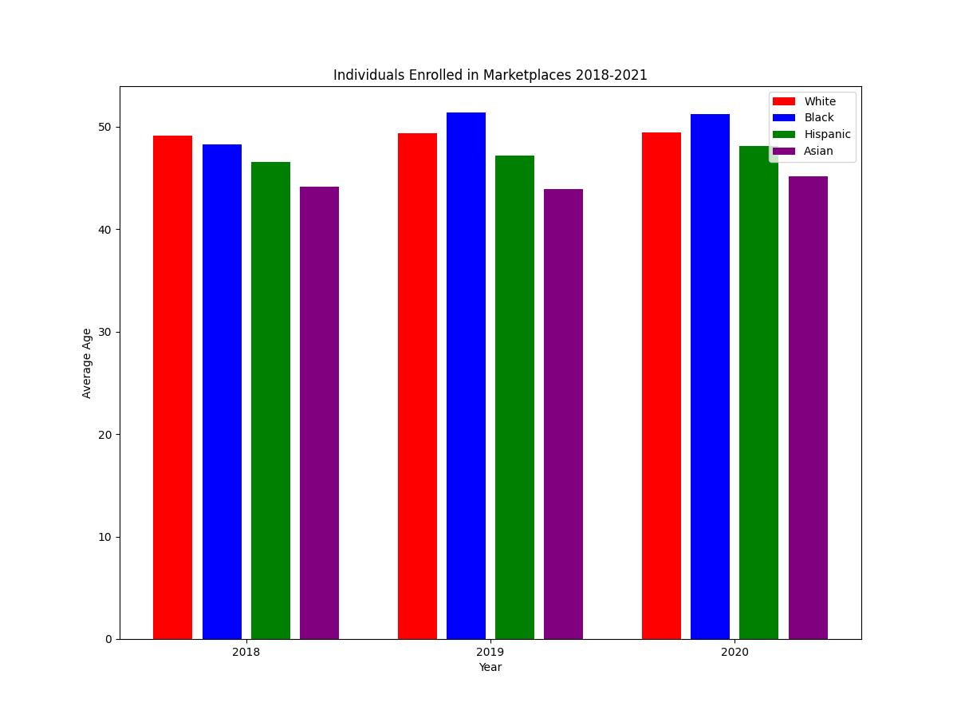 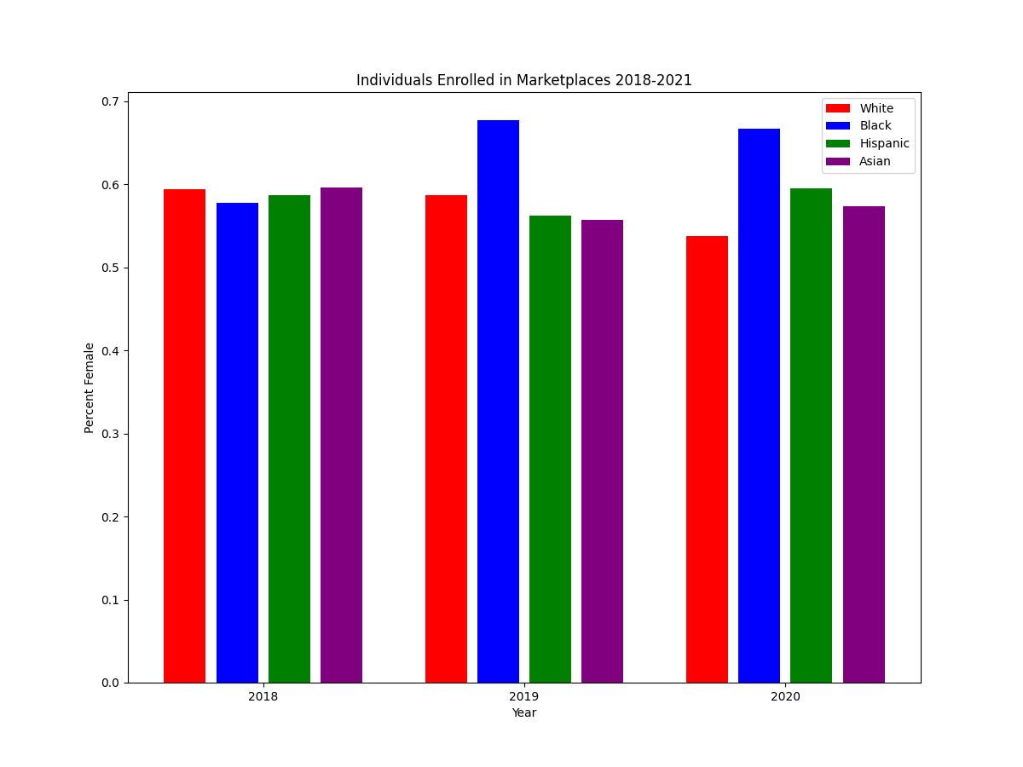 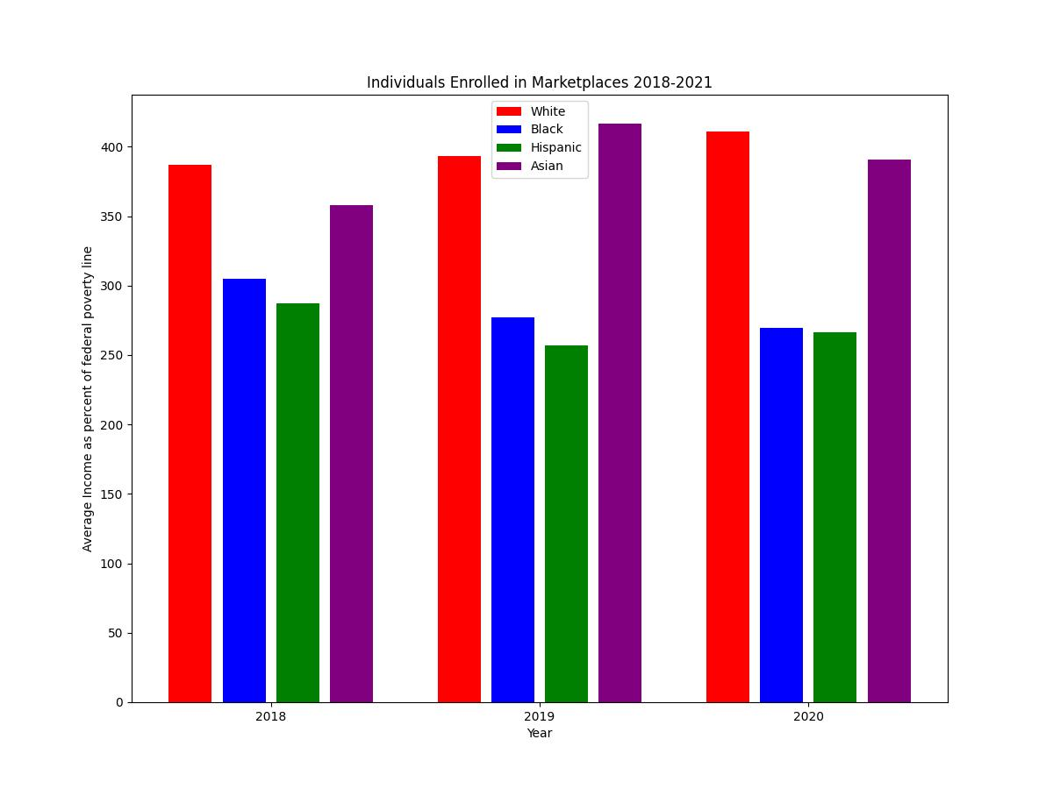 Number of Diagnoses per Person.jpeg) 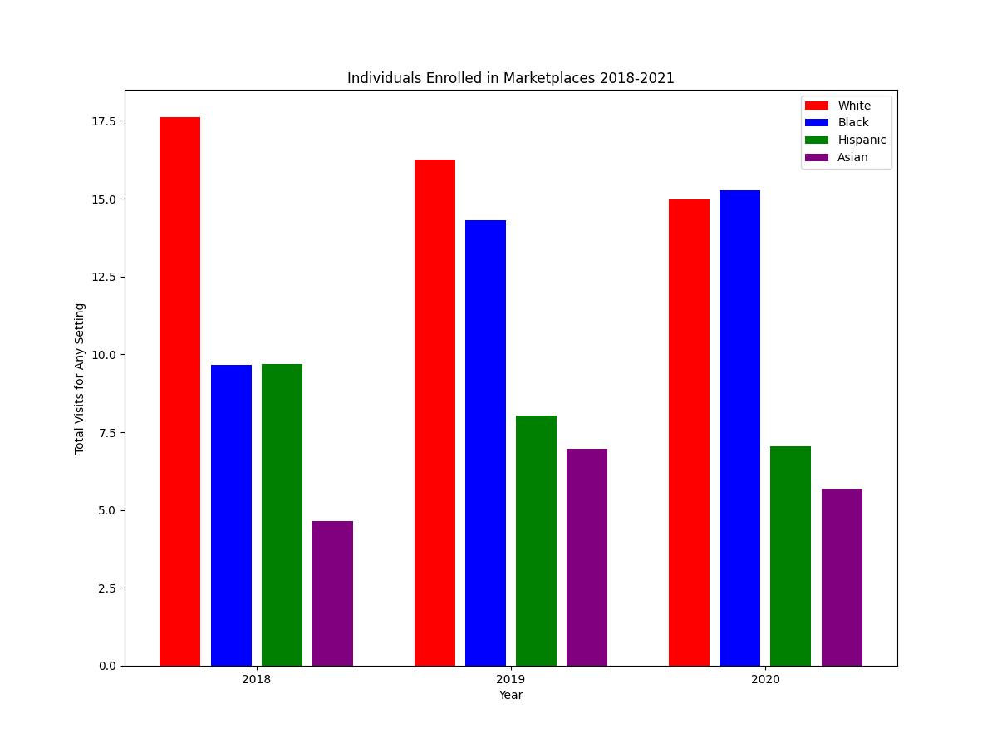 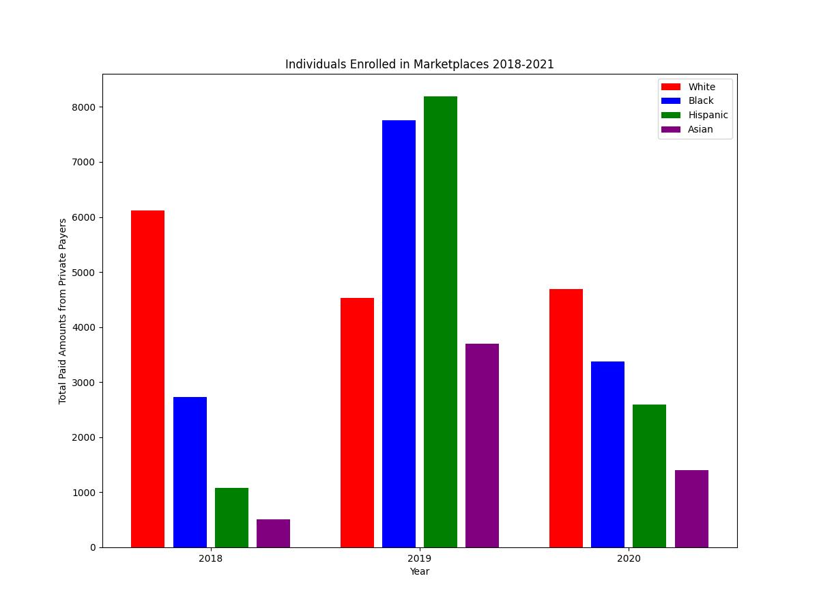

#### Regression Results

