Sensor Box manual

Operating and Modifying the sensor box thingo

QUT

ASTRI Sensor Logging

Contents

Sensor Architecture 2

High Temp Sensor 3

Pressure Sensor 3

Level Sensor 4

Central Node (Raspberry Pi) 6

# Sensor Architecture

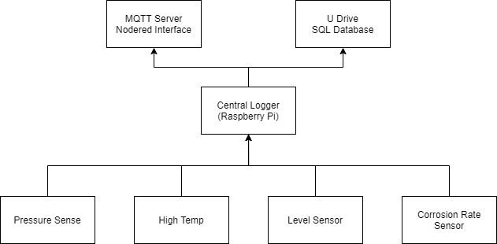The system can be split into 3 layers shown in Figure 1. The bottom layer consists of the sensors, these relay the data via serial to the central logger that is hosted on a raspberry pi. The data on the Pi is sorted and placed into an SQL database that can be accessed from QUT U Drive under the QUT-Astri Project. The data is also stored locally if the Pi isn’t connected to the qut network. For a live user interface a node red server is also running on the raspberry pi that displays a web page with the data being collected and current sensor readings.

Figure : Logging system architecture

# High Temp Sensor

The “High Temp” sensor is a five channel thermocouple reader that can measure up to 1300oC (dependent on attached thermo couples). The sensor has a Arduino nano 33 iot host microcontroller and uses 5 maxim integrated MAX31856 chips to read the termocouples. These sensors are interfaced to the Arduino over SPI.

The High temp sensor can also be configured with an SD card and DS3231 rtc for remote logging applications.

|  |  |
| --- | --- |
| Host microcontroller | Arduino nano 33 iot |
| Power supply | 5V - 21V can draw up to 2amps |
| Peripherals | MAX31856, SD card, DS3231 |

# Pressure Sensor

The “pressure Sense” board is designed as an interface for the Panasonic DP-100 series pressure sensors. These sensors output an analog signal that is then read via the Arduino nano and relayed over serial to the central logging system. Because the board is powering the external pressure sensors the power supply required needs to deliver between 12V-21V.

|  |  |
| --- | --- |
| Host microcontroller | Arduino nano 33 iot |
| Power supply | 12V - 21V can draw up to 2amps |
| Peripherals | Panasonic DP-100 |

# Level Sensor

The “Sodium Level Sensor” uses a series of metal probes to monitor the level of any conductive liquid at elevated temperatures. The sensor can monitor the level at 4 different intervals that are set by adjusting the lengths of the stainless-steel metal probes (3mm 316 welding wire).

To set the sensor adjust two probes to the minimum level required for monitoring, one probe acts as the reference for the all the other probes. Then set the remaining 3 probe lengths based on the levels at which you wish to be notified as the liquid drops. As the liquid level drops below each probe a high signal is received on the Arduino. The reference probe must be the last to leave the liquid as the level drops.

The data collected from the sensor is a list of number in the format “0, 0, 0, 0”. The each 0 represents a probe on the sensor (ignoring the ref probe). If all legs of the sensor are submerged the reading will be “1, 1, 1, 1”, as the level drops bellow the first probe it will read “0, 1, 1, 1” and so forth as the level drops.

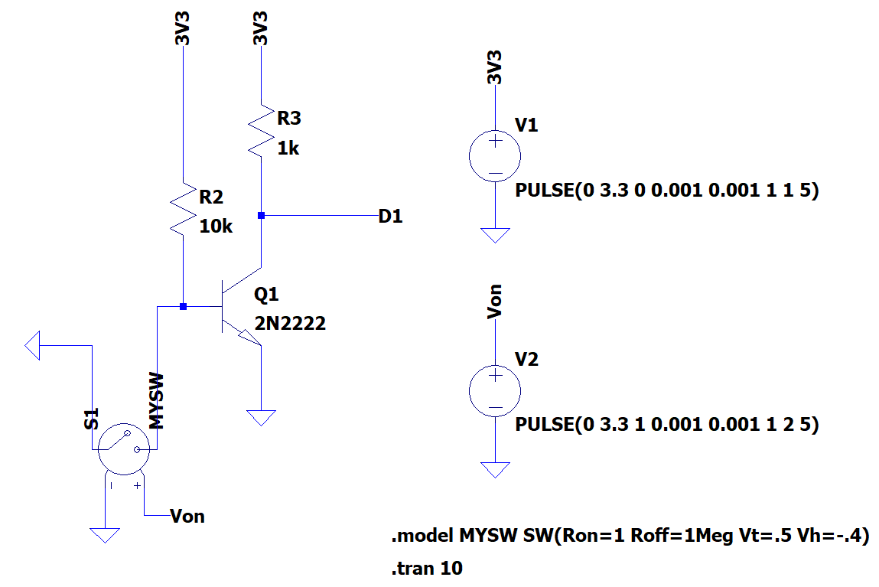

Figure : Circuit Diagram for level sensor

# Central Node (Raspberry Pi)

The Raspberry Pi serves two main purposes, it collects the data from the sensors and stores them in a database and it hosts the MQTT webserver.

The software written for the use in the logging box thingo is under the Central node project in the handover folder. The code is written in python and takes the sensor data over serial for the connected sensors, adds a timestamp then amends it into both a database and a plain csv file for later use.

On startup the sensors connected by serial are automatically detected and the data is collected over serial and added to the database with the COM port number. This database will be stored on the QUT U drive under the ASTRI folder.

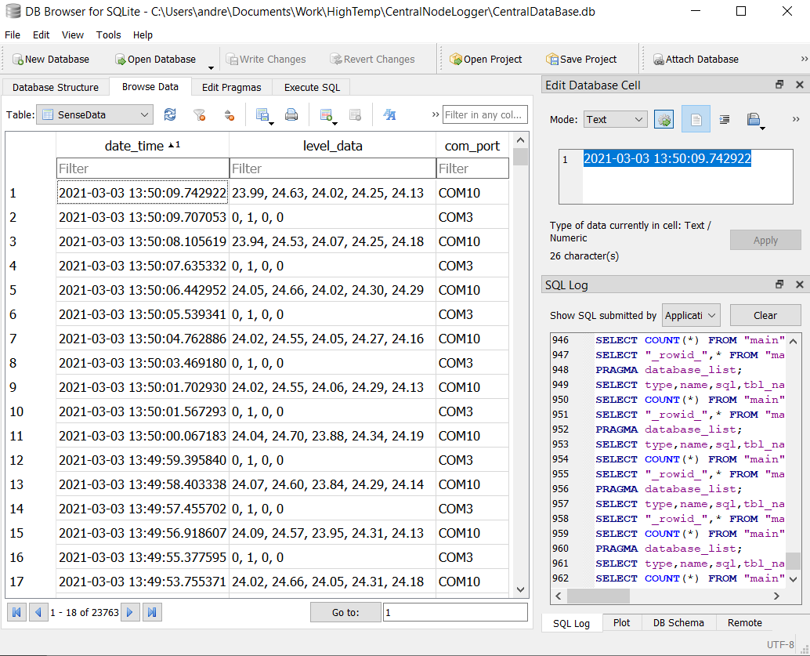

Figure : Data collected from the sodium level and high temp sensors. Viewed using DB browser for SQLite