HRRT_U 1.0 Installation Procedure

Installing the software on the reconstruction computer
Unzip the distribution file and launch setup.exe to start the installation. The installation procedure creates C:\cps\USERS_SW directory, copies the software files in the directory and adds C:\cps\USERS_SW to the path (verify and add it manually if not done by the installation procedure.

Configuring the reconstruction computer for cluster reconstruction.
The installation procedure installs the cluster executables (clc_u, clq_u, clcrecon) in c:\cps\USERS_SW. Follow the steps below to configure the cluster fileserver.
- Open a command window, go to c:\cps\USERS_SW: (1) type the commands “clc_u –u” and “clq_u –u” to uninstall the ClusterServer and ClusterQueue services if they already exist; (2) type “clc_u –i” and “clq_u –i” to (re)install the services.
- The services installation creates the services executables and log files in c:\cps\cluster_u directory, creating it if it doesn’t exit.
- Create the configuration files ClusterConfig.txt and QueueConfig.txt in C:\cps\cluster_u directory (see specifications document, section 4.1).
- Create a cluster account (e.g hrrt) used by the nodes to access the server files.

Installing the ClusterServer service on each cluster node
Copy clc_u.exe in a temp directory (e.g c:\temp), open a command window, go to the temp directory and type “clc_u –i” to install the service.
Follow the steps below to set the service account to the cluster account:
- Create the cluster account as on the fileserver
- Display the services (control panel->administrative tools->services), locate and right click on ClusterServer service as show on figure1 to display the properties dialog box shown on figure 2 ( start the service manually if it is not active).
- Check “this account” radio button, type in or select the account, type and confirm the password in the box showed on figure 2, restart the service as indicated.
Downloading executables service on each cluster node
Once the ClusterServer is installed on the nodes, the cluster management (software download and update) is done on the fileserver. Refer to keywords document for a complete list of functions.
On the file server: open a command window, go to c:\cps\USERS_SW and type “clc_u –d filename.exe” to download: clcrecon.exe, hrrt_osem3d.exe and gendelays.exe.

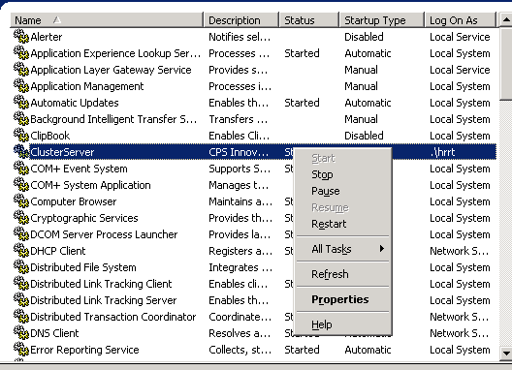
Figure 1: display ClusterServer Properties dialog box

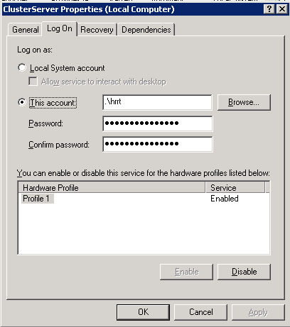
Figure 2: Setting ClusterServer service account

