02-10-2009
HRRT_U 1.1 Installation Procedure

1. Installing the software on the reconstruction computer (Reconserver)
Execute the distribution file (HRRT_U_1.1_install.exe) to start the installation. The installation procedure creates C:\cps\USERS_SW directory, copies the software files in the directory and adds C:\cps\USERS_SW to the path.

2. Configuring the software on the reconstruction computer
- Open ReconGUI_u, CorrectRun_u and DailyQC_u shortcut properties and set the "start in" directory to C:\CPS\USERS_SW.
- Start ReconGUI, open the transmission configuration to set your blank file and the scatter configuration to set your normalization file.

3. Installing the software on the ACS
Execute the distribution file (HRRT_U_1.1_install.exe) to start the installation. The installation procedure creates C:\cps\USERS_SW directory, copies the software files in the directory and adds C:\cps\USERS_SW to the path.
Scanit_u is installed in c:\cps\USERS_SW. Copy configuration files c:\cps\bin\*.cfng and c:\cps\bin\*.ini, Patient.ldb and db.cfg to c:\cps\USERS_SW. (Keep Patient.mdb in c:\cps\bin\.)

4.1. Configuring the reconstruction computer for cluster reconstruction
The installation procedure installs the cluster executables (clc_u, clq_u, clcrecon) in c:\cps\USERS_SW. Follow the steps below to configure the cluster fileserver.
- Open a command window, go to c:\cps\USERS_SW and type the commands “clc_u -i” and “clq_u -i” to install the ClusterServer and ClusterQueue services (or “clc_u -U” and “clq_u -U” to update the services if they existed already). The services installation will create the cluster directory c:\cps\cluster_u if not existing.
- Create the cluster configuration file ClusterConfig.txt in C:\cps\cluster_u directory (see also specifications document, section 4.1). An example for a four node cluster:
HOST reconserver
RAID reconserver 192.168.1.1
node node1 192.168.1.11
node node2 192.168.1.12
node node3 192.168.1.13
node node4 192.168.1.14
The file contains two entries for the server (one to specify that it is the server and one for its IP address) and one for each node (computer name and IP address). reconserver and nodeX are the computer names given in Windows and defining each computer on your network. (If you change the names of any of the computers, remember to update the DNS.)
- Create the queue configuration file QueueConfig.txt in C:\cps\cluster_u directory (see also specifications document, section 4.1):
#!QueueConfig
Recon-Jobs D:\Recon-Jobs
Jobs-Submitted D:\Recon-Jobs\Jobs-Submitted
Jobs-In-Progress D:\Recon-Jobs\Jobs-In-Progress
Jobs-Completed D:\Recon-Jobs\Jobs-Completed
ClusterSize.Min 1
ClusterSize.Max 4
ClusterSize.Set 1
ClusterSize.Max is the number of nodes. ClusterSize.Min and ClusterSize.Set are set to one to force the subcluster size to one. Such a cluster can reconstruct four frames in parallel.
- Create a cluster account (e.g. username: hrrt, password: hrrt) used by the nodes to access the server files.
- Share the data directory D:\SCS_SCANS as SCS_SCANS. The reconstruction service clcrecon running on the nodes replaces input file paths by UNC paths and executes the reconstruction program hrrt_osem3d using UNC path (e.g: \\fileserver\scs_scans\patient\em.s for d:\scs_scans\patient\em.s).

64 bit systems: If you are running on a 64 bit system, rename the files hrrt_osem3d_x64.exe and gendelays_x64.exe to hrrt_osem3d.exe and gendelays.exe. If you need the 32 bit versions for you cluster nodes, do the renaming after you have installed the software on the nodes. (The system can use a combination of 32 and 64 bit machines but each machine needs the files hrrt_osem3d.exe and gendelays.exe with these exact names.)

4.2. Installing the ClusterServer service on each cluster node
Make sure the cluster directory c:\cps\cluster_u exists or create it. Copy clc_u.exe onto a folder on the node c-drive (e.g. c:\temp), open a command window, go to the temp directory and type “clc_u -i” to install the service.
Follow the steps below to set the service account to the cluster account:
- Create the cluster account exactly(!) as on the fileserver.
- Display the services (Control Panel – Administrative Tools – Services), locate and right click on ClusterServer service as show in Figure 1 left to display the properties dialog box shown in Figure 1 right.
- Check the “this account” radio button, type in or select the account, type and confirm the password in the box showed on Figure 1 right.
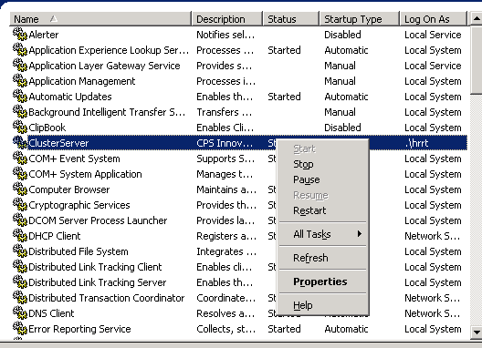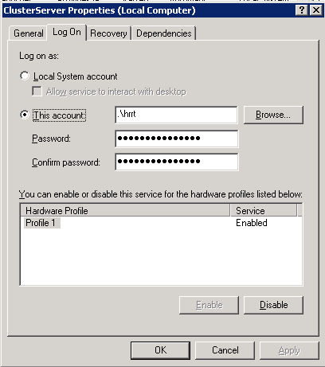
Figure 1: Displaying ClusterServer Properties dialog box and setting ClusterServer service account.
4.3 Downloading executables service on each cluster node
Once the ClusterServer is installed on the nodes, the cluster management (software download and update) is done on the fileserver. Refer to keywords document for a complete list of functions.
On the file server: open a command window, go to c:\cps\USERS_SW and type “clc_u -d filename.exe” to download: clcrecon.exe, hrrt_osem3d.exe and gendelays.exe, and “clc_u -d hrrt_rebinner.lut” to download the file hrrt_rebinner.lut to the nodes.
To get the communication running between the server and the nodes, shut off all firewalls between them. Alternatively, if you need firewalls running, create an exception for ClusterServer, as shown in Figure 2 for Windows.

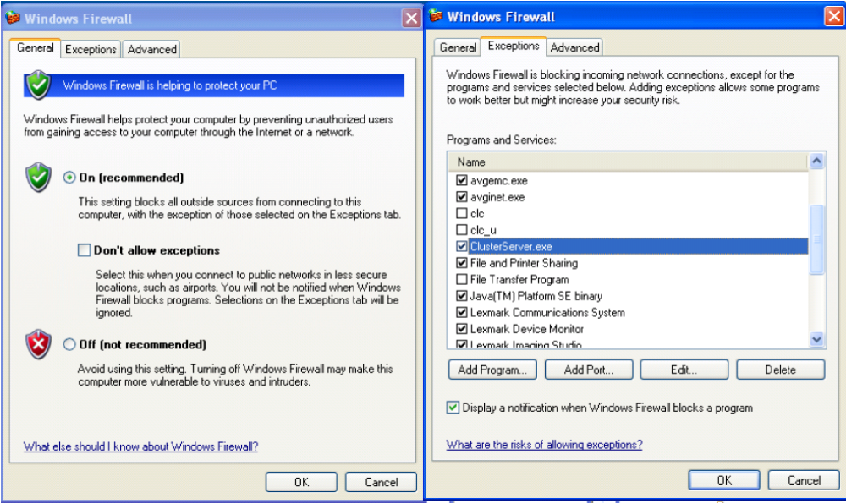
Figure 2: Creating an exception for ClusterServer in Windows Firewall.

4.4. Updating ClusterService (clc_u) on the cluster nodes
If you update clc_u to a newer version on the cluster node using the command “clc_u –U” (or reinstalling using “clc_u -i”) the ClusterService will be restarted on the node, but with Local System as the user and the cluster will reject reconstruction jobs. You have to restart it with you own user setting 8identiacal on Reconserver and nodes).

4.5. Example job script
To reconstruct on the cluster ReconGUI creates and sends a job script to D:\Recon-Jobs\Jobs-Submitted. The scripts, which of course can be created outside ReconGUI, are named (uniquely) with the current date and time and the frame number e.g. recon_job_090309192645_0.txt. The content of a job script is (example):
#!clcrecon
scanner_model 999
span 9
resolution 256
outputimage D:\SCS_SCANS\pt_name\pt_name-2008.5.27.14.2.2_em_frame37_3D.i

norm D:\SCS_SCANS\norm\span9-Archive\norm_2007-12-17_40h_span9.n
atten D:\SCS_SCANS\ pt_name\ pt_name -2008_5_27_13_42_23_TX.a
scatter D:\SCS_SCANS\ pt_name\pt_name-2008.5.27.14.2.2_em_frame37_sc.s

iterations 10
subsets 16
psf
weighting 3
prompt D:\SCS_SCANS\pt_name\pt_name-2008.5.27.14.2.2_em_frame37.s
delayed D:\SCS_SCANS\pt_name\pt_name-2008.5.27.14.2.2_em_frame37.ch

