High Resolution Research Tomograph
U S E R C O M M U N I T Y

HRRT_U 1.1 Release notes
HRRT_U 1.1 is a new software release replacing 1.0 release and 1.0.1 patch. The release is a self-install executable HRRT_U_1.1_install.exe. The main purpose of this version is to provide: Cologne specific gantry support, span 3 processing on 64bit, a new Component-Based Normalization (CBN) with corrections for reported artifacts in previous evaluation versions, and an optimized 3DRP reconstruction.

Program | HRRT_U 1.0 | HRRT_U 1.0.1 | HRRT_U 1.1
Calcringroiratio.exe | Aug 7 2008 16:42:02
clc_u.exe | Aug 11 2008 13:08:09 |  | Jul 17 13:17:40 2009
Clcrecon.exe | Oct 6 2008 16:46:32
clq_u.exe | Aug 11 2008 09:02:37
CorrectRun_u.exe | Aug 30 2008 11:55:09
Daily_QC.exe | Oct 25 2008 14:44:00
e7_atten_u.exe | Oct 25 2008 16:13:13 |  | Sep 27 2009 11:51:15
e7_fwd_u.exe | Aug 5 2008 11:23:35 |  | Sep 27 2009 11:51:15
e7_sino_u.exe | Aug 26 2008 10:02:04 |  | Nov 11 2009 15:00:32
Gen_delays.exe | Nov 11 2008 15:51:54 | Dec 22 2008 11:30:34 | Jul 16 2009 15:01:04
Gen_delays_x64.exe |  |  | Jul 17 2009 12:39:16
hrrt_osem3d_x64.exe | Nov 17 2008 09:09:58 | Dec 22 2008 16:55:20 | Oct 24 2009 23:58:07
hrrt_osem3d.exe | Nov 17 2008 09:08:35 | Dec 22 2008 16:26:13 | Oct 24 2009 23:58:18
hrrt_rebinner_lut.exe | Nov 12 2008 18:26:39 |  | Jul 16 2009 12:42:17
If2e7.exe | Oct 6 2008 18:24:14 |  | Jul 30 16:38:49 2009
lmhistogram_u.exe | Aug 7 2008 16:17:39 | Jan 11 2009 18:04:44 | Nov 12 2009 12:48:23
lmhistogram_u_x64.exe |  |  | Nov 12 2009 12:48:43
norm_process.exe | Nov 13 2008 21:50:42 |  | Oct 16 2009 11:45:43
norm_process_x64.exe |  |  | Oct 16 2009 11:45:33
ReconGUI_u.exe | Nov 21 2008 12:28:12 | Jan 19 2009 16:58:37 | Jul 28 2009 12:02:51
TX_TV3DReg.exe | Oct 27 2008 10:10:00
Ecat2dicom.exe |  | May 08 2008 18:00:00
update_dicom.exe |  | Jan 22 2008 12:54:39
gsmooth_u.exe |  |  | Aug 4 2009 16:31:32
ecat_3drp.exe |  |  | Nov 11 2009 12:01:03
ecat_3drp_x64.exe |  |  | Nov 11 2009 12:15:19
hrrt_sinocor.exe |  |  | Sep 26 2009 11:56:13
hrrt_sinocor_x64.exe |  |  | Sep 26 2009 11:56:20
hrrt_gapfill.exe |  |  | Jul 3 2009 18:55:29
hrrt_gapfill_x64.exe |  |  | Jul 3 2009 18:56:11
scanit_u.exe |  |  | Sep 26 2009 14:44:51
blockencode_1_0 |  |  | Oct 19 2005
masknorm_1_0 |  |  | Oct 19 2005
ch2bm |  |  | May 19 2005
Table 1: HRRT_U 1.1 program versions

HRRT_U 1.1 changes in existing components
- Component-Based Normalization (norm_process) and Transmission scatter correction with Total Variation 3D Regularization (TX_TV3DReg) are now released. Corresponding abstracts (1) and (2) have been accepted for IEEE-MIC 2009 and can used as references when using these methods.
- Lmhistogram_u and norm_process use rebinner LUTs to ensure the same result with 32bit and 64bit versions. They are faster and use less CPU ressources
- Gsmooth_u is a modified version of gsmooth to support multi-frame ECAT file smoothing. Only the first frame was smoothed in gsmooth due to a bug in the code.
- if2e7 default units are Bq/ml instead of kBq/ml
- gen_delays: code change to include TX LUT and linux support, no functionality changes
- hrrt_osem3d: span3 processing, apply normalization mask to prompt to remove artefacts when using normalization with masked blocks, dual logging to file and console. The normalization mask includes gaps and outliers set to 0 because the normalization factors are two high.The new reconstruction reduces noise from segments and gap border bins where normalization factors were thresholded (Figure 1).
- hrrt_rebinner_lut: Added transmission LUT.
- clc_u: new function (-P hostname) to report hostname time in milliseconds for time synchronization purpose.
- e7_tools code was modified to support linux. e7_atten_u and e7_fwd_u were rebuilt after code modification without functionality change. e7_sino_u was modified to output the scatter fraction in the scatter interfile header (..h33). The scatter fraction is also written in the image header by hrrt_osem3d and in the corrected sinogram by hrrt_sinocor.
- norm_process was modified to check input arguments and exit when an argument is invalid.

HRRT_U 1.1 new utility programs (not documented in specifications)
- blockencode_1_0: create as a listmode file with LORs through the specified block; the listmode can be histogramed to create a sinogram mask
- masknorm_1_0: Creates a new normalization with masked block using the sinogram mask and an exiting norm.
- ch2bm: creates a bitmap file from .ch file

HRRT_U 1.1 Installation instructions
- Make a copy of C:\CPS\USERS_SW directory
- Launch HRRT_U_1.1_install.exe and follow the instructions. If a previous was installed, this un-installs it, re-execute the program to install the new version
For 64bit, rename program.exe to program_x32.exe (e.g hrrt_osem3d.exe to hrrt_osem3d_x32.exe) and program_x64.exe to program.exe(e.g hrrt_osem3d_x64.exe to hrrt_osem3d.exe).
- See cluster installation instructions for cluster configuration.

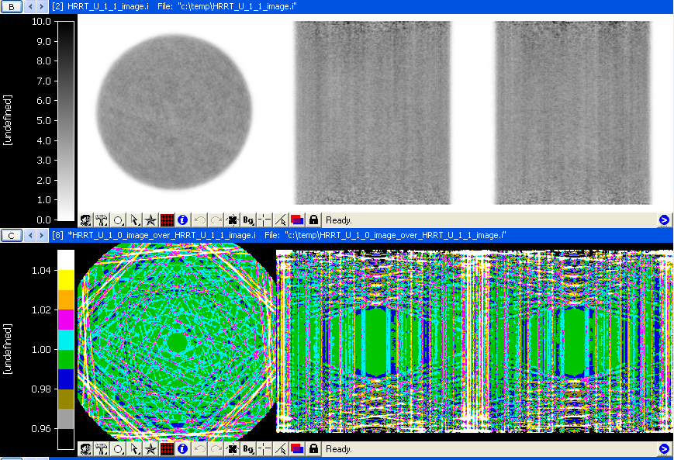
Figure 1: Differences between HRRT_U 1.1 and HRRT_U 1.0 reconstructions; HRRT_U 1.0 and. original CPS cluster reconstructions are identical.

References:
- Merence Sibomana, Sune Høgild Keller, Søren Holm, Peter M. Bloomfield, Stephan Blinder, Søren Baarsgaard Hansen and Christian Michel, ” Component-Based Normalization for the HRRT for Sinogram-mode reconstruction”, IEEE MIC conference , Orlando, 2009, Conference Record M05-133
- Merence Sibomana, Sune Høgild Keller, Søren Holm, Flemming Andersen, Claus Svarer and Liselotte Højgaard, “New Attenuation Correction for the HRRT Using Transmission Scatter Correction and Total Variation Regularization”, IEEE MIC conference , Orlando, 2009, Conference Record M09-224

