Report on artefact found in hrrt_gapfill.exe when running with HRRT User Group test data
Floris van Velden and Marc Huisman, VUmc Amsterdam, 14-12-2009

When running the hrrt_gapfill.exe with Inki’s 3DRP, stripe artefacts are observed in axial view and black line artefacts in coronal and sagittal views.

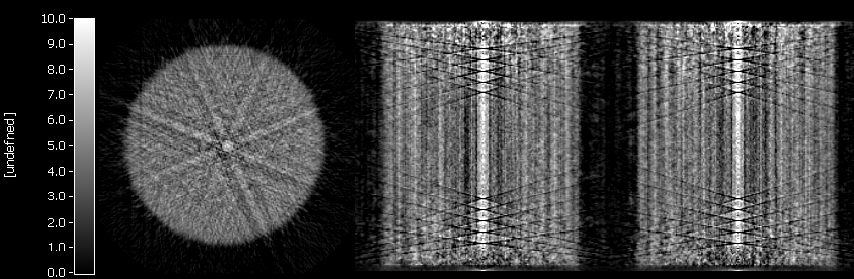

The line artefacts are gone by using VUmc’s 3DRP, as this version clips the five first and last planes of each segment. The first and last five planes often do not contain enough data to estimate the gaps with confosp or linear interpolation on angles.

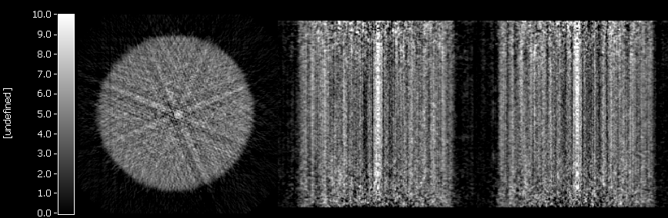

Confosp is known to converse slowly on very homogeneous objects (as reported earlier). Therefore, the default number of iterations (15, picture above) was increased to 30 (picture below) and 60 (picture below 30 iterations) iterations.

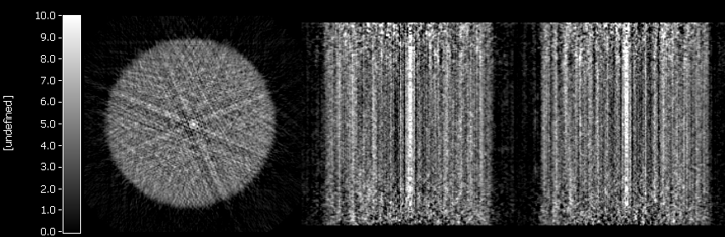

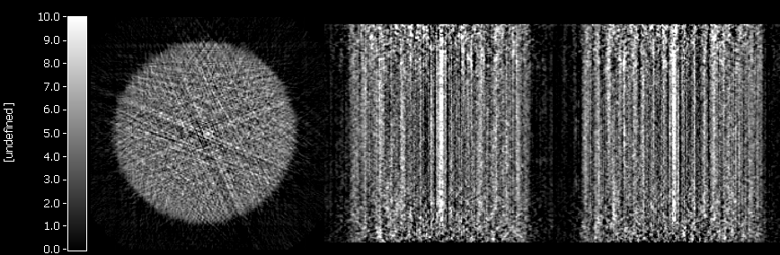

However, increasing the number of iterations did not improve the quality of the gap filling strategies. When running hrrt_gapfill.exe in combination with VUmc’s 3DRP on VUmc data, the artefacts are not very apparent, as can be seen in the picture below.

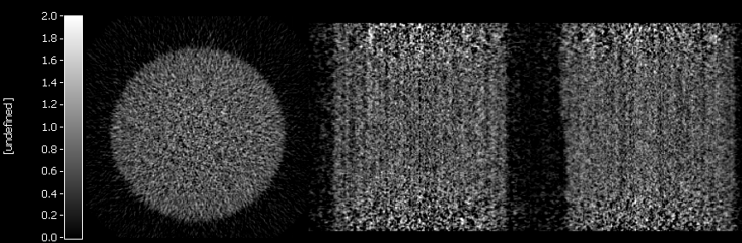

At this moment, we observed two clear differences between the data of VUmc and Copenhagen:
- Phantom of VUmc has been scanned for just 2 hours, while Copenhagen has scanned the phantom for 24 hours. Statistics is much better in Copenhagen data than in VUmc data. Noise might influence the performance of the confosp algorithm, as was observed earlier. Very homogeneous objects (having good statistics) needed more time to converge properly. However, we must note that increasing the number of iterations did not improve the quality of confosp here as was observed earlier.
- The normalization data of VUmc is different from the normalization of Copenhagen.

Normalization data Copenhagen:

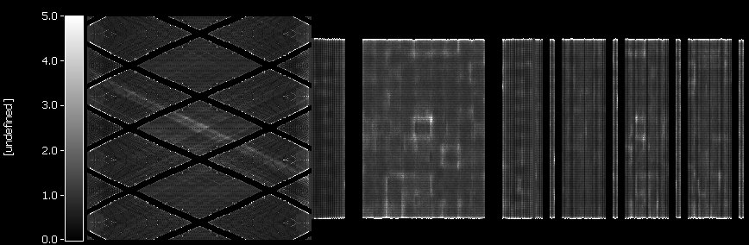

Normalization data VUmc:

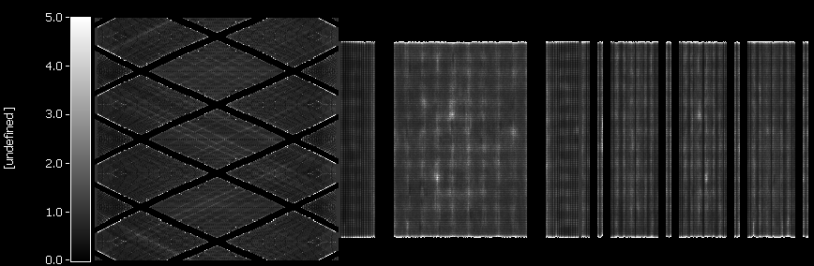

The normalization data from Copenhagen shows some lanes that have high normalization values. These lanes were often removed from VUmc normalization files. We tried to remove these lanes by thresholding the normalization file, setting all values above 2 to 0, creating artificial gaps. Please note that these gaps are not proper, as no lanes are introduced, but incidential zeros and small lanes. The gap filling strategies need at least small lanes to work properly. However, when applying this technique, we observed the following image:

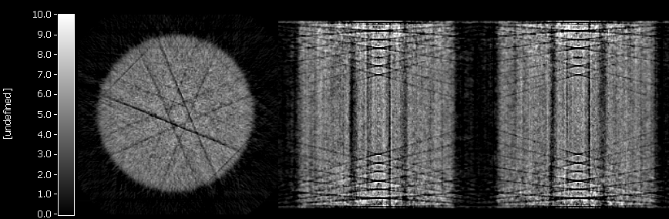

You can see that the image quality on the location of the gaps did improve. Black lanes are observed, but these are most likely due to the inability for the gap filling algorithms to fill incidental zero’s in the normalization file (it needs real lanes/gaps).

It is not clear to us what is the cause of the artefacts, either our own strategies or the normalization files with high values. However, we do think that, based on this data, it might be beneficial to implement the new strategies for normalization and prompt (/trues) sinogram handlings of Inki’s OSEM into the hrrt_gapfill.exe program (ie. strategies that remove high normalization values).

