This Snippet will call an open source NLP called wit.ai to use Natural Language.

This simple Code is a sample of how to integrate NLP into your automation, by providing one of the two phrases in the message box the NLP engine identifies your intent and returns it as an entity, these are very simple samples but it can get as complex as you want.

How to run the Automation.

The automation will work out of the box using an NLP instance that I have previously trained.

If you want to train and use your own NLP follow the next steps:

Create a free account in <http://wit.ai>

Train your NLP by typing phrases and relating them to entities.

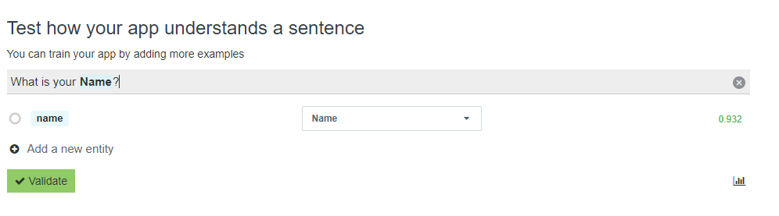Get the URL and the token to access your NLP as a web service. 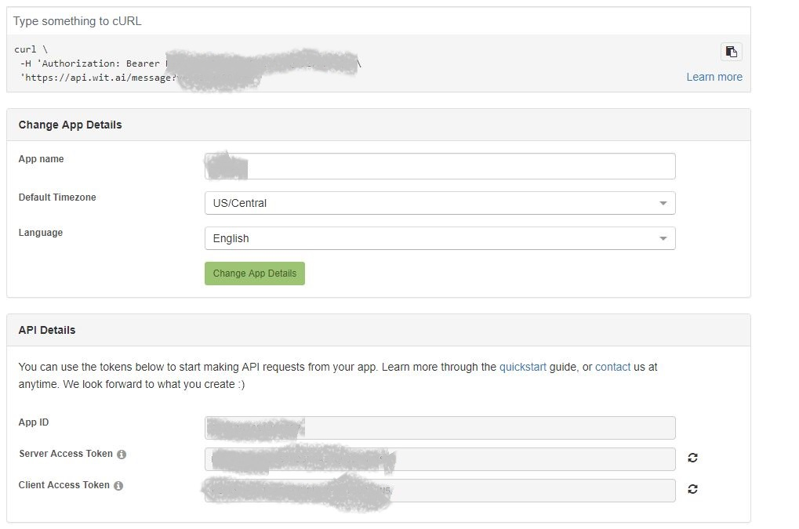

Update the Config File in the Data folder of the project with your own token.



Now you can use your Own NLP Engine for any purpose.