# Event Selection

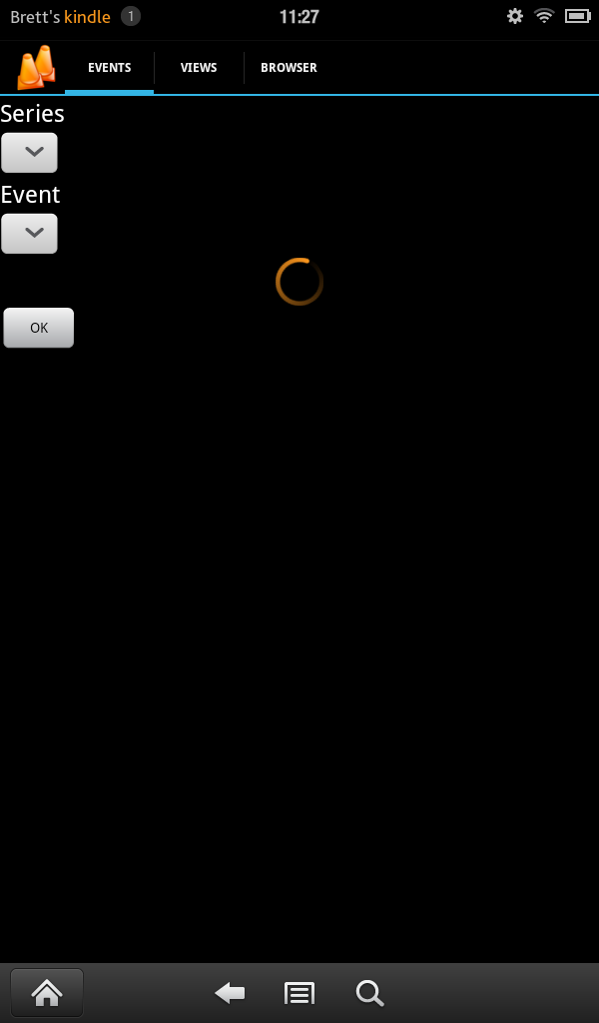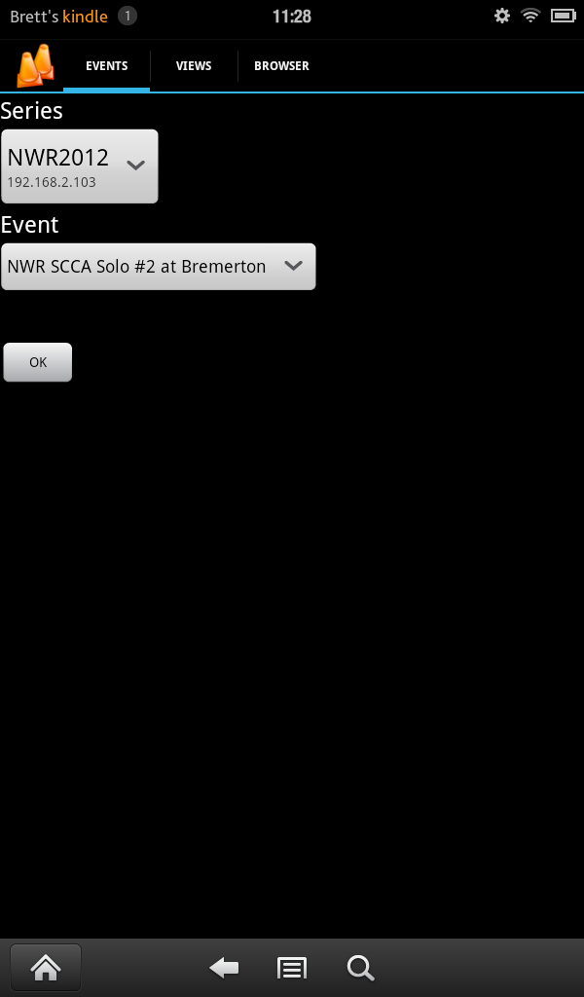

In the Kindle Fire screen captures above, you can see how the app first starts, it will search for available servers on the local network. This process requires that your device can send and receive multicast packets which most should. The second capture show the lists populated. In most cases there will only be one series to select from. Regardless, after selected, the list of events will be retrieved and displayed for selection. Press OK to move to the next step.

# View Setup

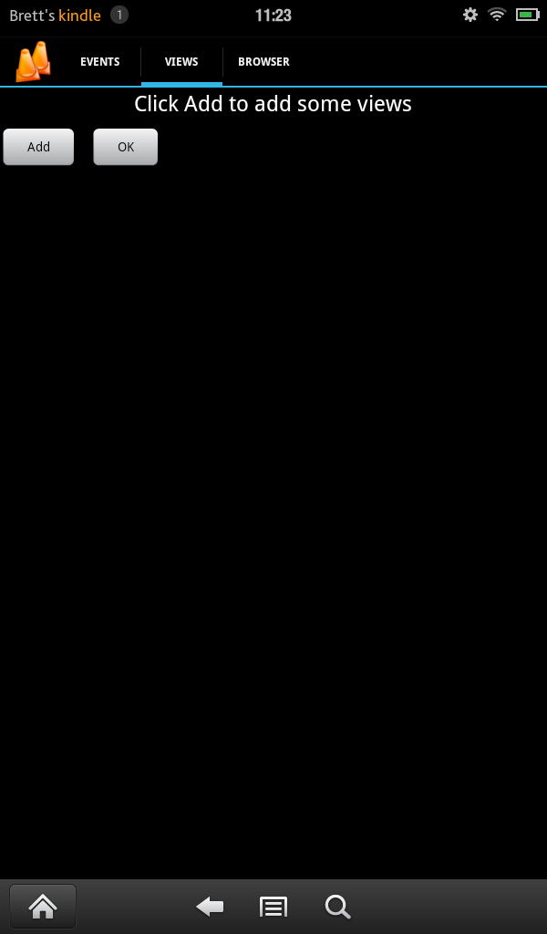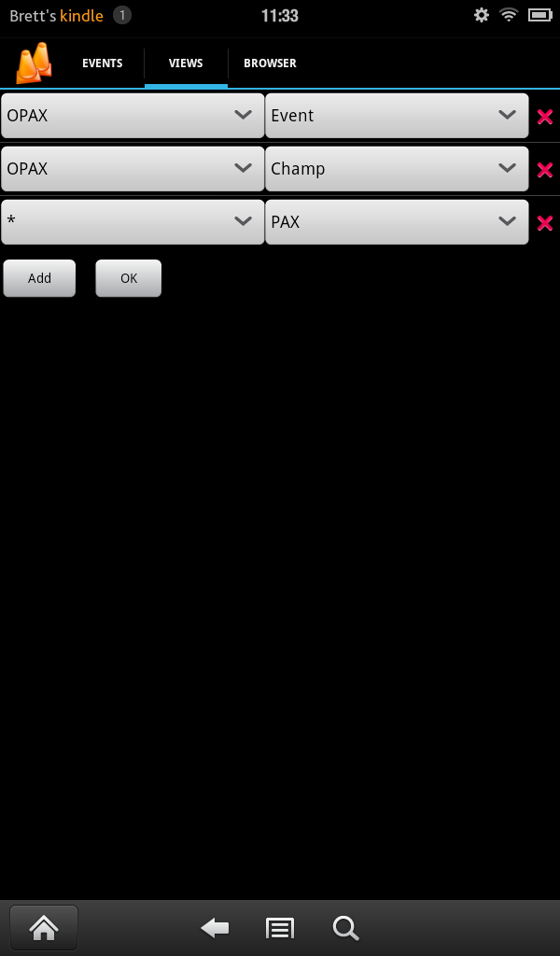

In the view setup page, you specify which classes and types of results that you are interested in watching. This list is saved for each series name so once setup for a series, it will remain the same for the other events until changed.

In the second screen capture, we have decided to watch the OPAX class events results as well as champ results. We also want to watch the top PAX times for the event. You will notice that the PAX list has the class of ‘*’ selected. This is a special class that says that we want the list to update on any new result. If we used OPAX for this list, it would only update when an OPAX competitor finished. It can also be used for event and champ results if you want to see updated results for each competitor to finish.

# Browser

# 

The browser is the portion of the app will you use the most. It provides a set of dynamically updated lists that you can scroll through up/down or page through left/right. The app will make a small check with the server periodically to see if there have been any changes to the classes being watched. When a change is detected, new results are loaded from the [onsite web server](http://scorekeeper.wwscc.org/doc/mobile.txt).

You can see the three page views that we configured in the previous section for class results, champ results and PAX list. In each, the latest competitor’s time is highlighted along with potentially highlighting old position (if there was an improvement) and/or possible position (if the raw time was an improvement but there were penalties).

The fourth image on the next page shows a double list paging if the screen is wide enough, i.e. landscape mode.

# 