# Merging registration databases

1. Take laptops where they are in network range of the data entry machine.
2. Open Change Viewer

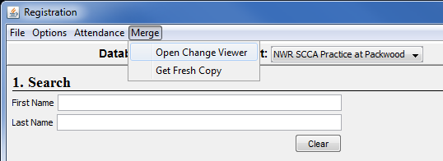

1. With the “Active” changeset selected, you can see the list of changes that were made and are ready to be merged. Click **Merge Changes**.

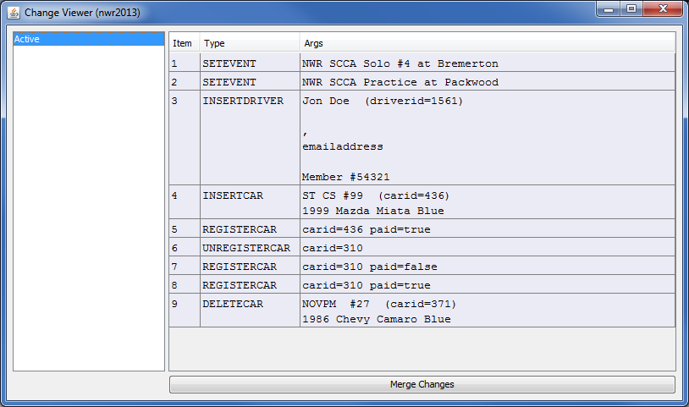

1. Select the correct host and database to merge with and the host and name values will be filled for you. There may be multiple databases at the same IP address. If for some reason, discovery if failing, you can manually enter the IP address and database name.

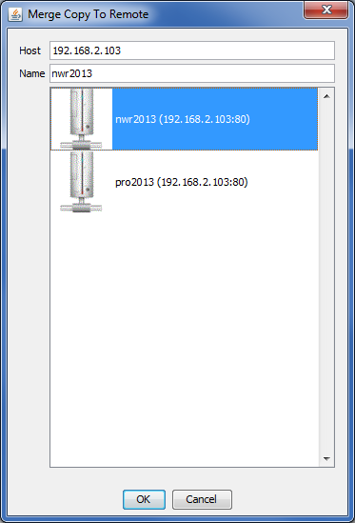

1. The merge process is done when an OK dialog is presented. It should be very quick.

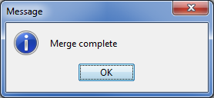

1. After a successful merge, you will notice that the active changeset is now listed as an Archive along with its last modification time. The last 9 changesets will remain present in the list unless they are deleted from the logs directory.

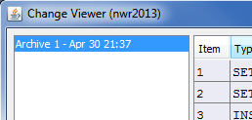

1. If there are multiple registration laptops and there is another session in the day, you will need to get a fresh copy so that both registration laptops now have all the same data. Once all have merged their data, select **Get Fresh Copy** and select the same host/name that you just merged with.

