**Questions | Chapter 3**

1. What is wrong with the general 'TREE-SEARCH' algorithm?
2. What are the four components of a node in a search tree? Provide an example using the 8-puzzle game.
3. What are the four ways to evaluate the performance of a search algorithm?
4. Discuss the space and time complexity of Breadth First Search.
5. Give a limitation of Breadth First Search.
6. Uniform-cost search expands the node n with the lowest path cost g(n). What is g(n)?
7. What data structures do BFS, Uniform-cost search, and DFS use?
8. What is the difference between Uniform-cost Search and Greedy Best-first Search?
9. Discuss the two commonly used heuristics for the 8-puzzle game. Use the following diagrams for your calculations.

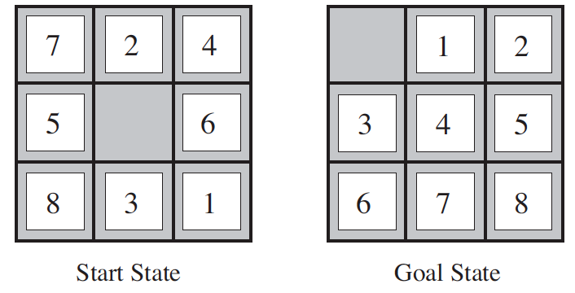

1. Discuss the “Manhattan distance” heuristic for the 8-puzzle game. Use the following diagrams for your calculations.



1. For a search problem that has a branching factor is 20, if 1000 nodes can be processed per second and each node require 1kb space, what will be the (a) total number of nodes, (b) time requirement, and (c) space requirement when running a Breadth First Search algorithm at a depth of 1, 2, and 3?
2. A search problem can be “well defined” formally by defining five components – initial state, actions, transition model, goal test, and path cost function. For the two-room vacuum world problem, answer the following:
   1. How many possible world states are there?
   2. Which will be the initial state?
   3. What actions are possible?
   4. Discuss the transition model.
   5. How is a state tested for a goal state?
   6. How is the path cost calculated?

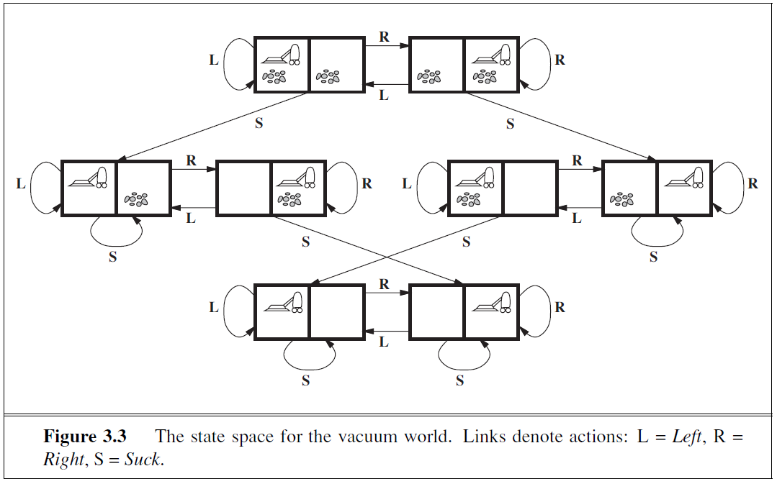

1. What are the advantages of DFS over BFS? Explain in the context of space complexity.
2. Write the DFS algorithm.
3. Write the BFS algorithm.
4. What is the difference between the tree search algorithm and graph search algorithm?
5. What is the difference between a state in a route-finding problem and a touring problem?
6. What is the difference between a leaf node and frontier?
7. Uniform-cost search expands the node n with lowest g(n). What is g(n)?
8. If g(n) is the cost to reach the node, and h(n) is the cost to get from the node to the goal, what is the difference between Uniform Cost search and A* search?
9. Given the following map (with the path costs shown) and the table with the heuristic function, we are interested in the stages of the A* search algorithm. Arad is the starting state and Bucharest is the goal state. As the A* search is executed, after Sibiu, the next node to be expanded is Rimnicu Vilcea. With calculations explain why.

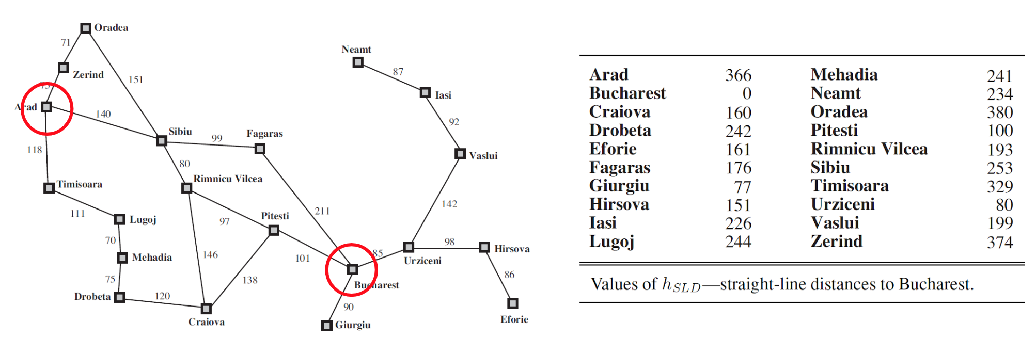

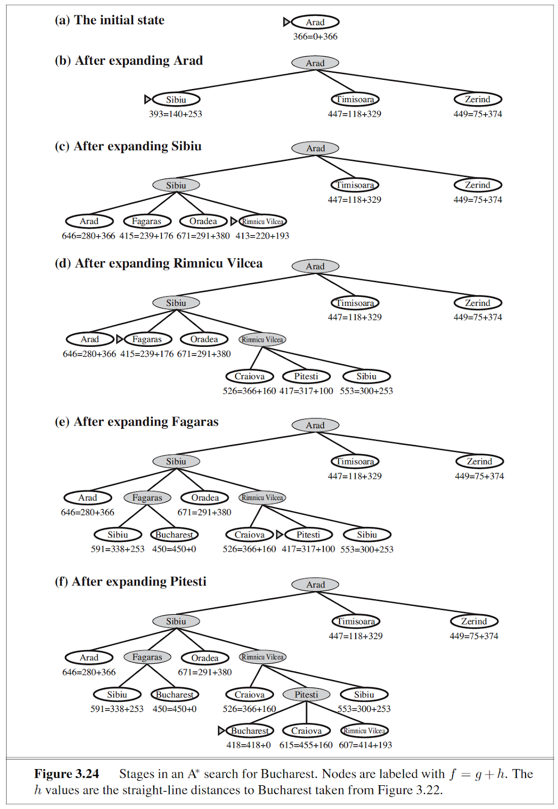

1. Given node A, having child nodes B, C, D with associated costs of (10, 5, 7). After expanding C, we see nodes E, F, G with costs of (40, 50, 60). Which node will be chosen by Uniform-cost search and Greedy best-first search? Explain with the following diagram as reference.

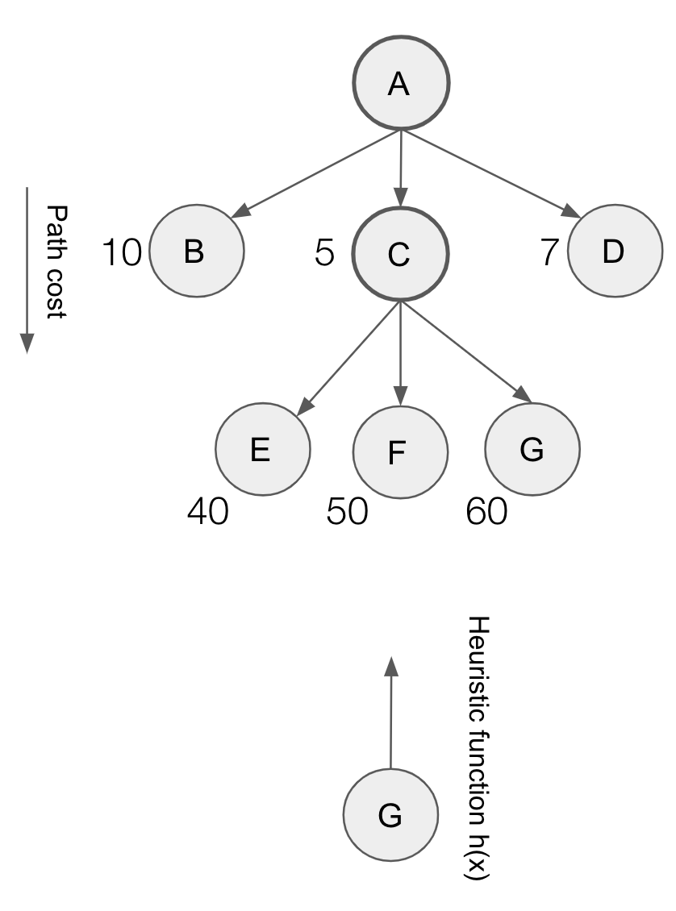

1. For the 8-puzzle game, what actions are possible in a given random state?



1. What will be the contents of the priority queue, as the UCS algorithm proceeds on the following graph? Show the contents of the priority queue, step-by-step.

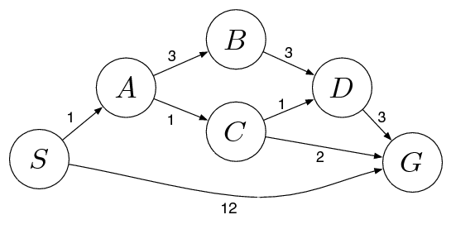 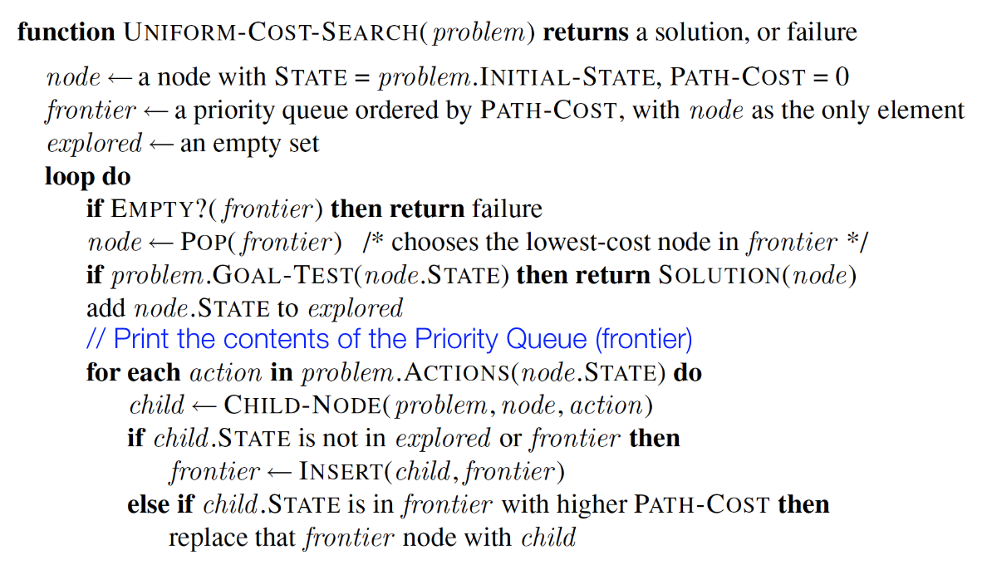

1. Given the general 'GRAPH-SEARCH' algorithm below which lines correspond to 'memorizing' the nodes that have already been visited?

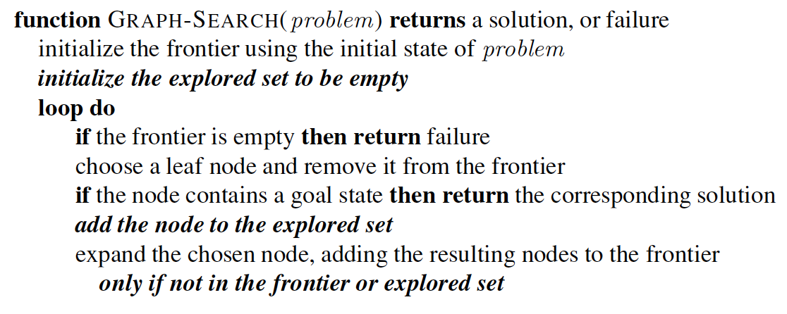

1. A search problem can be “well defined” formally by defining five components – initial state, actions, transition model, goal test, and path cost function. For the Romania problem below, if the initial state is “In(Arad)”,and the goal is to reach Bucharest, answer the following:
   1. What actions are possible?
   2. Discuss the transition model.
   3. How is a state tested for a goal state?
   4. How is the path cost calculated?

