Andrew Downie 0786342

CIS*3700 – Assignment

# Question 1) Soundness and completeness of inference algorithms

1. INF1 is sound, so any sentence generated by INF1 must be true. Therefore S1 is true in TE.
2. Because INF1 is not complete will not generate all valid sentences. (There are true sentences that do not get generated by INF1, and there are false sentences that do not get generated by INF1). This means that we cannot be sure if any sentence not generated by INF1 is true or false. Which means we cannot be sure whether or not S2 is true in TE.
3. While INF2 will generate every true sentence (it is complete), INF2 will also generate sentences that are false (it is not sound). Therefore we cannot be sure if anything generated by INF2 is true or false.
4. S4 will be false. INF2 can generate all true sentences (it is complete). Therefore anything that cannot be generated by INF2 must be false.
5. INF3 is sound, and so any sentence generated by INF3 will be true. Therefore S5 will be true in TE.
6. All sentences produced by INF3 will be true (it is sound). Therefore any sentence that cannot be produced by INF3 must be false.

# Question 2) Knowledge representation by logic sentences

1. P23 ⇔ (B12 ^ B22 ^ B23 ^ B33)
2. AN ^ AS ^ W14 ^ A12 => WumpusDead
3. TODO

# Question 3) Deciding entailment by model checking

1. There are: 2 ^ 8 = 256 models checked
2. The outcome is: isEntailed(KB, W31) == true

# Question 4) Converting sentence to CNF

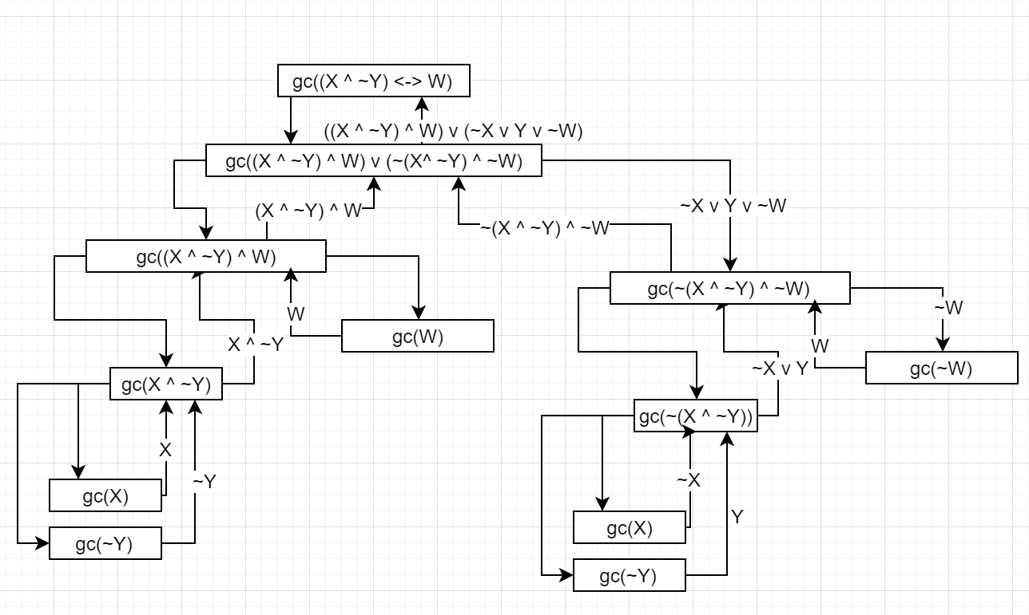

# Question 5) Resolution Closure

10! = 3,628,800

# Question 8) Knowledge representation and inference

|  |  |
| --- | --- |
| D) | i) N/A |
|  | ii) N/A |
|  | ii) N/A |