Andrew Downie 0786342

CIS*3700 – Assignment 3

# Question 1)

1. Supervised: people are training the parrot to give certain output, based on certain input. In other words, training examples are being used to train the parrot how to behave.
2. Unsupervised: the scientist does not know what causes the results. In other words, the scientist knows the results, but must discover the patterns in inputs that create this result.
3. Reinforced: The student is taught to associate know inputs with known outputs to learn how to act. The student corrects their actions (identifying the plant) based on whether they correctly identify the plant.
4. Reinforced: the bowling player knows the outcome they would like to achieve and works toward improving their skills by using feedback to determine how to better bowl. In other words, the bowler get their performance reinforced by how they bowl. The desired outcome is known, the inputs that lead to the desired outcome isn’t.

# Question 2)

Decision Tree: turnImmediately (inLeftLane, carTrailingClosely, roomToPullRight), the output of turnImmediately is either yes or no, meaning whether we should turn into the middle lane right away.

inLeftLane: whether we are driving in the left most lane

* Possible values: (yes, no)

carTrailingClosely: whether there is a car behind us, following closely, which implies they would like to pass us

* Possible values: (yes, no)

roomToPullRight: whether there is room for us to pull into the middle lane

* Possible values: (yes, no)

turnImmdiately(yes, yes, yes) = yes, otherwise this function will output no.

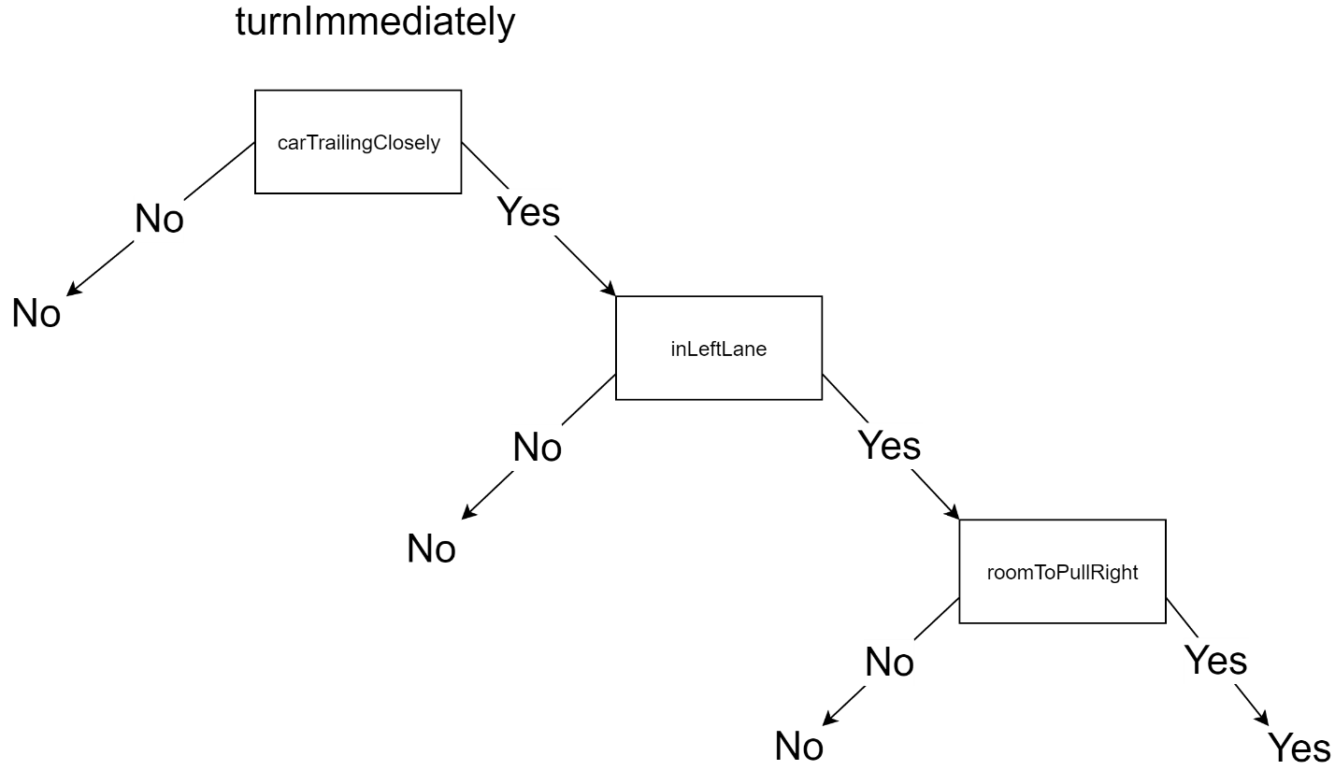

# Question 3)

Where:

* P must be the root
* If Q is present, Q must come before R
* If S is present, S must be the last node in a path

|  |  |
| --- | --- |
|  | C:\Users\drew\AppData\Local\Microsoft\Windows\INetCache\Content.Word\CIS 3700 - A3) Q3.png |

# Question 4)

Where:

* Info(x) = -log2(x)
* P(V1) = 0.2
* P(V2) = 0.3
* P(V3) = 0.5

1. W = I(P(V1), P(V2), P(V3)) = P(V1) * Info(P(V1) + P(V2) * Info(P(V2) + P(V3) * Info(P(V3)

W = I(0.2, 0.3, 0.5) = (0.2* Info(0.2)) +( 0.3 * Info(0.3)) + (0.5 * Info(0.5))

= (0.2 * -log2(0.2)) + (0.3 * -log2(0.3)) + (0.5 * -log2(0.5))

= 1.485 bits

1. Y = {yes, no}, 30 examples, 24 yes, and 6 no.

The answer w to the query y contains I((24/30), (6/30)) bits of information.

24/30 = 0.8

6/30 = 0.2

I(0.8, 0.2) = (0.8 * -log2(0.8)) + (0.2 * -log2(0.2))

= 0.722 bits of information contained by w

# Question 5)

Where:

* Info(x) = -log2(x)
* P(V1) = 64/88
* P(V2) = 24/88
* P(A = A1) = 30/88
* P(A = A2) = 58/88
* P(V1 | A = A1) = 25/30
* P(V2 | A = A1) = 5/30
* P(V1 | A = A2) = 39/58
* P(V2 | A = A2) = 19/58

1. Info(x) = I(P(V1), P(V2))

= P(V1) * Info(P(V1)) + P(V2) * Info(P(V2))

= P(V1) * -log2(P(V1)) + P(V2) * -log2(P(V2))

= 64/88 * -log2(64/88) + 24/88 * -log2(24/88)

= 0.845

1. Remainder(x) = P(A=A1) * I(P(V1 | A=A1), P(V2 | A=A1))

+ P(A=A2) * I(P(V1 | A=A2), P(V2 | A=A2))

= 30/88 * (25/30 * -log2(25/30) + 5/30 * -log2(5/30))

+ 58/88 * (39/58 * -log2(39/58) + 19/58 * -log2(19/58))

= 0.823 bits

1. Gain(x) = I(P(V1), P(V2)) – Remainder(x)

= 0.845 – 0.823

= 0.022 bits