CSE 205: Object Oriented Programming and Data Structures
Fall 2017, CIDSE, Arizona State University
Lecture Supplemental Activity (10/27/2017) – 10 Points

Name:………………………………………………….

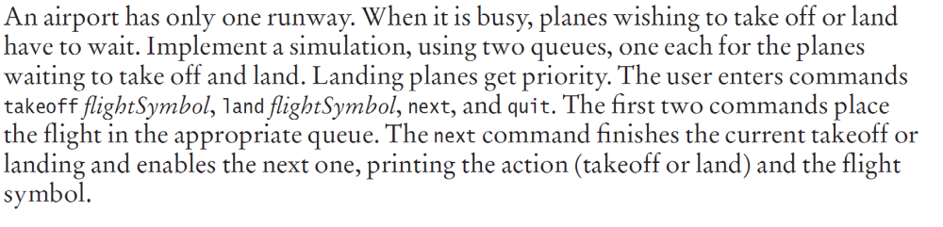
Sample Run:

To queue a plane takeoff or land, type takeoff/land followed by the flight symbol.
Type next to perform next action, and quit to quit simulation.
land
AU100

To queue a plane takeoff or land, type takeoff/land followed by the flight symbol.
Type next to perform next action, and quit to quit simulation.
takeoff
AB10

To queue a plane takeoff or land, type takeoff/land followed by the flight symbol.
Type next to perform next action, and quit to quit simulation.
next
Flight AU100 is landing.

To queue a plane takeoff or land, type takeoff/land followed by the flight symbol.
Type next to perform next action, and quit to quit simulation.
quit

