Andrew Durkiewicz
Homework 8
This homework did not require really any work by hand. I did all of it using python. Here is my work.

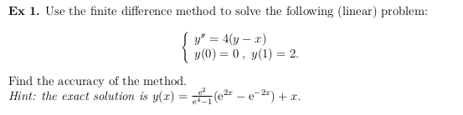
Results (Graphs, code follows immediately)

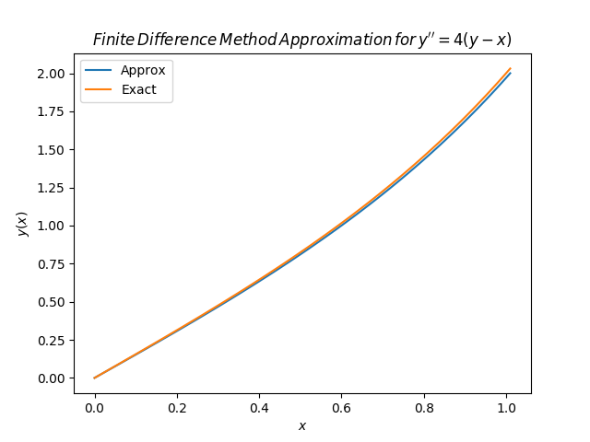

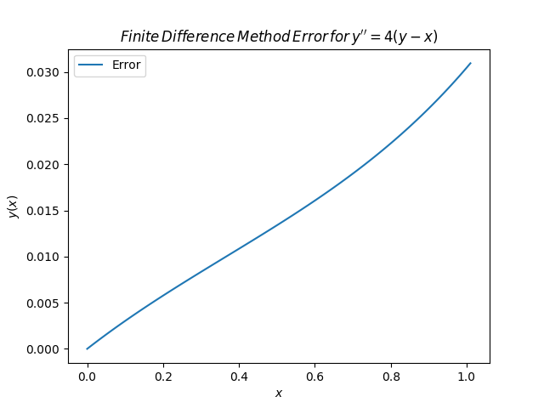
Note that this graph is not on the same scale as the first graph. In reality, when put on the same scale, the error is rather a small impact:
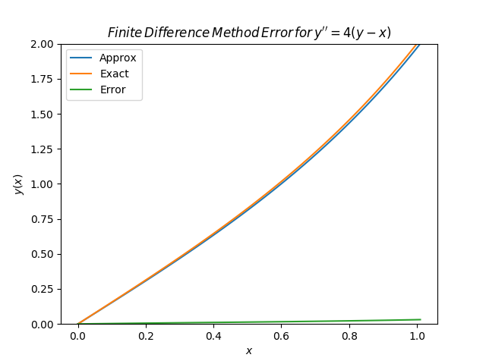

Code:
#!/usr/bin/env python3
#y'' = 4(y-x)
#y(0) = 0
#y(1) = 1
#exact solution y(x) = (e^2/(e^4 - 1))*(e^(2x) - e^(-2x)) + x

import numpy as np
import matplotlib.pyplot as plt
import matplotlib

def p(x):
return 0+0*x
def q(x):
return 4 + 0*x
def r(x):
return -4*x
def bvp(a,b,alpha,beta,N):
dx = (b-a)/(N)
x = a+np.arange(a,b,(dx))
A = -np.diag(1+dx/2*p(x[1:N]),-1) + np.diag(2+dx**2*q(x)) - np.diag(1-dx/2*p(x[0:(N-1)]),1)
vecB = -dx**2*r(x)
vecB[0] = vecB[0] + (1+dx/2*p(x[0]))*alpha
vecB[N-1] = vecB[N-1] + (1-dx/2*p(x[N-1]))*beta
Y = np.linalg.lstsq(A,vecB)
y_sol = np.concatenate(([alpha], Y[0].reshape(-1), [beta]))
x2 = a+dx*np.arange(0,N+2)
return y_sol,x2
def real(x):
return (np.exp(2)/(np.exp(4) - 1))*(np.exp(2*x) - np.exp(-2*x)) + x
def find_accuracy(y_sol,y_real):
return np.abs(y_real - y_sol)
def plot1(x2,y_sol,y_real):
plt.plot(x2,y_sol, label = 'Approx')
plt.plot(x2,y_real, label = 'Exact')
plt.legend()
plt.title(r'$Finite \/Difference \/Method \/Approximation \/for \/y^{\prime\prime} = 4(y-x)$')
plt.xlabel(r'$x$')
plt.ylabel(r'$y(x)$')
plt.savefig("Problem_1_Approx_vs_Real.png")

def plot2(x2,error):
c = plt.plot(x2,error, label = 'Error')
plt.legend()
plt.title(r'$Finite\/ Difference\/ Method\/ Error\/ for \/y^{\prime\prime} = 4(y-x)$')
plt.xlabel(r'$x$')
plt.ylabel(r'$y(x)$')
plt.ylim(0,2)
plt.savefig("Problem_1_Error_Autofit.png")
y_sol, x2 = bvp(0,1,0,2,100)
y_real = real(x2)
error = find_accuracy(y_sol,y_real)
#plot1(x2,y_sol,y_real)
plot2(x2,error)

Problem2
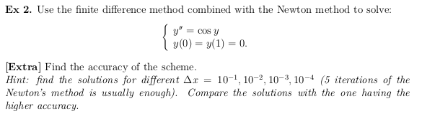

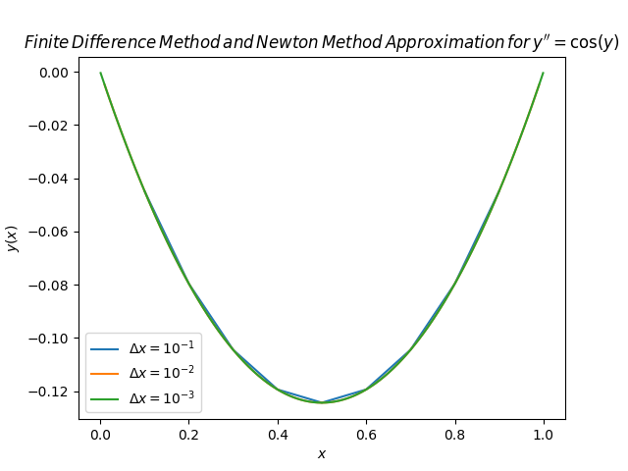

Code below

#!/usr/bin/env/ python3
import numpy as np
import matplotlib.pyplot as plt
def F(y):
return np.cos(y)
def DF(y):
return np.diag(-np.sin(y))
def calculate_solution(a,b,alpha,beta,N):
N = N-1
dx = (b-a)/(N+1)
x = a+dx*np.arange(1,N+1)
iterations = 5
yaxis = np.diag(np.ones(N))- np.diag(np.ones(N-1),1) - np.diag(np.ones(N-1),-1)
Y = 1+x
L = 2*np.diag(np.ones(N)) - np.diag(np.ones(N-1),1) - np.diag(np.ones(N-1),-1)
vecBC = np.zeros(N)
vecBC[0] = alpha
vecBC[-1] = beta
yaxis[0,:] = Y
for k in range(iterations):
DJ = L + dx**2*DF(Y)
tp = np.linalg.lstsq(DJ,L.dot(Y) + dx**2*F(Y)- vecBC)
Y = Y - tp[0]
yaxis[k+1,:] = Y
return x,Y

a = 0
b = 1
alpha = 0
beta = 0
exponent = np.arange(1,4)
N = []
for i in exponent:
N.append(10**(i))
ysolutions = [[]]*10
xsolutions = [[]]*10
tick = 0
while tick < len(N):
x,y = calculate_solution(a,b,alpha,beta,N[tick])
yvalues = np.array(y,dtype = object)
xvalues = np.array(x,dtype = object)

ysolutions[tick] = yvalues
xsolutions[tick] = xvalues
tick+=1
plotnumber = np.arange(0,len(N))

plt.plot(xsolutions[0],ysolutions[0],label = '$\Delta{x} = 10^{-%d}$' %exponent[0])
plt.plot(xsolutions[1],ysolutions[1],label = '$\Delta{x} = 10^{-%d}$' %exponent[1])
plt.plot(xsolutions[2],ysolutions[2],label = '$\Delta{x} = 10^{-%d}$' %exponent[2])

plt.title(r'$Finite \/Difference \/Method\/ and \/Newton \/Method\/Approximation \/for \/y^{\prime\prime} = \cos(y)$')
plt.xlabel(r'$x$')
plt.ylabel(r'$y(x)$')
plt.legend()
plt.savefig("Problem_2_Solution_vs_dx.png")

Problem 3
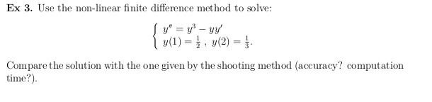

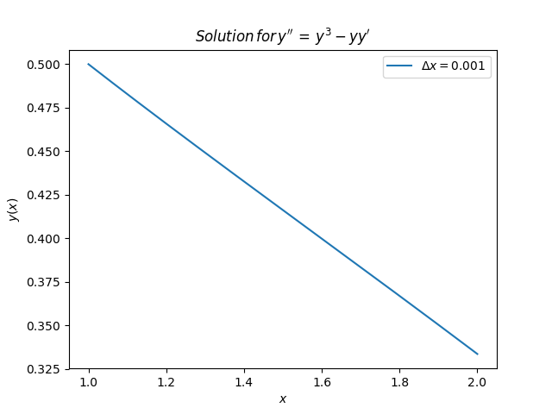
#!/usr/bin/python3
import numpy as np
from matplotlib import pyplot as plt

def derivative_matrix(N):
M = np.zeros((N, N))
for i in range(N):
line = np.array([0] * (i-1) +
[-1] * (i >= 1) +
[2] +
[-1] * (i < N-1) +
[0] * (N - i - 2))
M[i] = line
return M

def derivative(Y, dx):
dY = np.zeros(Y.shape)
dY[0] = (Y[1] - Y[0]) / dx
for i in range(1, len(Y)-1):
dY[i] = (Y[i-1] - Y[i+1]) / (2*dx)
dY[-1] = (Y[-1] - Y[-2]) / dx
return dY

def F(Y, dx):
return Y**3 - Y * derivative(Y, dx)

def DF(Y, dx):
N = len(Y)
DF = np.zeros((N, N))
for i, y_i in enumerate(Y):
if i > 0:
DF[i, i-1] = y_i / (2*dx)

if i == 0:
DF[i, i] = 3 * y_i**2 + (2*y_i - Y[i+1]) / dx
elif i == N-1:
DF[i, i] = 3 * y_i**2 + (Y[i-1] - 2*y_i) / dx
else:
DF[i, i] = 3 * y_i**2 - (Y[i+1] - Y[i-1]) / (2*dx)

if i < N-1:
DF[i, i+1] = -1 * y_i / (2*dx)
return DF
plt.figure()
for k, N in enumerate((1001,)):
x0 = 1
y0 = 1/2
xb = 2
yb = 1/3
dx = (xb - x0) / (N-1)
x_range = np.linspace(x0, xb, N)
Y0 = np.zeros(N)
Y0[0] = y0
Y0[-1] = yb
L = derivative_matrix(N)
Y = np.ones(N)
for i in range(5):
J = L.dot(Y) + dx**2 * F(Y, dx) - Y0
DJ = L + DF(Y, dx) * dx**2
dY = np.linalg.solve(DJ, J)
Y -= dY
plt.plot(x_range, Y, label='$\Delta x=%.3f$' % dx)
plt.title(r'$Solution\/ for\/ y^{\prime\prime} \/= \/y ^ {3}-yy^{\prime}$')
plt.xlabel(r'$x$')
plt.ylabel(r'$y(x)$')
plt.legend()
plt.savefig('Ex3-solution.png')

