1B and 1C

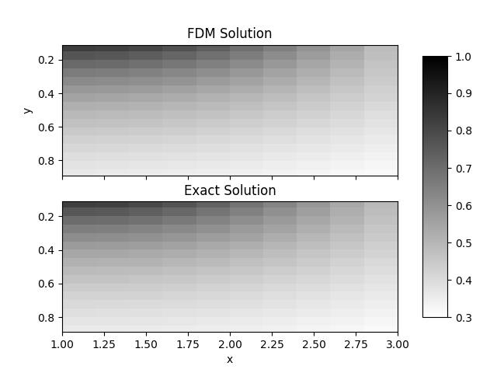

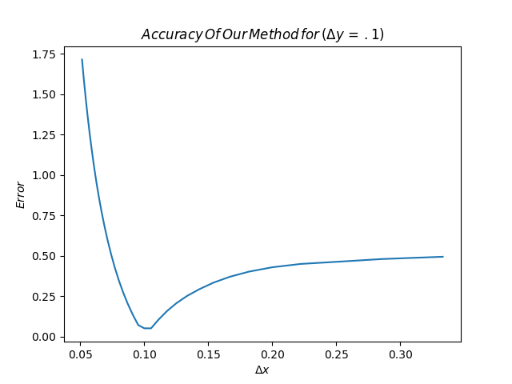

#!/usr/bin/env python3

import numpy as np

from matplotlib import pyplot as plt

import time

# Initial conditions

x0, x1 = 1, 3

y0, y1 = 0, 1

Ny = 9

error = []

x_range = []

for intX in range(5, 39):

dx = (x1 - x0) / (intX + 1)

dy = (y1 - y0) / (Ny + 1)

l_max = (intX-1)*(Ny-1)

def f(x, y):

# u_xx + u_yy = 0

return 0

#conditions given in the problem

def g_x0(y):

return 1/(1 + y**2)

def g_x1(y):

return 3/(9 + y**2)

def g_y0(x):

return 1/x

def g_y1(x):

return x/(x**2 + 1)

def ij_l(i_x, i_y):

#making our matrix for l

return i_x + (Ny - i_y - 1) * (intX - 1) - 1

#Setting the initial conditions for our matrix

A = np.zeros((l_max, l_max))

B = np.zeros(l_max)

start_time = time.time()

for i in range(1, intX):

for j in range(1, Ny):

l = ij_l(i, j)

x_i = x0 + i*dx

y_i = y0 + j*dy

l_ip = ij_l(i+1, j)

l_im = ij_l(i-1, j)

l_jp = ij_l(i, j+1)

l_jm = ij_l(i, j-1)

A[l, l] = -2 * (1 + dx**2 / dy**2)

B[l] = dx**2 * f(x_i, y_i)

#enforce BC

if i != 1:

A[l_im, l] = 1

else:

B[l] -= g_x0(y_i)

if i != intX-1:

A[l_ip, l] = 1

else:

B[l] -= g_x1(y_i)

if j != 1:

A[l, l_jm] = dx**2 / dy**2

else:

B[l] -= g_y0(x_i)

if j != Ny-1:

A[l, l_jp] = dx**2 / dy**2

else:

B[l] -= g_y1(x_i)

u_vec = np.linalg.solve(A, B)

u_solution = np.zeros((intX+1, Ny+1))

# Turn u_solution back into a 2d matrix

for i in range(intX+1):

for j in range(Ny+1):

# At border. These values are not in u_vec

if i==0 or i==intX or j==0 or j==Ny:

x_i = x0 + i*dx

y_i = y0 + j*dy

if i==0:

u_solution[i, j] = g_x0(y_i)

elif i==intX:

u_solution[i, j] = g_x1(y_i)

if j==0:

u_solution[i, j] = g_y0(x_i)

elif j==Ny:

u_solution[i, j] = g_y1(x_i)

continue

l = ij_l(i, j)

u_solution[i, j] = u_vec[l]

def solution(x, y):

return x / (x**2 + y**2)

u_exact_soln = np.zeros((intX+1, Ny+1))

for i, x in enumerate(np.linspace(x0, x1, intX+1)):

for j, y in enumerate(np.linspace(y0, y1, Ny+1)):

u_exact_soln[i, j] = solution(x, y)

if round(dx, 3) == .1:

#FDM Solution

cm = plt.get_cmap('binary')

fig, (ax1, ax2) = plt.subplots(2, 1, sharex=True)

ax1.imshow(u_solution, extent=[x0, x1, y1, y0], cmap=cm)

ax1.set_title('FDM Solution')

ax1.set_ylabel('y')

#Exact Solution Figure

im2 = ax2.imshow(u_exact_soln, extent=[x0, x1, y1, y0], cmap=cm)

ax2.set_title('Exact Solution')

ax2.set_xlabel('x')

#Our graph locations and plots

fig.subplots_adjust(right=.8)

ax3 = fig.add_axes([.85, .15, .05, .7])

fig.colorbar(im2, cax=ax3)

plt.savefig('FDMvsExact.png')

#appending our error so we can graph it later on another graph

error.append(np.max(np.abs(u_exact_soln - u_solution)))

x_range.append(dx)

plt.figure()

plt.plot(x_range, error)

plt.xlabel(r'$\Delta x$')

plt.ylabel(r'$Error$')

plt.title(r'$Accuracy\/Of\/Our\/Method\/for\/(\Delta y\/=\/.1)$')

plt.savefig('Error_Plot_Problem_1.png')

2B and 2C)

dx = .13

See how the vibrations overcome the error? Cool, but odd.

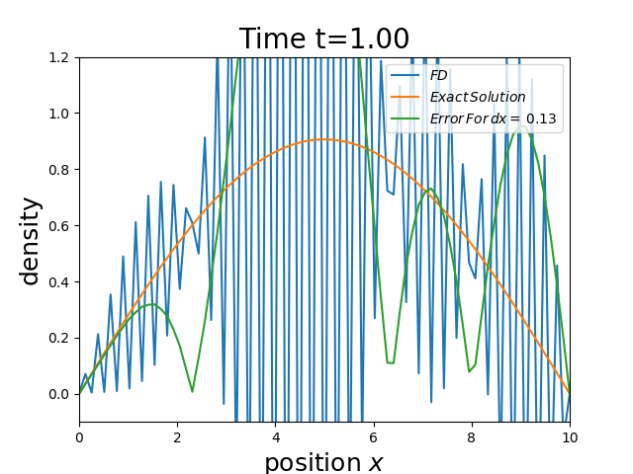

dx = .2

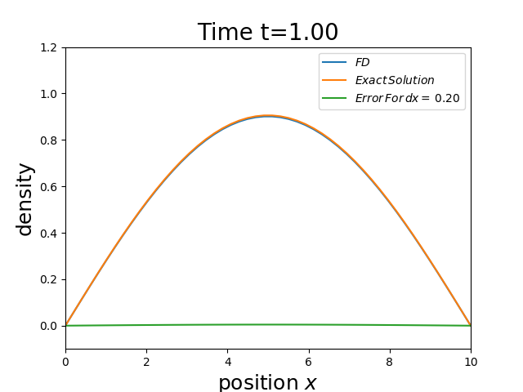

dx = 1

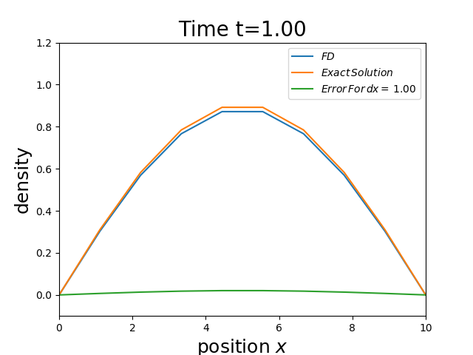

dx = 2

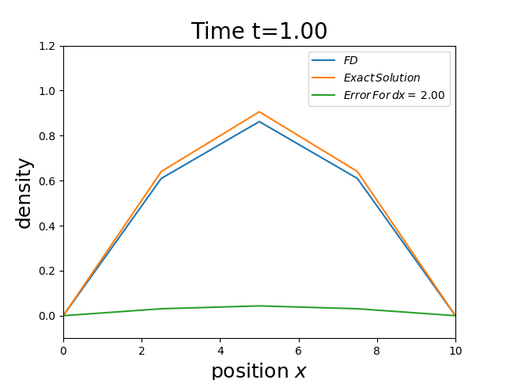

CODE

#using the labsolutions as my barebones code. Otherwise I have no clue how to make the graph move

#in time

import numpy as np

import matplotlib.pyplot as plt

D = 1

l = 10

T = 1

def u0(x):

return np.sin(np.pi * x / l)

dx = 2

dt = 10**(-2)

ld = D/dx**2*dt

nTime = int(T/dt+.5) + 1

nX = int(l/dx+.5)

intX = np.linspace(0,l,nX)

intT = np.linspace(dt,T)

u = u0(intX)

utrue = u0(intX)

error = np.abs(utrue-u)

plt.ion()

plt.clf()

pltU = plt.plot(intX, u,label = r'$FD$')[0]

pltUtrue = plt.plot(intX,u,label = r'$Exact\/Solution$')[0]

plterror = plt.plot(intX,error,label = r'$Error\/For\/dx=\/ $''%-.2f'%dx)[0]

plt.legend(loc = 1)

plt.axis([0, l, -.1, 1.2])

plt.xlabel(r'position $x$', fontsize=18)

plt.ylabel('density', fontsize=18)

theTitle = plt.title('Solution at T=' + '{:04.2f}, dx = %-.2f'.format(0*dt),

horizontalalignment='center', fontsize=20)

for n in range(nTime):

u_true = np.exp(-1*n*dt*np.pi**(2)/l**(2))*utrue

u = (1-2*ld)*u + ld*(np.append(u[1:], 0) + np.append(0, u[:-1]))

u[0] = 0

u[-1] = 0

plterror.set_ydata(np.abs(u_true - u))

pltU.set_ydata(u)

pltUtrue.set_ydata(u_true)

theTitle.set_text('Time t=' + '{:04.2f}'.format(n*dt))

plt.pause(.001)

if n ==0:

plt.savefig("FD_dx_%-.2f_t_%-.1f.png"%(dx,n*dt))

if n ==50:

plt.savefig("FD_dx_%-.2f_t_%-.1f.png"%(dx,n*dt))

if n ==100:

plt.savefig("FD_dx_%-.2f_t_%-.1f.png"%(dx,n*dt))