Andrew Durkiewicz Homework 11

Question 1

Part 1)

Below is a 3D graph of my solution for U(x,t):

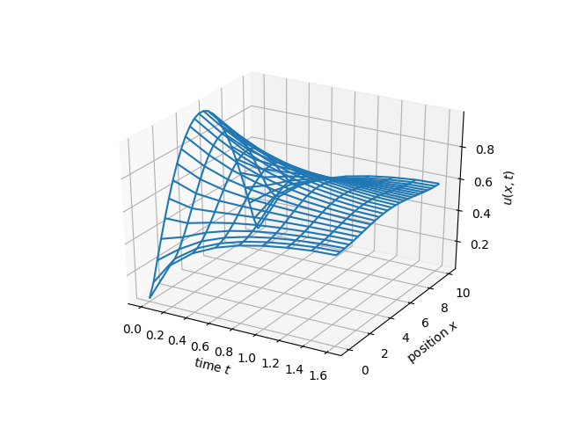

Part 2)

The mass is the total sum of all the U(x_n,t) values over the range of all n’s. Here is my plot of the total mass for each time t:

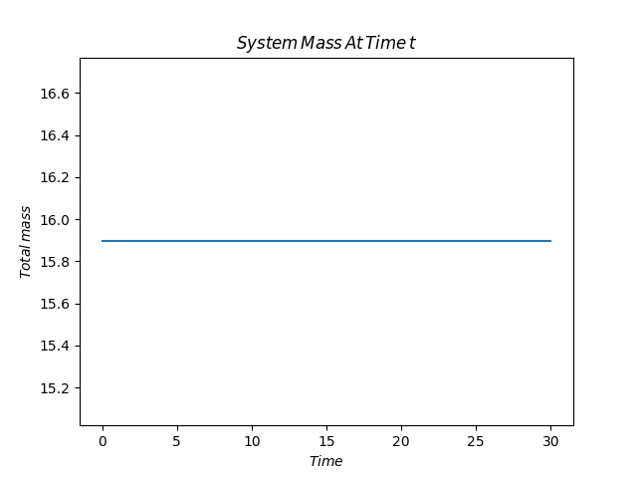

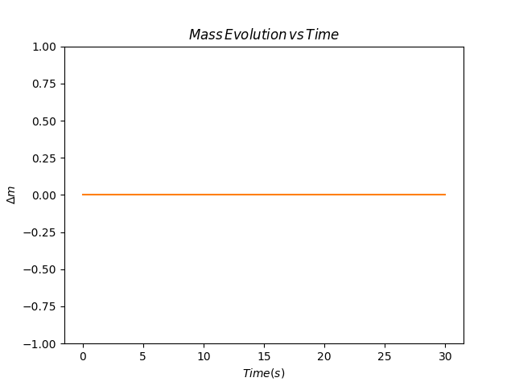

To show that the mass isn’t changing, I took the difference of the i’th t value for the mass M(x,t_i) and took plotted its variance with the initial mass. So, as can be seen by the plot, there is no variance with the mass in time:

CODE for question 1:

#!/usr/bin/env python3

import numpy as np

import matplotlib.pyplot as plt

from mpl_toolkits.mplot3d import Axes3D

a = .5**2

l = 10

T = 30

dx = .4

dt = .2

ld = a/dx**2*dt #lambda

Nx = int(1+round(10/dx))

Nt = 1 + round(T/dt)

x_range = np.linspace(0,l,Nx)

t_range = np.linspace(0,T,Nt)

def u0(x):

#initial conditions for when t = 0

return np.sin(np.pi * x / l)

#initialize u matrix:

u = u0(x_range)

#U_{n+1} = A.u_n

A = np.zeros((Nx,Nx))

#using the matrix form of our equation:

i = np.arange(Nx)

j = np.arange(Nx-1)

A[i,i] = 1-2*ld

A[j,j+1] = ld

A[j+1,j] = ld

A[0,-1] = ld

A[-1,0] = ld

step = 20 # Plot every 10 time steps

plot_data = np.zeros((Nt//step+2, Nx))

plt_i = 0

masses = np.zeros(Nt)

for t_i in range(Nt):

u = A.dot(u)

masses[t_i] = np.sum(u) # Probably off by a scalar factor

if t_i % step == 0 or t_i == Nt-1:

plot_data[plt_i, :] = u

plt_i += 1

graph = 0

while graph < 3:

if graph == 0:

# Setup plot

plt.plot(t_range, masses)

plt.title(r'$System\/Mass\/At\/Time\/t$')

plt.xlabel(r'$Time$')

plt.ylabel(r'$Total\/mass$')

plt.savefig('mass_at_time_t.png')

if graph == 2:

X, Y = np.meshgrid(range(plot_data.shape[0]), range(plot_data.shape[1]))

Z = plot_data[X, Y]

fig = plt.figure()

ax = fig.add_subplot(111, projection="3d")

ax.plot_wireframe(X*dt, Y*dx, Z)

ax.set_xlabel(r"time $t$")

ax.set_ylabel(r"position $x$")

ax.set_zlabel(r'$u(x,t)$')

plt.savefig("3d.png")

#lets find how much the mass deviates from the initial mass:

if graph == 1:

def mass_change(m0,m):

return abs(m-m0)

change_mass = np.array([])

for i in range(len(masses)):

change_mass=np.append(change_mass,(mass_change(masses[0],masses[i])))

plt.plot(t_range,change_mass)

plt.ylim(-1,1)

plt.xlabel(r'$Time(s)$')

plt.ylabel(r'$\Delta m$')

plt.title(r'$Mass\/Evolution\/vs\/Time$')

plt.savefig('Mass_Evolution_vs_time.png')

graph+=1

Question 2)

I solved the PDE using a 3D wireframe and used a contour:

|  |  |
| --- | --- |
| Δx = 0.2 , Δt = 0.1 | Δx = 0.1 , Δt = 0.2 |
|  |  |
|  |  |

The main difference that I notice is the way that peaks are occuring in U(x,t). For the δx = 0.2 and δt = 0.1, the peaks are much more smooth and less defined as the sharp peaks for δt = 0.2 and δx = 0.1.

Part C Below:

Part C)

|  |  |
| --- | --- |
| Δx = 1/10 | Δx = 1/30 |
|  |  |
| Δx = 1/70 | Δx = 1/200 |
|  |  |
| Δx = 1/550 | Δx = 1/1500 |
|  |  |

The accuracy order for each δx printed as such:

Order Error:

For dx = 1/10, the resulting accuracy is: 0.879133761846

For dx = 1/30, the resulting accuracy is: 1.11005002514

For dx = 1/70, the resulting accuracy is: 1.00479510211

For dx = 1/200, the resulting accuracy is: 1.00946343235

For dx = 1/550, the resulting accuracy is: 1.05517391856

CODE for problem2 parts a-b:

#!/usr/bin/env python3

import numpy as np

from matplotlib import pyplot as plt

from mpl_toolkits.mplot3d import Axes3D

import matplotlib.cm as cm

import matplotlib.mlab as mlab

error = []

## Initial conditions

T = 1

x0, x1 = 0, 1

dt = .2

dx = .1

c = 1

def u_t0(x):

# Initial positions

return np.sin(2 * np.pi * x)

def v_t0(x):

# Initial velocities

return 2 * np.pi * np.sin(2 * np.pi * x)

## Setup Parameters

intX = int(1 + round((x1-x0) / dx))

intT = 1 + round(T / dt)

x_range = np.linspace(x0, x1, intX)

t_range = np.linspace(0, T, intT)

#use our t values to make our u matrix

u_prev = u_t0(x_range) # t_i=0

u_mat = u_prev + dt * v_t0(x_range) # t_i=1

# u_{n+1} = A (dot) u_{n}

A = np.zeros((intX, intX))

range1 = np.arange(intX)

range2 = np.arange(intX-1)

ld = c**2 * dt**2 / dx**2

A[range1, range1] = 2 - 2*ld

A[range2, range2+1] = ld

A[range2+1, range2] = ld

A[0, -1] = ld # Coefficients for periodic boundary condition

A[-1, 0] = ld

plot_data = np.zeros((intT, intX))

plot_data[0, :] = u_prev

def solution(x, t):

return np.sin(2*np.pi*x) * (np.cos(2*np.pi*t) + np.sin(2*np.pi*t))

plot_our_solution = np.zeros_like(plot_data)

## Solve - iterate over time

for t_i in range(intT-1):

u_prev[:], u_mat = u_mat, A.dot(u_mat) - u_prev

plot_data[t_i, :] = u_mat

plot_our_solution[t_i, :] = solution(x_range, t_range[t_i])

error.append(np.max(np.abs(plot_data - plot_our_solution)))

# Setup plot

X, Y = np.meshgrid(range(plot_our_solution.shape[0]), range(plot_our_solution.shape[1]))

Z = plot_our_solution[X, Y]

fig = plt.figure()

ax = fig.add_subplot(111, projection="3d")

ax.plot_wireframe(X*dt, Y*dx, Z)

ax.set_xlabel(r"time $t$")

ax.set_ylabel(r"position $x$")

ax.set_title(r'$\Delta x\/=\/10^{-1}\/,\/t\/=\/2 \/ \cdot \/10^{-1}$')

plt.savefig('1b_final_true.png')

plt.show()

CODE for part c:

#!/usr/bin/env python3

import numpy as np

from matplotlib import pyplot as plt

from mpl_toolkits.mplot3d import Axes3D

dx_range = (1/10, 1/30, 1/70, 1/200, 1/550, 1/1500)

dx_range_string = ['1/10','1/30','1/70','1/200','1/550','1/1500']

error = []

for dx in dx_range:

## Initial conditions

T = 1

x0, x1 = 0, 1

dt = dx * .9

c = 1

def u_t0(x):

# Initial positions

return np.sin(2 * np.pi * x)

def v_t0(x):

# Initial velocities

return 2 * np.pi * np.sin(2 * np.pi * x)

## Setup Parameters

intX = int(1 + round((x1-x0) / dx))

intT = 1 + round(T / dt)

x_range = np.linspace(x0, x1, intX)

t_range = np.linspace(0, T, intT)

#use our t values to make our u matrix

u_prev = u_t0(x_range) # t_i=0

u_mat = u_prev + dt * v_t0(x_range) # t_i=1

# u_{n+1} = A (dot) u_{n}

A = np.zeros((intX, intX))

range1 = np.arange(intX)

range2 = np.arange(intX-1)

ld = c**2 * dt**2 / dx**2

A[range1, range1] = 2 - 2*ld

A[range2, range2+1] = ld

A[range2+1, range2] = ld

A[0, -1] = ld # Coefficients for periodic boundary condition

A[-1, 0] = ld

plot_data = np.zeros((intT, intX))

plot_data[0, :] = u_prev

def solution(x, t):

return np.sin(2*np.pi*x) * (np.cos(2*np.pi*t) + np.sin(2*np.pi*t))

plot_our_solution = np.zeros_like(plot_data)

## Solve - iterate over time

for t_i in range(intT-1):

u_prev[:], u_mat = u_mat, A.dot(u_mat) - u_prev

plot_data[t_i, :] = u_mat

plot_our_solution[t_i, :] = solution(x_range, t_range[t_i])

error.append(np.max(np.abs(plot_data - plot_our_solution)))

# Setup plot

if dx == 1/70:

X, Y = np.meshgrid(range(plot_our_solution.shape[0]), range(plot_our_solution.shape[1]))

Z = plot_our_solution[X, Y]

fig = plt.figure()

ax = fig.add_subplot(111, projection="3d")

ax.plot_wireframe(X*dt, Y*dx, Z)

ax.set_xlabel(r"time $t$")

ax.set_ylabel(r"position $x$")

plt.savefig('Ex-solution.png')

print('Order Error:')

for i in range(len(error)-1):

print("For dx = %s, the resulting accuracy is: "%dx_range_string[i],error[i+1]/error[i] / (dx_range[i+1]/dx_range[i]))