**LEBANESE AMERICAN UNIVERSITY**

**USAID – HIGHER EDUCATION SCHOLARSHIP PROGRAM**

**HES - Volunteering Program Verification Form**

This form is to be used to document volunteering hours. If a student volunteers for multiple organizations, a separate form must be used for each organization. **This form must be turned in by the 28th of each month, the latest.**

I certify that the scholar Andrew completed a total of 1 hours of service at InnovaThrive.

The hours were completed hours as per the below:

Hours # 1 (date) _4/11 – 8/11_ (initials of supervisor) __A.K.___

Hours # 1 (date) _11/11 – 15/11_ (initials of supervisor) __A.K.___

Hours # 1 date) _18/11 – 22/11 (initials of supervisor) __A.K.___

Hours # 1 date) _25/11 - 29/11 (initials of supervisor) __A.K.___

Brief description of the activities the scholar performed or participated in:

HHHSHSHSH

Written feedback about the scholar’s performance:

HSHSHSHS

Please rate the overall performance of the scholar at your organization:

|  |  |  |  |
| --- | --- | --- | --- |
|  | Mastery (5) | Proficient (3) | Emerging (1) |
| **Problem solver** | X |  |  |
| **Engaged & Committed** | X |  |  |
| **Open-minded & multicultural** | X |  |  |

Signature

& stamp

__________________________

_

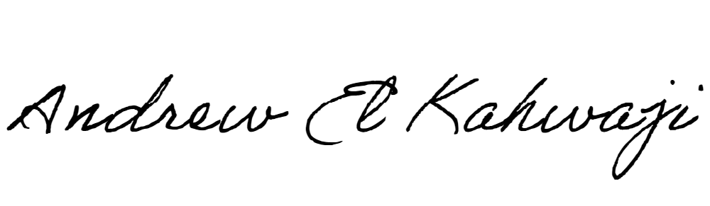

Printed Name _Andrew El Kahwaji_

Date __26/11/2024___

Email __andrew.lifesculptor.coo@gmail.com __

Phone __+961 71 914 378__

**LEBANESE AMERICAN UNIVERSITY**

**USAID – HIGHER EDUCATION SCHOLARSHIP PROGRAM**

