**LEBANESE AMERICAN UNIVERSITY**

**USAID – HIGHER EDUCATION SCHOLARSHIP PROGRAM**

**HES - Volunteering Program Verification Form**

This form is to be used to document volunteering hours. If a student volunteers for multiple organizations, a separate form must be used for each organization. **This form must be turned in by the 28th of each month, the latest.**

I certify that the scholar {{name}} completed a total of {{ht}} hours of service at InnovaThrive.

The hours were completed hours as per the below:

Hours # {{h1}} (date) _31/12 – 3/01_ (initials of supervisor) __A.K.___

Hours # {{h2}} (date) _6/01 – 10/01_ (initials of supervisor) __A.K.___

Hours # {{h3}} date) _13/01 – 17/01 (initials of supervisor) __A.K.___

Hours # {{h4}} date) _20/01 - 24/01 (initials of supervisor) __A.K.___

Brief description of the activities the scholar performed or participated in:

{{tasks}}

Written feedback about the scholar’s performance:

{{feedback}}

Please rate the overall performance of the scholar at your organization:

|  |  |  |  |
| --- | --- | --- | --- |
|  | Mastery (5) | Proficient (3) | Emerging (1) |
| **Problem solver** | X |  |  |
| **Engaged & Committed** | X |  |  |
| **Open-minded & multicultural** | X |  |  |

Signature

& stamp

__________________________

_

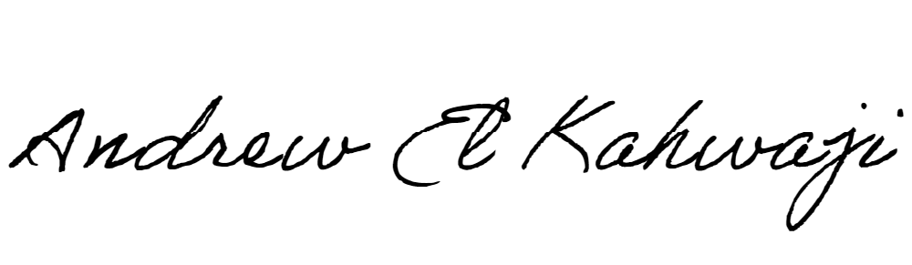

Printed Name _Andrew El Kahwaji_

Date __27/01/2025___

Email __andrew.lifesculptor.coo@gmail.com __

Phone __+961 71 914 378__