%This is The Master control file for the Walking Robot.
%Please Select the desired options in this file and run it. It will call
%all subsequent required files
%Simulation Type%%%%%%%%%%%%%%%%%%%%%%%%%%%%%%%%%%%%%%%%%%%%%%%%%%%%%%%%%%%
% 1 = on, 0 = off
%ScaleSIM------
%This simulation optimizes the scale of the model based on required torque
%at various weights, step lengths and power ov the motor. There are no
%visualizations during the scale Sim. Output will be displayed in the
%command window displaying the scale and velocity.
%Additional data will be displayed when a new maximum
%velocity is reached throughout the iteration. Due to placeholder values
%being used for the power if the motor, the velocity is treated as a unitless
%value and only the relative magnitude of the numbers should be considered
ScaleSim = 0;
%Torque Analysis-------
%This is build into the Scale simulation
%Required torques at each stage of the simulation can be outputted to the
%user by running the 'TorqueSolve.m' file
%Velocity Anylysis---------
%This Analysis displays the velocity vectors for one leg. This only
%functions in 2D. This function does contain some slight timming
%innacuracies due to how the dirrivatives were parsed through matlab. The
%vectors are correct althought they are not all displayed in sync with the
%simulation. This problem was not solved due to time restrictions. The
%velocity vectors are only displayed for 1 leg
VelAnalysis = 1;
%3D/2D----------
%Select Which Dimention to run the Sim 2 or 3
%Note: Must be 2D if velocity analysis is selected
Dimentions = 2;
%Simulation Settings%%%%%%%%%%%%%%%%%%%%%%%%%%%%%%%%%%%%%%%%%%%%%%%%%%%%%%
%Number of Legs-------------
%Must be set individually for 2D/3D. Velovity analysis is for Leg 1, so
%make sure that Leg 1 is displayed while running that.
%2D------
%Input leg numbers to simulate into matrix
%Default:
% Legs2D = [1 2 3 4];
Legs2D = [1 2 3 4];
%3D-------
%Default:
% Legs3D_1 = [1 2];
% Legs3D_2 = [3 4];
Legs3D_1 = [1 2];
Legs3D_2 = [3 4];
%Set Number of Revolutions--------
%Press Ctrl - C during the simultion to end the sim before all revolutions
%have elaplsed
rev = 1;
%Set Quality--------
%The Quality is the number of iterations per loop. A higher quality is
%recomended when running torque or scale simualtions as numerical
%integrations are preformed. High qualities will cause the simulation to
%slow. Recomended values are between 30 to 260.
quality = 30;
%Sets Scale Factor--------
%The scale simulation iterates this value to find the optimal scale for
%the design. During regualar simulation this value may be set. The
%recomended value for visualizaztion is 1
%1 unit = 1 mm
SF = 1;
%Set Angular Velocity of Input
%Angular velocity must be set as a global variable as it must be seen by
%various sub-functions
global W
W = 1;
%%%%%%%%%%%%%%%%%%%%%%%%%%%%%%%%%%%%%%%%%%%%%%%%%%%%%%%%%%%%%%%%%%%%%%%%%%
%Begins Code
SimulateLinkage;
V3 =
5.1464
V3 =
1.4300
V3 =
7.1734
V3 =
3.7175
V3 =
9.0740
V3 =
5.8367
V3 =
10.8445
V3 =
7.8208
V3 =
12.4650
V3 =
9.6793
V3 =
13.9036
V3 =
11.4027
V3 =
15.1199
V3 =
12.9666
V3 =
16.0674
V3 =
14.3359
V3 =
16.6926
V3 =
15.4680
V3 =
16.9307
V3 =
16.3145
V3 =
16.6972
V3 =
16.8186
V3 =
15.8750
V3 =
16.9102
V3 =
14.2961
V3 =
16.4956
V3 =
11.7193
V3 =
15.4430
V3 =
7.8179
V3 =
13.5624
V3 =
2.2160
V3 =
10.5845
V3 =
5.3145
V3 =
6.1571
V3 =
14.3444
V3 =
0.0806
V3 =
23.1228
V3 =
8.2125
V3 =
28.8858
V3 =
17.4278
V3 =
29.9257
V3 =
25.5097
V3 =
27.0202
V3 =
29.7679
V3 =
22.2045
V3 =
29.3002
V3 =
17.0839
V3 =
25.5297
V3 =
12.4120
V3 =
20.4785
V3 =
8.3837
V3 =
15.4592
V3 =
4.9496
V3 =
10.9974
V3 =
1.9886
V3 =
7.1785
V3 =
0.6207
V3 =
3.9164
V3 =
2.9760
V3 =
1.0851
Elapsed time is 12.971767 seconds.
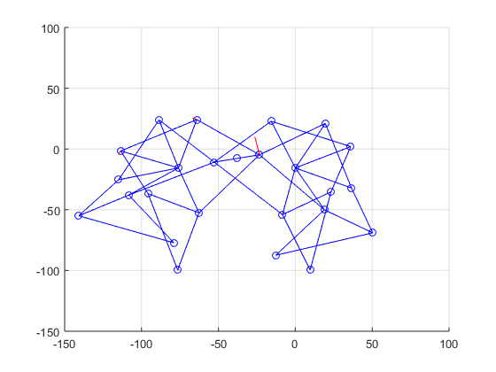
Published with MATLAB® R2015a

