%Runs Initialization File
close all;
%Starts runtime timer
tic
%Initialises a number of variables
WalkingRobot;
%Set Up Figure depending on dimention
if Dimentions == 3
limits = [-150, 100, -150, 100, -150, 100];
else
limits = [-150, 100, -150, 100];
end
%Sets initial max velocity for iteration
WalkerVelocityMax = 0;
%Initializes StepData aMAtrix
if ScaleSim == 1
StepData(rev, 2) = 0;
end
%Simulation Loop
for r = 1:rev
%initializes step radius for iteration
stepRadius = 0;
if ScaleSim == 1
%Sets link lengths based on scale factor during scale simulation
SF = r/ 50
SetLinkLengths;
WeightAssignment;
end
%Sets max torque for iteration
MaxTorque = 0;
%Sets link lengths
SetLinkLengths;
for i = 1:1:quality
%Set T (theta) from loop iteration and multiply by angular velocity
T = (i * 360 / quality) * W;
mod(T, 360);
%solves the two forward legs
SolveLeg1;
SolveLeg1_2;
%Solves the two rear legs
SolveLeg2;
SolveLeg2_2;
%Runs the torque simulation during a Scale Sim
if ScaleSim == 1
TorqueSim;
end
%Clear Figure
clf;
%Disables output during a scale sim
Draw = 1;
if ScaleSim ==1
Draw = 0;
end
if Draw == 1
%Draws in 3D
if Dimentions == 3
for legNum = Legs3D_1
for linkNum = 1:11
%DrawLink is a custom function
DrawLink3d_1(Leg(legNum).Link(linkNum).Pos(A).Cor(X).Rev(T),...
Leg(legNum).Link(linkNum).Pos(B).Cor(X).Rev(T),...
Leg(legNum).Link(linkNum).Pos(A).Cor(Y).Rev(T),...
Leg(legNum).Link(linkNum).Pos(B).Cor(Y).Rev(T))
end
end
for legNum = Legs3D_2
for linkNum = 1:11
DrawLink3d_2(Leg(legNum).Link(linkNum).Pos(A).Cor(X).Rev(T),...
Leg(legNum).Link(linkNum).Pos(B).Cor(X).Rev(T),...
Leg(legNum).Link(linkNum).Pos(A).Cor(Y).Rev(T),...
Leg(legNum).Link(linkNum).Pos(B).Cor(Y).Rev(T))
end
end
end
end
%Draws in 2D
if Dimentions == 2
for legNum = Legs2D
for linkNum = 1:11
DrawLink(Leg(legNum).Link(linkNum).Pos(A).Cor(X).Rev(T),...
Leg(legNum).Link(linkNum).Pos(B).Cor(X).Rev(T),...
Leg(legNum).Link(linkNum).Pos(A).Cor(Y).Rev(T),...
Leg(legNum).Link(linkNum).Pos(B).Cor(Y).Rev(T))
end
if VelAnalysis ==1
DrawVelocity(1, C, 2, A, T);
DrawVelocity(1, D, 2, B, T);
DrawVelocity(1, E, 7, B, T);
DrawVelocity(1, G, 4, B, T);
DrawVelocity(1, H, 11, A, T);
end
end
end
%Set Axis
axis(limits);
grid on
%Delay
if Draw == 1
pause(.05)
end
end
if ScaleSim == 1
%Solves approxiamte Step length using Numerical integration
StepLengthSolve
%Solves approximate velocity
WalkerVelocity = 3 * 0.0016667 * stepRadius / MaxTorque
%If a new greatest velocity is found, it displays additional data
if WalkerVelocity > WalkerVelocityMax
WalkerVelocityMax = WalkerVelocity;
MAX_torque = torque
MAX_step = stepRadius
MAX_Velocity = WalkerVelocityMax
Max_SF = SF
end
end
end
%Displays runtime
toc
V3 =
5.1464
V3 =
1.4300
V3 =
7.1734
V3 =
3.7175
V3 =
9.0740
V3 =
5.8367
V3 =
10.8445
V3 =
7.8208
V3 =
12.4650
V3 =
9.6793
V3 =
13.9036
V3 =
11.4027
V3 =
15.1199
V3 =
12.9666
V3 =
16.0674
V3 =
14.3359
V3 =
16.6926
V3 =
15.4680
V3 =
16.9307
V3 =
16.3145
V3 =
16.6972
V3 =
16.8186
V3 =
15.8750
V3 =
16.9102
V3 =
14.2961
V3 =
16.4956
V3 =
11.7193
V3 =
15.4430
V3 =
7.8179
V3 =
13.5624
V3 =
2.2160
V3 =
10.5845
V3 =
5.3145
V3 =
6.1571
V3 =
14.3444
V3 =
0.0806
V3 =
23.1228
V3 =
8.2125
V3 =
28.8858
V3 =
17.4278
V3 =
29.9257
V3 =
25.5097
V3 =
27.0202
V3 =
29.7679
V3 =
22.2045
V3 =
29.3002
V3 =
17.0839
V3 =
25.5297
V3 =
12.4120
V3 =
20.4785
V3 =
8.3837
V3 =
15.4592
V3 =
4.9496
V3 =
10.9974
V3 =
1.9886
V3 =
7.1785
V3 =
0.6207
V3 =
3.9164
V3 =
2.9760
V3 =
1.0851
Elapsed time is 12.371994 seconds.
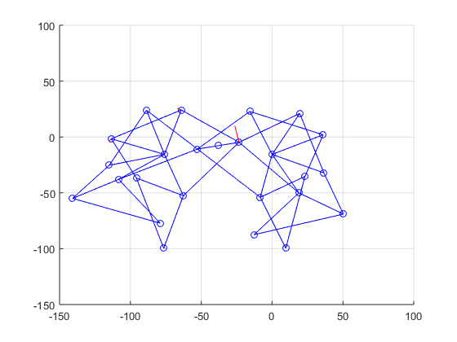
Published with MATLAB® R2015a

