Andrew Flack, Ratings Proxy Discussion
In my research, I decided to break down the problem into two parts: scoring the time slots independent of week, and scoring the weeks independent of time slot.
Ranking the time slots:
Researched and found several sources for costs of 30 second ad. I assume that since the NFL wants to make the most money, the slots with the most expensive ads must have the highest viewership.
I also calculated the average popularity of the teams that played in each time slot in 2014 by adding the total number of followers on the team’s official twitter and facebook pages.
Plotting both of these metrics, can see that they exhibit similar pattern. Primetime games also feature the most popular teams, but the effect isn’t quite as strong as it is with the ad prices.
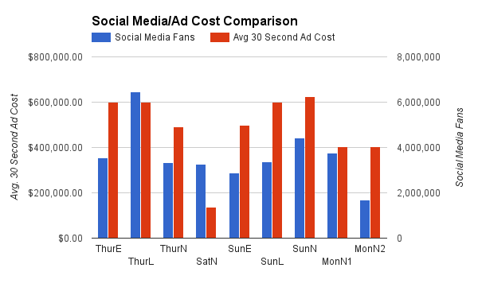
Ranking the weeks:
I assume that the first week is driven mostly by team popularity. The superbowl teams and/or very popular teams will fill the primetime slots because there is nothing else to go on. Starting about half way through the season, viewers tune in to follow the playoff storylines. Using data from FiveThirtyEight, I calculated the average playoff “leverage” by week, for weeks 8-17. This data is specific to the 2014 season, but I assume the effect takes roughly the same shape each season, with a peak around week 15, tapering off as the playoff picture firms up. I intend to look into this further.
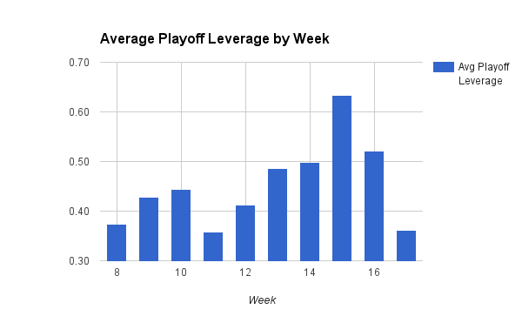
I envision building a matrix (heat map) that combines these effects. I’m not sure exactly how to implement it yet, but I feel these factors provide a good technique for ranking every time slot across the season.

