Chapter 1: Setup

Andrew Flowers

2/27/2017

Getting started with R can be frustrating. Actually, no, it’s *guaranteed* to be frustrating at the beginning But that’s entirely normal! Take a deep breath, persevere through the initial confusion and know that it gets easier. I promise that you’ll be glad you did.

To make things easier on you, in this chapter we’ll cover the common beginner-level mistakes in just getting your R coding environment in order. (I’ll assume you’ve [installed R](https://cran.r-project.org/mirrors.html).)

### RStudio IDE

First things first: what IDE are using? *“ID-what?”* you might say. An integrated development environment (IDE) is like a workstation. For your physical workstation, you probably prefer an ergonomic chair or maybe a modern standing desk. A good workstation can make a big difference in your productivity. Ditto for your digital workstation -- so take care in choosing.

Now, you don’t have to use an IDE to write R code; you can execute R commands and write R scripts using the pre-built R framework. But I wouldn’t recommend it.

By far the most widely-used IDE for R is RStudio. If you haven’t yet, go [install Rstudio](https://www.rstudio.com/products/rstudio/download/). RStudio makes writing R code less of a headache.

### More than one way to install a package

R is a set of tools. “Base R” -- the pre-installed set of functions like sum() and plot() -- is like a starter toolbelt, with just a hammer and wrench. It’s the minimal tools you need to accomplish simple tasks.

However, to do anything meaningful in R you need to install other R packages. Specifically, you need to install *and* load R packages into your R library. Perhaps the most common mistake that R newbies make is loading a package *before* installing it:

# NOTE: there is no ‘RPACKAGE’ package  
  
library(RPACKAGE)

## Error in library(RPACKAGE): there is no package called 'RPACKAGE'

The library() function loads an already-installed package into your R environment -- the set of packages you’ve activated at the moment. But for it to work, you first need install it; and most often you do that with the install.packages() function. Let’s start by installing and loading the tidyverse package, which is really a collection of packages, with the package name in quotes like ’tidyverse’.

The two-step process goes like this:

# Step 1: Install the package  
install.packages(‘tidyverse’)  
  
# Step 2: load the package  
library(tidyverse)   
  
# NOTE: quotes are optional for the library() function

You often will use the install.packages() function because it taps directly into [CRAN](https://cran.r-project.org/), the Comprehensive R Archive Network, where [thousands](https://cran.r-project.org/web/packages/available_packages_by_name.html) of R packages are approved and maintained. But this is not the only way to install an R package.

Another common method is via GitHub, but to do that you first need another R package called devtools. So first we’ll install devtools the old-fashioned way and then use its nifty function to install a second package -- called bookdown -- directly via GitHub. Just use the install_github() funciton with the author's name, a / and the package name. Because the GitHub user rstudio is the author of the bookdown package, it looks like this:

# Install and load the devtools package  
install.package(“devtools”)  
library(devtools)  
  
# Install the bookdown package (authored by rstudio) from GitHub  
install_github("rstudio/bookdown")

You could have installed bookdown through CRAN and the install.packages() function. But the devtools package, with its install_github function, allows you to broaden what R packages you can use.

### Working directory confusion

Another common R mistake is not being aware of your **working directory**, or the file/folder on your computer from which you’re currently working. R has useful functions -- getwd() and setwd() -- for discovering and changing your working directory. And I’d also recommend the dir() function to list which files are within your current working directory. Below I use getwd() to list my current working directory and the files within it, and then I use setwd() with .. to move one folder level higher in my directory.

getwd()

## [1] "/Users/andrewflowers/projects/oreilly/mistakes-in-R/draft-mistakes-in-R/chapters"

dir()

## [1] "01-setup.html" "01-setup.Rmd" "02-silly.html"   
## [4] "02-silly.Rmd" "03-style_cache" "03-style.html"   
## [7] "03-style.Rmd" "assets" "common_names.csv"  
## [10] "intro.html" "intro.Rmd" "nba_elo_data.csv"

# To move my working directory one folder higher:  
setwd('..')  
getwd()

## [1] "/Users/andrewflowers/projects/oreilly/mistakes-in-R/draft-mistakes-in-R"

If you've ever tried to import a data file -- like a .csv with data -- but get an erorr, it's probably because you've mistunderstood your working directory (or didn't correctly specifcy the path to your data file). See here for instance:

data <- read.csv("my-data-file.csv")

## Warning in file(file, "rt"): cannot open file 'my-data-file.csv': No such  
## file or directory

## Error in file(file, "rt"): cannot open the connection

# NOTE: my-data-file.csv is not in my current working directory  
  
dir()

## [1] "01-setup.html" "01-setup.Rmd" "02-silly.html"   
## [4] "02-silly.Rmd" "03-style_cache" "03-style.html"   
## [7] "03-style.Rmd" "assets" "common_names.csv"  
## [10] "intro.html" "intro.Rmd" "nba_elo_data.csv"

### RStudio Projects

There is an elegant fix to working directory headaches: [RStudio Projects](https://support.rstudio.com/hc/en-us/articles/200526207-Using-Projects). Projects automatically set your working directory to the location of the project, and provide a neat way to organize all your files (.R scripts, data files and so on). To create a project within RStudio, click in the top-right corner.

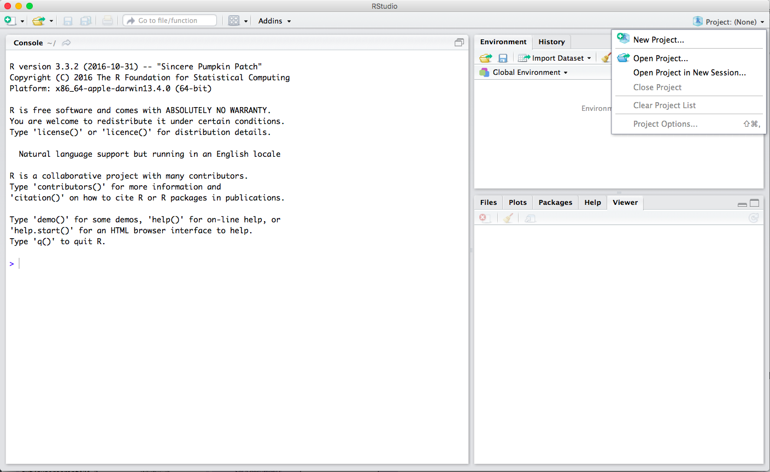

You'll then choose whether to create a new directory (or folder) to hold the project, or using an existing one.

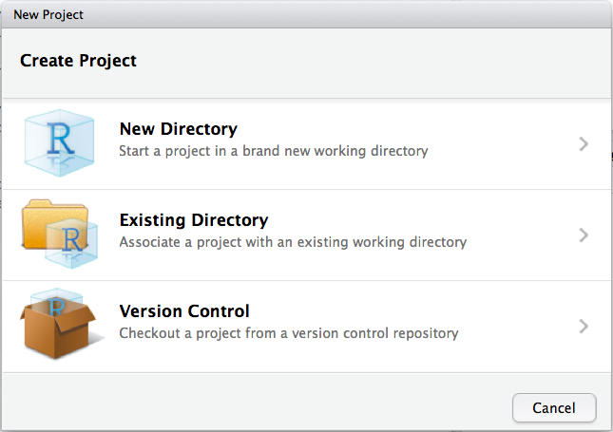

Most likely, you'll want to create an empty project.

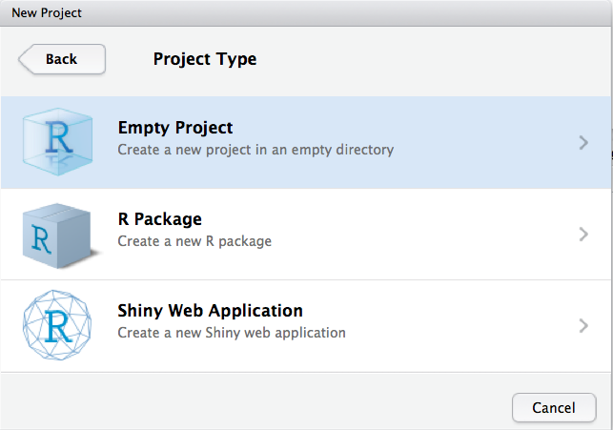

Then you'll specify the project name. Voila! Now you're all set.

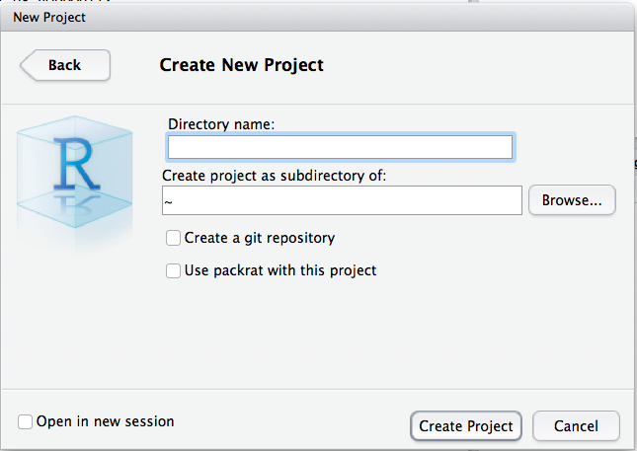

### *The* biggest R mistake

And that brings up what is probably the biggest R mistake you can make: **not using an R package that suits your problem, or using the wrong package**. Unfortunately, there is no error message for this; you learn it through experience.

For data science problems, though, a good place to start is the tidyverse package we just loaded. We’ll be referencing its various packages throughout this book. But when in doubt, look there first.